**FSM BASED VGA CONTROLLER   
(XGA STANDARDS 1024x768 @60Hz)**

Source Image (1024x768):

Reconstructed Image (1024x768):

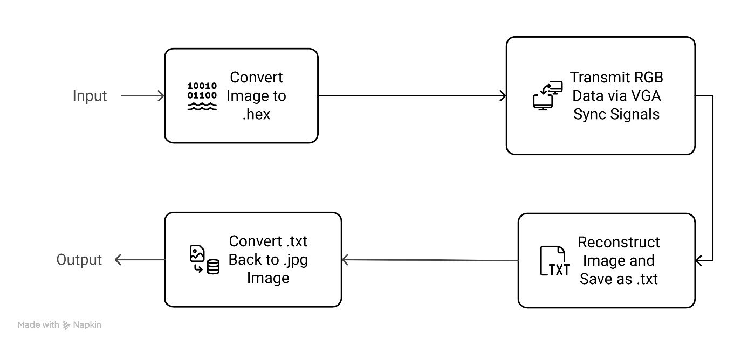Workflow:

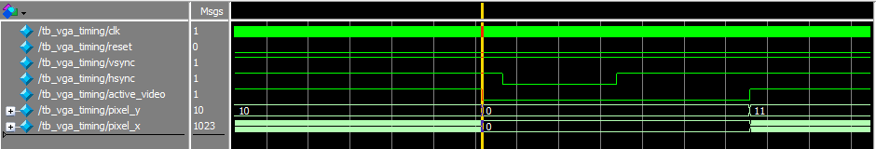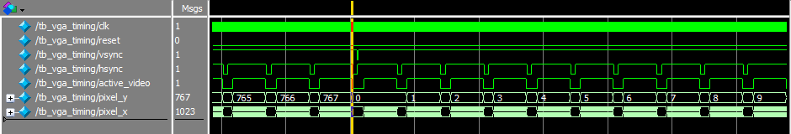Timing Signals:

Figure 2 - Hsync pulse after horizontal active video (0-1023)

Figure 3 - Vsync pulse after vertical active video (0-767)