DRAMS Live
Complete System Documentation
Architecture · Data Model · End-to-End Process Flowcharts

Platform: CTD telecom-data & person-intelligence analysis system
Framework: Kohana 3.x PHP (HMVC) · Production base URL: https://ctd.drams.com
Generated: 2026-06-08

1. Executive Overview
DRAMS Live is a web-based intelligence and investigation platform used to collect, enrich, analyse and report on persons of interest and their telecommunications activity. It is built for a law-enforcement / counter-terrorism workflow and centres on five capabilities:
# | Capability | What it does
1 | Person profiling | A 360 degree record per person: identity (CNIC/NADRA, foreigner, passport), addresses, education, banks, criminal record, affiliations, training, relations, devices, SIMs, photos.
2 | Telecom data acquisition | Submits formal data requests (CDR, subscriber info, current location, etc.) to mobile operators via email, then automatically parses the operators' email replies back into the database.
3 | CDR analysis | Call/SMS detail-record analytics: call & SMS summaries, B-party analysis, location/cell-tower tracking, device/IMEI/SIM history, graph visualisations.
4 | External data federation | Searches several external government/telecom databases (subscriber, ECP, KPK-CTD, DLMS, govt-employee) plus identity services (NADRA, Verisys, Family Tree, Travel) and an AIES/CCTW REST API.
5 | Watchlists, reporting & audit | Tag and watch persons, build user/person/admin analytics, and keep a full audit trail of every analyst action.

The system is role-based: each user only sees the menus and data their role permits, and every search, view and request is logged.

2. Technology Stack
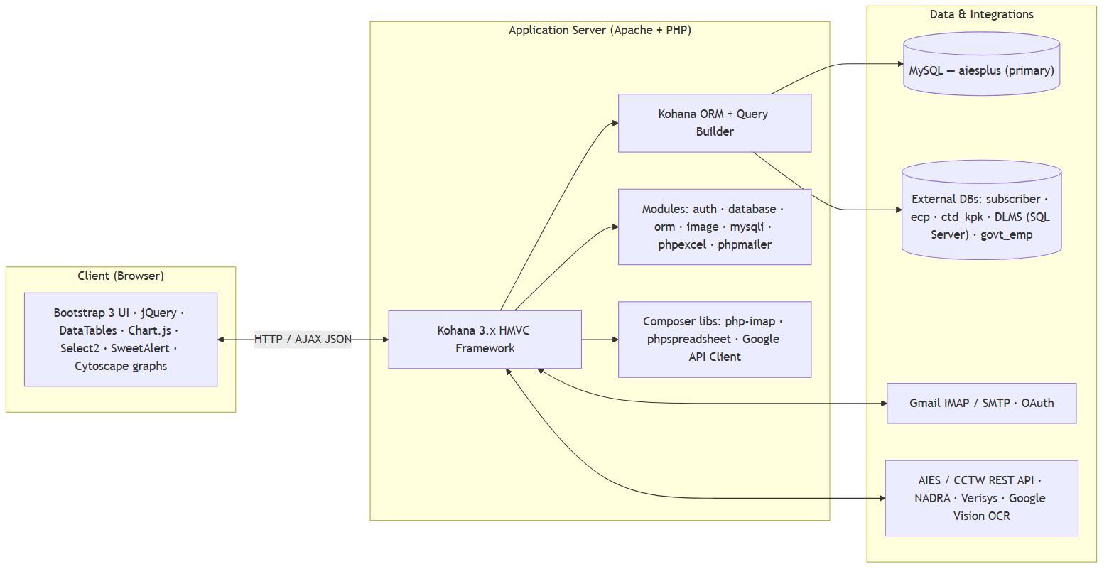
Figure 1 — Technology stack
Layer | Technology
Language / Runtime | PHP 5.x+ on Apache (XAMPP in dev)
Framework | Kohana 3.x (HMVC)
ORM / DB access | Kohana ORM, Query Builder, mysqli driver
Auth | Kohana auth module, ORM driver, SHA256 password hashing
Mail | PHPMailer (send) + PHP IMAP / webklex/php-imap (receive), Gmail OAuth
Spreadsheets | phpoffice/phpspreadsheet + legacy phpexcel (exports & bulk-upload parsing)
Frontend | Bootstrap 3.3, jQuery, DataTables, Chart.js, Select2, jQuery-Confirm, SweetAlert, Cytoscape (CDR graphs)
Primary DB | MySQL - aiesplus (prod) / aiesdev (dev)
Federated DBs | subscriber_db, ecp, ctd_kpk, DLMS_FamzSolutions (MS SQL Server), govt_emp_data

3. High-Level System Architecture
The application follows Kohana's HMVC pattern with a strict layered design. A single base controller (Controller_Working) enforces authentication and RBAC for every authenticated page; a few public controllers (login, cron, REST API) bypass it deliberately.
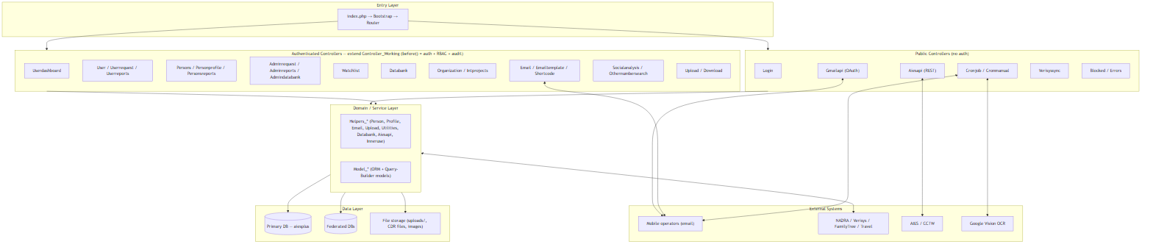
Figure 2 — High-level system architecture

Controller inheritance
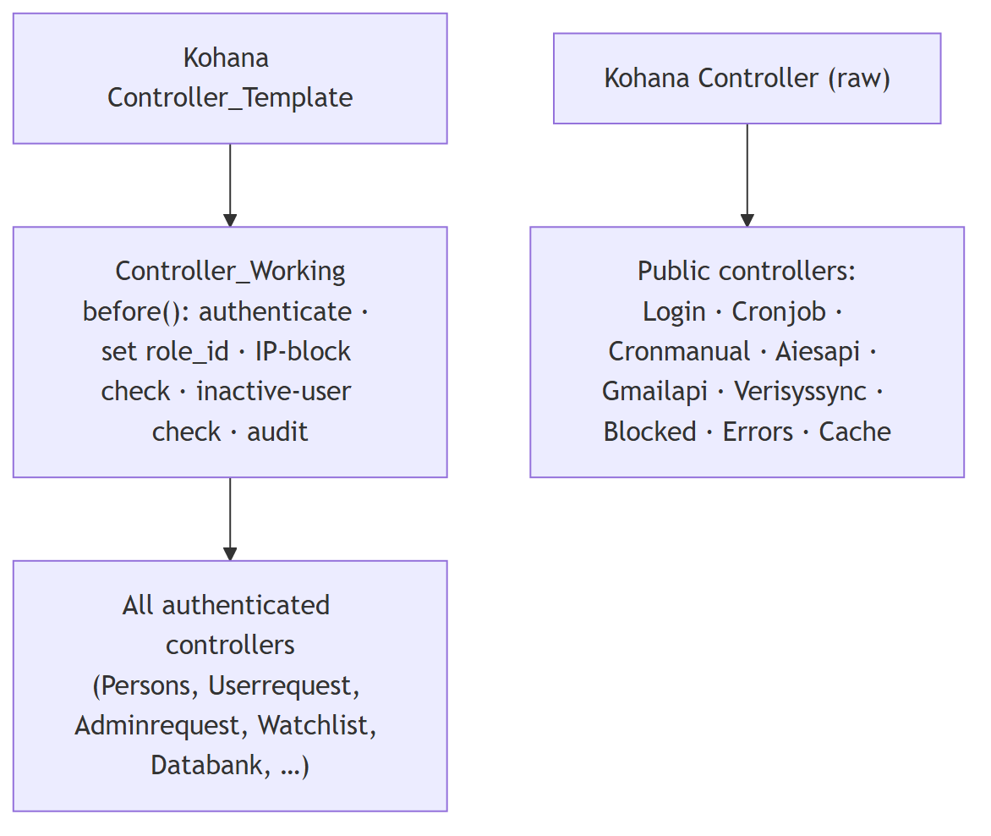
Figure 3 — Controller inheritance

4. Request Lifecycle (HMVC Flow)
Every browser hit follows the same pipeline. The default route maps /<controller>/<action>/<id> to a controller action; the default controller is login.
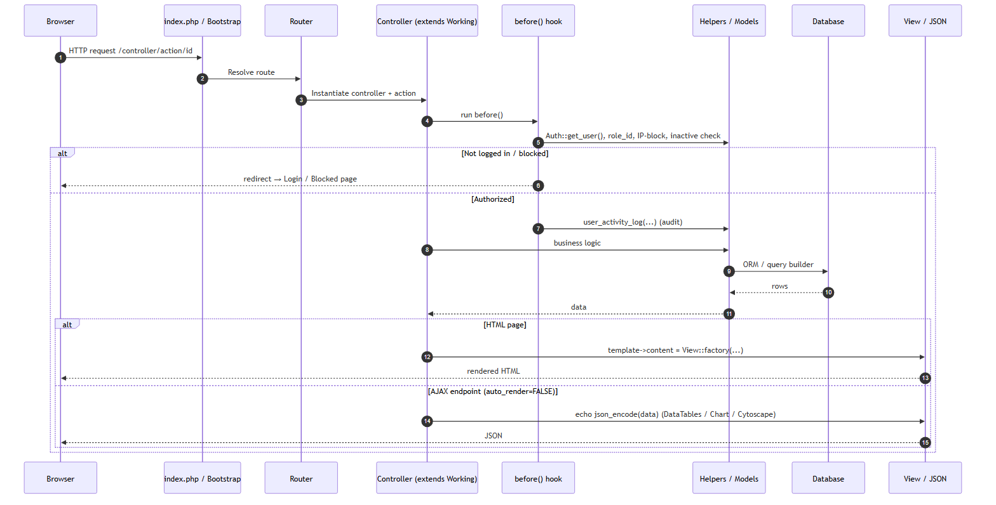
Figure 4 — Request lifecycle (HMVC sequence)

Two response styles
- Full pages render through the Kohana template wrapper (site-header, sidebar, site-footer); view bodies often live in *_functions/*.inc includes.
- AJAX endpoints set auto_render=FALSE and echo json_encode(...). Lists use the DataTables shape {sEcho, iTotalRecords, iTotalDisplayRecords, aaData}; charts use Chart.js arrays; the CDR network graph uses Cytoscape node/edge JSON.

5. Codebase / Module Structure
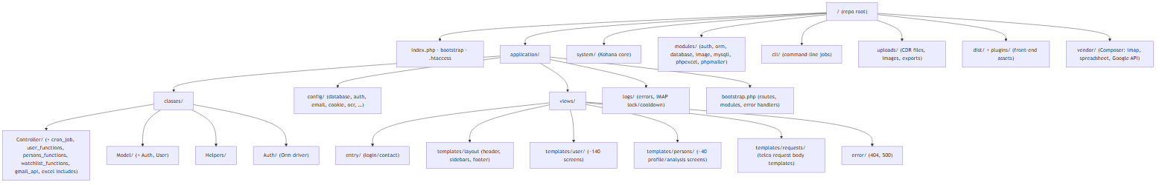
Figure 5 — Codebase / module structure
Include-file convention: large controllers keep each action's view-binding logic in a matching .inc include - user_functions/ (User), persons_functions/ (Persons), watchlist_functions/ (Watchlist), excel/ (report exports) and cron_job/<task>/ (per-operator send/parse logic).

6. Controller Catalogue
Controller | Auth | Purpose
Login | No | Username/password + IP-throttled login, one-time token login, password recovery
Userdashboard | Yes | Landing dashboard, person counts (black/grey/white), CNIC/password gating, charts
User | Yes | Person/identity search, bulk search, data-upload handlers, audit utilities
Userrequest | Yes | User telco data requests (CDR, subscriber, location, NADRA, family-tree, travel, blocked), scheduling, parsing queue, analytics (~60 actions)
Userreports | Yes | User-activity analytics: logins, requests sent, panel/URL logs, audit & performance
Persons | Yes | CDR analytics: call/SMS summaries & detail, B-party, location/cell logs, CDR graph, NADRA profile, family tree (~70 actions)
Personprofile | Yes | Edit the 360 person record (info, mobiles, relations, identities, education, banks, FIRs, affiliations, trainings); Verisys/FamilyTree/Travel updates
Personsreports | Yes | Person analytics: lists by category/district, devices/SIMs, top-searched, sensitive, breakups
Adminrequest | Yes | Admin/DRAMS-Plus requests + bulk CSV/Excel upload, autocomplete, status management
Adminreports | Yes | Identity breakups, Verisys pending/response, user breakup, blocked-IP list, menu management, password reset
Admindatabank | Yes | NADRA / MSISDN databank request management & breakup reports
Organization / Intprojects | Yes | Banned-organization registry / internal projects
Watchlist | Yes | Tag persons, add/remove from watchlist, area-wise & user watchlists
Databank | Yes | Federated search: subscriber, ECP (+family), KPK-CTD, DLMS, govt-employee
Email / Emailtemplate / Shortcode | Yes | Build & send telco request emails; CRUD for templates & short-codes
Socialanalysis / Othernumbersearch | Yes | Social/portal links; find other/affiliate numbers
Upload / Download | Yes | File upload (CDR/IMEI/doc), MSISDN/CNIC lookups; access-controlled downloads
Cronjob / Cronmanual | No | Background email send & parse, B-party rebuild, queue retries, OCR daemon, DB health
Aiesapi | No | REST API for AIES/CCTW: person lookup, 3D module, fingerprints, provisioning
Gmailapi | No | Gmail OAuth authorize/callback, send/read via Google API
Verisyssync | No | Sync temp-uploaded Verisys/FamilyTree/Travel images into person records
Blocked / Errors / ErrorLog / Cache | Mixed | Block page, error pages, error-log viewer, cache endpoints

7. Data Model (Entity-Relationship)
The domain centres on the person. person_initiate is the identity entry point (CNIC / foreigner-ID), person is the main record, and a constellation of attribute and activity tables hang off it. Users, roles, requests and lookup tables surround the core.
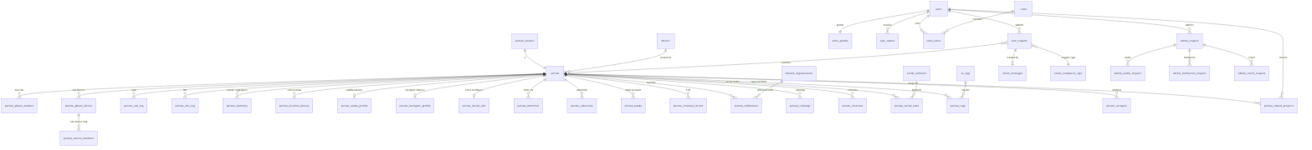
Figure 6 — Data model (Entity-Relationship)

Core entity descriptions
Entity | Role
person_initiate | Identity root - CNIC / foreigner CNIC, fingerprint flag
person | Main record - name, father, address, region/district/police-station
person_phone_number | SIM-person link (owner/user, IMSI, MNC, activation/last-use)
person_phone_device / person_device_numbers | Devices (IMEI) and SIM-device history
person_call_log / person_sms_log | Raw CDR - A-party, B-party, timestamp, duration, direction, cell/location
person_summary | Pre-aggregated contact counts per B-party
person_nadra_profile / person_foreigner_profile / person_detail_info | Identity & demographic enrichment
person attribute tables | education, banks, criminal_record, affiliations, trainings, identities, relations, social_links
person_tags + lu_tags | Tagging & watchlist membership (per district, per user)
user_request / admin_request (+nadra/familytree/travel) | Data-acquisition workflow records
email_messages / admin_email_messages | Outbound/inbound email audit (linked by message_id)
email_templates (+_type) | Per-operator request body templates
users / users_profile / roles / roles_users / user_tokens | Identity & access
banned_organizations | Org registry referenced by affiliations
manu_management | Per-role menu access matrix (RBAC)
files / inner_token | Uploaded file tracking / stored API credentials

8. Database Connections (Federated Data Sources)
database.php defines six connections. The primary (default) holds all DRAMS data; the others are read-only federated sources searched from the Databank module.
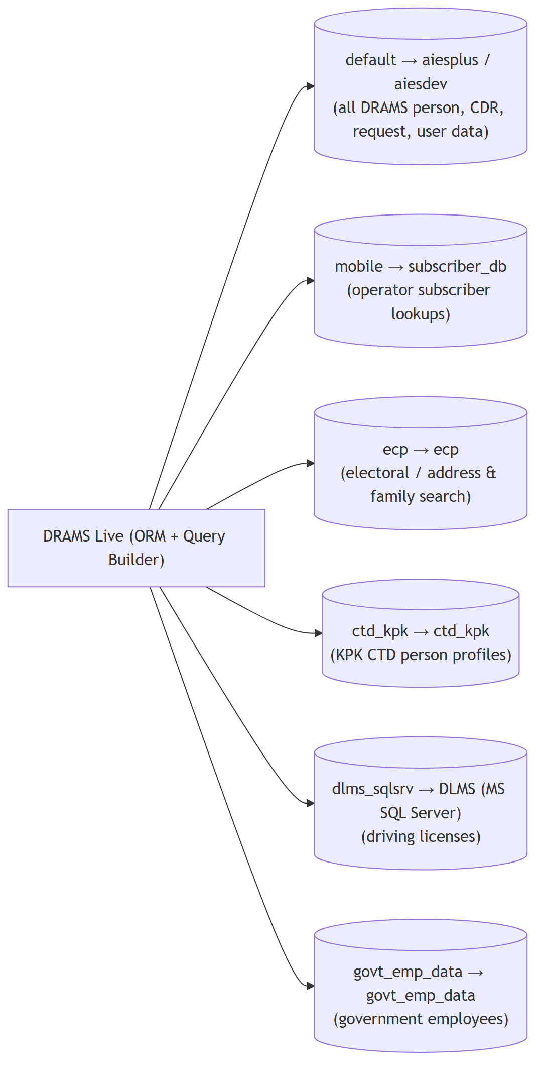
Figure 7 — Federated database connections
Connection | Database | Use
default | aiesplus / aiesdev (MySQL) | All DRAMS person, CDR, request, user data
mobile | subscriber_db (MySQL) | Operator subscriber lookups
ecp | ecp (MySQL) | Electoral / address & family search
ctd_kpk | ctd_kpk (MySQL) | KPK CTD person profiles
dlms_sqlsrv | DLMS_FamzSolutions (MS SQL Server) | Driving licenses
govt_emp_data | govt_emp_data (MySQL) | Government employees

9. Authentication, Sessions & RBAC
Driver: Kohana auth module, ORM driver (Auth_Orm). Passwords are SHA256-hashed. The session stores only the user_id; the full Model_User ORM object is rehydrated per request. Token lifetime is up to 14 days.

Three login paths (Controller_Login)
- Username/password - action_check() with per-IP brute-force throttling (~5 attempts -> IP block).
- One-time token - remote-workspace SSO; URL token validated for expiry, consumed once, then force_login().
- Password recovery - action_forget() email flow.

Enforcement in Controller_Working::before()
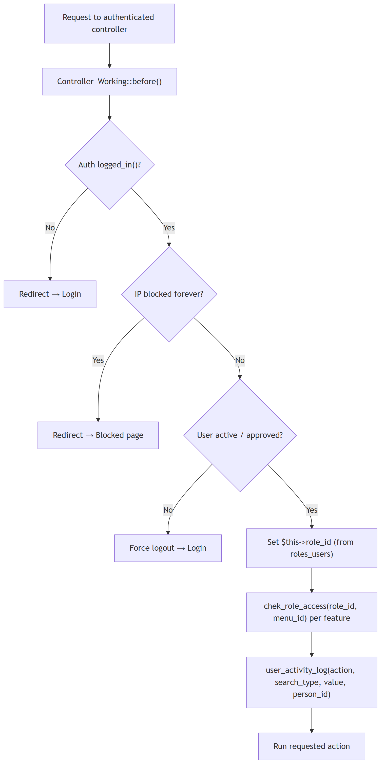
Figure 8 — Authentication & RBAC enforcement (before hook)

RBAC model
Access is decided by combining a permission tier, a data scope, and a menu matrix:
- Permission level - get_user_permission(user_id) returns a 0-5 tier (Administrator -> Field Officer -> Dev support).
- Data scope - get_user_permission_for_requests(user_id) returns all | region | district | own, filtering every request/report query.
- Menu access - chek_role_access(role_id, menu_id) reads the manu_management matrix to show/hide each sidebar item.
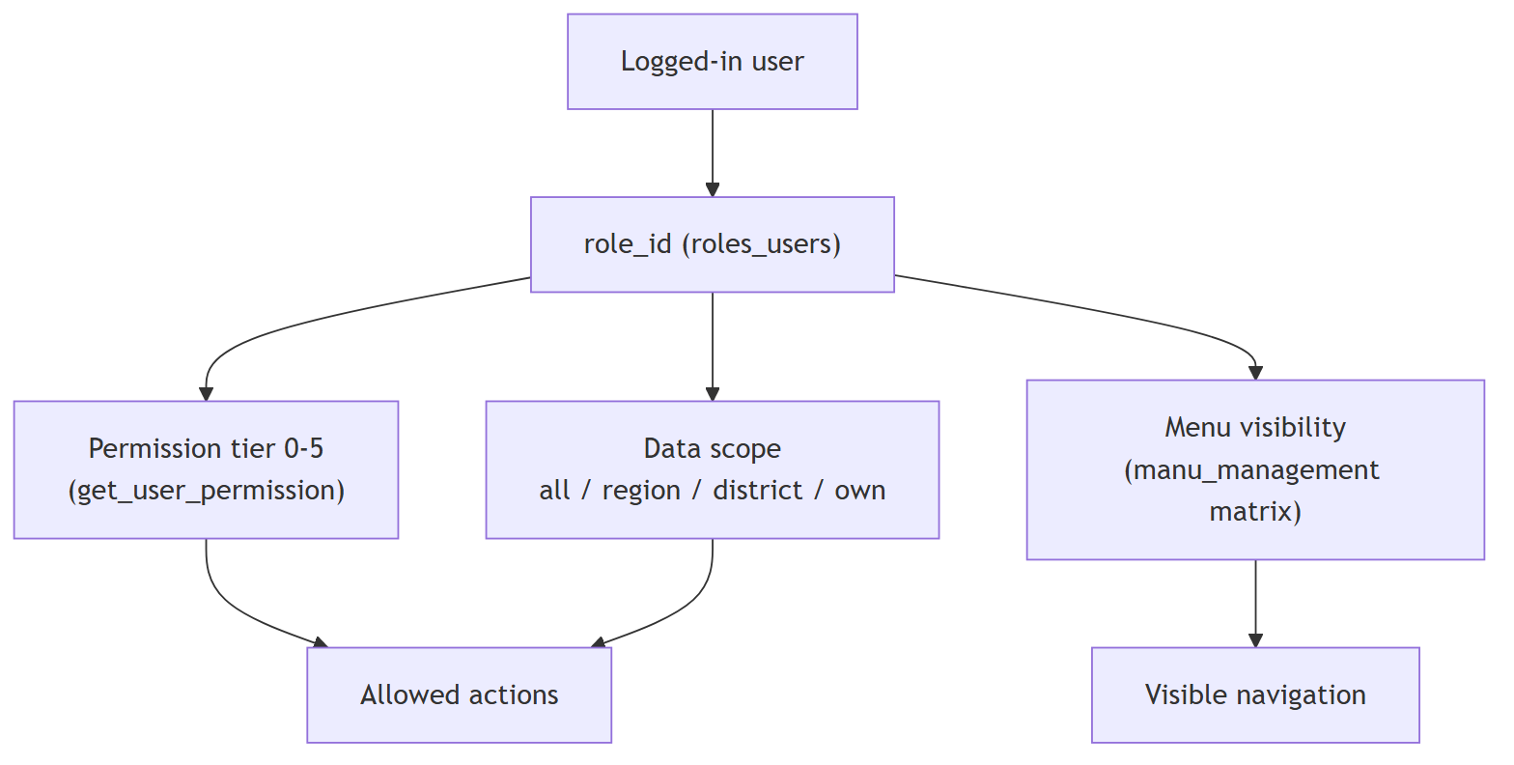
Figure 9 — RBAC decision model
Tier | Example roles | Capability
1 - Administrator | role 1 | Full access; user registration; menu management; ACL
2 - Technical support | roles 2, 4, 6 (HQ/Regional/District) | Search, analysis, reports within scope
3 - Executives | roles 3, 5, 7 | Officer-level review within scope
4 - Field officer | role 8 | Limited / own scope
5 - Dev support | role 9 | Maintenance, menu/user admin

Additional fine-grained roles gate individual modules (Watchlist add = 25, Organization view/edit = 31/32, Databank = 34/35). Sensitive persons are further protected by cis_sensitive_person_acl.

10. Core Process Flowcharts

10.1 Login & Session Flow
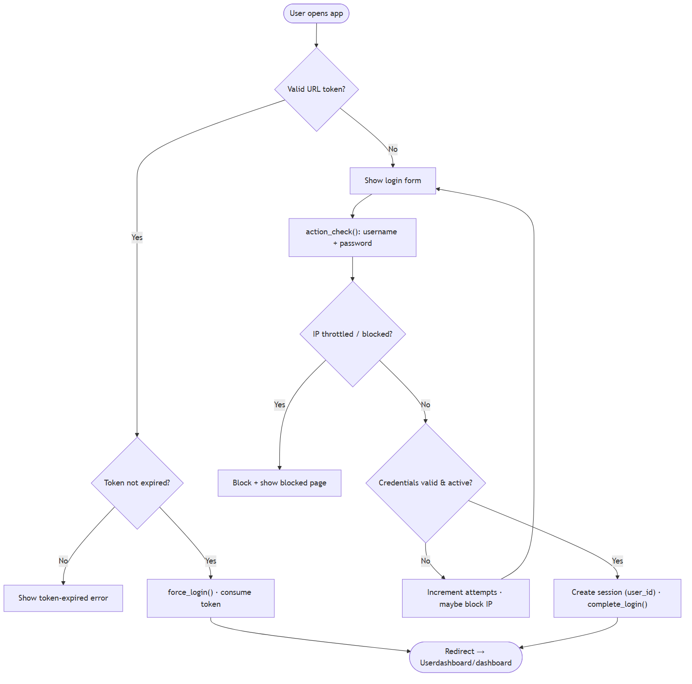
Figure 10 — Login & session flow

10.2 Person Search to Profile Flow
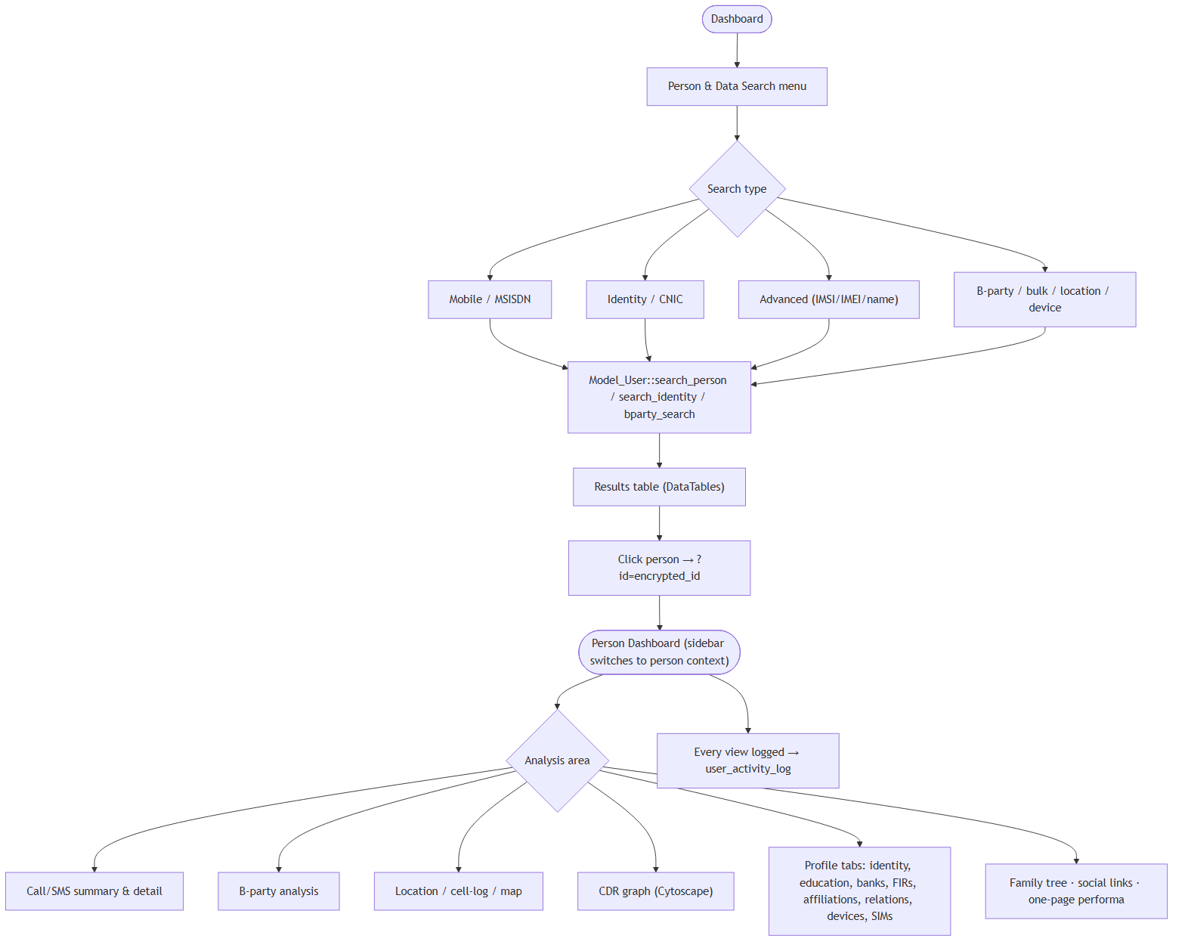
Figure 11 — Person search to profile flow

10.3 Telecom Data Request Lifecycle (the core flow)
This is the heart of DRAMS: a request is created, queued, emailed to the operator, the operator emails a reply, and a cron parser writes the data back to the person record. It is fully asynchronous and email-driven.
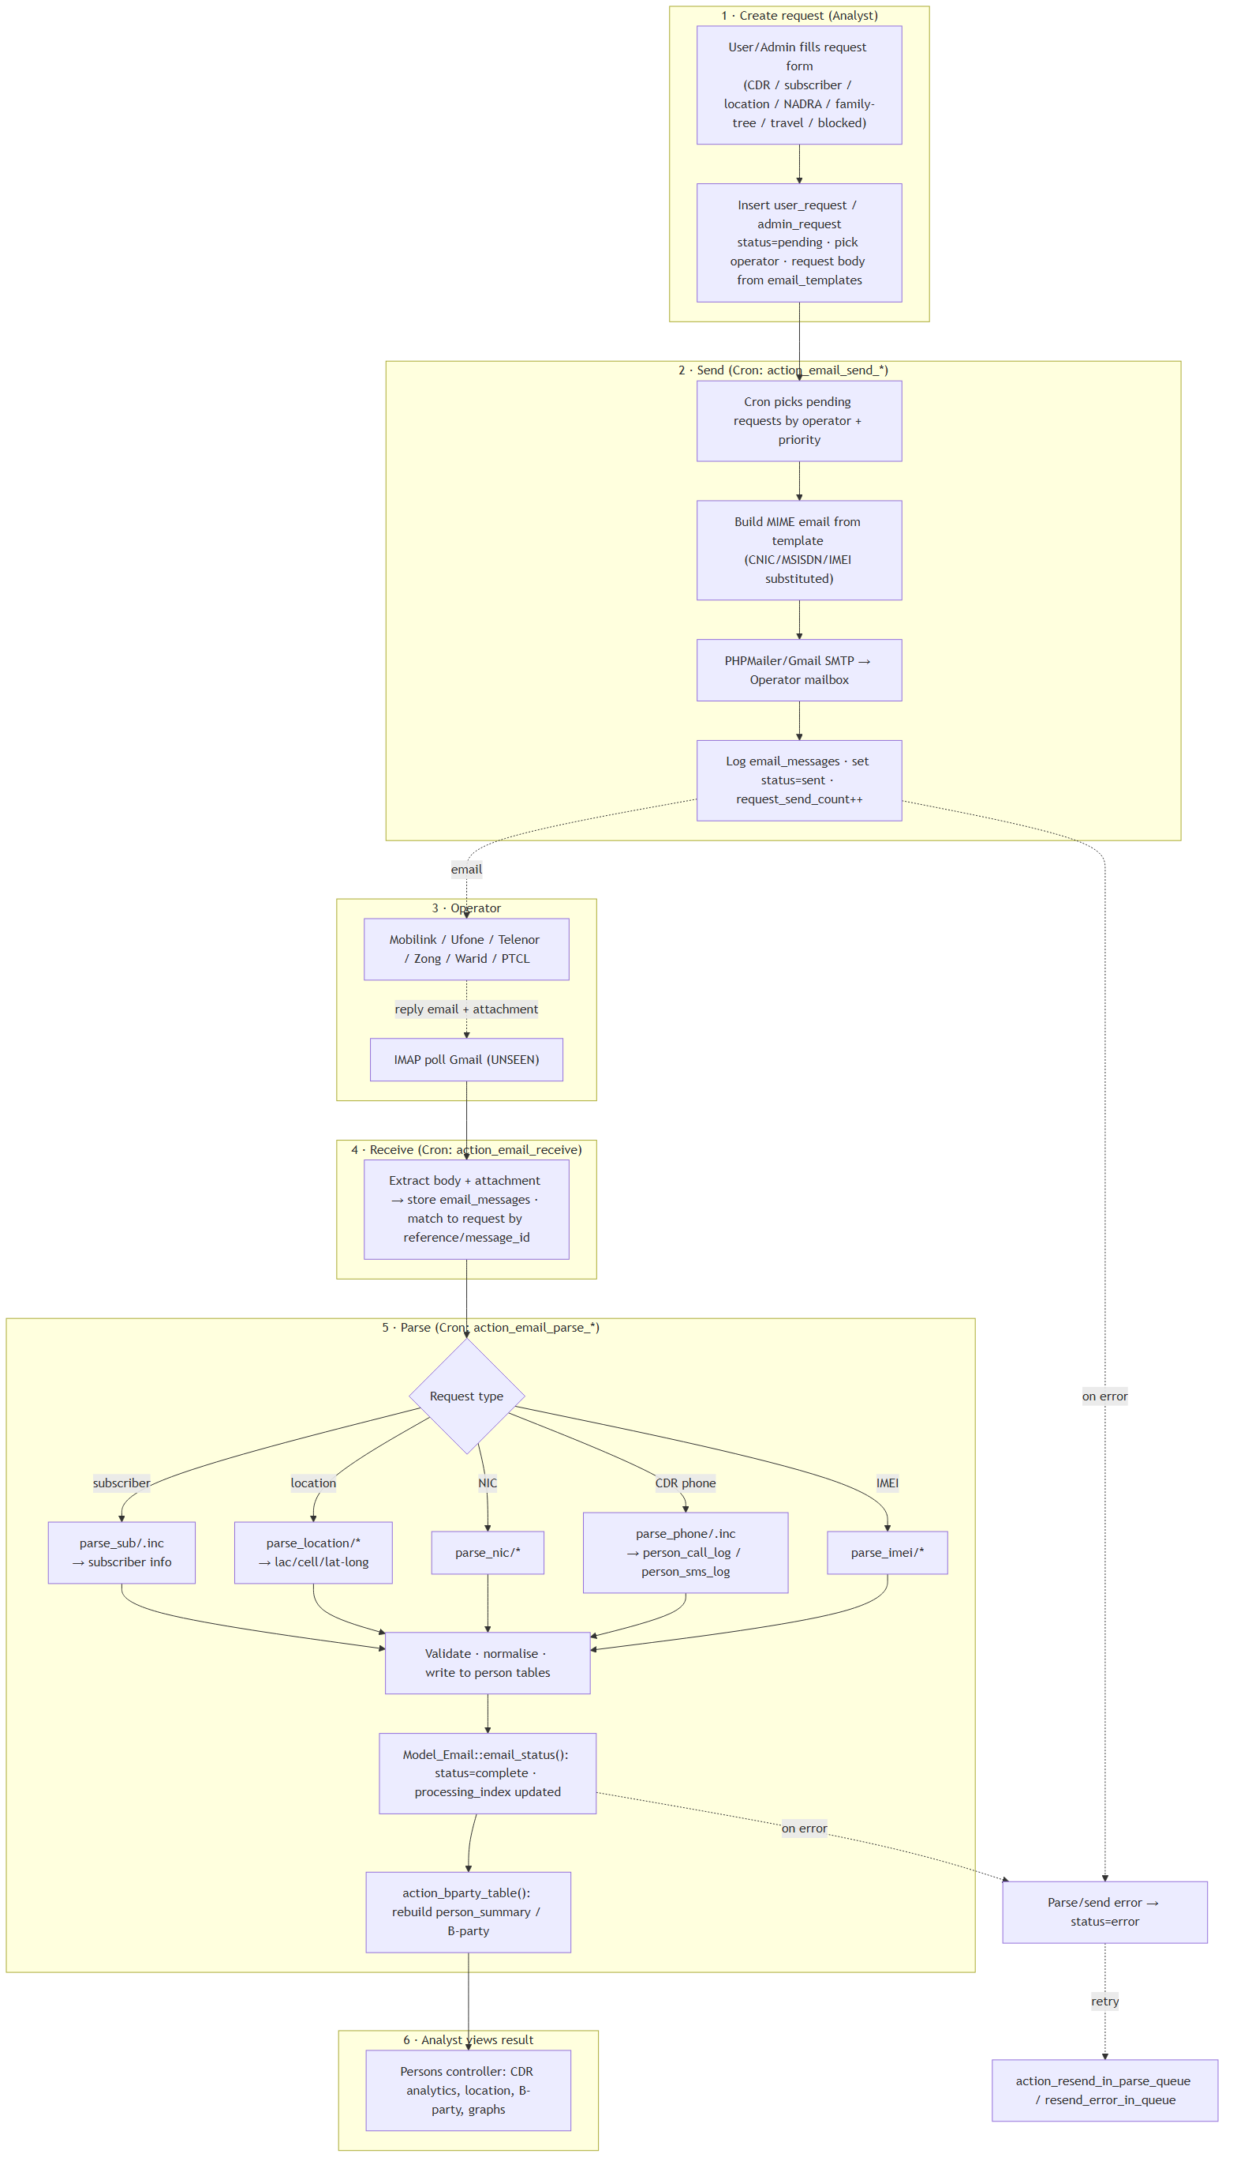
Figure 12 — Telecom data request lifecycle (core flow)

Status & processing codes (observed)
Field | Value | Meaning
status | 0 | pending
status | 1 | processed / sent
status | 2 | processing / complete-pending
status | 3 | error
processing_index | 3 | error
processing_index | 4 | received
processing_index | 5 | not found
processing_index | 7 | uploaded
processing_index | 8 | no data

Operators are addressed by company case in the parser switch (Mobilink/Warid, Ufone, Telenor, Zong, PTCL). Request types are keyed by user_request_type_id (1/6 = CDR, 3 = subscriber, 4 = location, 5 = NIC, 8 = Verisys, 10 = family tree, 11 = travel).

10.4 CDR / Bulk Data Ingestion Flow
When CDR data is supplied as a file (not by email), analysts upload it directly.
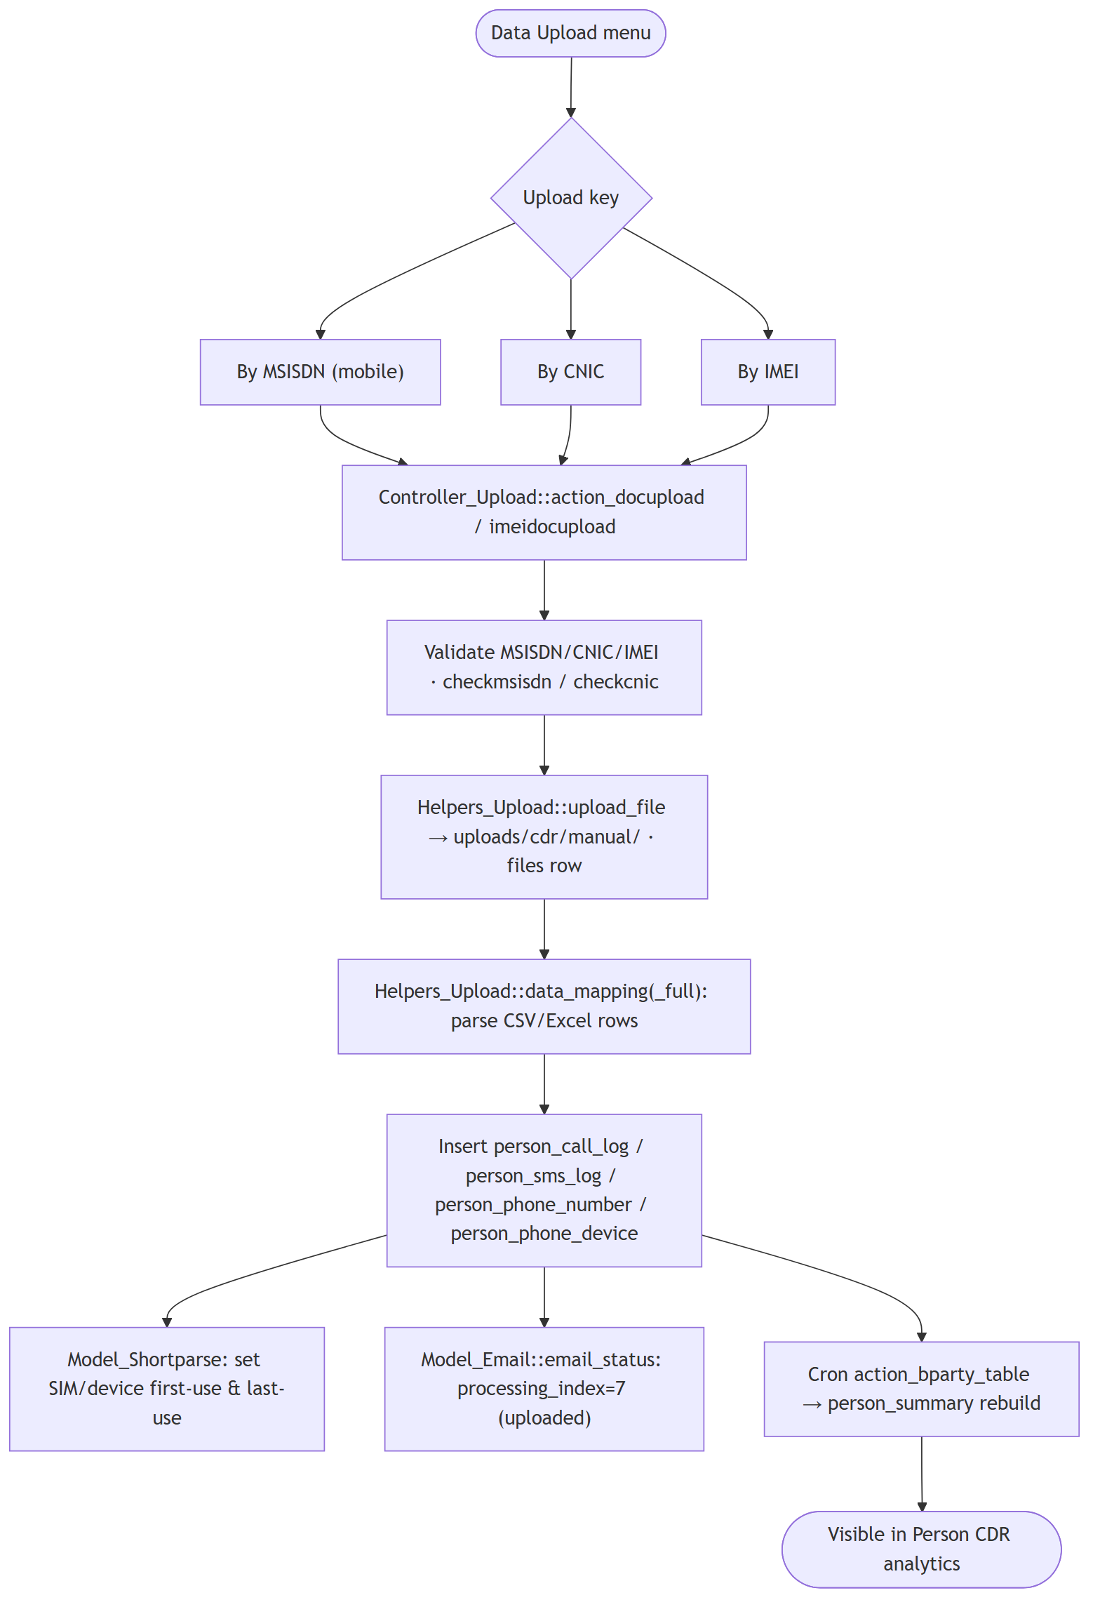
Figure 13 — CDR / bulk data ingestion flow

10.5 Identity Sync - NADRA / Verisys / Family Tree / Travel
Identity-document requests follow a two-step pattern: the request goes out (email/API), images/data are dropped into a temp staging area, and Verisyssync matches them by CNIC into the person record.
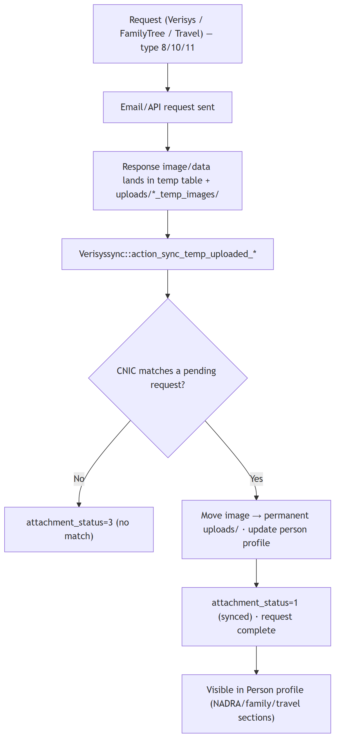
Figure 14 — Identity sync (NADRA / Verisys / Family Tree / Travel)

10.6 Watchlist Management Flow
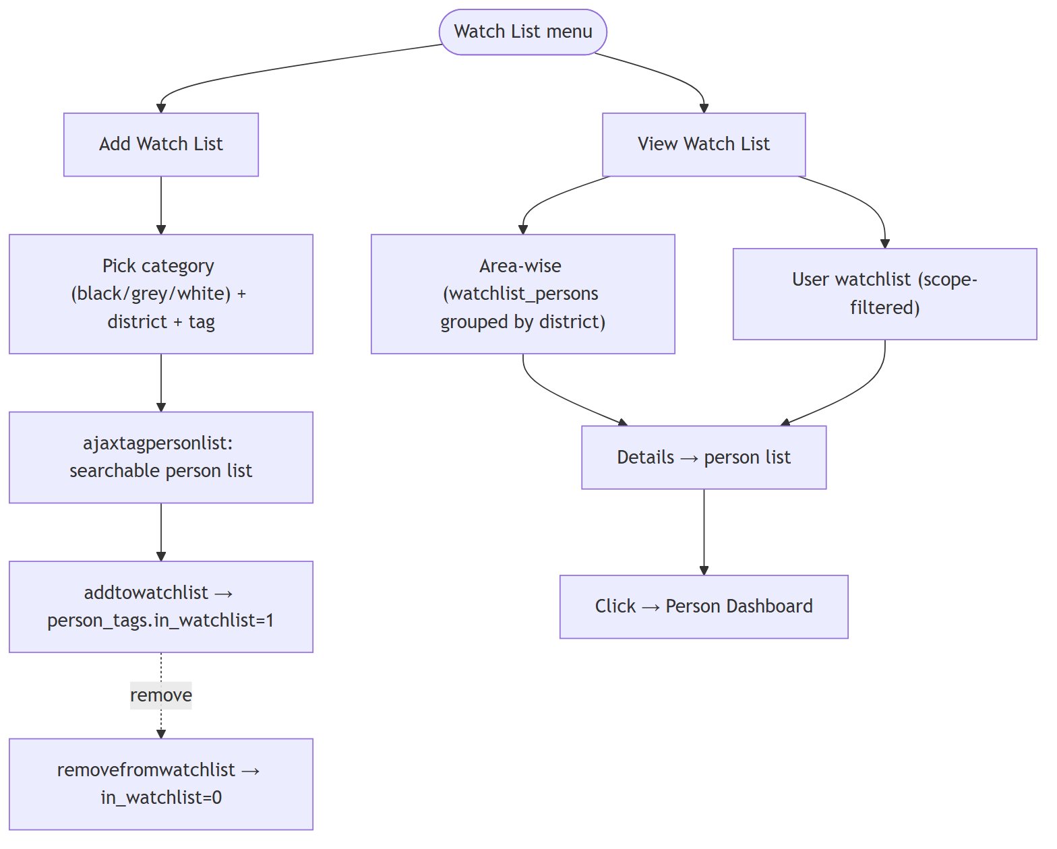
Figure 15 — Watchlist management flow

10.7 Reporting & Audit Flow
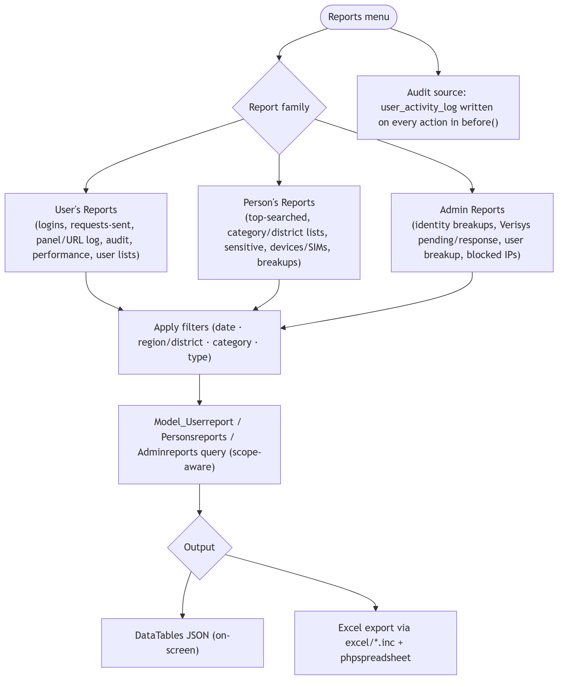
Figure 16 — Reporting & audit flow

10.8 Cron / Background Processing Pipeline
The Cronjob controller is the asynchronous engine. Scheduled HTTP hits (or CLI) trigger send/parse/maintenance actions. Locks/cooldowns prevent overlapping IMAP runs.
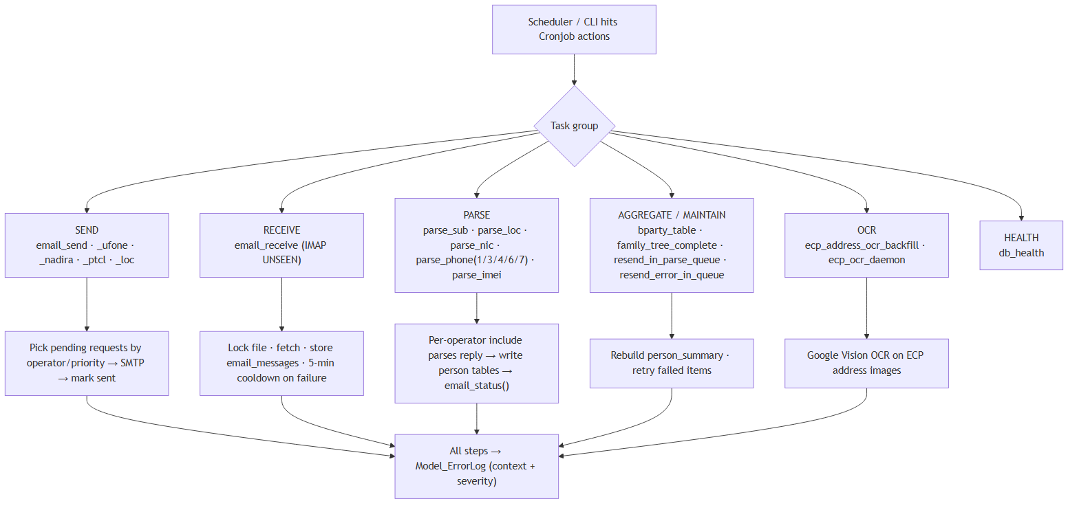
Figure 17 — Cron / background processing pipeline

10.9 External Integrations (AIES/CCTW, Gmail, OCR)
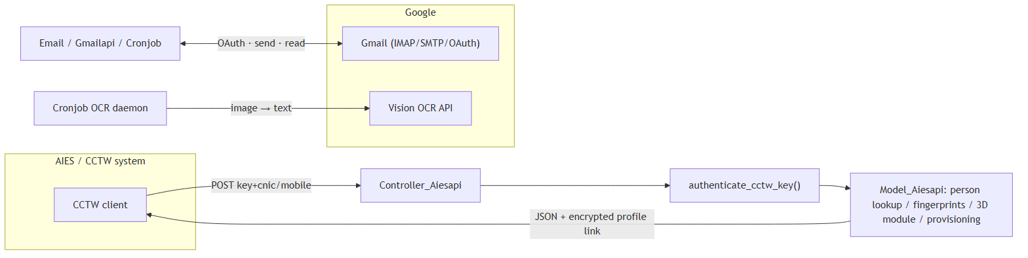
Figure 18 — External integrations

11. Sitemap & Navigation
The left sidebar (sidebar_user.php) is role-filtered; once a person is opened, it swaps to a person-context sidebar (sidebar_person.php).
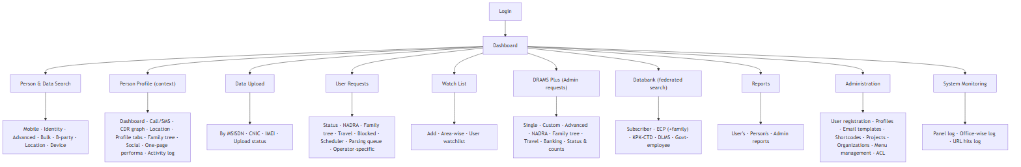
Figure 19 — Sitemap & navigation

12. User Roles & Journeys
User type | Typical roles | Primary journeys
Super Admin | 1 | User registration, menu management, ACL, all reports & DRAMS Plus
Dev / Tech support | 9 (+2,4,6) | Maintenance, user admin, system logs
Analyst / Operator | 2-8 | Search persons, analyse CDR, submit requests, build reports
Request manager | 14+ | Manage request queue, scheduling, projects
Data-upload operator | 9-12 | Bulk-upload CDR files, monitor parsing
Watchlist user | 25-26 | Tag & monitor persons
Databank user | 34/35 | Federated identity/address searches
Monitoring | 57-58 | Panel & URL audit logs

Representative end-to-end journey (analyst):
Figure 20 — Analyst end-to-end journey

Appendix A - Database Table Inventory
Person core & activity: person_initiate, person, person_detail_info, person_nadra_profile, person_foreigner_profile, person_phone_number, person_phone_device, person_device_numbers, person_call_log, person_sms_log, person_summary, person_location_history, person_category, person_category_history.
Person attributes: person_identities, person_education, person_banks, person_criminal_record, person_affiliations, person_trainings, person_relations, person_social_links, person_tags, person_linked_projects.
Requests & email: user_request, admin_request, admin_nadra_request, admin_familytree_request, admin_travel_request, email_messages, admin_email_messages, email_templates, email_templates_type, files.
Identity / access: users, users_profile, roles, roles_users, user_tokens, manu_management, cis_sensitive_person_acl, inner_token.
Lookups / geography: banned_organizations, lu_tags, social_websites, telco_short_code, district, region, police_station.
Table and column names are inferred from model/query-builder code; treat as authoritative for documentation but verify against the live schema before migrations.

Appendix B - Glossary
Term | Meaning
DRAMS | The platform name (CTD person-intelligence & telecom-data analysis system)
DRAMS Plus | Admin-tier advanced/bulk request module
CDR | Call Detail Record - call/SMS metadata supplied by operators
B-party | The other party a target communicates with (called/calling number)
MSISDN | Mobile phone number
IMSI / IMEI | SIM identity / device identity
CNIC | Pakistani national ID number (13 digits)
NADRA | National identity database (identity profile source)
Verisys | Biometric / identity verification service
ECP | Electoral database (address/family search)
DLMS | Driving-license management system (MS SQL Server source)
KPK-CTD | Khyber Pakhtunkhwa CTD person database
AIES / CCTW | External counter-terrorism system integrating via REST API
HMVC | Hierarchical Model-View-Controller (Kohana's request pattern)
manu_management | Per-role menu-access matrix table (RBAC)

End of document - DRAMS Live System Documentation.

