**Lab 2: time and frequency domain electro mechanical system identification**

Alireza Alizadegan

# Abstract

This report presents procedure and results of Lab 2. Objective of this lab is identification of hybrid electro mechanical drive system by time and frequency domain methods. In pre lab, drive system is represented by lumped mass model in which masses and stiffness will identified based on measured natural frequencies. Natural frequencies of table and motor screw subsystem are derived analytically with nut disengaged. Then nut is engaged and natural frequencies of drive is obtained by symbolic calculations based on given mass and stiffness matrices. In main lab, four identification experiments as summarized in table below are performed

Table 1 - overview of experiments performed in lab 2

|  |  |  |  |
| --- | --- | --- | --- |
| **Model parameters** | **Physical component** | **Identification domain** | **I/O signals** |
| Friction | Guideways | Time | Current/velocity |
| Mass | Table | Time | Current/acceleration |
| Electrical dynamics | Linear motor | Frequency | Command/actual current |
| Mass & stiffness | Mechanical components | Frequency | Current/velocity  Force/acceleration |

# Introduction

System identification is collection of techniques which uses statistical methods to represent dynamical systems by mathematical models based on data measured from system. Dynamical system may be physical (e.g., falling body under gravity) or nonphysical (e.g., stock market reactions to external influences). System identification techniques may use input and output data or only output data. Typically, identification by input output data is more accurate; however, input data may not be available some times. In engineering system identification is used for identification of physical systems where, fortunately, input data is typically available. In mechanical engineering, more specifically, electromechanical mechatronics for manufacturing is probably most common and important physical systems that are identified. In manufacturing, feed drive systems are very common and important in manufacturing process. Therefore, Lab 2’s objective is to apply common system identification techniques to electro mechanical drive systems as well as familiarize with available data and obstacles of their systems identification.

# Procedures, results, and discussions

The target electromechanical system is single axis hybrid feed drive shown in Figure 1 of lab instructions. It is proposed to use 3-mass-1-inertia model to describe behavior of mechanical components of feed drive and 3rd order transfer function to describe behavior of mechanical components of feed drive. Model is illustrated in Figure 2 of lab instructions. Objective is to obtain numeric values of parameters of model.

To achieve goal, natural frequencies of subsystems of model are obtained analytically in pre lab. Then, numeric values of natural frequencies are identified experimentally in main lab. Numeric values of parameters are calculated by equation of analytical expressions of natural frequencies to numeric values obtained from experiment. Table 2 summarizes analytical expressions of natural frequencies obtained in pre lab as well as parameters in each natural frequency expression that will be identified by experiment.

Table 2 - analytical expressions of natural frequencies obtained in pre lab as well as parameters to be identified by them

|  |  |  |
| --- | --- | --- |
| **Analyzed subsystem** | **Derived expressions of natural frequencies** | **Identified parameter** |
| Table & guideways | $ω_{n,1}=\sqrt{k_{gw}/m_{t}}$ for translation degree of freedom | $$k_{gw}$$ |
| $ω_{n,2}=\sqrt{k_{gw}b^{2}/I_{t}}$ for rotation degree of freedom | $$I_{t}$$ |
| Motor & screw | $$ω_{n}=\sqrt{k_{ms}(m_{m}+m_{s})/(m_{m}m_{s})},ω_{a}=\sqrt{k_{ms}/m_{s}}$$ | $m_{m}$, $m_{s}$, $k_{ms}$ |
| Integrated system (r=0) | $$ω_{n,3}=f_{3}\left(k_{st}\right), ω_{n,4}=f_{4}(k_{st})$$ | $$k_{st}$$ |

$f_{3}$ and $f_{4}$ are expressions as follows:

|  |  |
| --- | --- |
| $$f_{3}=$$ |  |
| $$f_{4}=$$ |  |

Where #1 refers to following term:

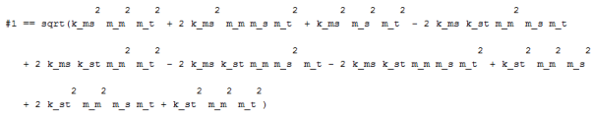

As shown $f_{3}$ and $f_{4}$ are functions of $k_{st}$ as well as other parameters; however, they are denoted in Table 2 as functions of $k_{st}$ only because they are used when other parameters are identified and substituted in them to calculate $k_{st}$.

## Identification of friction model of guideways

In this experiment model of friction of guideway given by equation below was identified.

|  |  |
| --- | --- |
|  | (1) |

Identification of friction model is performed in two experiments, namely identification of static friction and identification of dynamic friction. In both cases, friction forces are identified by multiplication of measurement of current to motor constant (57 N/A).

Objective of identification of static friction is to obtain value of $F_{stat}^{+}$ and $F_{stat}^{-}$ in newtons (N). This value corresponds to minimum force required to just start motion of feed drive in positive and negative directions. To obtain value integral action of velocity controller is turned off and speed command is set to small value. Speed command is gradually increased while monitor of motor force (current). Static friction force is force that corresponds to when motion begins. Current command needed to just start motion was 1.5 A and -1.3 A in positive and negative directions, respectively. Therefore, static friction is identified as $F_{stat}^{+}=85.5 N$ and $F_{stat}^{-}=-74.1 N$. Dynamic friction is identified by measurement of current of linear motor and commands of velocity of table. Velocity commands were 1, 5, 10, 20, 40, 60, 80, 100, 200, 300, 400, and 500 mm/s. For each of these velocity commands, current and velocity data was processed to obtain friction curve. Commanded distance changed proportional to commanded velocity because velocity was commended for fixed period of time. Therefore, as velocity increases distance increases proportional to velocity with multiplier of fixed time period. Post processing of data includes following procedure:

1. set start and end sample number for positive and negative velocity ranges by inspection of raw data of each command velocity
2. insert start and end sample numbers in template script
3. clear headers and other info from raw data files
4. process data by modified template script to generate friction curve by calculation of average force and average velocity in positive and negative ranges of each velocity command data file.

In post process, measured velocity was used rather than commanded velocity. Measured velocity is closer to velocity of system than commanded velocity due to existence of tracking error.

Figure 1 shows friction curve obtained by application of described procedure.

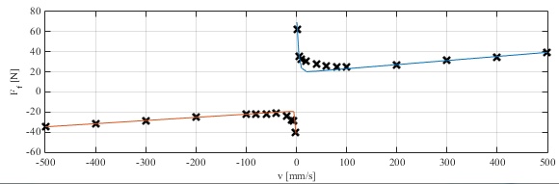

Figure 1 friction curve and identified model

Parameters of coulomb (i.e., $F_{coul}^{+}$ and $F_{coul}^{-}$) and viscous friction (i.e., B+, B-,) of friction model (1) were identified by fit of line to linear portions of friction curve. Curve fit is performed on linear portions of positive and negative velocities separately. Figure 2 shows curve fits on positive and negative velocity ranges. As shown in figure, linear curve fit matches data very well.

|  |  |
| --- | --- |
|  |  |
| 1. curve fit of positive portion | 1. curve fit of negative portion |

Figure 2 - curve fit of linear portions of friction curve

Parameters of coulomb and viscous friction are equal to intercepts and slopes of curve fits shown in Figure 2, respectively. Numeric values of these parameters are shown in second and third column of Table 3. Parameters representing boundary and partial lubrication zones are identified by nonlinear least squares curve fit of friction curve by model (1) after coulomb and viscous parameters are substituted. Las two columns of Table 3 shows values of boundary and partial lubrication zones identified by nonlinear least squares implemented on MATLAB by lsqcurvefit function.

Table 3 - summary of values of parameters of friction model

|  |  |  |  |  |  |
| --- | --- | --- | --- | --- | --- |
|  | $$F_{static}(N)$$ | $$F_{coul} (N)$$ | ***B (N.s/mm)*** | $$v_{1} (mm/s)$$ | $$v_{2} (mm/s)$$ |
| **+** | +85.5 | +19.036 | 0.040673 | 3.709645 | 3.7095109 |
| **-** | -74.1 | -19.021 | 0.031437 | 1.071195 | 1.0711556 |

Based on values in Table 3, identified model is compared with measured friction curve in Figure 1. As shown model predicts measurements quite well.

## Identification of mass of table

In this section, objective is to identify mass of table based on newton’s law where force and acceleration is measured. More specifically, newton’s law applied to hybrid drive is $F_{LM}-F_{f}\left(v\right)=m_{t}a$, where $F_{LM}$ is known force applied by linear motor according to current command, $F_{f}(v)$ is obtained by substitution of measured velocity in friction model identified in previous section, *a* is measured acceleration, and $m_{t}$ is mass of table to be identified. Acceleration and velocities are obtained by differentiation of position measurements. Velocity and acceleration measurements are filtered by Butterworth filter of order 4 with different cut off frequencies before use in least squares estimation of mass of table. Table 4 shows estimates of mass of table obtained for each normalized cut off frequencies.

Table 4 - estimates of mass of table for different cut off frequencies of Butterworth filter

|  |  |  |  |  |  |  |
| --- | --- | --- | --- | --- | --- | --- |
| **Normalized cut off frequencies** | 0.8 | 0.4 | 0.2 | 0.1 | 0.05 | 0.025 |
| **Estimated mass (kg)** | 10.3065 | 25.6806 | 39.7554 | 41.2851 | 41.4955 | 41.5479 |

As shown, it makes sense to choose 0.05 as suitable normalized cut off frequency because as cut off frequency increases accuracy of estimate of mass of table decreases due to noise caused by differentiation of position measurements. To validate estimated mass of table. Force on table is predicted by estimate of mass of table and compared with measurements of force in Figure 3. In figure dashed line is prediction of force based on estimate of mass corresponding to 0.05 cut off frequency. This force is obtained by multiplication of estimate of mass with measured acceleration ($m_{t}a$). Solid line is measurements of force obtained by subtraction of friction force $F_{f}(v)$ from force applied by linear motor ($F_{LM}$). $F_{LM}$ is measured directly while $F_{f}(v)$ is obtained by substitution of measured velocity in friction model identified in previous section.

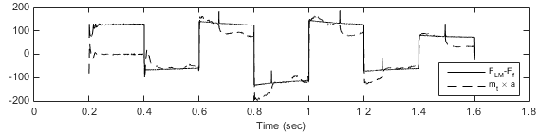

Figure 3 - comparison of measured applied force to table and predicted value based on estimated mass of table

## Identification of electrical dynamics

Objective of this section is to identify electrical dynamics of linear motor. Electrical dynamics is from current command to actual current generated by amplifier. Structure of model is proposed as 3rd order transfer function of form $G_{e}\left(s\right)=\frac{b_{1}s^{2}+b_{2}s+b_{3}}{s^{3}+a_{1}s^{2}+a_{2}s+a_{3}}$. Parameters of model are identified in frequency domain by application of sine sweep signal as current command to amplifier and measurement of actual current generated by amplifier. Raw data obtained from experiment were post processed to obtain frequency response function data which includes frequencies of sine sweep signal, real component of response for each frequencies, and imaginary component of response for each frequencies. In Figure 4, black solid curves show represent post processed frequency response data by bode plots.

|  |  |
| --- | --- |
|  | |
| 1. models obtained by use of frequencies 10 Hz to 500 Hz | 1. models obtained by use of frequencies 10 Hz to 1000 Hz |

Figure 4 - bode plots of data and models

Coefficients of transfer function are identified by two methods: (1) formulation as least squares (LS) problem (2) invfreq (IF) command in MATLAB. In Figure 4, red dashed curve shows model obtained by invfreq and blue dotted curve shows model obtained by least squares. For each method, models are obtained once by use of frequencies 10 Hz to 500 Hz, shown in Figure 4 (a), and once use of frequencies 10 Hz to 1000 Hz as shown in Figure 4 (b). As shown in all figures, least squares method and invfreq command match closely which indicates invfreq maybe using least squares based optimization algorithm. In models obtained by use of frequencies 10 Hz to 500 Hz prediction is accurate in low frequency range and less accurate in high frequency range, while in models obtained by use of frequencies 10 Hz to 1000 Hz predictions are more accurate in high frequency range and less accurate in low frequency range

When frequencies from 10 Hz to 1000 Hz were used for identification, accuracy of prediction of magnitude in low frequency region decreased because least squares algorithm takes prediction errors at high frequencies into account; however, due to fixed number of degrees of freedom of model, prediction of high frequency data comes at cost of decrease of accuracy in low frequency region. Since data at high frequency are noisy as shown in magnitude plots it is not so useful to take them into account. Numeric values of parameters of models are summarized in Table 5.

Table 5 - parameters of transfer function identifed by different methods/data

|  |  |  |  |  |  |  |
| --- | --- | --- | --- | --- | --- | --- |
|  | ***a1*** | ***a2*** | ***a3*** | ***b1*** | ***b2*** | ***b3*** |
| **LS (500)** |  |  |  |  |  |  |
| **IF (500)** | $${4.32×10}^{3}$$ | $${1.68×10}^{7}$$ | $${1.33×10}^{10}$$ | $${4.29×10}^{2}$$ | $${7.21×10}^{6}$$ | $${1.31×10}^{10}$$ |
| **LS (1000)** | $${-1.29×10}^{3}$$ | $${5.44×10}^{7}$$ | $${9.66×10}^{10}$$ | $${2.61×10}^{11}$$ | $${-2.25×10}^{7}$$ | $${1.60×10}^{10}$$ |
| **IF (1000)** | $${6.86×10}^{3}$$ | $${4.50×10}^{7}$$ | $${5.83×10}^{10}$$ | $${-1.32×10}^{3}$$ | $${9.55×10}^{6}$$ | $${5.39×10}^{10}$$ |
| **IF (500)**  **1 iter** | $${4.32×10}^{3}$$ | $${1.68×10}^{7}$$ | $${1.33×10}^{10}$$ | $${4.29×10}^{2}$$ | $${7.21×10}^{6}$$ | $${1.31×10}^{10}$$ |
| **IF (500)  10 iter** | $${4.32×10}^{3}$$ | $${1.68×10}^{7}$$ | $${1.33×10}^{10}$$ | $${-1.29×10}^{6}$$ | $${1.08×10}^{11}$$ | $${1.50×10}^{13}$$ |

invfreqs(h,w,n,m,wt,iter) provides superior algorithm that guarantees stability of resulting linear system and searches for best fit using iterative scheme. The iter parameter tells invfreqs to end iteration when solution has converged, or after iter iterations, whichever comes first. invfreqs defines convergence as occurred when norm of gradient vector is less than tol, where tol is an optional parameter that defaults to 0.01. Figure 5 shows identified models with different number of iterations based on frequencies up to 1000 Hz. As number of iterations of algorithm increases model matches data better.

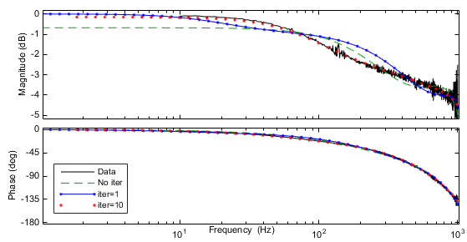

Figure 5 - identified models with different number of iterations

File GenerateFRF.m generates FRF from sine sweep data. Output of file inludes array whose first row is frequencies of sine sweep. In GenerateFRF.m, this row is obtained by set of start, end, and resolution frequencies in start of file according to experiment. Second and third row are, respectively, real and imaginary components of response. Response at each frequency is obtained by ratio of discrete Fourier transform of post processed output signal to normalized frequencies by number of points of discrete Fourier transform. Discrete Fourier transform is performed by Fast Fourier Transform algorithm implemented by fft command in MATLAB.

## Identification of flexible dynamics

Objective of this section is to identify mass and stiffness of 3-mass-1-inertia model. More specifically, parameters to be identified include mass of rotary motor and screw and stiffness of thrust bearing, nut, and guideways.

*Identification of mass of rotary motor and screw as well as stiffness of thrust bearing*

In this step, nut was disengaged and sine sweep current command was sent to rotary motor while corresponding velocity is measured by rotary encoder. Experiment is performed with and without offset of current command signal. Figure 6 shows comparison of comparison of frequency response of rotary motor with and without offset. As shown magnitude bode plot of experiment without offset is noisier than experiment with offset around anti resonance due to effect of static friction. According to frequency response, resonance frequency ($ω_{n}$) is 846 Hz (5316 rad/sec) and anti resonance frequency ($ω_{a}$) is 414 Hz (2601 rad/sec).

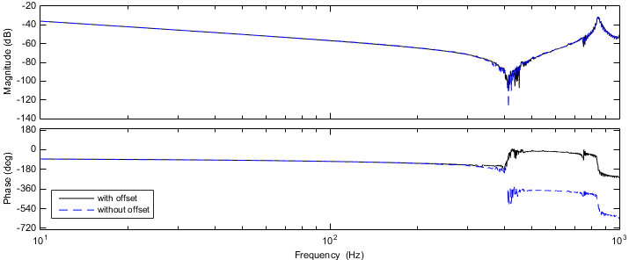

Figure 6 - comparison of frequency response of rotary motor with and without offset signal in identification

Based on expressions of $ω_{n}$ and $ω_{a}$ in Table 2, mass of motor can be obtained as $m_{m}=\left(m_{m}+m_{s}\right){\left(\frac{ω_{a}}{ω_{n}}\right)}^{2}=148.9 kg$. Total mass of motor and screw $\left(m_{m}+m_{s}\right)$ is assumed to be identified as 622 kg using similar method for identification of rigid body mass as performed for identification of mass of table. Based on this value mass of screw is identified as $m_{s}=\left(m_{m}+m_{s}\right)-m_{m}=473.1 kg$. Finally, based on expression of $ω_{a}$ in Table 2, $k_{ms}$ can be obtained as $k_{ms}=m_{s}{ω_{a}}^{2}=3.2×{10}^{9}N/m$.

Expressions in Table 2 are derived for model without damping; however, many types of frictions including viscous friction exists in real integration of motor and ball screw which contributes to modeling error. Values of mass of motor and screw are much larger than mass of table (41.5 kg) because they are amplified by factor of gear reduction ratio.

*Identification of stiffness of nut*

In this step, nut was engaged and sine sweep current command was sent to rotary motor while corresponding velocity is measured by linear encoder. Figure 7 shows bode plot of frequency response of from current command to velocity of linear encoder by blue dashed line.

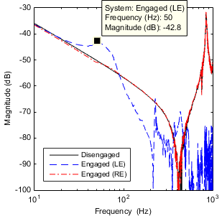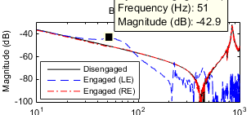

Figure 7 - frequency response of from current command to velocity. Solid black: data measured while nut was disengaged, dashed blue: data measured from linear encoder while nut was engaged, red dashed dotted: data measured from rotary encoder while nut was engaged

According to data, resonance frequency is 50 Hz. This value as well as mass of motor and screw and stiffness of thrust bearing are substituted to expressions of 3rd and 4th natural frequencies obtained in pre lab. Then, resulting nonlinear equations are solved for stiffness of nut. There was no solution for case of 4th natural frequency; however, solution corresponding to 3rd natural frequency was 12222 N/m. Nonlinear equation of resonance frequency is solved by nonlinear solver implemented by function fsolve in MATLAB and validated by plot of function and identification of its zero cross over value.

While nut engaged, similar frequency response data is collected by measurement of velocity from rotary encoder. Data are shown in Figure 7 by red dashed dotted line. Small resonance peak is observed around peak of data with linear encoder. This peak is not present on data while nut was disengaged (shown by solid black line) because it is related to stiffness of nut which doesn’t show up until nut is engaged; however, peak in case of rotary encoder is not as prominent as linear encoder due to sensor actuator collocation. Rotary encoder measures motion before elastic elements (e.g., coupler, screw, nut, etc.) while linear encoder measures motion after and therefore resonance due to stiffness shows up.

*Identification of stiffness of guideways*

In this step, nut was disengaged again and impact force was applied to middle of edge of table in direction perpendicular to guideways by impact hammer while acceleration in same direction being measured. Figure 8(a) shows magnitude bode plot of frequency response corresponding to this experiment and corresponding resonance frequency is $ω_{n,1}=$ 577 Hz. Using expression of $ω_{n,1}$ in Table 2, $k_{gw}$ can be obtained as $k_{gw}=m_{t} {ω_{n,1}}^{2}={5.45×10}^{8}$.

|  |  |
| --- | --- |
| Frequency (Hz)   1. frequency response of translational DOF perpendicular to guideways ($y_{t}$) | Frequency (Hz)   1. frequency response of yaw DOF ($θ_{t}$) |

Figure 8 - magnitude bode plat of frequency responses with impact hammer experiments

*Identification of rotational moment of inertia of table*

Keeping nut disengaged, impact force was applied to end of edge of table in direction parallel to guideways by impact hammer while acceleration measured on opposite end of same edge. Figure 8(b) shows magnitude bode plot of frequency response corresponding to this experiment and corresponding resonance frequency is 422 Hz. Using expression of $ω_{n,2}$ in Table 2, $I_{t}$ can be obtained as $I_{t}=k_{gw}b^{2} {/ω_{n,2}}^{2}=0.8481$. Summary of values of identified parameters are tabulated in Table 6.

Table 6 - summary of identified parameters of 3-mass-1-inertia model

|  |  |  |  |  |  |  |
| --- | --- | --- | --- | --- | --- | --- |
| $$m_{m} (kg)$$ | $$m_{s} (kg)$$ | $$m_{t} (kg)$$ | $$I_{t} (kg.m^{2})$$ | $$k_{ms} (N/m)$$ | $$k_{st}(N/m)$$ | $$k_{gw} (N/m)$$ |
| 148.9 | 473.1 | 41.5 | 0.8481 | $${3.21×10}^{9}$$ | 12222 N/m | ${5.45×10}^{8}$. |

Values in Table 6 as well as 104.55 mm for *b* and 98.25 mm for *r* are substituted in mass matrix (**M** in lab instructions) and stiffness matrix (**K** in lab instructions) of 3-mass-1-inertia model. Natural frequencies are obtained by root squares of eigenvalues of $M^{-1}K$. Table 7 shows values of calculated natural frequencies in Hz.

Table 7 – natural frequencies of 3-mass-1-inertia model

|  |  |  |  |  |  |
| --- | --- | --- | --- | --- | --- |
| Mode number | 1 | 2 | 3 | 4 | 5 |
| Natural frequency (Hz) | 847.31 | 421.81 | 0 | 2.82 | 576.75 |

## 

Figure 9 - mode shapes of different resonance modes of integrated system

## Conclusions

Learning objectives achieved through this lab are summarize below categorized to pre lab and main lab:

* Pre lab
  + Familiarized with typical approach of modeling feed drive system by lumped mass model as well as incorporation of electrical dynamics
  + Natural frequencies of different subsystems were derived analytically based on parameters of model with intention to be used for system identification
  + Sketched mode shapes of resonance modes to gain insight for design of experiment to identify corresponding natural frequencies
  + Derivation of analytic expressions for
* Main lab
  + Performed experiments and collected input output data from feed drive in different configuration (e.g., nut engaged/disengaged) and different sensors (linear/rotary encoder)
  + Performed post processing on raw data based on fast Fourier transforms to obtain frequency response data used for system identification
  + Identified frictions based on measured force of motor and rigid body mass of components based on acceleration measured
  + Identified natural frequencies natural frequencies by inspection of data and used analytic expressions of natural frequencies strategically to derive parameter values one after other