Test shows 48 errors (i.e. 4.8% misclassification rate). Termination criterion was 10% error of optimizer ($\hat{θ}$). Value of objective function at optimum is 307.84.
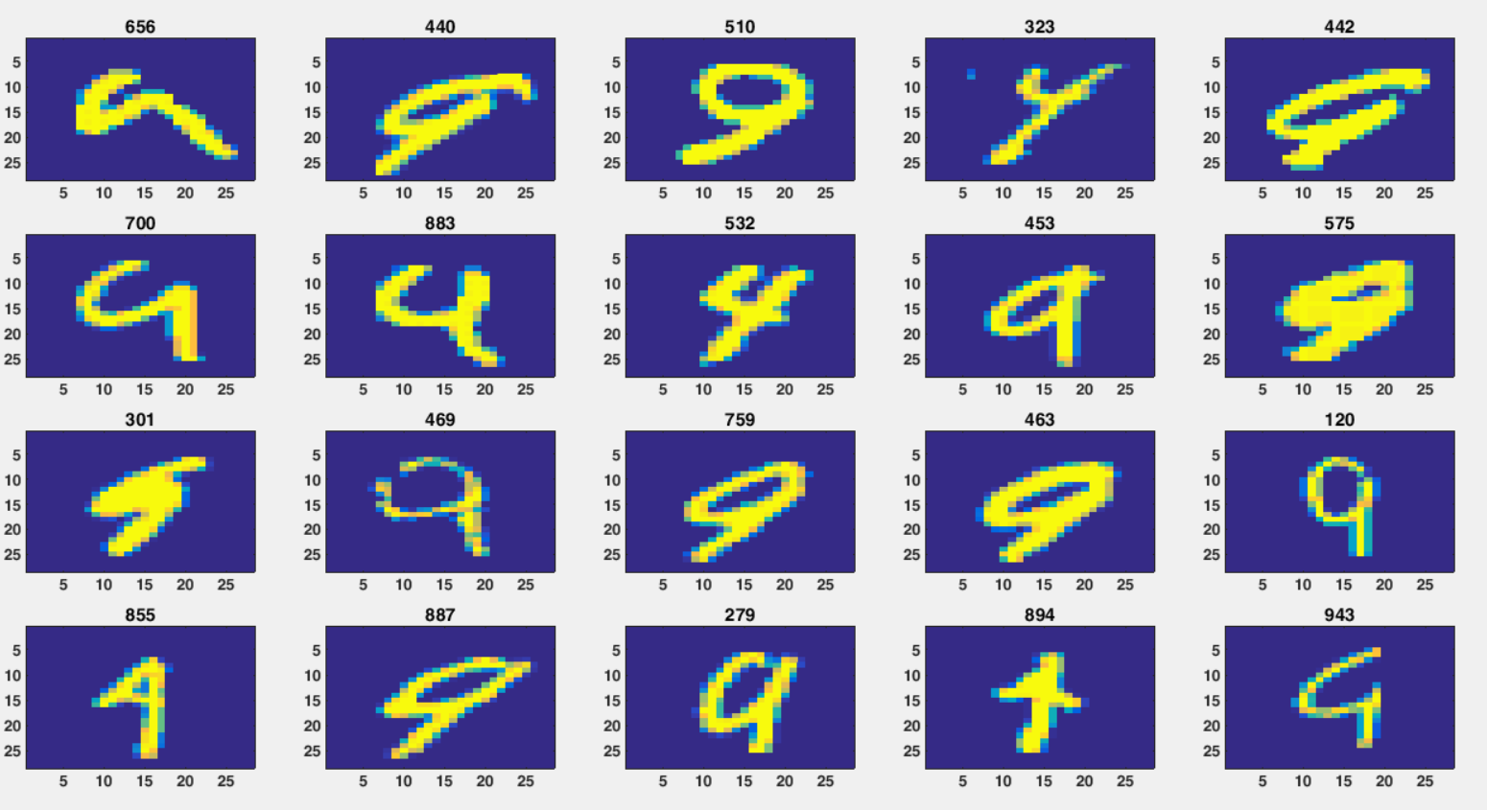
Code for calculating thetahat
close all; clear all; clc
load mnist_49_3000

global x_train y_train lambda thetahat

[d,n]=size(x);

x_train=x(:,1:2000);
y_train=y(1:2000);
x_test=x(:,2001:3000);
y_test=y(2001:3000);
lambda=10;

k=1;
theta(:,1)=zeros(size(x_train,1)+1,1);
theta_old=ones(size(x_train,1)+1,1);
epsilon=1e-1;
while norm(theta_old-theta(:,k))>epsilon
grad(theta(:,k));
hes(theta(:,k));
theta_old=theta(:,k);
theta(:,k+1)=theta(:,k)-hes(theta(:,k))\grad(theta(:,k));
k=k+1;
end
thetahat=theta(:,k);
J(thetahat)
save('thetahat')

Code for calculating gradient
function grad=grad(theta)
global x_train y_train lambda

xTilde_train=[ones(1,size(x_train,2)); x_train];
grad=2*lambda*theta;
for i=1:numel(y_train)
grad=grad+y_train(i)*xTilde_train(:,i)*exp(y_train(i)*theta'*xTilde_train(:,i))/(1+exp(y_train(i)*theta'*xTilde_train(:,i)));
end
end

Code for calculating Hessian
function hes=hes(theta)
global x_train y_train lambda

xTilde_train=[ones(1,size(x_train,2)); x_train];
hes=2*lambda*eye(size(theta,1));
for i=1:numel(y_train)
hes=hes+y_train(i)^2*xTilde_train(:,i)*xTilde_train(:,i)'*exp(y_train(i)*theta'*xTilde_train(:,i))/(1+exp(y_train(i)*theta'*xTilde_train(:,i)))^2;
end
end

Code for calculating LR objective function
function J=J(theta)
global x_train y_train lambda

xTilde_train=[ones(1,size(x_train,2)); x_train];
J=lambda*(norm(theta))^2;
for i=1:numel(y_train)
J=J+log(1+exp(y_train(i)*theta'*xTilde_train(:,i)));
end
end

Code for calculating etahat
function pr=etahat(x_test)
global thetahat

pr=1/(1+exp(-thetahat'*[1;x_test]));

end

Code for classifier
function [y_pred,conf]=LRclsf(x_test)

if etahat(x_test)>=.5
y_pred=-1;
else
y_pred=1;
end
conf=abs(etahat(x_test)-.5);
end

Code for obtaining results
close all; clear all; clc
load mnist_49_3000
load thetahat

[d,n]=size(x);

x_test=x(:,2001:3000);
y_test=y(2001:3000);

for i=1:size(x_test,2)
[y_pred(1,i),conf(i)]=LRclsf(x_test(:,i));
end
error=abs(y_pred-y_test);
ind=find(error)
misclsConf=conf(ind);
errorSum=0;
for i=1:numel(error)
errorSum=errorSum+error(i)/2;
end

errorSum
misclas_rate=errorSum/numel(y_test)

[misclsConfSrt,IndVec]=sort(misclsConf);
ind1=fliplr(ind(IndVec));

k=1;
plotInd=ind1(1:20);
for i=plotInd
subplot(4,5,k)
imagesc(reshape(x_test(:,i),[sqrt(d),sqrt(d)])');
% title(num2str(conf(i)))
title(num2str(i))
k=k+1;
end

