|  |  |
| --- | --- |
| Objective function values versus iterations | Compressed image compared to original image |
|  |  |

Difference image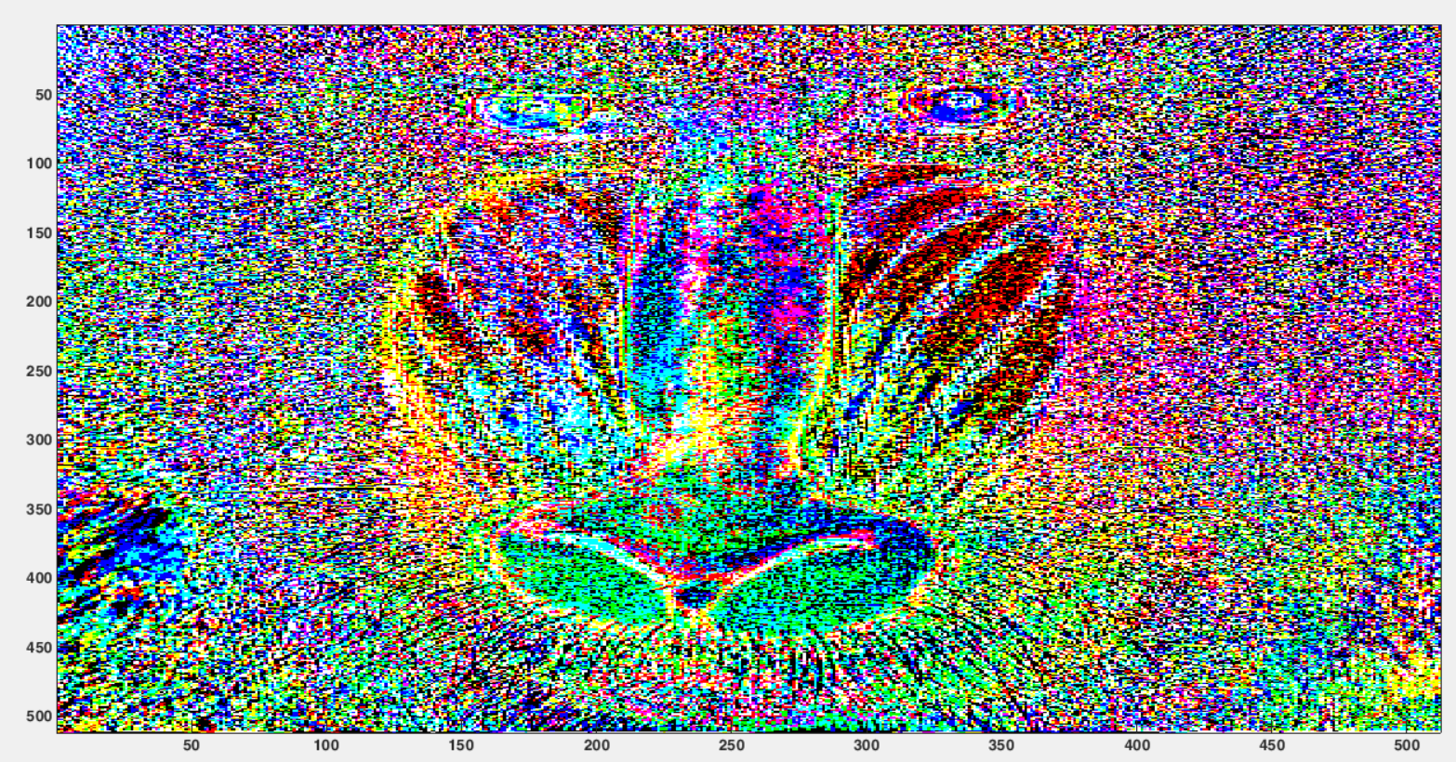

Nose region is not preserved as much because there are details in difference image while eyes and outer part of face is more preserved because there are nothing significant in difference image.