Supplementary File 2: Forest plots of single-arm meta-analyses

1A. Cancer prevalence among COVID-19 patients (Leave one out analysis)
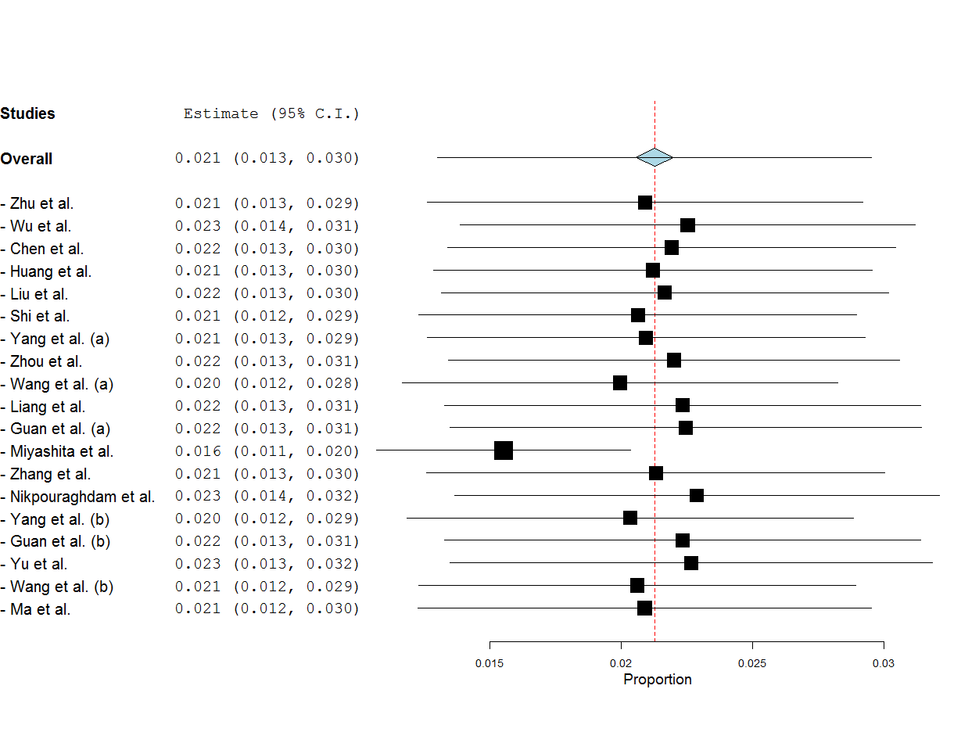

2A. Mortality in Cancer-COVID-19 patients (Main Analysis)
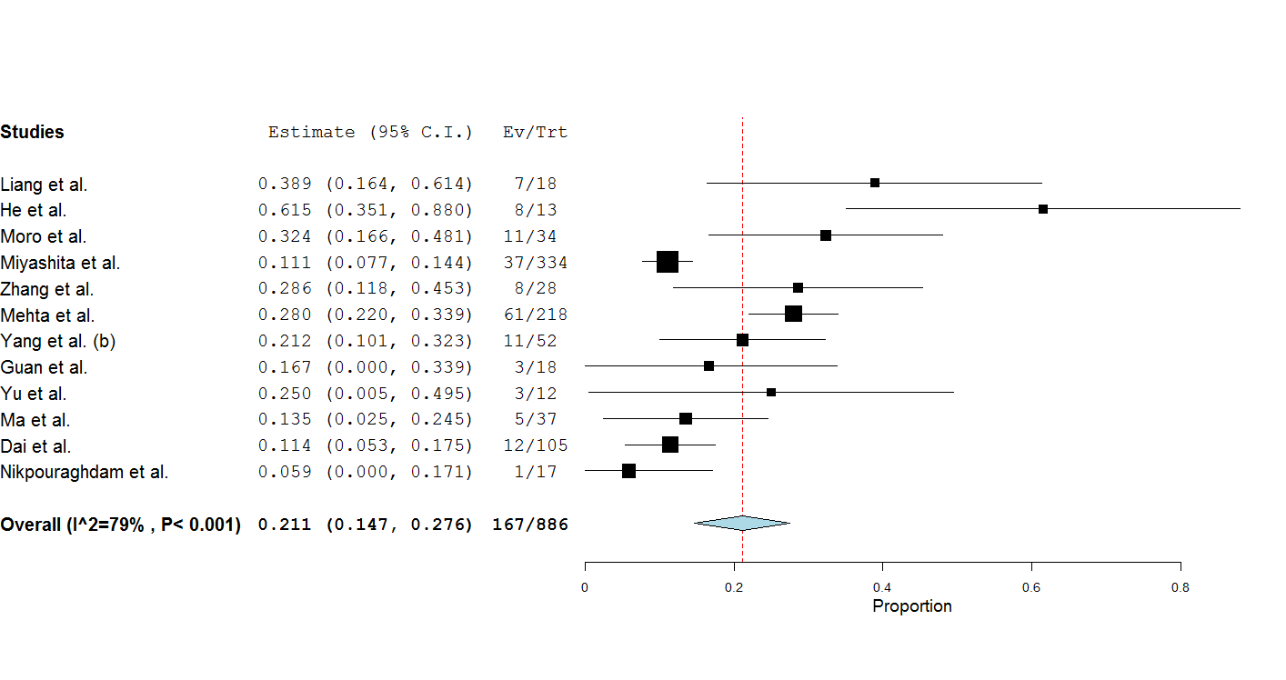
2B. Mortality in Cancer-COVID-19 patients (Leave one out analysis)
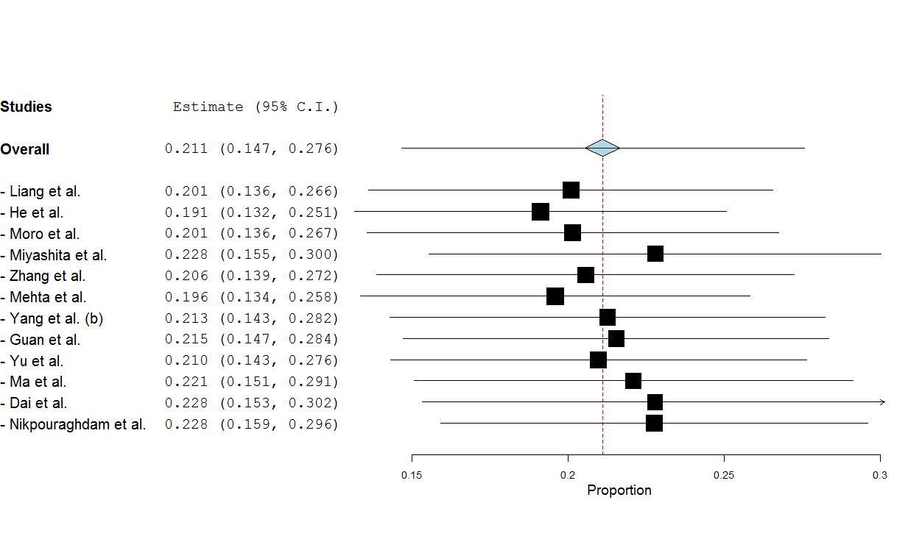

3A. Severe Disease in Cancer-COVID-19 patients (Main Analysis)
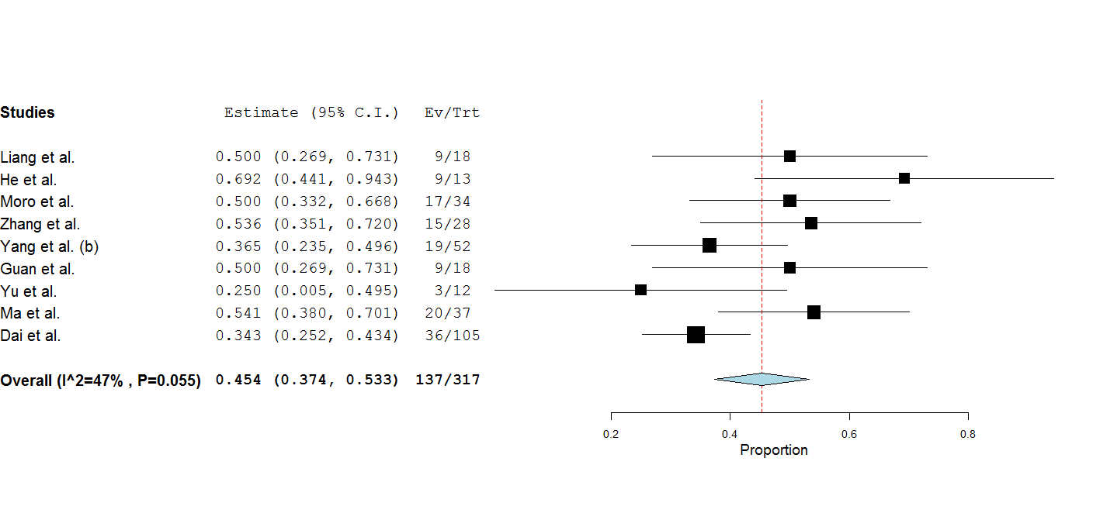
3B. Severe Disease in Cancer-COVID-19 patients (Leave one out analysis)
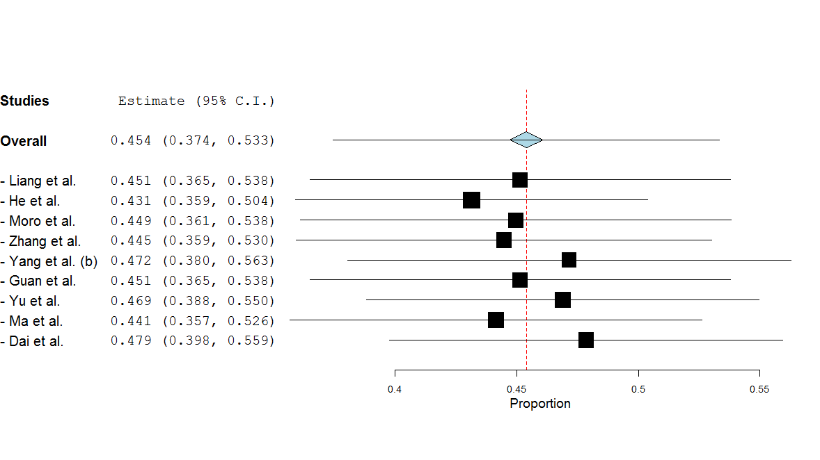

4A. ICU Admission in Cancer-COVID-19 patients (Main Analysis)
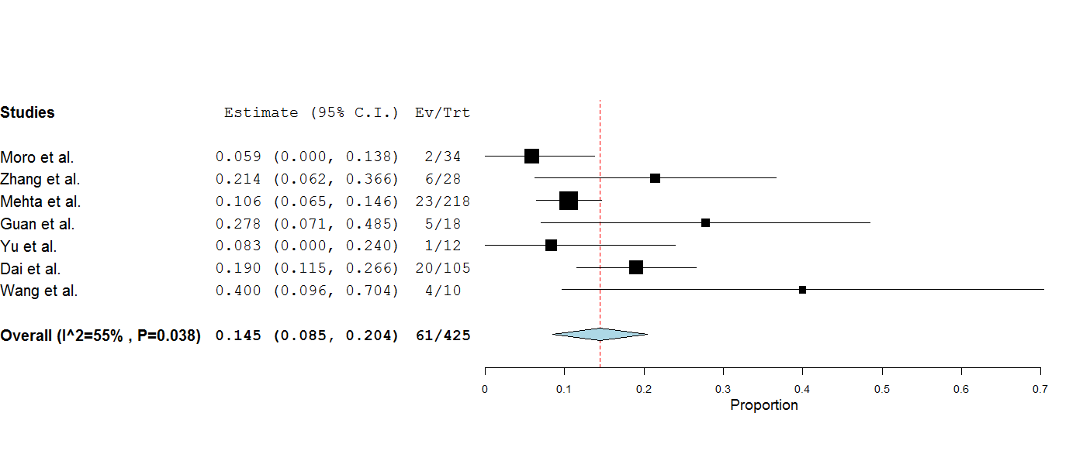
4B. ICU Admission in Cancer-COVID-19 patients (Leave one out analysis)
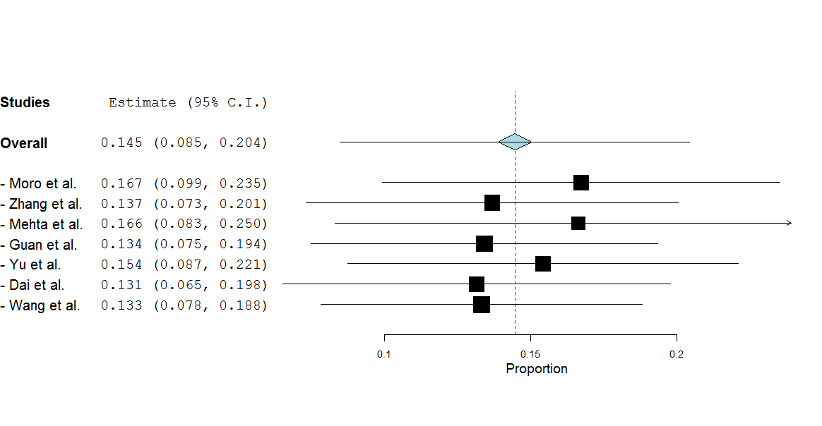

5A. Mechanical Ventilation in Cancer-COVID-19 patients (Main Analysis)
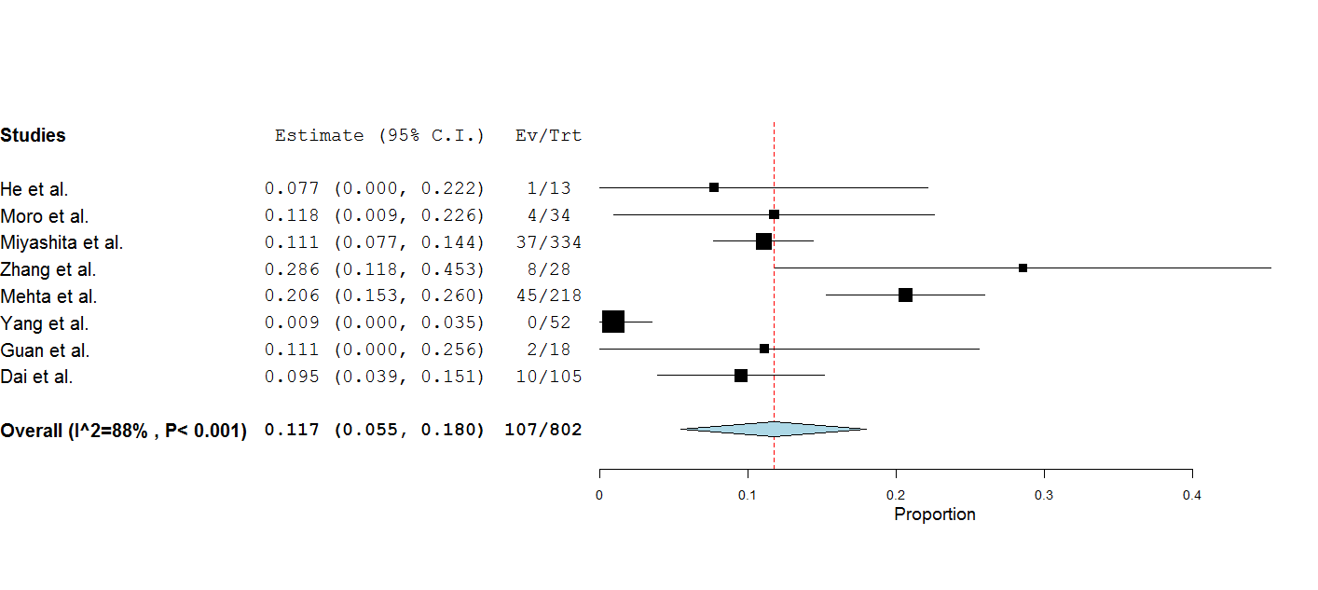
5B. Mechanical Ventilation in Cancer-COVID-19 patients (Leave one out analysis)


