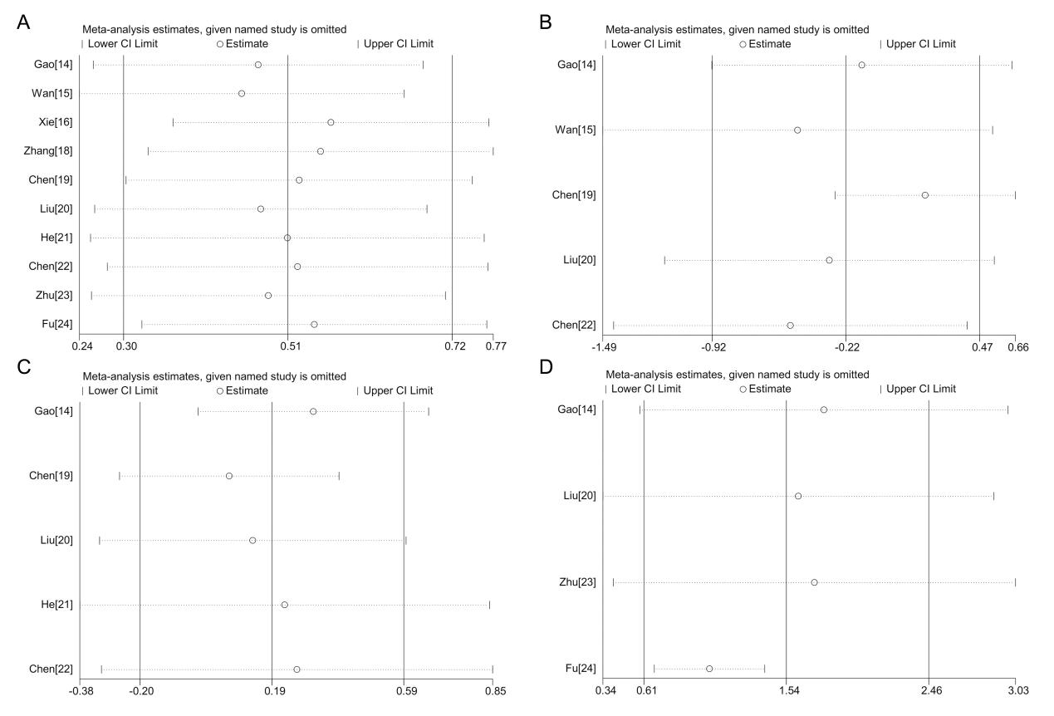
Figure S1. Sensitivity analyses by excluding one study at a time. (A)D-dimer; (B)APTT; (C)PT;(D)Fibrinogen.

