Methods E1
1 Coronavirus infections/
2 (coronavirus adj2 infection*).mp.
3 (exp coronavirus/ or coronavirus*.mp.) and (wuhan or beijing or shanghai or 2019-nCoV or nCov or COVID-19 or SARS-CoV-2).mp.
4 coronavirus*.ti. or (novel coronavirus*.mp. and (exp china/ or china.mp.)) or ((pneumonia.mp. or exp pneumonia/) and Wuhan.mp.)
5 (COVID* or 2019-nCov or SARS-CoV-2).mp.
6 Severe acute respiratory syndrome/
7 (severe adj2 acute adj2 respiratory adj2 syndrome*).mp.
8 (severe adj2 acute adj2 respiratory adj2 infect*).mp.
9 (sudden adj2 acute adj2 respiratory adj2 syndrome*).mp.
10 SARS virus/
11 sars.mp.
12 Middle East Respiratory Syndrome Coronavirus/
13 (middle adj2 east adj2 respiratory).mp.
14 (mers or mersc*).mp.
15 exp Influenza, Human/
16 (Influenza* or H1N1).mp.
17 exp Influenza A virus/
18 infectious disease transmission, patient-to-professional/
19 occupational exposure/
20 air microbiology/
21 exp infectious disease transmission/
22 infection control/
23 aerosols/
24 ((droplet* or aerosol* or cough*) adj2 (infect* or pathog*)).mp.
25 or/1-24
26 exp Cardiopulmonary resuscitation/
27 resuscitation*.mp.
28 exp Oxygen Inhalation Therapy/
29 oxygen*.mp.
30 Noninvasive ventilation/
31 (Noninvasive adj2 ventilation).mp.
32 (Non invasive adj2 ventilation).mp.
33 "Rapid Sequence Induction and Intubation"/
34 (rapid sequence adj2 intubation).mp.
35 (rapid sequence adj2 induction).mp.
36 exp Intubation, Intratracheal/
37 (endotracheal adj2 intubation).mp.
38 (intratracheal adj2 intubation).mp.
39 exp Airway management/
40 ((airway adj2 management) or (airway adj2 control) or (breathing adj2 control) or (breathing adj2 regulation) or (respirat* adj2 regulation) or (respirat* adj2 control)).mp.
41 exp Positive-Pressure Respiration/
42 ((positive adj2 pressure adj2 respiration) or (positive adj2 pressure adj2 ventilation) or (positive adj2 expirator* adj2 pressure)).mp.
43 (bag adj2 valve adj2 mask*).mp.
44 bipap.mp.
45 cpap.mp.
46 ((bilevel or continuous) adj2 (positive adj2 (airway or pressure))).mp.
47 ((high adj2 flow) or high-flow).mp.
48 ((aerosol* adj2 procedure*) or (aerosol* and agp*)).mp.
49 or/26-48
50 25 and 49
51 limit 50 to yr="2000 -Current"

Embase
1 Coronavirus infection/
2 (coronavirus adj2 infection*).mp.
3 (exp coronavirus/ or coronavirus*.mp.) and (wuhan or beijing or shanghai or 2019-nCoV or nCov or COVID-19 or SARS-CoV-2).mp.
4 coronavirus*.ti. or (novel coronavirus*.mp. and (exp china/ or china.mp.)) or ((pneumonia.mp. or exp pneumonia/) and Wuhan.mp.)
5 (COVID* or 2019-nCov or SARS-CoV-2).mp.
6 severe acute respiratory syndrome/
7 (severe adj2 acute adj2 respiratory adj2 infect*).mp.
8 (severe adj2 acute adj2 respiratory adj2 syndrome*).mp.
9 SARS coronavirus/
10 sars.mp.
11 Middle East respiratory syndrome coronavirus/
12 (mers or mersc*).mp.
13 exp influenza/ or influenza.mp.
14 h1n1.mp.
15 exp influenza a virus/
16 disease transmission/
17 ((medical or health or healthcare) and (staff or worker* or personnel)).ti. and (hospitali* or exposure or infect*).tw.
18 occupational exposure/
19 airborne infection/
20 infection control/
21 virus transmission/
22 hospital infection/
23 aerosol/
24 ((droplet* or aerosol* or cough*) adj2 (infect* or pathog*)).mp.
25 or/1-24
26 resuscitation/
27 resuscitation*.mp.
28 exp oxygen therapy/
29 oxygen*.mp.
30 noninvasive ventilation/
31 ((Noninvasive adj2 ventilation) or (Non invasive adj2 ventilation)).mp.
32 (rapid sequence adj2 intubation).mp.
33 (rapid sequence adj2 induction).mp.
34 endotracheal intubation/
35 (endotracheal adj2 intubation).mp.
36 (intratracheal adj2 intubation).mp.
37 respiration control/
38 ((airway adj2 management) or (airway adj2 control) or (breathing adj2 control) or (breathing adj2 regulation) or (respirat* adj2 regulation) or (respirat* adj2 control)).mp.
39 positive end expiratory pressure/
40 ((positive adj2 pressure adj2 respiration) or (positive adj2 pressure adj2 ventilation)).mp.
41 (bag adj2 valve adj2 mask*).mp.
42 bipap.mp.
43 cpap.mp.
44 ((bilevel or continuous) adj2 (positive adj2 (airway or pressure))).mp.
45 ((high adj2 flow) or high-flow).mp.
46 ((aerosol* adj2 procedure*) or (aerosol* and agp*)).mp.
47 or/26-46
48 25 and 47
49 limit 47 to yr="2000 -Current"

Results E1

Endotracheal intubation
Three case series observed an infection risk of 0%, 10% and 100% respectively when performing an endotracheal intubation and did not add useful information (Table E2).^{29, 57, 73} An additional study did not observe an increased probability of obtaining a positive influenza aerosol sample during intubation in an intensive care unit (OR=2.37 [95%CI 0.13–41.50]) (Table E2).⁶⁹

Bag valve mask ventilation
Two studies described models of bag valve mask ventilation (Table E3).^{58, 59} In the first of these studies, an air leak from the expiration director was seen at 20cm (95%CI 15-25) from the head of the manikin, which decreased with the use of a filter.⁵⁸ However, the addition of a filter increased the leak from the mask-face interface to 35cm (95%CI 17-53) from the head of the manikin.⁵⁸ In the second study, 20% of the maximal jet of air was seen at up to 27cm (95%CI 18-35) from the head of the manikin.⁵⁹ Air dispersion distance varied from 16cm (95%CI 15-17) to 27cm (95%CI 18-35) depending of the profession of the provider and the type of mask used.⁵⁹ The addition of a breathing filter reduced dispersion distance for some providers (anesthesiologists, intensivists, respiratory physicians and medical students), but not for others (nurses).⁵⁹

Non-invasive ventilation
Six case series observed an infection risk of 0% and while another observed risk of 100% when HCW were exposed to NIV (Table E4).^{19, 23, 56, 60, 70-72} Notably, in one of the case series in which no HCWs were infected, there were nine infections amongst patients which followed a spatial distribution suggesting a possible role of aerosol transmission.²³ Six additional studies described models of air or droplet dispersion during NIV.^{44, 50, 62-64, 67} In the four studies by Hui et al, it was observed that the length of air jet increased along with the delivered pressure (e.g. from 69 cm [95%CI 53-86] to 92cm [95%CI 85-99] for one type of mask).^{44, 62-64} The type of mask affected dispersion distance as well.^{44, 63, 64} The use of a helmet / full face with a double limb circuit seemed to decrease dispersion, while the addition of a whisper swivel seemed to increase dispersion.^{44, 63} In the study by O’Neil et al, aerosol level measured during the use of BiPAP was similar to the baselines of other evaluated procedures.⁶⁷ However, no formal assessment of the variation in aerosol levels was made because no baseline data was available for BiPAP therapy.⁶⁷ In the study by Simonds et al, the use of a BiPAP increased the amount of droplets larger than 10μm by up to 81% when measurements were performed next to the faces of patients and coryzal volunteers.⁵⁰ In the same study, for the subgroup of coryzal volunteers, the use of BiPAP also increased the amount of droplets of more than 10μm (+57%), of 5-10μm (+42%) and of 3-5μm (+23%) when the measurements were performed 1m away from the face.⁵⁰

High-flow nasal cannula
One case report and one case series reported no infection amongst HCWs exposed to HFNC (Table E5).^{21, 45} Seven additional studies described models of air or droplet dispersion during the use of a HFNC (Table E5).^{20, 22, 25, 48, 64-66} Hui et al and Leonard et al reported on air dispersion distance with the use of HFNC.^{22, 64} Distances varied substantially between the two experiments (from 17cm [95%CI 11-24] at 60L/min to 100cm at 40L/min).^{22, 64} Higher HFNC flow rate seemed to increase dispersion distance, while covering the face with a surgical mask lowered dispersion distance.^{22, 64} In Iwashyna et al and Roberts et al, aerosol concentration was measured during the use of HFNC.^{25, 48} In Iwashyna et al, no change in aerosol concentration was observed.²⁵ while on the contrary, in Roberts et al, aerosol concentration increased (no numerical data provided) during the use of HFNC, but significantly less than when volunteers snorted.⁴⁸ Kotoda et al and Loh et al evaluated the dispersion of droplets with the use of HFNC.^{20, 65} In Kotoda et al, droplets spontaneously travelled 30 cm away from the head of the manikin.⁶⁵ Manual repositioning of the HFNC increased that distance to around 45 cm.⁶⁵ In Loh et al, the droplets travelled to 291cm (95%CI 78-504) when volunteers simulated coughing with HFNC, an increase of 42cm (95%CI 25-109) as compared to without one.²⁰ Finally, in Leung et al, the environmental contamination by viable bacteria was not superior with HFNC as compared with conventional oxygen therapy amongst patients suffering from bacterial pneumonia.⁶⁶

Conventional oxygen therapy
Nine studies described models of air dispersion during the use of conventional oxygen therapy (Table E6).22, 25, 26, 44, 46, 47, 50, 61, 68 Four studies described models of oxygen delivery with the use of a nasal cannula.^{22, 25, 44, 46} In these experiments, increasing the flow of the nasal cannula seemed to increase the dispersion distance (e.g. from 66cm at 1L/min to 100cm at 5L/min in one experiment).^{22, 44, 46} The room configuration also significantly impacted air dispersion distance (e.g. from 45cm in one room to 100cm in another room at 5L/min).⁴⁶ The use of a surgical mask reduced air dispersion distance in one model when using a nasal cannula.²² In the study by Iwashyna et al, the quantity of aerosol in the room did not increase with the use of a nasal cannula at 6L/min.²⁵ Seven studies described models of oxygen delivery with the use of a face mask.^{25, 26, 44, 47, 50, 61, 68} In the study by Somogyi et al, without any oxygen flow, the plumes of exhaled breath were concentrated in the exhalation port of the face mask.⁶⁸ This decreased with the addition of a filter on the exhalation port.⁶⁸ In two studies by Hui et al and the study by Ip et al, air dispersion distance using different types of mask and varying oxygen flows were described.^{44, 47, 61} In these experiments, increasing the flow of oxygen to the mask seemed to increase dispersion distance (e.g. from 20cm at 4L/min to 40cm at 10L/min in one experiment with a simple mask).^{44, 47} Venturi masks generally had higher dispersion distance than other types of masks at a given flow.^{44, 47} Non-rebreather masks had a much lower dispersion distance in one of the experiment by Hui et al, but this was not the case in the study by Ip et al.^{44, 47} Coughing also increased air dispersion distance.⁴⁴ In the study by Iwashyna et al, the quantity of aerosol in the room did not increase with the use of a face mask at 15L/min.²⁵ In the study by Simonds et al, the use of an oxygen mask did not increase the amount of droplets adjacent to the face of the volunteers and at 1m.⁵⁰ Finally, Mardimae et al observed that a N95 mask could be modified and used as an oxygen delivery device, which also filtered exhaled particles.²⁶

Mixed exposure
Three case series reported on infection risks and oxygen therapy with multiple modalities or in combination with other high-risk intervention (mixed exposure) (Table E7).^{30, 42, 43} In the study by Christian et al, two HCWs out of the nine (22%) who were exposed to a patient having received oxygen 100% via face mask, chest compressions, bag valve mask ventilation and an endotracheal intubation were infected. In the study by Nam et al, one HCW out of the six (17%) who were exposed to a patient having received chest compressions, an endotracheal intubation and airway suctioning was infected.⁴³ In the study by Park et al, no HCW was infected out of the five (0%) who performed an endotracheal intubation or airway suctioning.³⁰

Figure E1. Preferred Reporting Items for Systematic Reviews and Meta-Analyses checklist

Page 1 of 2
Section/topic | # | Checklist item | Reported on page #
TITLE
Title | 1 | Identify the report as a systematic review, meta-analysis, or both. | 1
ABSTRACT
Structured summary | 2 | Provide a structured summary including, as applicable: background; objectives; data sources; study eligibility criteria, participants, and interventions; study appraisal and synthesis methods; results; limitations; conclusions and implications of key findings; systematic review registration number. | 3-4
INTRODUCTION
Rationale | 3 | Describe the rationale for the review in the context of what is already known. | 5
Objectives | 4 | Provide an explicit statement of questions being addressed with reference to participants, interventions, comparisons, outcomes, and study design (PICOS). | 5-6
METHODS
Protocol and registration | 5 | Indicate if a review protocol exists, if and where it can be accessed (e.g., Web address), and, if available, provide registration information including registration number. | 6
Eligibility criteria | 6 | Specify study characteristics (e.g., PICOS, length of follow-up) and report characteristics (e.g., years considered, language, publication status) used as criteria for eligibility, giving rationale. | 7
Information sources | 7 | Describe all information sources (e.g., databases with dates of coverage, contact with study authors to identify additional studies) in the search and date last searched. | 6
Search | 8 | Present full electronic search strategy for at least one database, including any limits used, such that it could be repeated. | eAppendix1
Study selection | 9 | State the process for selecting studies (i.e., screening, eligibility, included in systematic review, and, if applicable, included in the meta-analysis). | 6
Data collection process | 10 | Describe method of data extraction from reports (e.g., piloted forms, independently, in duplicate) and any processes for obtaining and confirming data from investigators. | 7
Data items | 11 | List and define all variables for which data were sought (e.g., PICOS, funding sources) and any assumptions and simplifications made. | 7
Risk of bias in individual studies | 12 | Describe methods used for assessing risk of bias of individual studies (including specification of whether this was done at the study or outcome level), and how this information is to be used in any data synthesis. | 8
Summary measures | 13 | State the principal summary measures (e.g., risk ratio, difference in means). | 8
Synthesis of results | 14 | Describe the methods of handling data and combining results of studies, if done, including measures of consistency (e.g., I²) for each meta-analysis. | 8-9

Section/topic | # | Checklist item | Reported on page #
Risk of bias across studies | 15 | Specify any assessment of risk of bias that may affect the cumulative evidence (e.g., publication bias, selective reporting within studies). | 9
Additional analyses | 16 | Describe methods of additional analyses (e.g., sensitivity or subgroup analyses, meta-regression), if done, indicating which were pre-specified. | 9
RESULTS
Study selection | 17 | Give numbers of studies screened, assessed for eligibility, and included in the review, with reasons for exclusions at each stage, ideally with a flow diagram. | 6  Figure 1
Study characteristics | 18 | For each study, present characteristics for which data were extracted (e.g., study size, PICOS, follow-up period) and provide the citations. | 9-10  Table 1
Risk of bias within studies | 19 | Present data on risk of bias of each study and, if available, any outcome level assessment (see item 12). | eTable 1
Results of individual studies | 20 | For all outcomes considered (benefits or harms), present, for each study: (a) simple summary data for each intervention group (b) effect estimates and confidence intervals, ideally with a forest plot. | 10-12  eAppendix 2  eTables 2-7
Synthesis of results | 21 | Present results of each meta-analysis done, including confidence intervals and measures of consistency. | Figure 2-4
Risk of bias across studies | 22 | Present results of any assessment of risk of bias across studies (see Item 15). | eFigure 3
Additional analysis | 23 | Give results of additional analyses, if done (e.g., sensitivity or subgroup analyses, meta-regression [see Item 16]). | 12  eFigure 2
DISCUSSION
Summary of evidence | 24 | Summarize the main findings including the strength of evidence for each main outcome; consider their relevance to key groups (e.g., healthcare providers, users, and policy makers). | 12-15
Limitations | 25 | Discuss limitations at study and outcome level (e.g., risk of bias), and at review-level (e.g., incomplete retrieval of identified research, reporting bias). | 16
Conclusions | 26 | Provide a general interpretation of the results in the context of other evidence, and implications for future research. | 16
FUNDING
Funding | 27 | Describe sources of funding for the systematic review and other support (e.g., supply of data); role of funders for the systematic review. | 18

Figure E2. Forest plot describing the infection risk during endotracheal intubation, including the study by Teleman et al

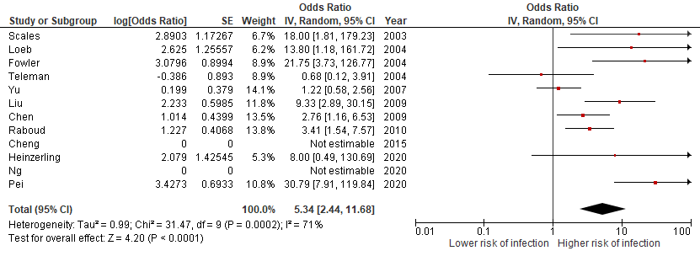

Figure E3. Forest plot describing the infection risk during endotracheal intubation, excluding articles at high risk of bias
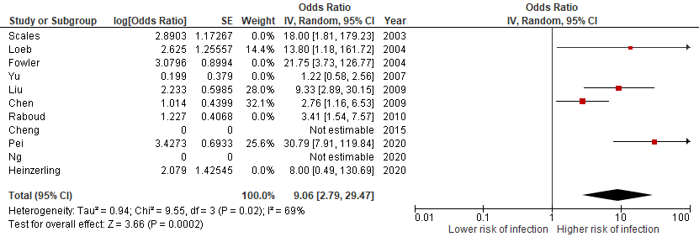

Figure E4. Forest plot describing the infection risk during bag valve mask ventilation, excluding articles at high risk of bias
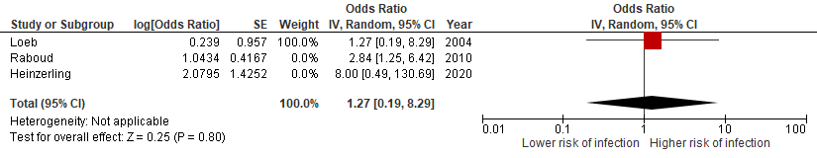

Figure E5. Forest plot describing the infection risk during non-invasive ventilation, excluding articles at high risk of bias
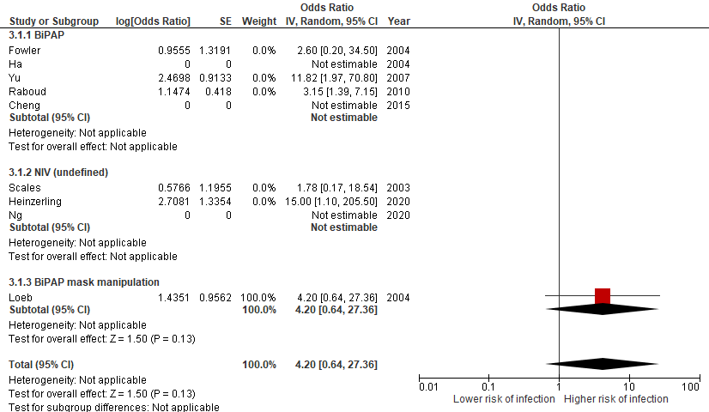

Figure E6. Funnel plot for the evaluation of publication bias for endotracheal intubation
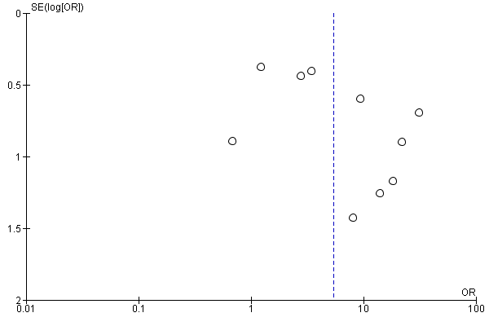

Table E1. Quality Assessment and Risk of Bias
Study | Study design | Newcastle-Ottawa scale rating (1-9) | Points lost | Risk of bias
Belenguer-Muncharaz 2011⁵⁶ | Case series | - | - | High
Cai 2020⁵⁷ | Case series | - | - | High
Caputo 2006²⁹ | Case series | - | - | High
Chan 2013⁵⁸ | Model | - | - | High
Chan 2018⁵⁹ | Model | - | - | High
Chen 2006⁴⁰ | Case-control | 6 | S2-E1-E3 | High
Chen 2009³¹ | Case-control | 5 | S4-C1-C2-E3 | Moderate
Cheng 2015³²* | Retrospective cohort | - | - | High
Cheung 2004⁶⁰ | Case series | - | - | High
Christian 2004⁴² | Case series | - | - | High
Fowler 2004²⁸ | Retrospective cohort | 5 | S3-S4-C1-C2 | High
Ha 2004³⁹ | Retrospective cohort | 3 | S3-S4-C1-C2-O2-O3 | High
Han 2004¹⁹ | Case series | - | - | High
Heinzerling 2020³³ | Retrospective cohort | 4 | S1-S4-C1-C2-O2 | High
Hui 2006-1⁶¹ | Model | - | - | High
Hui 2006-2⁶² | Model | - | - | High
Hui 2011⁴⁶ | Model | - | - | High
Hui 2014⁴⁴ | Model | - | - | High
Hui 2015⁶³ | Model | - | - | High
Hui 2019⁶⁴ | Model | - | - | High
Ip 2007⁴⁷ | Model | - | - | High
Iwashyna 2020²⁵ | Model | - | - | High
Kotoda 2020⁶⁵ | Model | - | - | High
Leonard 2020²² | Model | - | - | High
Leung 2019⁶⁶ | Model | - | - | High
Liu 2009³⁴ | Case-control | 6 | S2-E1-E3 | Moderate
Loeb 2004²⁷ | Retrospective cohort | 7 | C1-C2 | Moderate
Loh 2020²⁰ | Model | - | - | High
Luo 2015⁴⁵ | Case report | - | - | High
Mardimae 2006²⁶ | Model | - | - | High
Nam 2017⁴³ | Case report | - | - | High
Ng 2020³⁵ | Retrospective cohort | - | - | High
Nishiyama 2008⁴¹ | Retrospective cohort | 5 | S4-C1-C2-O3 | High
O’Neil 2017⁶⁷ | Model | - | - | High
Park 2004³⁰ | Retrospective cohort | 4 | S3-S4-C1-C2-O3 | High
Pei 2006³⁶ | Case-control | 6 | S2 E1 E3 | Moderate
Raboud 2010²⁴ | Case-control | 5 | C1-C2-E1-E3 | High
Rello 2012²¹ | Case series | - | - | High
Roberts 2015⁴⁸* | Model | - | - | High
Scales 2003³⁷ | Case-control | 5 | S2-C1-C2-E1 | High
Simonds 2010⁵⁰ | Model | - | - | High
Somogyi 2004⁶⁸ | Model | - | - | High
Teleman 2004³⁸ | Case-control | 4 | S2-C1-C2-E1-E3 | High
Thompson 2013⁶⁹ | Model | - | - | High
Tonveronachi 2011⁷⁰* | Case series | - | - | High
Vivarelli 2013⁷¹ | Case series | - | - | High
Wong 2010²³ | Case series | - | - | High
Wong 2011⁷²* | Case series | - | - | High
Yu 2007¹⁸ | Case-control | 5 | C1-C2-E1-E3 | High
Zhao 2003⁷³ | Case series | - | - | High

Table E2. Infection risk during endotracheal intubation
Study | Study design | Risk in HCW exposed  (n infected /  n exposed) | Risk in HCW not exposed (n infected /  n not exposed) | Odds ratio  (95%CI)
Chen 2009³¹ | Case-control | 16/33 | 75/715 | 2.76 (1.16-6.53)
Cheng 2015*³² | Retrospective cohort | 0/5 | 0/77 | -
Fowler 2004²⁸ | Retrospective cohort | 6/14 | 2/60 | 21.75 (3.73–126.77)
Heinzerling 2020³³ | Retrospective cohort | 1/3 | 2/34 | 8.00 (0.49-130.69)
Liu 2009³⁴ | Case-control | 6/12 | 45/465 | 9.33 (2.89-30.15)
Loeb 2004²⁷ | Retrospective cohort | 3/4 | 5/28 | 13.80 (1.18-161.72)
Ng 2020³⁵ | Retrospective cohort | 0/10 | 0/31 | -
Pei 2006³⁶ | Case-control | 28/37 | 119/406 | 30.79 (7.91-119.84)
Raboud 2010²⁴ | Case-control | 12/132 | 14/492 | 3.41 (1.54-7.57)
Scales 2003³⁷ | Case-control | 3/5 | 2/26 | 18.00 (1.81-179.23)
Teleman 2004³⁸ | Case-control | 2/6 | 34/80 | 0.68 (0.12-3.91)
Yu 2007†¹⁸ | Case-control | NA | NA | 1.22 (0.58–2.56)
Cai 2020‡⁵⁷ | Case series | 0/9 | - | -
Caputo 2006²⁹ | Case series | 3/33 | - | -
Zhao 2003⁷³ | Case series | 4/4 | - | -
Thompson 2013⁶⁹ | Model | Performing an intubation did not significantly increase the probability of sampling a positive aerosol (Odds ratio 2.37 [95%CI 0.13–41.50])
*: Abstract only; †: Odds of having a super spreading event in a ward; ‡: Bronchoscope-assisted; HCW: Healthcare worker; CI: Confidence interval; NA: Not available;

Table E3. Infection risk during bag valve mask ventilation
Study | Study design | Risk in HCW exposed  (n infected /  n exposed) | Risk in HCW not exposed (n infected /  n not exposed) | Odds ratio  (95%CI)
Heinzerling 2020³³ | Retrospective cohort | 1/3 | 2/34 | 8.00 (0.49-130.70)
Loeb 2004²⁷ | Retrospective cohort | 2/7 | 6/25 | 1.27 (0.19-8.29)
Raboud 2010²⁴ | Case-control | 10/118 | 16/506 | 2.84 (1.25-6.42)
Chan 2013⁵⁸ | Model | 20% of maximal jet of air seen at 35cm (95%CI 17-53) from the head of the manikin; Most important leak is from the interface between mask and face; Filter decreased the leak from the expiratory director, but increased the leak from the interface between mask and face
Chan 2018⁵⁹ | Model | 20% of maximal jet of air seen at 27cm (95%CI 18-35) from the head of the manikin; Varying results between types of masks and profession of provider
HCW: Healthcare worker; CI: Confidence interval

Table E4. Infection risk during non-invasive ventilation
Study | Study design | Risk in HCW exposed  (n infected /  n exposed) | Risk in HCW not exposed (n infected /  n not exposed) | Odds ratio  (95%CI)
BiPAP
Cheng 2015*³² | Retrospective cohort | 0/19 | 0/63 | -
Fowler 2004²⁸ | Retrospective cohort | 1/6 | 2/28 | 2.60 (0.20-34.5)
Ha 2004³⁹ | Retrospective cohort | 0/40 | 0/22 | -
Raboud 2010²⁴ | Case-control | 10/109 | 16/515 | 3.15 (1.39-7.15)
Yu 2007†¹⁸ | Case-control | NA | NA | 11.82 (1.97–70.80)
Belenguer-Muncharaz 2011⁵⁶ | Case series | 0/NA | - | -
Cheung 2004⁶⁰ | Case series | 0/105 | - | -
Han 2004¹⁹ | Case series | 0/NA | - | -
Tonveronachi 2011†⁷⁰ | Case series | 0/NA | - | -
Vivarelli 2013⁷¹ | Case series | 0/NA | - | -
Wong 2010‡²³ | Case series | 0/NA | - | -
Hui 2006-2⁶² | Model | Jet of air seen at 45 cm from the head of the manikin; Increasing inspiratory pressure extended the length of the jet
Hui 2014⁴⁴ | Model | 20% of maximal jet of air seen at >95 cm from the head of the manikin; Varying results between types of BiPAP masks and exhalation device
Hui 2015⁶³ | Model | 20% of maximal jet of air seen at 92cm (95%CI 85-98) from the head of the manikin; less with a helmet interface
O’Neil 2017⁶⁷ | Model | Aerosol level during BiPAP similar to the other procedures’ baseline, but no baseline data available for BiPAP
Simonds 2010⁵⁰ | Model | Increase in droplets > 10μm adjacent to the face (+81%); increase in droplets > 10μm (+57%), 5-10μm (+42%) and 3-5μm (+23%) at 1m for coryzal volunteers
CPAP
Belenguer-Muncharaz 2011⁵⁶ | Case series | 0/NA | - | -
Vivarelli 2013⁷¹ | Case series | 0/NA | - | -
Hui 2019⁶⁴ | Model | 20% of maximal jet of air seen at 33cm (95%CI 27-40) from the head of the manikin; Increasing inspiratory pressure extended the length of the jet; Varying results between types of CPAP masks and lung condition
Non-invasive ventilation (undefined)
Heinzerling 2020³³ | Retrospective cohort | 2/6 | 1/31 | 15.00 (1.10-205.50)
Ng 2020³⁵ | Retrospective cohort | 0/25 | 0/16 | -
Scales 2003³⁷ | Case-control | 4/22 | 1/9 | 1.78 (0.17-18.54)
Wong 2011⁷² | Case series | 3/3 | - | -
BiPAP mask manipulation
Loeb 2004²⁷ | Retrospective cohort | 3/6 | 5/25 | 4.20 (0.64-27.36)
*: Abstract only; †: Odds of having a super spreading event in a ward; ‡: Nine infections amongst patients; HCW: Healthcare worker; CI: Confidence interval; NA: Not available; BiPAP: Bilevel positive airway pressure; CPAP: Continuous positive airway pressure

Table E5. Infection risk with high-flow nasal cannula
Study | Study design | Risk in HCW exposed  (n infected /  n exposed) | Risk in HCW not exposed (n infected /  n not exposed) | Odds ratio  (95%CI)
Luo 2015⁴⁵ | Case report | 0/NA | - | -
Rello 2012²¹ | Case series | 0/NA | - | -
Hui 2019⁶⁴ | Model | 20% of maximal jet of air seen at 17cm (95%CI 11-24) from the head of the manikin; Increasing the flow extended the length of the jet
Kotoda 2020⁶⁵ | Model | Dispersal of droplets at 30-45 cm from the head of the manikin; Increased with manual repositioning of the cannula
Iwashyna 2020²⁵ | Model | No increase in aerosol concentration in the room
Leonard 2020²² | Model | Jet of air seen at 100 cm from the head of the manikin; Lowered with the addition of a mask on the head of the manikin
Leung 2019⁶⁶ | Model | Similar growth of bacteria in proximity to patients as compared to oxygen mask
Loh 2020²⁰ | Model | Droplets travelled to 291cm (95%CI 78-504) during simulated coughing; Increase of 42cm (95%CI 25-109) as compared to without a high-flow nasal cannula
Roberts 2015*⁴⁸ | Model | Snorting without a high-flow nasal cannula produced the most aerosol; Higher flow increased the quantity of aerosol produced (up to 10% of the amount produced when snorting)
*: Abstract only; NA: Not available; HCW: Healthcare worker; CI: Confidence interval

Table E6. Infection risk during conventional oxygen therapy
Study | Study design | Risk in HCW exposed  (n infected /  n exposed) | Risk in HCW not exposed (n infected /  n not exposed) | Odds ratio  (95%CI)
Face mask > 6L/minute
Yu 2007*¹⁸ | Case-control | NA | NA | 7.08 (95%CI 1.30–38.42)
High-flow oxygen (undefined)
Heinzerling 2020³³ | Retrospective cohort | 1/10 | 2/27 | 1.39 (95%CI 0.11-17.24)
Raboud 2010²⁴ | Case-control | 2/108 | 24/516 | 0.39 (95%CI 0.09-1.66)
Oxygen therapy (undefined)
Chen 2006†⁴⁰ | Case-control | NA | NA | 4.60 (95%CI 1.40–15.08)
Nishiyama 2008⁴¹ | Retrospective cohort | NA/49 | NA/36 | 2.65 (95%CI 0.66-10.70)
Teleman 2004³⁸ | Case-control | 7/17 | 29/40 | 0.97 (95%CI 0.33-2.84)
Yu 2007*¹⁸ | Case-control | NA | NA | 10.97 (95%CI 1.73–69.39)
Oxygen mask manipulation
Heinzerling 2020³³ | Retrospective cohort | 2/7 | 1/30 | 11.60 (0.88-153.29)
Loeb 2004²⁷ | Retrospective cohort | 7/14 | 1/17 | 17.00 (1.75-165.00)
Raboud 2010²⁴ | Case-control | 17/297 | 9/327 | 2.14 (0.94-4.89)
Nasal cannula 1L/min
Hui 2011⁴⁶ | Model | 20% of maximal jet of air seen at 66cm from the head of the manikin; Significant impact of room conformation
Hui 2014⁴⁴ | Model | 20% of maximal jet of air seen at 30cm from the head of the manikin
Nasal cannula 3L/min
Hui 2011⁴⁶ | Model | 20% of maximal jet of air seen at 70cm from the head of the manikin; Significant impact of room conformation
Hui 2014⁴⁴ | Model | 20% of maximal jet of air seen at 36cm from the head of the manikin
Nasal cannula 5L/min
Hui 2011⁴⁶ | Model | 20% of maximal jet of air seen at 100cm from the head of the manikin; Significant impact of room conformation
Hui 2014⁴⁴ | Model | 20% of maximal jet of air seen at 42cm from the head of the manikin
Nasal cannula 6L/min
Leonard 2020²² | Model | Jet of air seen at 50cm from the head of the manikin; Lowered with the addition of a mask on the head of the manikin
Iwashyna 2020²⁵ | Model | No increase in aerosol concentration in the room while volunteers
Face mask without oxygen flow
Somogyi 2004⁶⁸ | Model | Exhaled plume of air by exhalation port of the face mask; Less with a filter
Simple mask 4L/min
Hui 2006-1⁶¹ | Model | Exhaled plume of air by exhalation port seen at 40 cm from the head of the manikin
Hui 2014⁴⁴ | Model | 20% of maximal jet of air seen at 20cm from the head of the manikin
Simple mask 6L/min
Hui 2014⁴⁴ | Model | 20% of maximal jet of air seen at 22cm from the head of the manikin
Simple mask 8L/min
Hui 2014⁴⁴ | Model | 20% of maximal jet of air seen at 30cm from the head of the manikin
Simple mask 10L/min
Hui 2014⁴⁴ | Model | 20% of maximal jet of air seen at 40cm from the head of the manikin; Increased to > 40cm with a simulated cough
Ip 2007⁴⁷ | Model | Jet of air seen at 13cm (95%CI 11-14) from the head of the manikin
Simple mask 15L/min
Ip 2007⁴⁷ | Model | Jet of air seen at 21cm (95%CI 18-23) from the head of the manikin
Simple mask 60%
Simonds 2015⁵⁰ | Model | No change in droplets concentration adjacent to the face and at 1m
Non-rebreather mask 2L/min
Mardimae 2006²⁶ | Model | No isolation from aerosol particle; Better isolation when a N95 mask was modified and used as an oxygen delivery device
Non-rebreather mask 6L/min
Hui 2014⁴⁴ | Model | 20% of maximal jet of air seen at <10cm from the head of the manikin
Non-rebreather mask 8L/min
Hui 2014⁴⁴ | Model | 20% of maximal jet of air seen at <10cm from the head of the manikin
Ip 2007⁴⁷ | Model | Jet of air seen at 36cm (95%CI 30-42) from the head of the manikin
Non-rebreather mask 10L/min
Hui 2014⁴⁴ | Model | 20% of maximal jet of air seen at <10cm from the head of the manikin
Ip 2007⁴⁷ | Model | Jet of air seen at 26cm (95%CI 22-31) from the head of the manikin
Mardimae 2006²⁶ | Model | No isolation from aerosol particle; Better isolation when a N95 mask was modified and used as an oxygen delivery device
Non-rebreather mask 12L/min
Hui 2014⁴⁴ | Model | 20% of maximal jet of air seen at <10cm from the head of the manikin
Non-rebreather mask 15L/min
Iwashyna 2020²⁵ | Model | No increase in aerosol concentration in the room
Venturi 4L/min
Hui 2014⁴⁴ | Model | 20% of maximal jet of air seen at 40cm from the head of the manikin
Simonds 2010⁵⁰ | Model | No change in droplets concentration adjacent to the face and at 1m
Venturi 6L/min
Ip 2007⁴⁷ | Model | Jet of air seen at 40cm (95%CI 36-43) from the head of the manikin
Venturi 8L/min
Hui 2014⁴⁴ | Model | 20% of maximal jet of air seen at 33cm from the head of the manikin
*: Odds having a super spreading event in a ward; †: Odds of a patient infecting someone else; HCW: Healthcare worker; CI: Confidence interval; NA: Not available

Table E7. Infection risk during mixed exposure
Study | Study design | Risk in HCW exposed  (n infected /  n exposed) | Risk in HCW not exposed (n infected /  n not exposed) | Odds ratio  (95%CI)
Face mask 100%, chest compression, bag valve mask ventilation and intubation
Christian 2004⁴² | Case series | 2/9 | - | -
Chest compression, intubation and airway suctioning
Nam 2017⁴³ | Case report | 1/6 | - | -
Intubation or airway suctioning
Park 2004³⁰ | Case series | 0/5 | - | -
HCW: Healthcare worker; CI: Confidence interval

