CLM-20-18519.R1
Supplementary tables and figures
Figure S1: Assessment of quality of studies using ROBIN-I for randomized studies
Figure S2: Assessment of quality of studies using ROBIN-I for non-randomized studies
Figure S3. Forest plot for hydroxychloroquine alone and COVID-19 mortality risk, subgroup analysis per risk of bias*
Figure S4. Influence analysis for hydroxychloroquine and COVID-19 mortality*
Figure S5. Posterior distribution obtained with 4,000 iterations by the Bayesian multilevel meta-analysis to assess the pooled effect (Relative Risk) for mortality and hydroxychloroquine alone*
Figure S6. Funnel plot for hydroxychloroquine alone and COVID-19 mortality risk*
Figure S7: Funnel plot for hydroxychloroquine with azithromycin and COVID-19 mortality risk*
Figure S8. Forest plot for hydroxychloroquine with azithromycin and COVID-19 mortality risk, subgroup analysis per risk of bias*
Figure S9. Posterior distribution obtained with 4,000 iterations by the Bayesian multilevel meta-analysis to assess the pooled effect for mortality and hydroxychloroquine with azithromycin*
Figure S10. Influence analysis for hydroxychloroquine with azithromycin and COVID-19 mortality*
Supplementary Excel file 1: Risk of bias assessment using ROBIN-I for non-randomized studies and RoB2 for RCT
S1. Full electronic search strategy
S2: PRISMA Checklist
Table S1. Characteristics of studies included in the meta-analysis for COVID-19 mortality
Table S2: Reported and calculated effect sizes of studies included in the meta-analysis for COVID-19 mortality*
Table S3. Reported concomitant use of corticosteroids in studies included in our meta-analysis
Table S4. Subgroup analysis for the associations between HCQ alone or HCQ associated with AZI and mortality risk of patients with COVID-19*
Table S5. Bayesian meta-analysis and traditional random effect meta-analysis for the association between hydroxychloroquine alone with or without azithromycin and mortality in patients with COVID-9
Table S6. Subgroup analysis for the associations between hydroxychloroquine with or without azithromycin and mortality in patients with COVID-19

Figure S1: Assessment of quality of studies using ROBIN-I for randomized studies
D1: Bias arising from the randomization process. D2: Bias due to deviations from intended intervention. D3: Bias due to missing outcome data. D4: Bias in measurement of the outcome. D5: Bias in selection of the reported result.
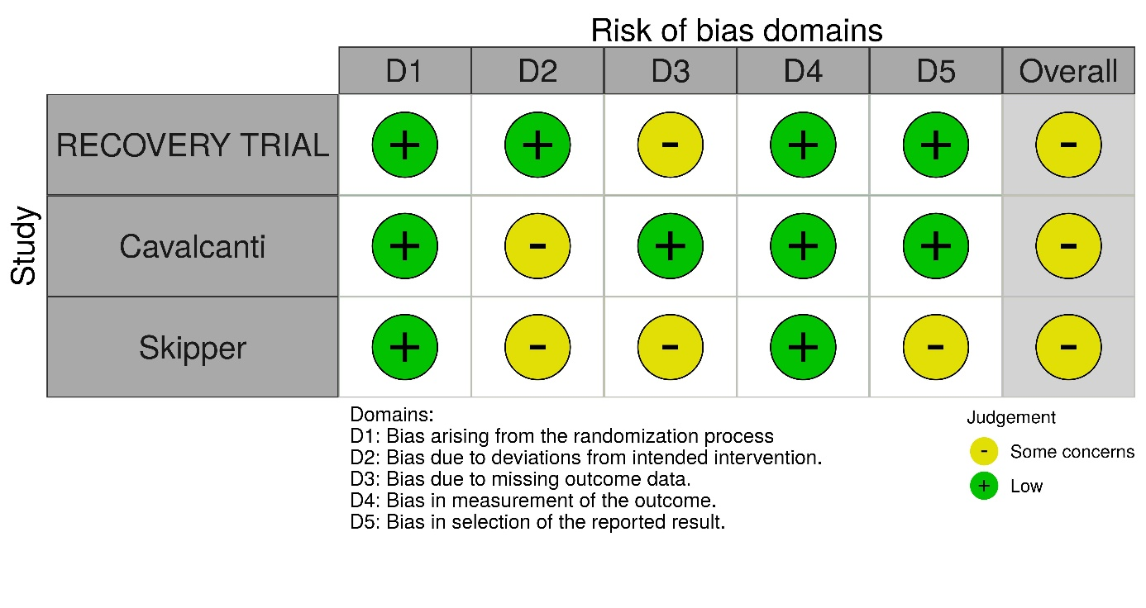

Figure S2: Assessment of quality of studies using ROBIN-I for non-randomized studies
D1: Bias due to confounding. D2: Bias due to selection of participants. D3: Bias in classification of interventions. D4: Bias due to deviations from intended interventions. D5: Bias due to missing data. D6: Bias in measurement of outcomes. D7: Bias in selection of the reported result.
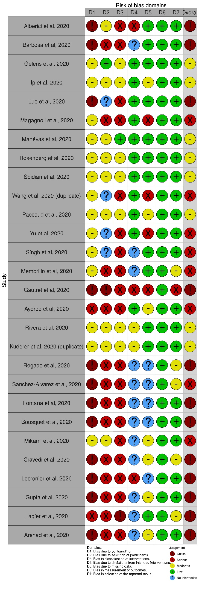

Figure S3. Forest plot for hydroxychloroquine alone and COVID-19 mortality risk, subgroup analysis per risk of bias*
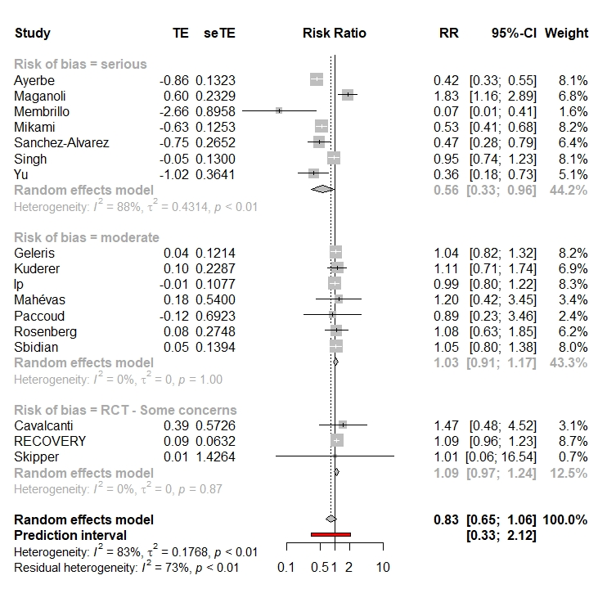

*Excluding studies with critical risk of bias

Figure S4. Influence analysis for hydroxychloroquine and COVID-19 mortality*

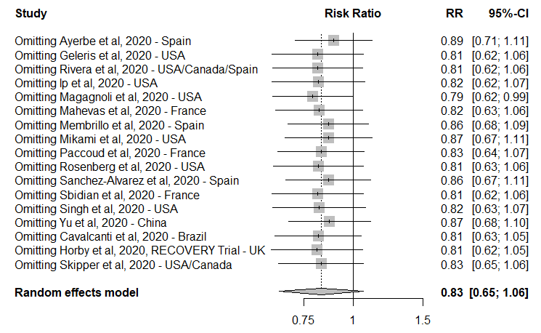
*Excluding studies with critical risk of bias

Figure S5. Posterior distribution obtained with 4,000 iterations by the Bayesian multilevel meta-analysis to assess the pooled effect (RR, Relative Risk) for mortality and hydroxychloroquine alone and the joint posterior density of heterogeneity (τ) and effect (μ)*

Darker shading corresponds to higher probability density. The red lines indicate (approximate) 2-dimensional credible regions, and the green lines show marginal posterior medians and 95% credible intervals. The blue lines show the conditional posterior mean effect $\hat{µ}$(τ) as a function of the heterogeneity τ along with a 95% interval based on its conditional standard error $\hat{σ}$(τ). The red cross (+) indicates the posterior mode, while the pink cross (×) shows the ML estimate

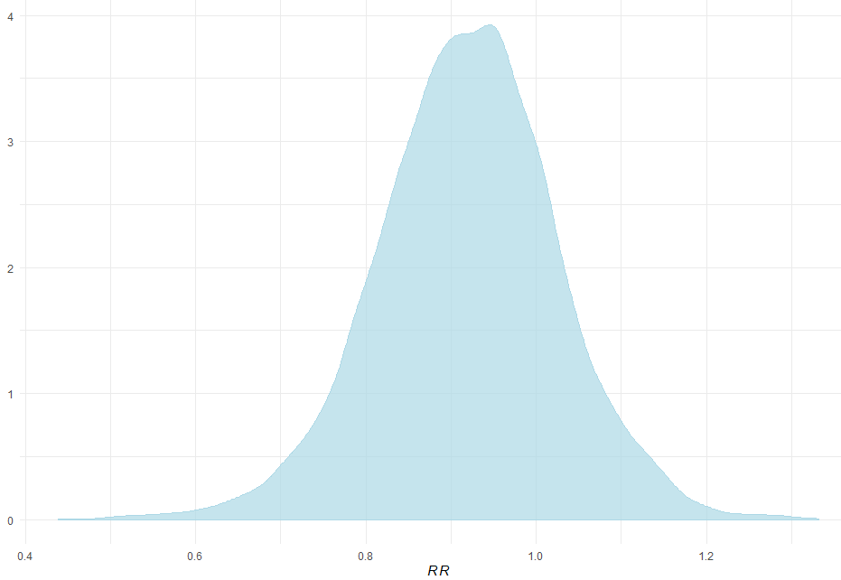
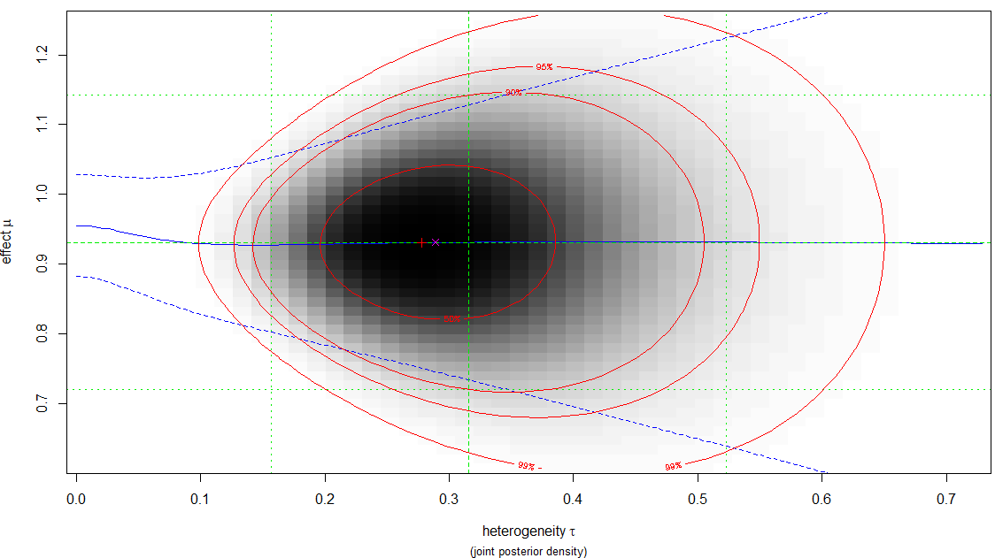

*Excluding studies with critical risk of bias

Figure S6. Funnel plot for hydroxychloroquine alone and COVID-19 mortality risk*

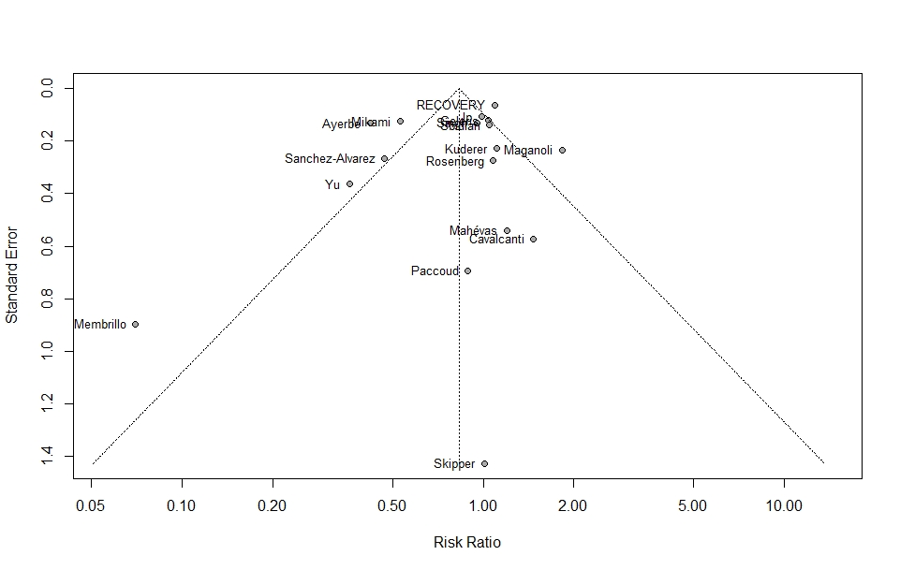
*Excluding studies with critical risk of bias

Figure S7: Funnel plot for hydroxychloroquine with azithromycin and COVID-19 mortality risk (without studies with critical risk of bias)*
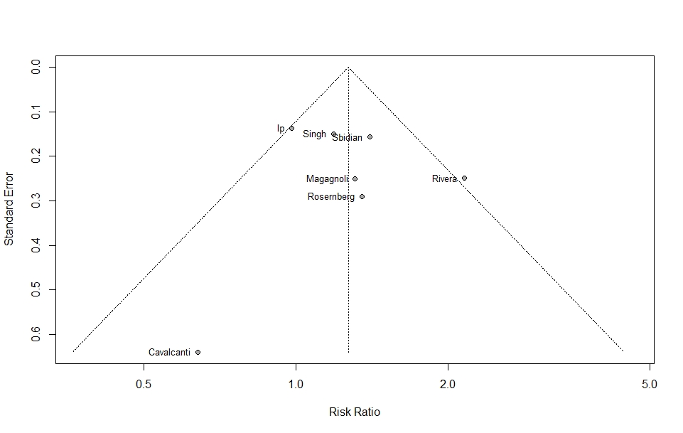

*Excluding studies with critical risk of bias

Figure S8. Forest plot for hydroxychloroquine with azithromycin and COVID-19 mortality risk, subgroup analysis per risk of bias*

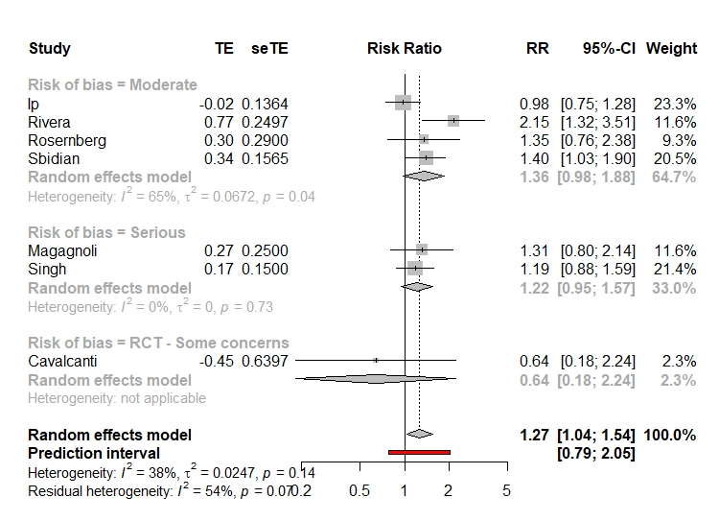

*Excluding studies with critical risk of bias

Figure S9. Posterior distribution obtained with 4,000 iterations by the Bayesian multilevel meta-analysis to assess the pooled effect for mortality and hydroxychloroquine with azithromycin*

Darker shading corresponds to higher probability density. The red lines indicate (approximate) 2-dimensional credible regions, and the green lines show marginal posterior medians and 95% credible intervals. The blue lines show the conditional posterior mean effect $\hat{µ}$(τ) as a function of the heterogeneity τ along with a 95% interval based on its conditional standard error $\hat{σ}$(τ). The red cross (+) indicates the posterior mode, while the pink cross (×) shows the ML estimate
*Excluding studies with critical risk of bias

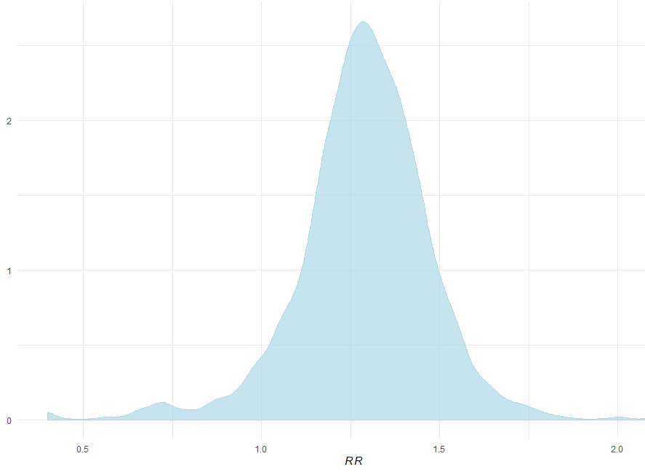
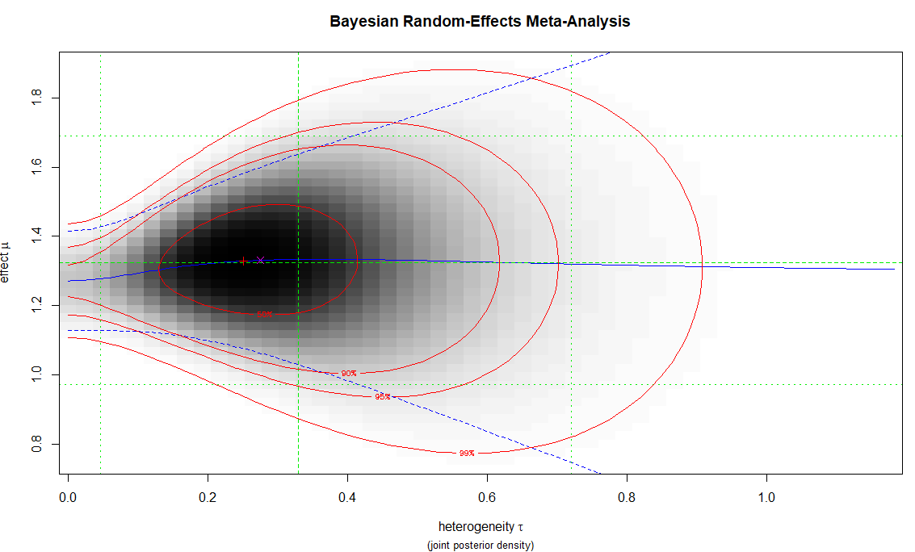

Figure S10. Influence analysis for hydroxychloroquine with azithromycin and COVID-19 mortality*
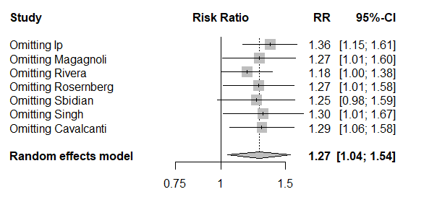

*Excluding studies with critical risk of bias

Supplementary Excel file 1: Risk of bias assessment using ROBIN-I for non-randomized studies and RoB2 for RCT
S1. Full electronic search strategy
For hydroxychloroquine
Cochrane Library
Website: https://www.cochranelibrary.com/advanced-search
Cochrane Review matching (Hydroxychloroquine or HCQ) in Title Abstract Keyword AND (mortality or death) in Title Abstract Keyword AND (COVID-19 or SARS-CoV-2) in Title Abstract Keyword - (Word variations have been searched)

PubMed
Website: https://pmlegacy.ncbi.nlm.nih.gov/pubmed/?term=(hydroxychloroquine+or+HCQ)+AND+(COVID-19+OR+SARS-CoV-2+OR+coronavirus)+AND+(Mortality+OR+death)
((hydroxychloroquine or HCQ) AND (COVID-19 OR SARS-CoV-2 OR coronavirus) AND (Mortality OR death)

Additional search on PubMed with controlled vocabulary | Number of results
((((covid19[MeSH Terms])) OR (sars-CoV-2[MeSH Terms])) AND (hydroxychloroquine[MeSH Terms])) AND ((mortality[MeSH Terms]) OR (death[MeSH Terms])) | 0
(sars)[MeSH Terms]) | 0
(covid19[MeSH Terms]) AND (hydroxychloroquine[MeSH Terms]) | 1
(COVID-19[MeSH Major Topic]) AND (hydroxychloroquine[MeSH Major Topic]) | 1
(COVID-19[MeSH Major Topic]) | 0
(coronavirus[MeSH Major Topic]) AND (hydroxychloroquine[MeSH Major Topic]) | 71
(coronavirus[MeSH Terms]) AND (hydroxychloroquine[MeSH Terms]) | 263

Web of Science
Website: http://apps.webofknowledge.com.proxy.insermbiblio.inist.fr/Search.do?product=UA&SID=F6KgcWI7K6kjXJwhAoH&search_mode=GeneralSearch&prID=9a27b347-ecf8-4832-9206-db1bbd2cc9a8
You searched for: TOPIC: (covid-19 OR SARS-CoV-2) AND TOPIC: (hydroxychloroquine or HCQ) AND TOPIC: (mortality or death)

EMBase
('hydroxychloroquine'/exp OR hydroxychloroquine OR hcq) AND ('covid 19'/exp OR 'covid 19' OR 'sars cov 2'/exp OR 'sars cov 2' OR 'coronavirus'/exp OR coronavirus) AND ('mortality'/exp OR mortality OR 'death'/exp OR death)"

Manual additional searches:
MedRxiv
https://www.medrxiv.org/
Search: Hydroxychloroquine COVID-19 mortality
Google scholar:
https://scholar.google.com/scholar?hl=en&as_sdt=0%2C5&q=hydroxychloroquine+COVID-19&btnG=
Search: Hydroxychloroquine COVID-19 mortality

For chloroquine
Cochrane Library
Cochrane Review matching (chloroquine or CQ) in Title Abstract Keyword AND (mortality or death) in Title Abstract Keyword AND (COVID-19 or SARS-CoV-2) in Title Abstract Keyword - (Word variations have been searched)

PubMed
((chloroquine or CQ) AND (COVID-19 OR SARS-CoV-2 OR coronavirus) AND (Mortality OR death)

Web of Science
You searched for: TOPIC: (covid-19 OR SARS-CoV-2) AND TOPIC: (chloroquine or CQ) AND TOPIC: (mortality or death)

EMBase
('chloroquine'/exp OR chloroquine OR hcq) AND ('covid 19'/exp OR 'covid 19' OR 'sars cov 2'/exp OR 'sars cov 2' OR 'coronavirus'/exp OR coronavirus) AND ('mortality'/exp OR mortality OR 'death'/exp OR death)"

S2. PRISMA Checklist
Section/topic |  | # |  | Checklist item | Reported on page #
TITLE
Title |  | 1 |  | Identify the report as a systematic review, meta-analysis, or both. | 1
ABSTRACT
Structured summary |  | 2 |  | Provide a structured summary including, as applicable: background; objectives; data sources; study eligibility criteria, participants, and interventions; study appraisal and synthesis methods; results; limitations; conclusions and implications of key findings; systematic review registration number. | 3-4
INTRODUCTION
Rationale |  | 3 |  | Describe the rationale for the review in the context of what is already known. | 5
Objectives |  | 4 |  | Provide an explicit statement of questions being addressed with reference to participants, interventions, comparisons, outcomes, and study design (PICOS). | 6
METHODS
Protocol and registration |  | 5 |  | Indicate if a review protocol exists, if and where it can be accessed (e.g., Web address), and, if available, provide registration information including registration number. | 6  PROSPERO (Registration number: CRD42020190801
Eligibility criteria |  | 6 |  | Specify study characteristics (e.g., PICOS, length of follow-up) and report characteristics (e.g., years considered, language, publication status) used as criteria for eligibility, giving rationale. | 6-7
Information sources |  | 7 |  | Describe all information sources (e.g., databases with dates of coverage, contact with study authors to identify additional studies) in the search and date last searched. | 6
Search |  | 8 |  | Present full electronic search strategy for at least one database, including any limits used, such that it could be repeated. | 6  S1. Full electronic search strategy
Study selection |  | 9 |  | State the process for selecting studies (i.e., screening, eligibility, included in systematic review, and, if applicable, included in the meta-analysis). | 6-7
Data collection process |  | 10 |  | Describe method of data extraction from reports (e.g., piloted forms, independently, in duplicate) and any processes for obtaining and confirming data from investigators. | 7
Data items |  | 11 |  | List and define all variables for which data were sought (e.g., PICOS, funding sources) and any assumptions and simplifications made. | 7
Risk of bias in individual studies |  | 12 |  | Describe methods used for assessing risk of bias of individual studies (including specification of whether this was done at the study or outcome level), and how this information is to be used in any data synthesis. | 8
Summary measures |  | 13 |  | State the principal summary measures (e.g., risk ratio, difference in means). | 7-8
Synthesis of results |  | 14 |  | Describe the methods of handling data and combining results of studies, if done, including measures of consistency (e.g., I²) for each meta-analysis. | 8-9
Section/topic |  | # |  | Checklist item | Reported on page #
Risk of bias across studies |  | 15 |  | Specify any assessment of risk of bias that may affect the cumulative evidence (e.g., publication bias, selective reporting within studies). | 8
Additional analyses |  | 16 |  | Describe methods of additional analyses (e.g., sensitivity or subgroup analyses, meta-regression), if done, indicating which were pre-specified. | 8-9 for subgroup analysis
RESULTS
Study selection | 17 |  | Give numbers of studies screened, assessed for eligibility, and included in the review, with reasons for exclusions at each stage, ideally with a flow diagram. |  |  | 9
Study characteristics | 18 |  | For each study, present characteristics for which data were extracted (e.g., study size, PICOS, follow-up period) and provide the citations. |  |  | 10  Tables S1,S2
Risk of bias within studies | 19 |  | Present data on risk of bias of each study and, if available, any outcome level assessment (see item 12). |  |  | 11-12  Figures S1 S2
Results of individual studies | 20 |  | For all outcomes considered (benefits or harms), present, for each study: (a) simple summary data for each intervention group (b) effect estimates and confidence intervals, ideally with a forest plot. |  |  | 11-12  Figures 2;-3
Synthesis of results | 21 |  | Present results of each meta-analysis done, including confidence intervals and measures of consistency. |  |  | 11-12  Figures 2-3
Risk of bias across studies | 22 |  | Present results of any assessment of risk of bias across studies (see Item 15). |  |  | Figures S6 S
Additional analysis | 23 |  | Give results of additional analyses, if done (e.g., sensitivity or subgroup analyses, meta-regression [see Item 16]). |  |  | Figures S4, S5, S7, S8,S9,S10
DISCUSSION
Summary of evidence | 24 |  | Summarize the main findings including the strength of evidence for each main outcome; consider their relevance to key groups (e.g., healthcare providers, users, and policy makers). |  |  | 12-14
Limitations | 25 |  | Discuss limitations at study and outcome level (e.g., risk of bias), and at review-level (e.g., incomplete retrieval of identified research, reporting bias). |  |  | 15
Conclusions | 26 |  | Provide a general interpretation of the results in the context of other evidence, and implications for future research. |  |  | 15-16
FUNDING
Funding | 27 |  | Describe sources of funding for the systematic review and other support (e.g., supply of data); role of funders for the systematic review. |  |  | 16

Table S1 (continued): Characteristics of studies included in the meta-analysis for COVID-19 mortality
First Author | Type of study | Country | Treatment | Number of participants |  | Number of deaths |  | HCQ dosing | Ageª  (years) | Patients | Study quality
 |  |  |  | Control | HCQ  alone | Control | HCQ alone
Alberici et al[43], 2020 | Observational, cohort | Italy | HCQ alone | 22 | 72 | Not reported | Not reported | Not specified | 72  (median)  IQ=62-79 | Hospitalized patients with haemodialysis | Critical
Arshad et al[50], 2020 | Observational, cohort | USA | HCQ alone  HCQ+AZI | 409 | 1202 | 108 | 162 | 800mg/day on day 1, 400mg for 4 additional days | 64 (median)  IQ=53-76 | Hospitalized patients | Critical
Ayerbe et al[17], 2020 | Observational, cohort | Spain | HCQ alone | 162 | 1857 | 49 | 237 | Not specified | 67,57  (mean) | Hospitalized patients | Serious
Barbosa Joshua et al[23], 2020 | Observational, cohort | USA | HCQ alone | 21 | 17 | 1 | 2 | 800 mg for 2 days then 200-400mg for 3-4 days | 62.7  (mean)  SD=15.1 | Hospitalized patients (mild/moderate symptoms) | Critical
Bousquet al[60], 2020 | Observational, cohort | France | HCQ+AZI | 27 | 81 | Not reported | Not reported | Dose not specified  for 1-9 days | 78.4  (mean)  SD=7.8 | Hospitalized patients (23% mild, 38% moderate, 29% severe) | Critical
Cavalcanti et al[51], 2020 | RCT | Brazil | HCQ alone  HCQ+AZI | 173 | 159 | 6 | 7 | 800mg/day for 7 days | 50.3 (mean)  SD=14.6 | Hospitalized patients with mild-to-moderate symptoms | Some concerns
Cravedi et al[52], | Observational, cohort | USA, Italy and Spain | HCQ alone | 43 | 101 | 10 | 36 | Not specified | 60  (mean)  SD=12 | Hospitalized kidney transplant patients with immunosuppression | Critical
Gupta et al[53], | Observational, cohort | USA | HCQ alone  HCQ+AZI | 454 | 1761 | 153 | 631 | Not specified | 60.5 (mean)  SD=14.5 | Hospitalized patients in ICU | Critical
Fontana et al[65], 2020 | Observational, cohort | Italy | HCQ alone | 3 | 12 | 2 | 4 | 125-400mg for a median time of 6.5 days | 75.96  (mean)  SD=11.09 | Dialysis patients | Critical
Gautret et al[24], 2020 | Non-randomised controlled trial | France | HCQ alone | 16 | 26 | 0 | 1 | A maintenance dose of 600 mg/day | 45.1 (mean)  SD=22 | Hospitalized patients (mild symptoms) | Critical
Geleris et al[15], 2020 | Observational, cohort | USA | HCQ alone | 565 | 811 | 75 | 157 | 1200mg at day 1 then 400mg for 4 days | From <40 to >80 | Hospitalized patients (moderate/severe symptoms) | Moderate
Ip et al[42], 2020 | Observational, cohort | USA | HCQ alone  HCQ+AZI | 598 | 1914 | 115 | 432 | 800mg at day 1 then 400mg on day 2-5 (80%) | 64 (median)  IQ=52-76 | Hospitalized patients (44% moderate/severe symptoms) | Moderate
Lagier et al[59], 2020 | Observational, cohort | France | HCQ alone  HCQ+AZI | 162 | 101 | 4 | 2 | 600mg/day for 10 days | 45.3 (mean)  SD=16.8 | Hospitalized patients (mild symptoms) | Critical
Lecronier et al[54], 2020 | Observational, cohort | France | HCQ alone | 22 | 38 | 9 | 9 | 400mg/day  Duration is not specified | 57 (median)  IQ=53-68 | Hospitalized patients in ICU (severe cases) | Critical
Luo et al[49], 2020 | Observational, cohort | USA | HCQ alone | 102 |  | 25 |  | NA | 68 (median)  Min-max 31-91 years | Hospitalized patients with a lung cancer | Critical
Kuderer et al[12], 2020 | Observational, cohort  (CCC19 cohort study) | USA  Canada  Spain | HCQ alone  HCQ+AZ | 486 | 89 | 41 | 11 | Not specified | 66 (median)  IQ=57-76 | Hospitalized patients with who have a current or past diagnosis of cancer | Moderate
Rivera et al[47], 2020 | (CCC19 cohort study, updated) | USA, Canada, Spain | HCQ alone  HCQ+any other drug | 1321 | 179 | 115 | 44 | Not specified | 67 (median)  IQ=57-77 | Hospitalized patients with who have a current or past diagnosis of cancer | Moderate
Magagnoli et al[41], 2020 | Observational, cohort | USA | HCQ alone  HCQ+AZI | 395 | 198 | 37 | 38 | Median HCQ dose: 400mg/day  Median HCQ+AZ dose: 422.2 mg/day | 70 (median)  IQ=60-75 | Hospitalized patients | Serious
Mahevas et al[13], 2020 | Observational, cohort | France | HCQ alone | 89 | 84 | 8 | 9 | 600mg/day | 60 (median)  IQ=52-68 | Hospitalized patients with covid-19 pneumonia who require oxygen: | Moderate
Membrillo et al[16], 2020 | Observational, cohort | Spain | HCQ alone | 43 | 123 | 21 | 27 | A loading dose of 800 mg + 400 mg in following days (ten days for moderate cases) | HCQ: 61.5  No HCQ: 68.7 (mean) | Hospitalized patients | Serious
Mikami et al[56], 2020 | Observational, cohort | USA | HCQ alone | 895 | 2813 | 231 | 575 | Not specified | 66 (median)  IQR=55-78 | Hospitalized patients | Serious
Paccoud et al[46], 2020 | Observational, cohort | France | HCQ alone | 46 | 38 | 6 | 3 | Compassionate basis: 600mg/day for 10 days | 65.5  SD=16 | Hospitalized patients | Moderate
Horby, et al[40], 2020  RECOVERY TRIAL | Randomized controlled trial | UK | HCQ alone | 3132 | 1542 | 736 | 396 | A loading dose of 2400mg at day 1, then 800mg/day for 10 days | Not specified | Hospitalized patients | Some concerns
Rogado et al[57], 2020 | Observational, cohort | Spain | HCQ+AZI | 8 | 18 | Not reported | Not reported | Not specified | 71 (median)  Range:34-90 | Hospitalized patients  (64% severe cases) | Critical
Rosenberg et al[18], 2020 | Observational, cohort | USA | HCQ alone  HCQ+AZI | 221 | 271 | 28 | 54 | 400mg then 200-400mg at 2nd prescription then 200-400mg at 3rd | 63 (median) | Hospitalized patients | Moderate
Sanchez-Alvarez et al[44], 2020 | Observational, cohort | Spain | HCQ alone | 53 | 322 | 32 | 166 | Not specified | 71  SD=15 | (85%) required hospital admission, 8% in intensive care units, with haemodialysis | Serious
Sbidian et al[48], 2020 | Observational, cohort | France | HCQ alone  HCQ+AZI | 623 | 3792 | 830 | 111 | A loading dose of 600mg on day 1 then 400mg/day for 9 days | 66.1 (mean)  SD=18 | Hospitalized patients (moderate/severe cases) | Moderate
Singh et al[58], 2020 | Observational, cohort | USA | HCQ alone  HCQ+AZI | 910 | 910 | 104 | 109 | Not specified | 62  SD=17 | Hospitalized patients | Serious
Skipper et al[39], 2020 | RCT | USA and Canada | HCQ alone | 247 | 244 | 1 | 1 | A loading dose of 800mg then 600 mg in 6-8h, then 600mg/day for 4 days | 40 (median)  IQ=32-50 | Non-hospitalized adults | Some concerns
Wang et al[36], 2020 | Observational, cohort | USA | HCQ alone  HCQ+AZI | 4165 | 591 | 168 | 101 | Not specified | NA | Hospitalized patients | Serious
Yu et al[14], 2020 | Observational, cohort | China | HCQ alone | 502 | 48 | 238 | 9 | 400mg during 7-10 days | 68 (median)  IQ: 59-77 | Critically ill patients | Serious
IQ=Interquartile range, SD=Standard Deviation, HCQ=Hydroxychloroquine, AZI=Azithromycin, NA=Not available
ªSome studies did not report mean or median age
*Excluding studies with critical risk of bias

Table S2: Reported and calculated effect sizes of studies included in the meta-analysis for COVID-19 mortality*
First Author | Effect size reported in each study^{b} | Adjustments
Alberici et al[43], 2020 | OR=0,44 [0,16-1,24] | Not adjusted
Arshad et al[50], 2020 | HR=0.34 [0.254-0.455]  HR=0.294 [0.218-0.396] | Adjusted on demographics (e.g., age, gender), preexisting medical conditions (e.g. CVD, lung disease) and clinical disease severity (mSOFA, O2 saturation
Ayerbe et al[17], 2020 | OR=0,422 [0,325-0,546] | Adjusted for age, gender, temperature > 37C and  Oxygen Saturation < 90% (complementary information from ResearchGate)
Barbosa Joshua et al[23], 2020 | RR_{calculated}=2,47 [0,24-24,98] | Not adjusted
Bousquet et al[60], 2020 | HR=0.49 [0.19-1.29] | Not adjusted
Cravedi et al[52], 2020 | RR_{calculated} =1.53 [0.84-2.80] | Not adjusted. Not included in the reported logistic regression
Cavalcanti et al[51], 2020 | HR=1.47 [0.48-4.53]  HR=0.64 [0.18-2.21] | Cox model adjusted for age and the use of supplemental oxygen at admission.
Fontana et al[65], 2020 | RR_{calculated}=0.50 [0.16-1.55] | Not adjusted
Gautret et al[24], 2020 | RR_{calculated} =3,41 [0,1505,77,45] | Not adjusted
Geleris et al[15], 2020 | HR=1,04 [0,82-1,32] | Cox model adjusted on demographic factors, clinical factors, laboratory tests, and medications.  Inverse probability weighting from a propensity-score based on these same covariates.
Gupta et al[53], 2020 | RR_{calculated} = 1.06 [0.92-1.23]  RR_{calculated} = 0.96 [0.86-1.08] | Not adjusted. Not included in the reported Cox models
Horby et al[40], 2020  RECOVERY TRIAL | HR=1.09 [0.96-1.23] | Log-rank ‘observed minus expected’ statistic. There was nearly no imbalance of baseline characteristics between HCQ and usual care groups
Ip et al[42], 2020 | HR=0.99 [0.8-1.22]  HR=0.98 [0.75-1.28] | Cox model adjusted on the propensity-score variable: gender, coronary disease, stroke, heart failure, arrhythmia, African American, COPD, , renal failure, rheumatologic disorder, inflammatory bowel disease, advanced liver disease, age, diabetes mellitus, insulin use prior to hospitalization, asthma, HIV/hepatitis, any cancer, and log ferritin
Kuderer et al[12], 2020^{c} | OR=1,06 [0,51,2,2]  OR=2.93 [1.79-4.79] | Adjusted for age, sex, smoking status, and obesity
Rivera et al[47], 2020 | OR=1.11 [0.71-1.74]  OR=2.15 [1.15-3.06] | Multivariable logistic regression, adjusted on age, sex, self-reported race and ethnicity, region of patient residence, smoking status, obesity, hypertension, diabetes, cardiovascular, pulmonary and renal comorbidities, ECOG PS, cancer status, baseline severity of COVID-19. A Propensity score matching regression model was conducted to assess the relationship between the treatment e xposure and 30-day all-cause mortality
Lagier et al[59], 2020 | RR_{calculated} = 0.8 [0.15-4.3]  RR_{calculated} = 0.29 [0.1-0.83] | Not adjusted. The article reported an effect size a comparison between HCQ+AZ>3 days vs "other drugs". Other drugs included HQ alone, HQ+AZ<3 days, neither drug.
Lecronier et al[54], 2020 | RR_{calculated}= 0.58 [0.27-1.24] | Not adjusted
Luo et al, [49] 2020 | OR=1.03 [0.26-3.55] | Not adjusted (univariate logistic regression)
Magagnoli et al[41], 2020 | HR=1.83 [1.16-2.89]  HR=1.31 [0.80-2.15] | Propensity score adjustment. All baseline covariates were included in the propensity score models (age, race, BMI, SpO2, breaths per minute, heart rate, T°, systolic blood pressure, ALT, AST, serum albumin, Total bilirubin, Creatinine, Erythrocytes, Haematocrit, Leukocytes, Lymphocytes, Platelets, Blood urea nitrogen, C-reactive protein
Mahevas et al[13], 2020 | HR=1,2 [0,4,3,3] | Inverse probability of treatment weighting in Cox model. age, sex, comorbidities (presence of chronic respiratory insufficiency during oxygen treatment, or asthma, cystic fibrosis, or any chronic respiratory disease likely to result in decompensation during a viral infection; heart failure (New York Heart Association class III or IV); chronic kidney disease; liver cirrhosis with Child-Pugh class B or more; personal history of cardiovascular disease (hypertension, stroke, coronary artery disease, or cardiac surgery); insulin dependent diabetes mellitus, or diabetic microangiopathy or macroangiopathy; treatment with immunosuppressive drugs, including anticancer chemotherapy; uncontrolled HIV infection or HIV infection with CD4 cell counts <200/µL; or a haematological malignancy); body mass index (≥30 or not); third trimester of pregnancy; treatment by angiotensin converting enzyme inhibitors or angiotensin receptor blockers13; time since symptom onset; and severity of condition at admission (percentage of lung affected: ≥50% or not; presence of confusion; respiratory frequency; oxygen saturation without oxygen; oxygen flow; systolic blood pressure; and C reactive protein level).
Membrillo et al[16], 2020 | OR=0,07 [0,012,0,402] | Adjusted on variables with p<0,25in univariate analysis
Mikami et al[56], 2020 | HR=0.53 [0.41-0.67] | Cox model adjusted for age, sex, race, cigarette use history, past medical history of asthma, hypertension, diabetes, or cancer, systolic BP, RR, SpO2, BMI, initial laboratory values (lymphocyte proportion, D-dimer, IL-6), and hydroxychloroquine use.  IPTW-adjusted Cox with doubly robust methods (inverse probability weighting (IPTW) based on propensity scoring to control for observed differences in baseline characteristics between treatment group and control group)
Paccoud et al[46], 2020 | HR=0.89 [0.23-3.47] | Propensity score based on time between symptom onset and admission ≤ 7, Charlson comorbidity index, NEWS2 score at admission, pneumonia severity and medical history of arterial hypertension or obesity.
Rogado et al[57], 2020 | OR=0,02 [0,01,0,73] | Adjusted by median age, histology, staging, cancer treatment received and hypertension
Rosenberg et al[18], 2020 | HR=1,08 [0,63,1,85]  HR=1.35 [0.76-2.4] | Multiple adjustments on potential confounders (age>65, sex, hospital, comorbidities, respiratory capacities
Sanchez-Alvarez et al[44], 2020 | OR=0,471 [0,28,0,792] | No information about adjustments in logistic regression
Sbidian et al[48], 2020 | HR=1.05 [0.77-1.33]  HR=1.40 [0.98-1.81] | Baseline covariables considered for adjustment were sex, age, current smoker, diabetes, obesity, hypertension, dyslipidemia, Ischaemic heart disease, rhythmic heart diseases, Chronic renal failure & Chronic end-stage kidney failure, any chronic lung disease, hepatic failure, cancer, hemopathies, chemotherapy, current steroid use, oxygen saturation, partial pressure of oxygen, paCO2, lymphocytes, neutrophils,D-Dimer, Creatine, C Reactive protein, Dehydrogenase lactate, prothrombin time
Singh et al[58], 2020 | HR=0,95 [0,74,1,23]  HR=1.19 [0.89-1.60] | Creation of groups based on propensity score matching for age, gender, race, confounding comorbidities
Skipper et al[39], 2020 | RR_{calculated} = 1.01 [0.06-16.09] | Not adjusted. HR for mortality were not reported
Wang et al[36], 2020 | OR=0.96 [0.69-1.34]  OR=0.94 [0.73-1.21] | Adjustment on covariables with p<0.05 in the bivariate analysis with mortality, then application of a backward selection algorithm
Yu et al[14], 2020 | HR=0,36 [0,18,0,75] | Adjustment: respiratory rate, shortness of breath, alanine aminotransferase (when p<0,01 in univariate Cox model)
HR and OR are the most adjusted effect size reported in each study. Some studies did not report effect size. RR_{calculated} were calculated using the number of deaths in the treatment and the control groups

*Excluding studies with critical risk of bias

Table S3. Reported concomitant use of corticosteroids in studies included in our meta-analysis
First author | Use of dexamethasone?
Rosenberg et al, 2020 | Not used
Geleris et al, 2020 | yes, some glucocorticoids (26.6% in HQ group vs 10.1% in control)
Magagnoli et al, 2020 | Not specified
Yu et al, 2020 | Not specified
lp et al, 2020 | Not specified
Luo et al, 2020 | Not specified
Sbidian et al, 2020 | Steroids have been administrated in 17% of HCQ group, 18.9 of HCQ-AZI group and 10.5% in the control group
Wang et al, 2020 | Not used
Paccoud et al, 2020 | No patient received glucorticosteroid therapy
Mahevas et al, 2020 | Not used
Alberici et al, 2020 | Not used
Barbosa et al, 2020 | Not specified
Gautret et al, 2020 | Not specified
Singh et al, 2020 | Not specified
Membrillo et al, 2020 | Steroids have been used
Ayerbe et al, 2020 | Steroids have been used (46% ; 960/2075)
Kuderer et al, 2020 | Not used
Sanchez-Alvarez et al, 2020 | Steroids were used
RECOVERY Trial | Use of dexamethasone was similar in both arms (8% vs 9%)
Lagier et al, 2020 | Not specified
Arshad et al, 2020 | Steroids have been administrated in 79% of HQ group, 74% of HCQ-AZI group and 36% in the control group
Fontana et al. 2020 | Two patients (13%) received steroids infusion.
Bousquet t al, 2020 | Not used
Mikami et al, 2020 | Not used
Cravedi et al, 2020 | Steroids were used (66%)
Lecronier et al, 2020 | Not used
Gupta et al, 2020 | Not used
Skipper et al, 2020 | Not specified
Cavalcanti et al, 2020 | Use of corticosteroids in 19.8% in HCQ-AZI group, 19.5% in HCQ group and 20.2% in control group

Table S4. Subgroup analysis for the associations between HCQ alone or HCQ associated with AZI and mortality risk of patients with COVID-19*

 | N | Pooled Relative Risk | Heterogeneity
 |  |  | I² (%) | P _{within} | P_{between} (test for subgroup differences)
HCQ alone
All Studies | 17 | 0.83 [0.65-1.06] | 83% | <0.01
Study Design
Non-randomised | 14 | 0.79 [0.60-1.04] | 84% | <0.01 | 0.03
RCT | 3 | 1.09 [0.97-1.24] | 0% | 0.487 | 0.03
Among non-randomised studies | 14
Type of article
Peer-reviewed | 10 | 0.77 [0.5-1.13] | 85% | <0.01 | 0.22
Unpublished | 4 | 0.98 [0.82-1.13] | 67% | 0.03 | 0.22
Adjusted estimate
Yes | 13 | 0.82 [0.62-1.09] | 84% | <0.01 | 0.06
No | 1 | 0.47 [0.28-0.79] | NA | NA | 0.06
Risk of bias
Moderate | 7 | 1.03 [0.91-1.17] | 0% | 0.99 | 0.03
Serious | 7 | 0.56 [0.33-0.96]] | 88% | <0.01 | 0.03
Mean daily dose
<500 mg/d | 5 | 1.08 [0.79-1.46] | 74% | <0.01 | 0.02
>500 mg/d | 3 | 1.04 [0.83-1.31] | 0% | 0.9 | 0.02
Not specified | 6 | 0.60 [0.42-0.86] | 84% | <0.01 | 0.02
Age
63 years or less | 5 | 0.99 [0.84-1.16] | 57% | 0.25 | 0.17
64 years or more | 9 | 0.75 [0.52-1.08] | 87% | <0.01 | 0.17
Cancer or haemodialysis patient based-population
No | 12 | 0.80 [0.58-1.09] | 85% | <0.01 | 0.85
Yes | 2 | 0.73 [0.32-1.69] | 83% | 0.01 | 0.85
HCQ+AZI
All Studies | 7 | 1.27 [1.04-1.54] | 38% | 0.14
Study Design
non-randomised | 6 | 1.29 [1.06-1.58] | 42% | <0.01 | 0.28
RCT | 1 | 0.64 [0.18-2.24] | NA | NA | 0.28
Among non-randomised studies
Type of article | 6
Peer-reviewed | 3 | 1.58 [1.14-2.20] | 69% | 0.04 | 0.12
Unpublished | 3 | 1.16 [0.95-1.43] | 33%% | 0.22 | 0.12
Adjusted estimate
Yes | 6 | 1.29 [1.06-1.58] | 42% | <0.01 | NA
No | 0 |  |  |  | NA
Risk estimated
Reported in the paper | 6 | 1.29 [1.06-1.58] | 42% | <0.01
Calculated | 0
Risk of bias
Moderate | 4 | 1.36 [0.98-1.88] | 80% | <0.01 | 0.59
Serious | 2 | 1.22 [0.95-1.57] | 0% | 0.73 | 0.59
Mean daily dose
<500 mg/d | 4 | 1.20 [0.96-1.50] | 13% | 0.33 | 0.4
>500 mg/d | 2 | 1.54 [0.86-2.76] | 76% | <0.01 | 0.4
Age
63 years or less | 2 | 1.22 [0.94-1.58] | 0% | 0.69 | 0.62
64 years or more | 4 | 1.35 [0.99-.1.84] | 65% | <0.01 | 0.62
Cancer or haemodialysis patient based-population
No | 6 | 1.29 [1.06-1.58] | 42% | <0.01
Yes | 0 | NA | NA | NA
N: number of studies. NA: Not applicable for a single study
*Excluding studies with critical risk of bias

Table S5. Bayesian meta-analysis and traditional random effect meta-analysis for the association between HCQ alone with or without azithromycin and mortality in patients with COVID-19*
 | Bayesian meta-analysis |  |  |  | Traditional random-effect model
 | Prior distribution
 | µ: Normal (1,100)  τ: Cauchy (0,0.5) |  | µ: Normal (1,1)  τ: Cauchy (0,0.5)
 | RR | τ | RR | τ | RR | τ
HCQ alone n=17 | 0.93 [0.72-1.14] | 0.33 | 0.93 [0.72-1.14] | 0.33 | 0.83 (0.65-1.06) | 0.18
HCQ n=14 (exclusion of RCT) | 0.90 [0.65-1.13] | 0.12 | 0.90 [0.66-1.14] | 0.35 | 0.79 [0.60-1.04] | 0.20
HCQ n=3 RCT | 1.14 [0.64-1.69] | 0.24 | 1.13 [0.56-1.70] | 0.31 | 1.09 [0.97-1.24] | 0
HCQ +AZI n=7 | 1.32 [0.97-1.68] | 0.17 | 1.32 (0.96-1.65] | 0.35 | 1.27 [1.04-1.54] | 0.03
HCQ +AZI n=6 (exclusion of RCT) | 1.37 [0.97-1.79] | 0.21 | 1.36 [1.01-1.74] | 0.36 | 1.29 [1.06-1.58] | 0.03
n=number of studies τ =between-study heterogeneity RR=Relative Risk
*Excluding studies with critical risk of bias

Table S6. Subgroup analysis for the associations between hydroxychloroquine with or without azithromycin and mortality in patients with COVID-19

 | N | Pooled Relative Risk | Heterogeneity
 |  |  | I² (%) | P _{within} | P_{between} (test for subgroup differences)
HCQ alone
All Studies | 27 | 0.80 [0.65-1.00] | 83% | <0.01
Study Design
non-randomised | 24 | 0.77 [0.61-0.98] | 83% | <0.01 | 0.01
RCT | 3 | 1.09 [0.97-1.24] | 0% | 0.87 | 0.01
Among non-randomised studies | 24
Type of article
Peer-reviewed | 19 | 0.75 [0.57-0.98] | 85% | <0.01 | 0.08
Unpublished | 5 | 0.98 [0.85-1.13] | 58% | 0.05 | 0.08
Adjusted estimate
Yes | 14 | 0.76 [0.56-1.03] | 88% | <0.01 | 0.8
No | 10 | 0.81 [0.56-1.17] | 49% | 0.04 | 0.8
Risk of bias
Moderate | 7 | 1.03 [0.91-1.17] | 0% | 0.9 | 0.04
Serious | 7 | 0.56 [0.33-0.96] | 88% | <0.01 | 0.04
Critical | 10 | 0.75 [0.48-1.16] | 84% | <0.01 | 0.04
Mean daily dose
<500 mg/d | 8 | 0.72 [0.43-1.19] | 89% | <0.01 | 0.09
>500 mg/d | 6 | 1.05 [0.84-1.32] | 0% | 0.9 | 0.09
Not specified | 10 | 0.71 [0.52-0.97] | 87% | <0.01 | 0.09
Age
63 years or less | 11 | 1.03 [0.93-1.14] | 32% | 0.14 | 0.01
64 years or more | 13 | 0.67 [0.49-0.92] | 87% | <0.01 | 0.01
Cancer or haemodialysis patient based-population
No | 18 | 0.77 [0.58-1.01] | 86% | <0.01 | 0.9
Yes | 6 | 0.79 [0.49-1.27] | 60% | 0.03 | 0.9
HCQ+AZI
All Studies | 12 | 0.87 [0.59-1.27] | 88% | <0.01
Study Design
Non-randomised | 11 | 0.88 [0.59-1.32] | 89% | <0.01 | 0.6
RCT | 1 | 0.64 [0.18-2.24] | NA | NA | 0.6
Among non-randomised studies | 11
Type of article
Peer-reviewed | 8 | 0.73 [0.40-1.34] | 91% | <0.01 | 0.15
Unpublished | 3 | 1.16 [0.95-1.43] | 33% | 0.22 | 0.15
Adjusted estimate
Yes | 7 | 1.27 [1.04-1.56] | 56% | <0.01 | 0.004
No | 4 | 0.48 [0.25-0.91] | 95% | <0.01 | 0.004
Risk estimated
Reported in the paper | 9 | 0.94 [0.60-1.49] | 91% | <0.01 | 0.5
Calculated | 2 | 0.60 [0.19-1.88] | 79% | 0.03 | 0.5
Risk of bias
Moderate | 4 | 1.36 [0.98-1.88] | 65% | <0.01 | 0.008
Serious | 2 | 1.22 [0.95-1.57] | 0% | 0.73 | 0.008
Critical | 5 | 0.43 [0.22-0.84] | 94% | <0.01 | 0.008
Mean daily dose
Not specified | 5 | 1.04 [0.62-1.74] | 78% | <0.01 | 0.09
<500 mg/d | 5 | 0.92 [0.51-1.67] | 94% | <0.01 | 0.09
>500 mg/d | 1 | 0.29 [0.10-0.84] | NA | NA | 0.09
Age
63 years or less | 4 | 1.01 [0.84-1.22] | 63% | 0.05 | 0.6
64 years or more | 7 | 0.84 [0.45-1.56] | 93% | <0.01 | 0.6
Cancer or haemodialysis patient based-population
No | 11 | 0.88 [0.59-1.32] | 89% | <0.01 | NA
Yes | 0 | NA | NA | NA | NA

N=Number of studies NA=Not Available

