Supplementary Material

Supplementary Table 1. Quality assessment of the included studies.
First author | Selection |  |  |  | Comparability | Outcome |  |  | Total score
 | Representativeness of the exposed cohort | Selection of the non-exposed cohort | Ascertainment of exposure | Demonstration that the outcome of interest was not present at the start of the study | Comparability of cohorts based on the design or analysis | Assessment of outcome | Was follow-up long enough for outcomes to occur? | Adequacy of the follow-up of cohorts | Total score
Ng et al. (2020) | 1 | 1 | 1 | 0 | 0 | 1 | 1 | 1 | 6
Huang et al. (2020) | 1 | 1 | 1 | 0 | 0 | 1 | 1 | 1 | 6
Rajpal et al. (2020) | 1 | 1 | 1 | 0 | 0 | 1 | 1 | 1 | 6
Clark et al. (2021) | 1 | 1 | 1 | 0 | 0 | 1 | 1 | 1 | 6
Knight et al. (2020) | 1 | 0 | 1 | 1 | 0 | 1 | 1 | 1 | 6
Puntmann et al. (2020) | 1 | 1 | 1 | 1 | 0 | 1 | 1 | 1 | 7
Eiros et al. (2020) | 1 | 1 | 1 | 1 | 0 | 1 | 1 | 1 | 7
Vago et al. (2020) | 1 | 1 | 1 | 0 | 0 | 1 | 1 | 1 | 6
Brito et al. (2020) | 1 | 1 | 1 | 0 | 0 | 1 | 1 | 1 | 6
Malek et al (2021) | 1 | 0 | 1 | 0 | 0 | 1 | 1 | 1 | 5
Li et al (2021) | 1 | 1 | 1 | 1 | 0 | 1 | 1 | 1 | 7
Starekova et al (2021) | 1 | 0 | 1 | 0 | 0 | 1 | 1 | 1 | 5
Wang et al (2021) | 1 | 1 | 1 | 1 | 0 | 1 | 1 | 1 | 7
Pan et al (2021) | 1 | 1 | 1 | 1 | 0 | 1 | 1 | 1 | 7
Zhou et al (2021) | 1 | 0 | 1 | 1 | 0 | 1 | 1 | 1 | 6
Kotecha et al (2021) | 1 | 1 | 1 | 1 | 0 | 1 | 1 | 1 | 7

Supplemental Appendix 1. Search terms used in PubMed, the Cochrane library and EMBASE
- Search terms for PubMed and the Cochrane library:
Myocardium[MeSH Terms] OR Heart[MeSH Terms] OR Heart Ventricles[MeSH Terms] OR Myocarditis[MeSH Terms] OR Heart or myocardium or myocardial or cardiac or ventricle or ventricular or myocarditis or (myocardial injury)
AND ((("COVID-19"[Supplementary Concept] OR "Coronavirus"[MeSH Terms]) OR "severe acute respiratory syndrome coronavirus 2"[Supplementary Concept]) OR ((((("Coronavirus"[MeSH Terms] OR "Coronavirus"[All Fields]) OR "coronaviruses"[All Fields]) OR ((((((("COVID-19"[All Fields] OR "covid 2019"[All Fields]) OR "severe acute respiratory syndrome coronavirus 2"[Supplementary Concept]) OR "severe acute respiratory syndrome coronavirus 2"[All Fields]) OR "2019 ncov"[All Fields]) OR "sars cov 2"[All Fields]) OR "2019ncov"[All Fields]) OR (("wuhan"[All Fields] AND ("Coronavirus"[MeSH Terms] OR "Coronavirus"[All Fields])) AND (2019/12/1:2019/12/31[Date - Publication] OR 2020/1/1:2020/12/31[Date - Publication])))) OR (("severe acute respiratory syndrome coronavirus 2"[Supplementary Concept] OR "severe acute respiratory syndrome coronavirus 2"[All Fields]) OR "2019 ncov"[All Fields])) OR (("severe acute respiratory syndrome coronavirus 2"[Supplementary Concept] OR "severe acute respiratory syndrome coronavirus 2"[All Fields]) OR "sars cov 2"[All Fields])))
AND Magnetic Resonance Imaging"[Mesh] OR "Magnetic Resonance Imaging, Cine"[Mesh] or magnetic resonance or MR or CMR or MRI or cmri
2) Search terms for EMBASE:
(('heart'/exp OR 'cardiac muscle'/exp OR 'myocarditis'/exp) OR (heart OR myocardium OR myocardial OR cardiac OR ventricle OR ventricular OR myocarditis OR (myocardial AND injury))) AND (('coronavirus infection'/exp OR 'coronavirus disease 2019'/exp) OR (coronavirus OR 'covid 19' OR '2019 ncov' OR 'sars cov 2')) AND (('cardiovascular magnetic resonance'/exp OR 'cine magnetic resonance imaging'/exp) OR (magnetic AND resonance OR mr OR cmr OR mri OR cmri))

Supplementary Figure 1. Funnel plots to detect publication bias.
Each circle represents a study included in the analysis. Probability values of asymmetry from the Egger tests are shown.
- Prevalence of total abnormal CMR findings

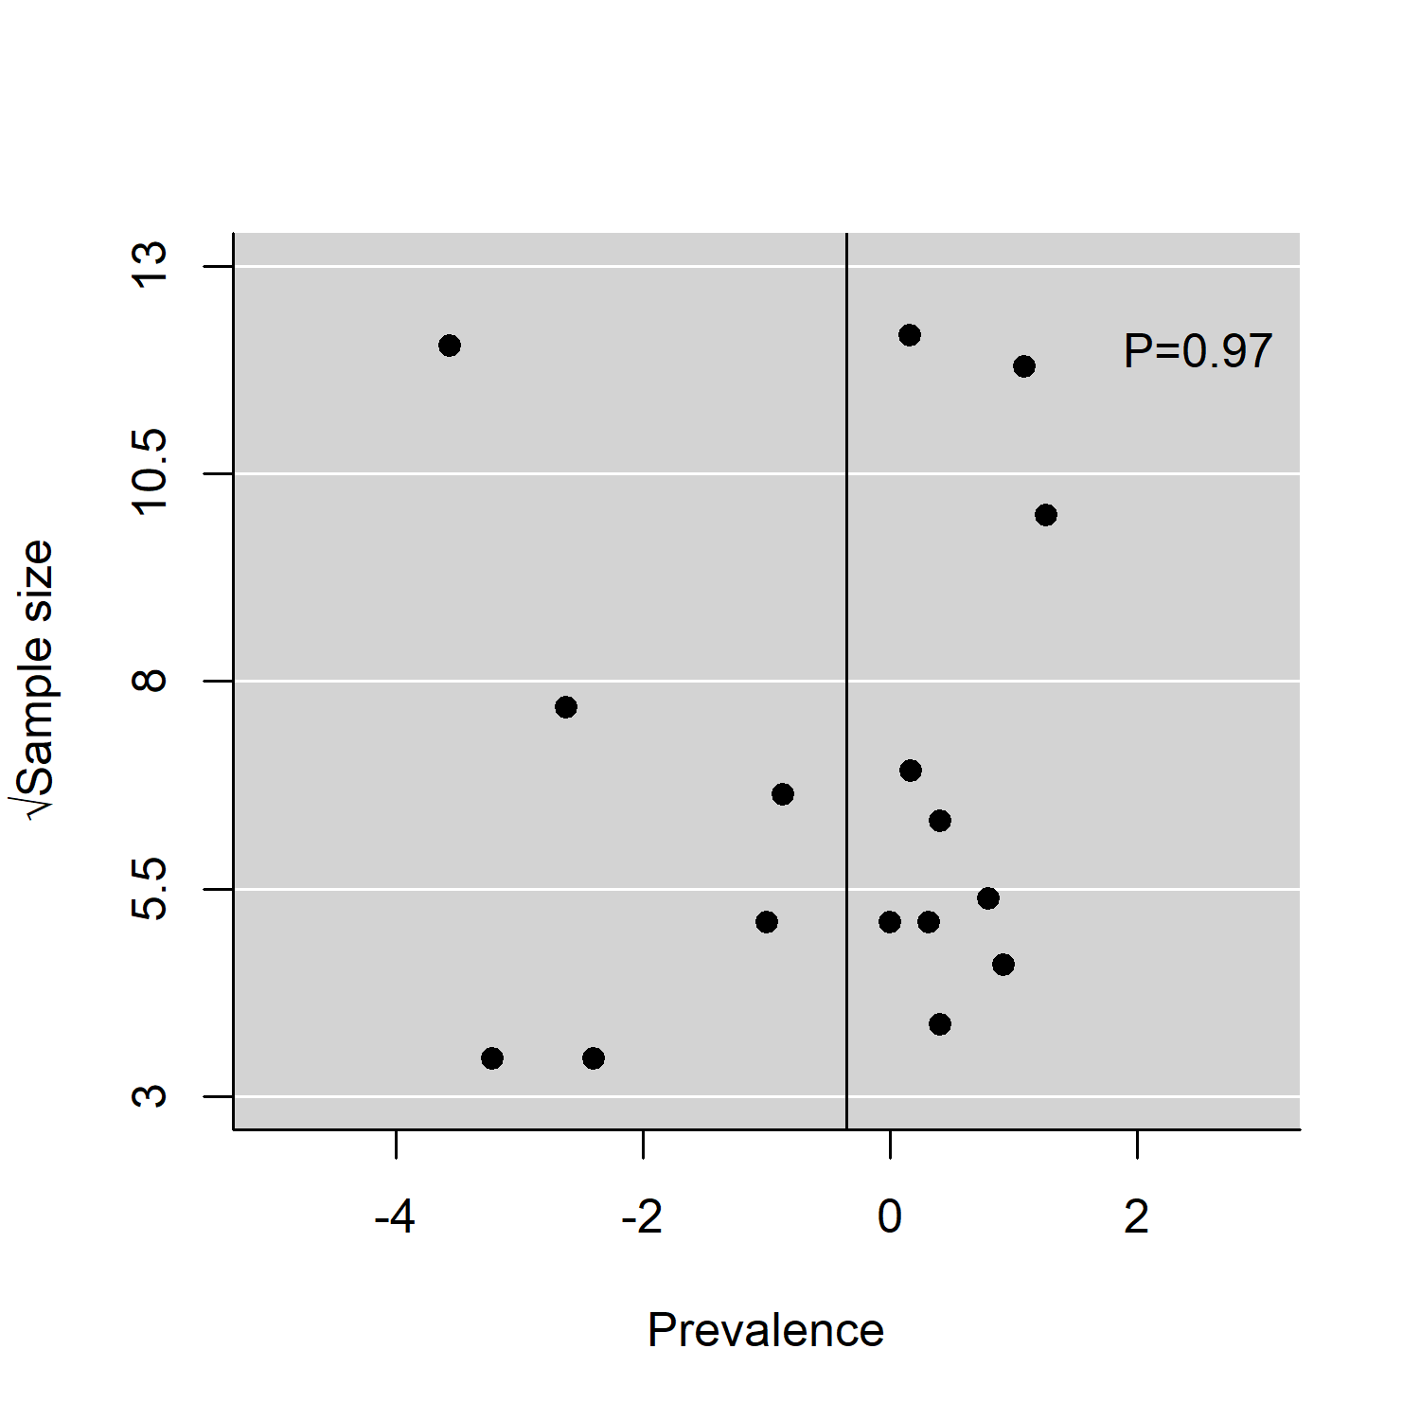
- Prevalence of the diagnosis of myocarditis on CMR

- Prevalence of myocardial LGE

- Prevalence of pericardial LGE

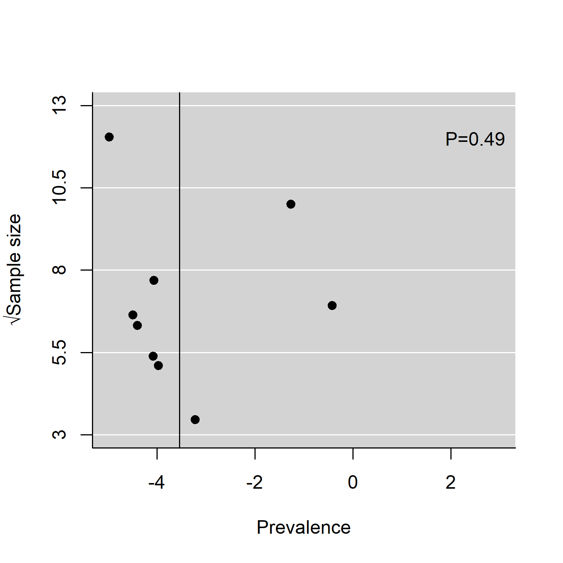
- Prevalence of increased T1 value on T1 map

- Prevalence of T2 abnormality

- Prevalence of LGE without T2 abnormality

- Prevalence of abnormal T2 without LGE

- Prevalence of ventricular dysfunction

- Prevalence of pericardial effusion
CMR: cardiac magnetic resonance imaging, LGE: late gadolinium enhancement.

