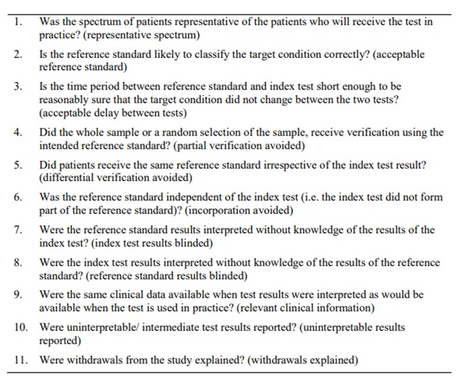
Supplementary Figure S1. Methodological quality assessment tool endorsed by the Cochrane Handbook for Systematic Reviews of Diagnostic Test Accuracy [13].

