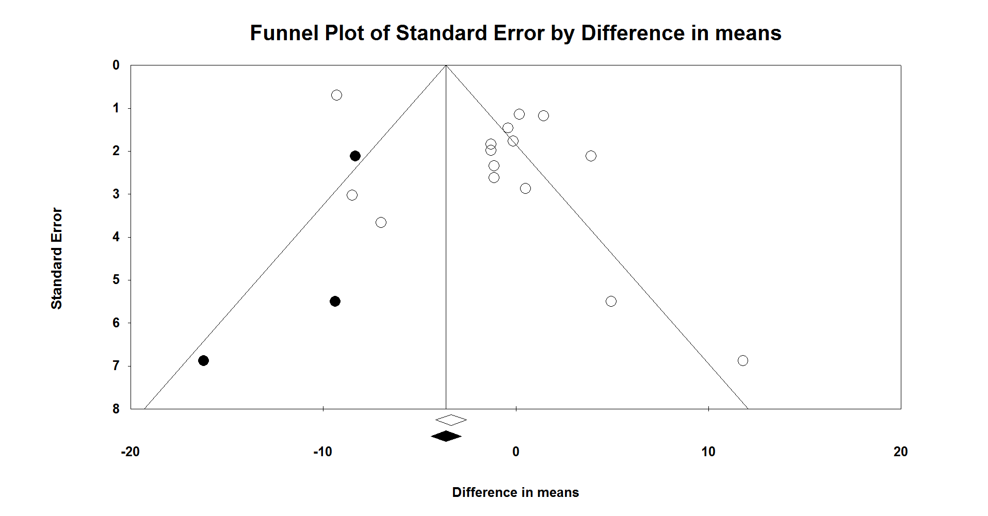

Supplementary figure 7. Trim and fill method was used to impute for potentially missing studies for alanine aminotransferase (ALT), open circles represent observed published studies; open diamond represents observed effect size; closed diamond represents imputed effect size; closed circles represents imputed studies.

