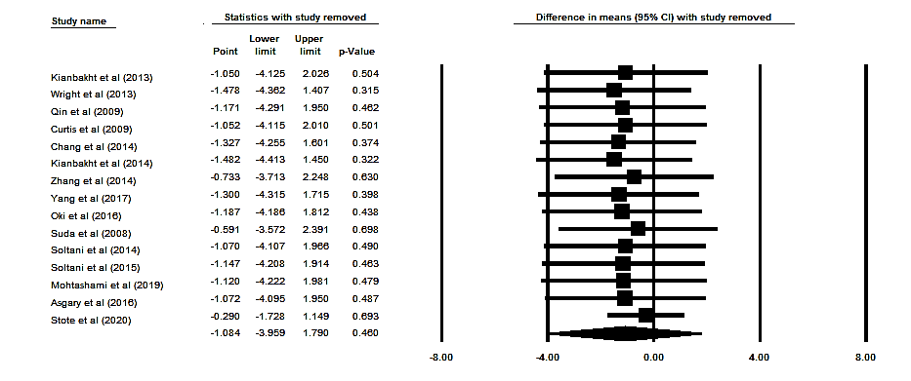

Supplementary figure 1. Sensitivity analysis was performed using a random-effect model for impact of anthocyanins and Alanine Aminotransferase (ALT) concentration.

