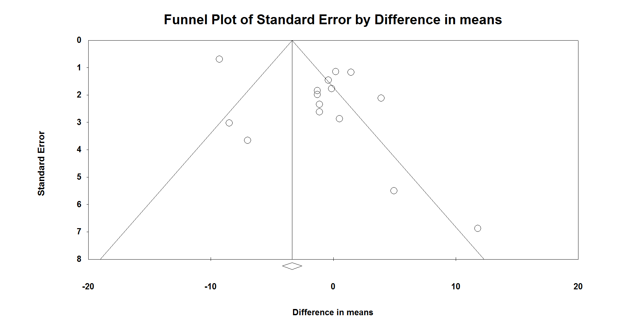
A

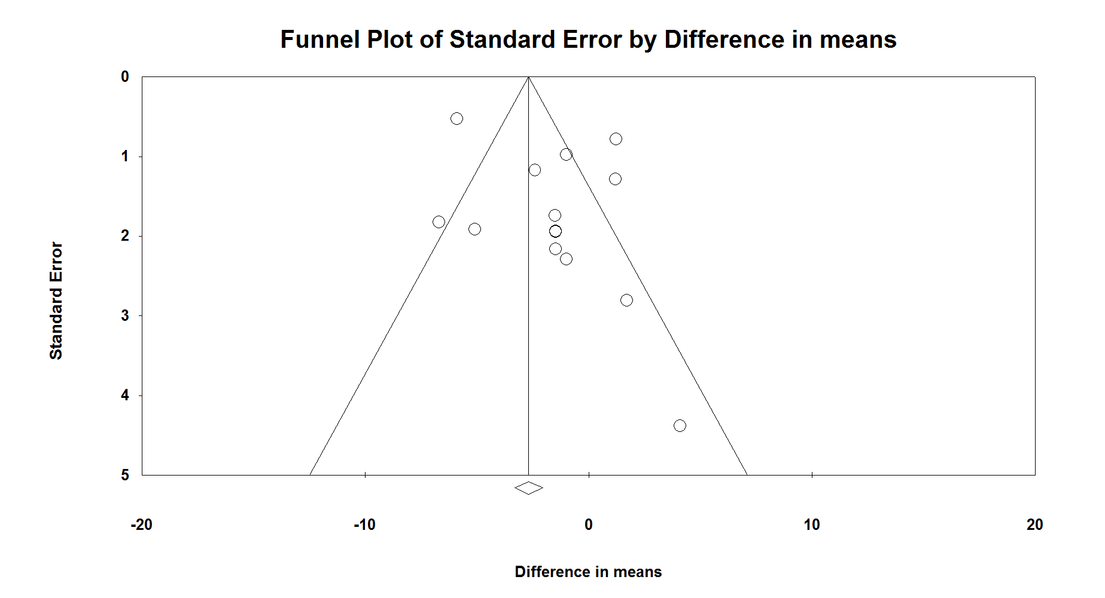
B

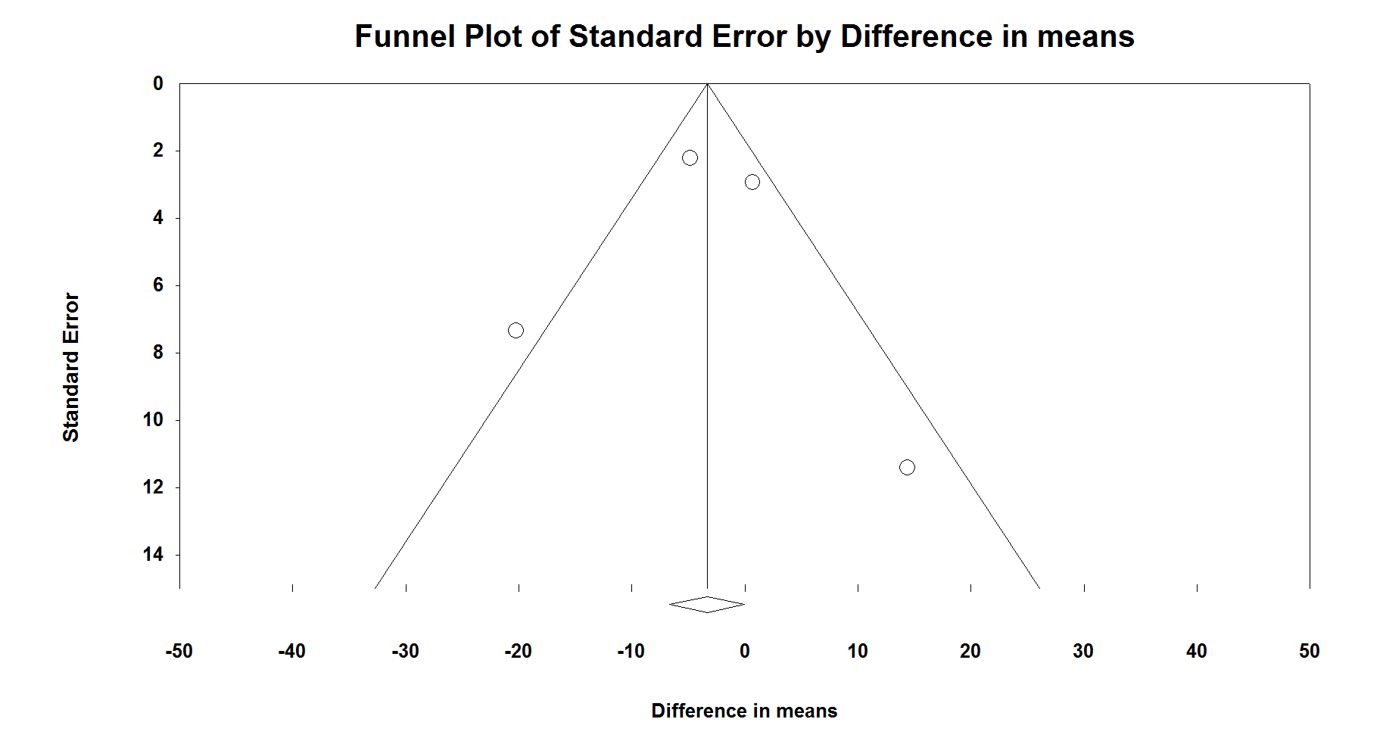
C

Supplementary figure 6. Funnel plot (with 95 % confidence intervals) of weighted mean differences for liver enzymes (A: Alanine Aminotransferase (ALT), B: Aspartate Aminotransferase (AST), C: Gamma-Glutamyl Transferase) concentrations with anthocyanins. The vertical line (——) shows the combined mean differences calculated with the random-effects model.

