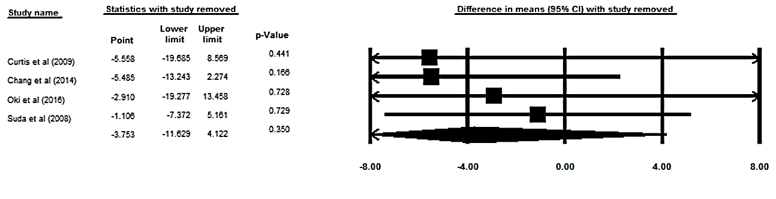

Supplementary figure 5. Sensitivity analysis was performed using a random-effect model for impact of anthocyanins and Gamma-Glutamyl Transferase (GGT) concentration.

