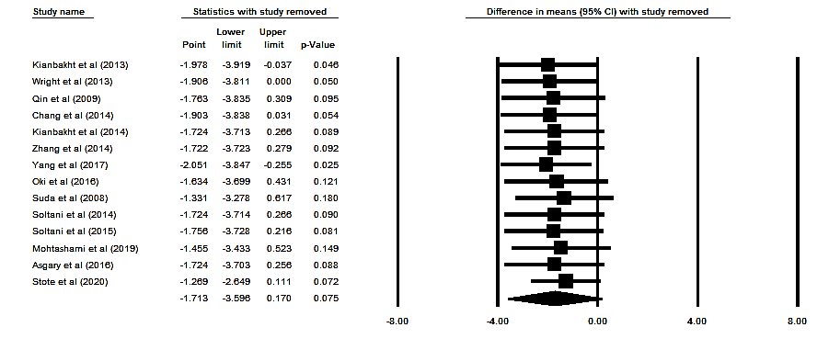

Supplementary figure 4. Sensitivity analysis was performed using a random-effect model for impact of anthocyanins and Aspartate Aminotransferase (AST) concentration.

