Figure A1. Share of various topics covered by the training programs

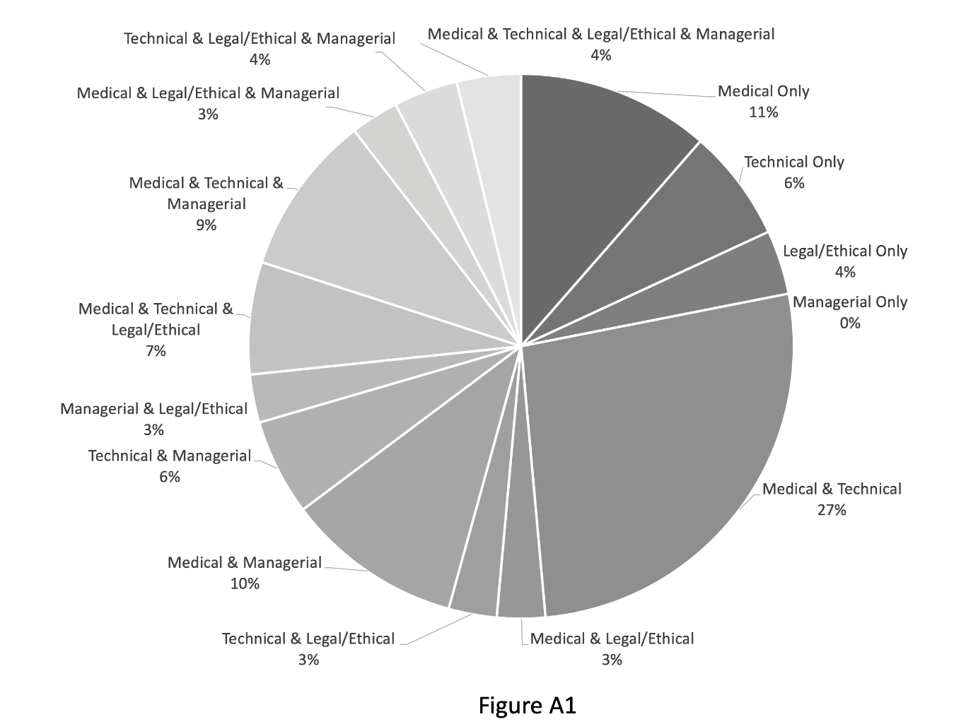

Table A1. Price of training programs
Price
Free | 47 programs | Explanatory notes: some training programs take place within a larger event such as a conference. These training programs’ prices are assessed based on the price of the event, since that amount is required to be paid to access the training program. In that context, some programs need to be bought in combination which provides access to a package of training programs rather than just one. Here, the total package price has been considered since that amount is required to access the program, even if it’s only one.  Some affiliations do not mention anything about their prices. Although no hasty conclusion can be drawn, this may indicate that providing agents deliberately hide their prices because of underlying motives.
0-50EUR | 12 programs
50-100EUR | 15 programs
100-200EUR | 3 programs
200-400EUR | 2 programs
400 + EUR | 2 programs
Not specified | 6 programs

Table A2. Duration of training programs
Duration
0 – 1 hour | 58 programs | Explanatory notes: the training programs with long duration (1 day or longer) are courses specifically designed for AI training on radiologists. Based on their specified and qualified content, they are considered as appropriate training programs. Some of these programs could not be broken down into smaller ones. This may explain the differences in duration. One day equals approximately eight hours.
1 – 3 hours | 20 programs
3 – 6 hours | 2 programs
1 day | 5 programs
2 days | 11 programs
20 hours | 1 program
7 days | 1 program

Table A3. Different content types
Content |  | Description | Illustrative finding
Passive | Theoretical | Discussing theoretical concepts of radiology, technologies or other topics that are not related to the application of AI | “General concepts of machine and deep learning will be explored” (ESR – Intelligence, Innovation, Imaging – The Perfect Vision of AI)  “Tips on knowing the use cases, emphasizing the expected value of AI, and familiarize with the organization's operational state and business goals” (SIIM – AI Implementation)
Passive | Application | Discussing actual applications of AI in radiology, explanation of these applications and modality-specific examples | “How the basic technical principles of AI are applied to diagnostic imaging and clinical applications” (ESR)  “The application of AI explained in steps for image acquisition and image reconstruction, segmentation, identification of anatomical structures” (EuSoMii – Machine Learning in Cardiovascular imaging)
Active | Hands-on | Practicing with knowledge and skills learned and apply it into clinical practice | “Gain practical skills to improve patient care in your practice to advance your practice” (RSNA – Radiology in the Age of AI)  “The first module introduces data sets for a concrete AI project in Medical Imaging. It teaches participants on how to use tools to prepare imaging data for analysis with Artificial Intelligence.” (Sitem Insel – Artificial Intelligence Project)

Table A4. Overview of topics covered in the training programs
Topic | Description | Example | Included in:
Medical | How AI is influencing the clinical radiology practice including specific modalities or radiology specializations | “the clinical applications of a cutting-edge brain imaging AI in the evaluation of patients with dementia, multiple sclerosis and traumatic brain injury” (AIMed – Transforming patient care through imaging AI) | 75 programs
Technical | Discussing the foundations and both the basic and advanced techniques of AI technology and related technologies | “Includes a general tutorial on machine learning that aims to convey the importance of AI.” (SCCME – Artificial Intelligence and Machine Learning in MSK Radiology) | 69 programs
Managerial | Elaboration of implementation and integration of AI in the radiology department and workflow | “Gain unique insights into how organizations can overcome the challenges through a platform approach to AI implementation in imaging workflows that makes it seamless.” (GE Healthcare – How to Seamlessly Integrate AI into your Imaging Workflows) | 40 programs
Legal/Ethical | Questions that are emerged through AI regarding legal, ethical and social issues | “Explain hurdles and steps to regulatory clearance and define evaluations of AI and common issues including bias, brittleness, and fairness” (ACR – Monitoring and Evaluating AI: Challenges and Practical Implications) | 29 programs

Table A5. Backgrounds of the instructors
Radiologist | Diagnostic Radiology  Diagnostic Imaging  Radiology  Neuroradiology  Radiology Informatics  Musculoskeletal Radiology  Breast Imaging  Cardiothoracic Radiology  Cardiovascular Imaging  Interventional Radiology  Emergency Radiology  Paediatric Radiology
Other Medical Professionals | Professor of Medicine  Researcher in Translational Neuroscience  Physician Scientist  Clinical Scientist  Medical Doctor
Technical Background | Computational Imaging  Biomedical Engineer  Biomedical/Medical/Diagnostic Image Analysis  Medical Image Analysis  Diagnostic Physics and Imaging Informatics  Medical/Imaging/Radiology/Clinical Informatics  Pathology Informatics  Physics in Medical Data  Medical Physicist  Biomathematics, Biostatistics and Human Genetics  Medicine and Tropical Diseases  Bioengineering, Of Genetics, Of Medicine  AI Expert  Computer Science  Data Scientist  Machine Learning Engineer  Statistical Methods  Computer Vision Engineer  Information Technology  Electrical Engineering  Human Centered Design & Engineering
Other Backgrounds | Medical Manager (E.G., Chief Medical Officer, Clinical Health Sciences)  Medical Entrepreneur  Medical Consultant (E.G., Consultant-Healthcare Strategies, Marketing Strategy and Product Development.)  Healthcare Policy and Research  History of Medicine

Table A6. list of providing agents and the number of training programs
Providing Agents | Professional Institutions | Academic | Commercial | Other
AI in Healthcare |  | 2
AIDoc |  |  | 5
AIMed |  |  | 4
American College of Radiology ACR | 7
American Osteopathic College of Radiology AOCR | 1
Applied Radiology Expert Forums |  |  | 1
Aunt-MinnieEurope |  |  | 2
British Institute of Radiology | 3
Coursera |  |  | 1
European School of Radiology ESOR | 1
European Society of Medical Imaging Informatics (EuSoMII) | 8
European Society of Radiology ESR | 15
GE Healthcare |  |  | 2
iCad |  |  | 2
Indian Radiological & Imaging Association | 1
M&I Partners |  |  | 1
Noord West Ziekenhuisgroep |  |  |  | 1
North West Radiology Network NWRN | 1
Quantib |  |  | 2
Radiological Society of North America RSNA | 5
Radiology Business |  |  | 2
Radsite |  |  | 1
Sitem Insel |  |  | 6
Skyl.ai |  |  | 2
Smart Health |  |  | 1
Society for Imaging Informatics in Medicine SIIM | 10
Society of Nuclear Medicine and Molecular Imaging SNMMI | 6
Stanford Center for Continuing Medical Education; SCCME |  | 2
University Hospital Zürich UHZ |  | 1
University of Toronto |  | 1
UT Southwestern Radiology | 1
VUB Artificial Intelligence Lab |  | 2
Total | 59 | 8 | 32 | 1

Table A7 Legitimization strategies used for promoting the training programs
Strategies | Description
Content | How do the providing agents show that the content of their training programs is important and relevant?
Offering Agent | How do the providing agents show that they are suitable to offer the training programs?
Formal Recognition | How do training programs show that they have been formally recognized (e.g., by receiving a certificate)?
Acknowledgement | How do the providing agents show that the stakeholders (e.g., learners) have been satisfied with the training programs?

Table A8. List of the training programs (ordered based on the offering agents)
Training Program | Offering Agent
Architecting AI: Rethinking Medical Imaging & Defining the Strategy | AI in Healthcare
Architecting AI: Why Machine Learning is Changing Medical Imaging | AI in Healthcare
Is AI ready to become standard of care? | AIDoc
Integrating AI into the Radiology Workflow - Dos and Dont's | AIDoc
Deep Learning for Medical Imaging | AIDoc
Showing the value of AI - Quality in the radiology workflow | AIDoc
Beyond the Hype; AI in Practice | AIDoc
Radiology: Pragmatic Solutions for Ever-Evolving Areas of Medicine | AIMed
Continuing the discussion for successful translation of AI into clinical radiology | AIMed
Transforming patient care through imaging AI | AIMed
Breaking through the bottlenecks: successful translation of AI into clinical radiology | AIMed
Monitoring and Evaluating AI: Challenges and Practical Implications | American College of Radiology
Current State of AI in Practice: Diverse Perspectives and Panel Discussion | American College of Radiology
How Enterprise Imaging Intersects Enterprise AI Development | American College of Radiology
Update on Regulatory and Reimbursement Challenges with AI | American College of Radiology
Data Access, Privacy and Security of AI | American College of Radiology
Optimizing the IT Supply Chain to Deploy AI in the Clinical Workflow | American College of Radiology
ACR AI-LAB: bringing AI to Routine Clinical Practice: Concepts and Demonstration | American College of Radiology
Leveraging Artificial Intelligence to Improve Radiologist Reporting Quality & Efficiency | American Osteopathic College of Radiology
Leveraging Artificial Intelligence in a COVID-19 Environment | Applied Radiology Expert Forums
Virtual Conference Radiology | Aunt Minnie
Making AI Meaningful: How AI Is Being Used To Transform Radiology Practices | Aunt Minnie
Artificial Intelligence in Radiology 2020 | British Institute of Radiology
Artificial Intelligence in Radiology 2019 - where are we now | British Institute of Radiology
AI in radiology: the main worries | British Institute of Radiology
AI for Medical Diagnosis | Coursera
Foundation Course on Artificial Intelligence in Radiology. | European School of Radiology
Data sharing and analytics platforms for medical imaging in the age of big data | European Society of Medical Imaging Informatics
Preparing medical imaging data for machine learning | European Society of Medical Imaging Informatics
Integration of AI in radiological workflow | European Society of Medical Imaging Informatics
From Idea to Product: AI Based Applications in Radiological Breast Imaging | European Society of Medical Imaging Informatics
Machine Learning in cardiovascular imaging | European Society of Medical Imaging Informatics
AI & Neuroimaging | European Society of Medical Imaging Informatics
AI & MSK Imaging | European Society of Medical Imaging Informatics
AI to the clinic | European Society of Medical Imaging Informatics
Radiology fighting COVID-19: How artificial intelligence can help | European Society of Radiology
Intelligence, Innovation, Imaging - The Perfect Vision of AI | European Society of Radiology
Artificial Intelligence: presented with new lecture formats | European Society of Radiology
Artificial intelligence (AI): driven by radiologists | European Society of Radiology
Artificial intelligence (AI): our future cannot be predicted, but we have to be | European Society of Radiology
Artificial intelligence in hybrid imaging | European Society of Radiology
1: Basics of Machine Learning and Deep Learning for AI in Medicine | European Society of Radiology
2: Machine Learning in medical imaging going forward | European Society of Radiology
3: How to integrate AI technology in radiology today | European Society of Radiology
4: The impact of AI technologies in patient care: advantages and limitations | European Society of Radiology
5: How will the introduction of AI change the role of the…? | European Society of Radiology
1: The one where we classify breast cancer with MRI | European Society of Radiology
2: The one where we tackle fibrosis | European Society of Radiology
3: The one where we make the connection | European Society of Radiology
4: The one with whole body MRI | European Society of Radiology
The role of the CT & AI in the detection, diagnosis & follow-up of COVID-19 | GE Healthcare
How to Seamlessly Integrate AI Into Your Imaging Workflows | GE Healthcare
How Radiologists can Easily and Effortlessly Integrate Artificial Intelligence in Breast Screening During and After the COVID-19 | iCad
Assisting Radiologists: How can AI improve the efficiency of breast healthcare after COVID-19? | iCad
What do tech companies want from radiologists? | Indian Radiological & Imaging Association
AI in Radiology | M&I Partners
Leergang Data Science for Healthcare | Noord West Ziekenhuisgroep
What Keeps Radiology Administrators Up at Night? | NorthwestRadiologyNetwork
How AI can help with quantification in radiology | Quantib
How to successfully and responsibly introduce AI in neuro-radiology | Quantib
Intro to AI and Machine Learning: Why All the Buzz? | Radiological Society of North America
Current State and Future Perspectives of AI | Radiological Society of North America
AI: An Ally or an Enemy? A roundtable discussion | Radiological Society of North America
Radiology in the Age of AI | Radiological Society of North America
Demystifying Machine Learning and Artificial Intelligence for the Radiologist | Radiological Society of North America
Radiology Technology Innovations: AI and Beyond | Radiology Business
Artificial Intelligence Adoption in Imaging and Informatics, and Why Infrastructure Matters | Radiology Business
Artificial Intelligence in Medical Imaging: Hype, Reality and Future Applications | Radsite
Artificial Intelligence Project | Sitem Insel
Statistics and Programming | Sitem Insel
Fundamentals in AI | Sitem Insel
Applied AI in Medical Imaging | Sitem Insel
Applications of AI | Sitem Insel
Legal and Ethical Challenges of AI | Sitem Insel
AI in Healthcare: How to implement Medical Imaging using Machine Learning | Skyl.ai
AI in Healthcare: Can AI help us in Diagnosing Corona Virus | Skyl.ai
Masterclass Kunstmatige Intelligentie | Smart Health
SIIM Webinar | Society for Imaging Informatics in Medicine
AI Infrastructure at an Organization | Society for Imaging Informatics in Medicine
AI Implementation Examples | Society for Imaging Informatics in Medicine
AI in Clinical Practice | Society for Imaging Informatics in Medicine
Machine Learning and Artificial Intelligence in Radiology: A "Gentle" Introduction | Society for Imaging Informatics in Medicine
Simplifying Machine Learning to Enable Citizen Scientists | Society for Imaging Informatics in Medicine
Assessment Methods and Regulatory Frameworks for Quantitative Imaging and Machine Learning Tools | Society for Imaging Informatics in Medicine
Driving AI Adoption in Clinical Practice | Society for Imaging Informatics in Medicine
Deep Learning for Medical Image Interpretation | Society for Imaging Informatics in Medicine
Challenging Trust: What do Competitions Need to do to Build Confidence in Imaging AI? | Society for Imaging Informatics in Medicine
1: Introduction on AI, Machine Learning, and Deep Learning with focus on DL methods and Architectures | Society of Nuclear Medicine and Molecular Imaging
2: Hands-on training for AI | Society of Nuclear Medicine and Molecular Imaging
3: Radiomics, its link to Machine Learning and Deep Learning, and Uses in Predictive Modeling | Society of Nuclear Medicine and Molecular Imaging
4: How Machine Learning Will Change Clinical Radiology and Nuclear Medicine | Society of Nuclear Medicine and Molecular Imaging
5: Emerging uses of AI by Industry for Radiology and Nuclear Medicine | Society of Nuclear Medicine and Molecular Imaging
6: Translating AI Approaches to Clinical Cardiovascular Imaging | Society of Nuclear Medicine and Molecular Imaging
COVID-19 and AI: A virtual conference | Stanford Center for Continuing Medical Education
Artificial Intelligence and Machine Learning in MSK Radiology | Stanford Center for Continuing Medical Education
Applied Machine Learning in Diagnostic Imaging | University Hospital Zürich
COVID-19: Medical Imaging Updates and Lessons Learned | University of Toronto
Artificial Intelligence: Hype, Reality and Future Implications for Diagnostic Imaging | UT Southwestern Radiology
CT Lung Image Analysis and Artificial Intelligence | VUB Artificial Intelligence Lab
The Continuing Challenge of AI & Data Protection Law amid the COVID-19 Crisis | VUB Artificial Intelligence Lab

