Supplementary material S3 - supplementary figures

Uptake of HIV testing by type of support for HIV self-testing, HIV self-testing compared to standard facility-based testing

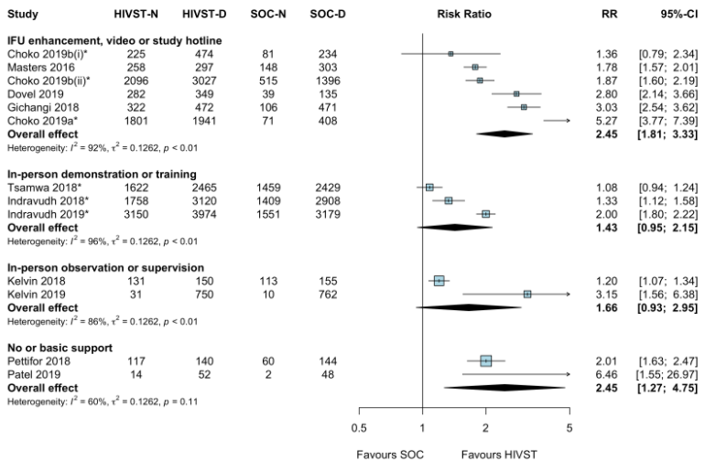
* Cluster RCTs
Choko 2019b(i): HIVST distribution by HIV-positive (index) clients to their partners
Choko 2019b(ii): HIVST distribution by antenatal women to their male partner
CI: confidence interval; D: denominator; HIVST: HIV self-testing; N: Numerator; RR: risk ratio; SOC: standard of care.

Funnel plot for uptake of HIV testing

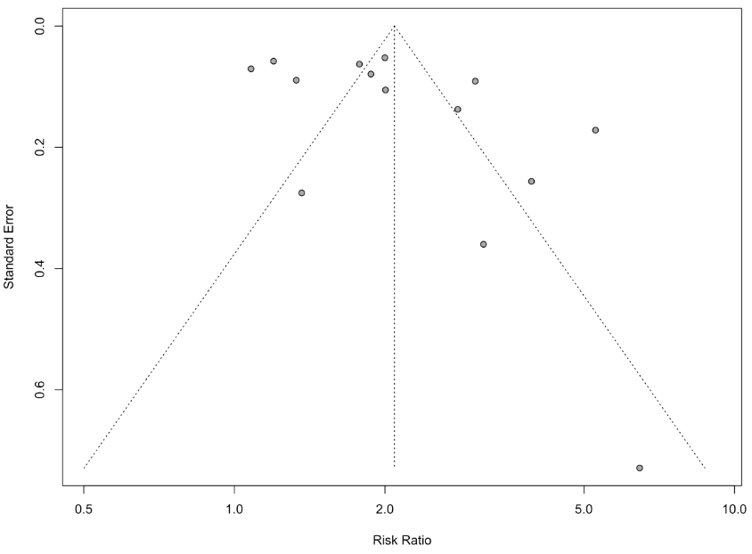

Uptake of HIV testing among men, HIVself-testing compared to standard facility-based testing

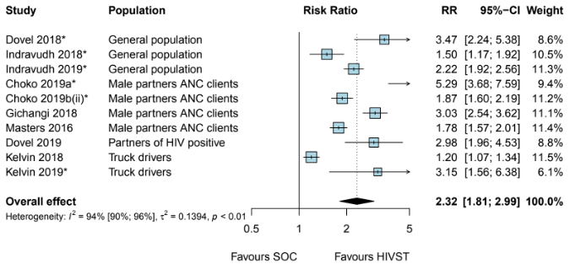
* Cluster RCTs
Choko 2019b(ii): HIVST distribution by antenatal women to their male partner
CI: confidence interval; HIVST: HIV self-testing; RR: risk ratio; SOC: standard of care.

Uptake of HIV testing among women, HIV self-testing compared to standard facility-based testing
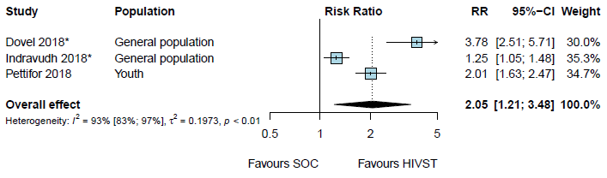
* Cluster RCTs
CI: confidence interval; HIVST: HIV self-testing; RR: risk ratio; SOC: standard of care.
Uptake of HIV testing among young people aged 16–24 years, HIV self-testing compared to standard facility-based testing

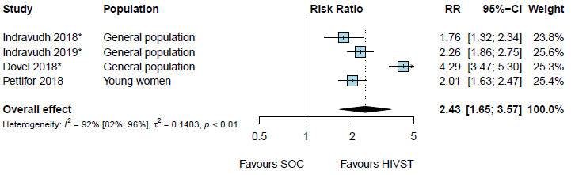
* Cluster RCTs
CI: confidence interval; HIVST: HIV self-testing; RR: risk ratio; SOC: standard of care.

Linkage to HIV care or treatment among those diagnosed, HIV self-testing compared to standard facilty-based HIV testing, by type of linkage support
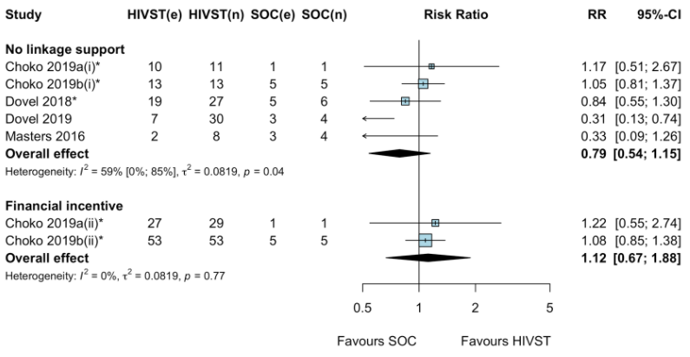
*cluster RCTs
Choko 2019a(i): HIVST alone
Choko 2019a(ii): HIVST + linkage provider financial incentive arms
Choko 2019b(i): HIVST distribution by HIV-positive (index) clients to their partners
Choko 2019b(ii): HIVST distribution by ANC women to their male partners
e: number of events; HIVST: HIV self-testing; n: denominator; RR: risk ratio; SOC: standard of care.

