Sensorineural hearing loss and risk of stroke: A systematic review and meta-analysis
Masoud Khosravipour¹, Fatemeh Rajati²
Students Research Committee, Kermanshah University of Medical Sciences, Kermanshah, Iran.
Email: masoudkhosravipour74@gmail.com
²*Fatemeh Rajati:
Research Center for Environmental Determinants of Health, Health Institute, Kermanshah University of Medical Sciences, Kermanshah, Iran.
Email: f.rajati@kums.ac.ir, *Corresponding Author
Phone: +988338350177
Postal address: Kermanshah University of Medical Sciences, Kermanshah, Iran.
Running head: Sensorineural hearing loss and risk of stroke
Sources of financial support: Kermanshah University of Medical Sciences

Supplemental table 1. The Newcastle-Ottawa Assessment Scale for studies
Quality assessment | Chang 2018 | Chou  2018 | Kim  2018 | Lin  2008 | Ciorba  2015 | Deal  2018 | Gopinath  2009 | Fang 2018 | Kim  2017
Exposed cohort representative?
Selection of non-exposed cohort?
Ascertainment of exposure?
Outcome at baseline?
Controls for important factors?
Controls for other confounders?
Assessments of outcome?
Adequacy of follow-up duration?
Adequacy of lost to follow up?
Quality score | 9 | 6 | 8 | 9 | 7 | 8 | 8 | 6 | 8
Quality score | Good | fair | good | good | fair | good | good | fair | good

Supplemental Figure 1. Forest plot for the association between sensorineural hearing loss (SNHL) and the incidence of stroke according to types of SNHL in the unadjusted model. HR, adjusted hazard ratio; CI, confidence interval.

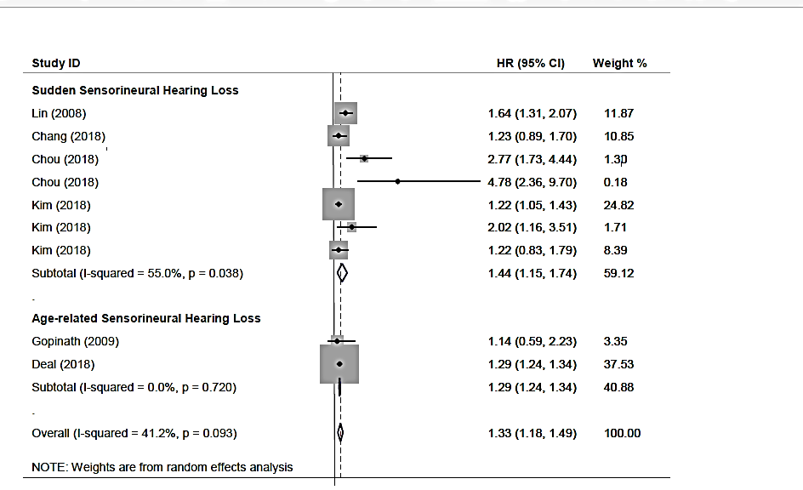
Supplemental Figure 2. Forest plot for the association between sensorineural hearing loss (SNHL) and the incidence of stroke according to types of SNHL in the adjusted model. HR, adjusted hazard ratio; CI, confidence interval.

Supplemental Table 2. Sensitive analysis for SSNHL
Variables |  |  | Types of  stroke | Number of  Studies (estimations) | HR(95%CI) | Heterogeneity
 |  |  |  |  |  | I² | p-value
Types of participants | Only SSNHL | Adjusted | B,H,I | 3(4) | 1.38(1.10,1.65) | 43.4% | 0.151
Types of participants | Only SSNHL | Unadjusted | B,H,I | 4(6) | 1.16(0.81,1.51) | 88.8% | <0.001
Types of participants | Patients with SSNHL | Adjusted | B,H,I | 2(4) | 1.91(1.04,2.77) | 64.4% | 0.038
Types of participants | Patients with SSNHL | Unadjusted | B,H,I | 2(4) | 1.96(1.45,2.46) | 19.6% | 0.292
Gender |  | male vs, female | B,H,I | 2(3) | 1.14(0.80,1.47) | 43.0% | 0.173
Age |  | < 45 vs. 45-64 | B | 2(2) | 5.87(3.56,8.18) | 0.0% | 0.888
 |  | < 45 vs. 64 < | B | 2(3) | 15.35(10.46,20.24) | 0.0% | 0.606
Diabetes |  | Yes vs. No | B,H,I | 3(3) | 1.62(0.44,2.28) | 81.7% | 0.004
Hypertension |  | Yes vs. No | B,H,I | 3(3) | 3.03(0.29,5.77) | 93.1 | < 0.001
Hyperlipidemia |  | Yes vs. No | B,H,I | 3(3) | 1.37(0.54,2.21) | 0.0% | 0.461
Gout |  | Yes vs. No | H,I | 1(2) | 1.42(0.20,2.65) | 0.0 | 0.570
Renal |  | Yes vs. No | B | 1(1) | 0.9(0.42,1.94) | NA. | NA.
Comorbidity |  | Yes vs. No | B | 1(1) | 3.7(2.15,6.35) | NA. | NA.
Combined |  | Yes vs. No | B,H,I | 3(13) | 1.97(1.25,5.69) | 77.7% | < 0.001

Abbreviation: HR, hazard ratio; CI, confidence interval; I, ischemic strike; H, hemorrhagic stroke; B, both types; SSNHL, sudden sensorineural hearing loss.

