Supplementary Material

Supplementary Figures and Tables

Supplementary Figures
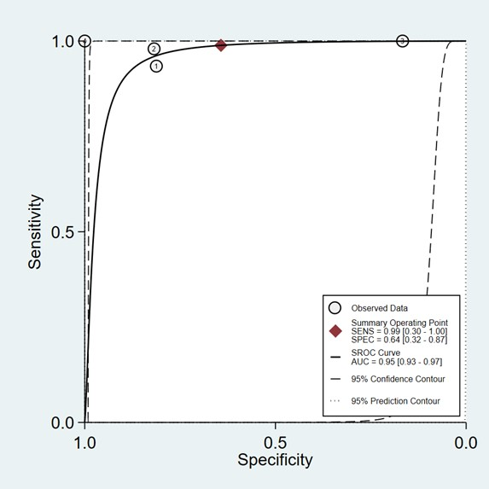
Supplementary Figure 1: Summary receiver operating curve for Thyroseq v3 panel
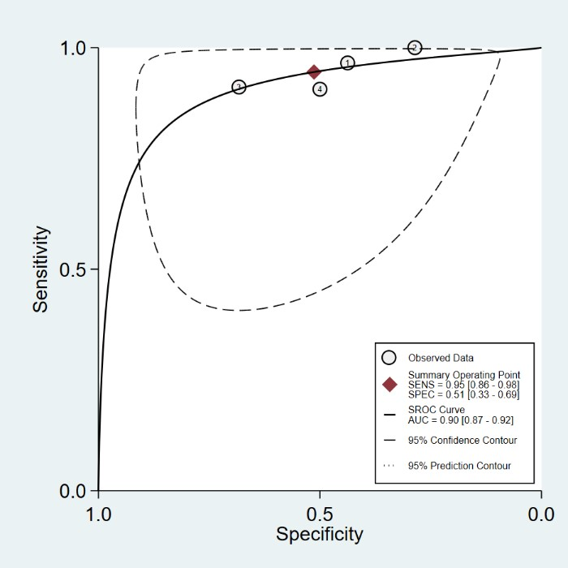
Supplementary Figure 2: Summary receiver operating curve for Afirma GSC
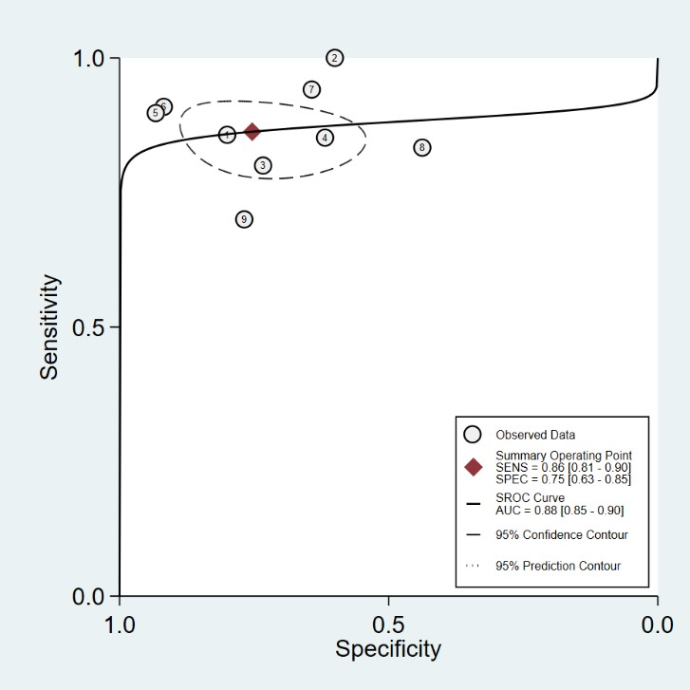
Supplementary Figure 3: Summary receiver operating curve for Thyroseq 2

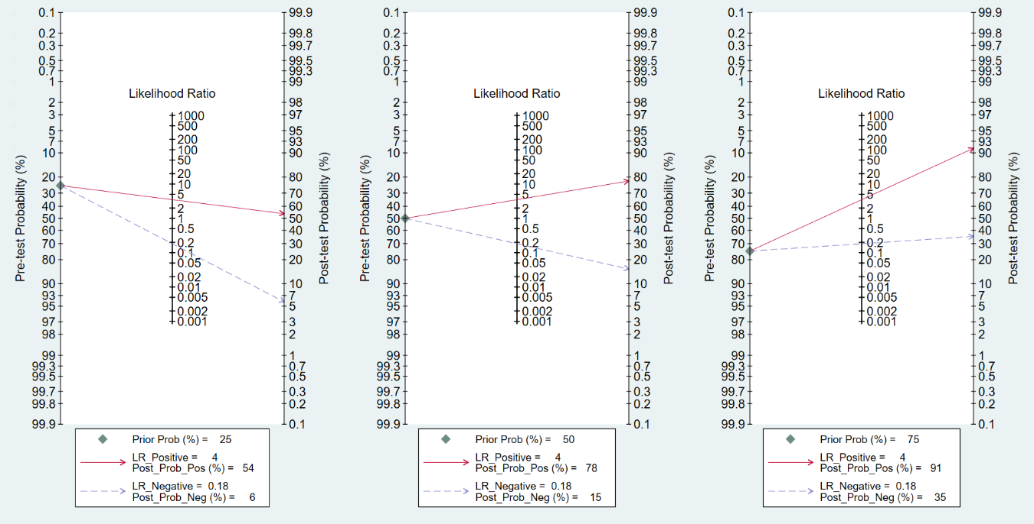
Supplementary Figure 4: Fagan’s nomogram for Thyroseq 2

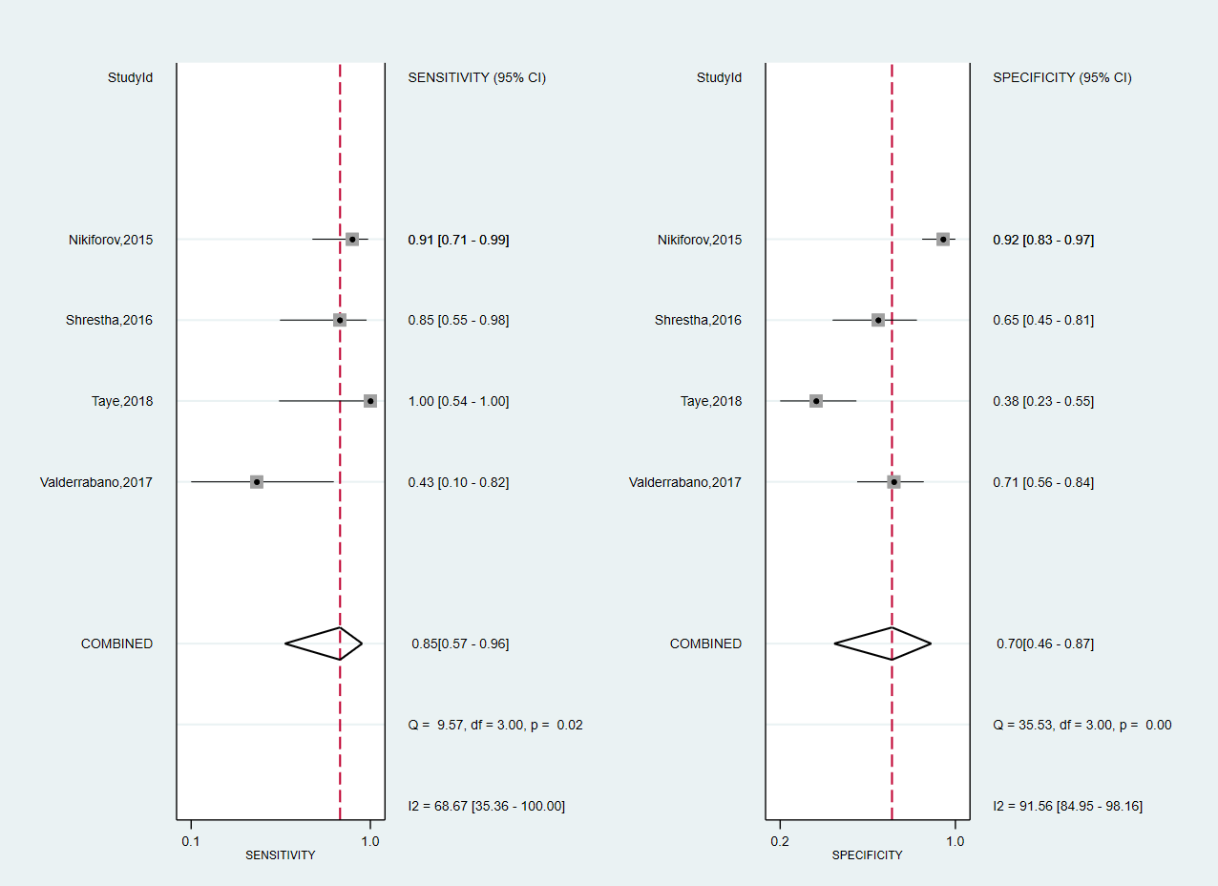
Supplementary Figure 5: Forest plot for Thyroseq 2 overall sensitivity and specificity in Bethesda III nodules
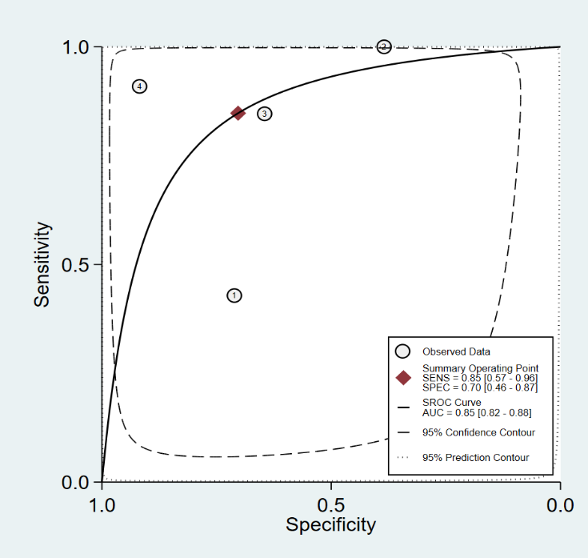
Supplementary Figure 6: SHROC curve for Thyroseq 2 overall sensitivity and specificity in Bethesda III nodules
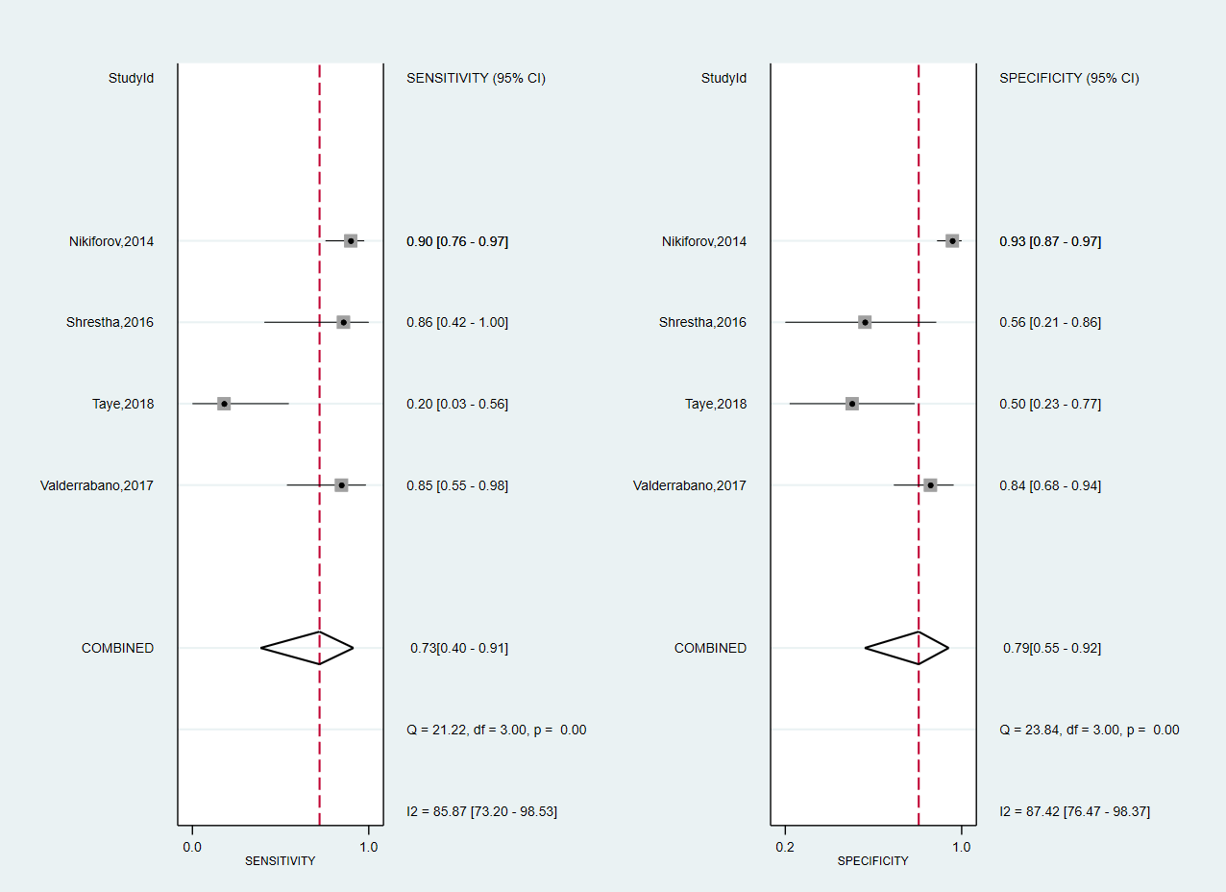
Supplementary Figure 7: Forest plot for Thyroseq 2 overall sensitivity and specificity in Bethesda IV nodules
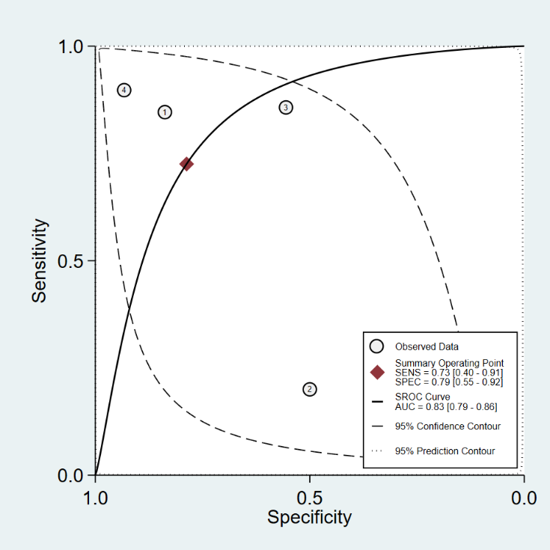
Supplementary Figure 8: SHROC curve for Thyroseq 2 overall sensitivity and specificity in Bethesda IV nodules
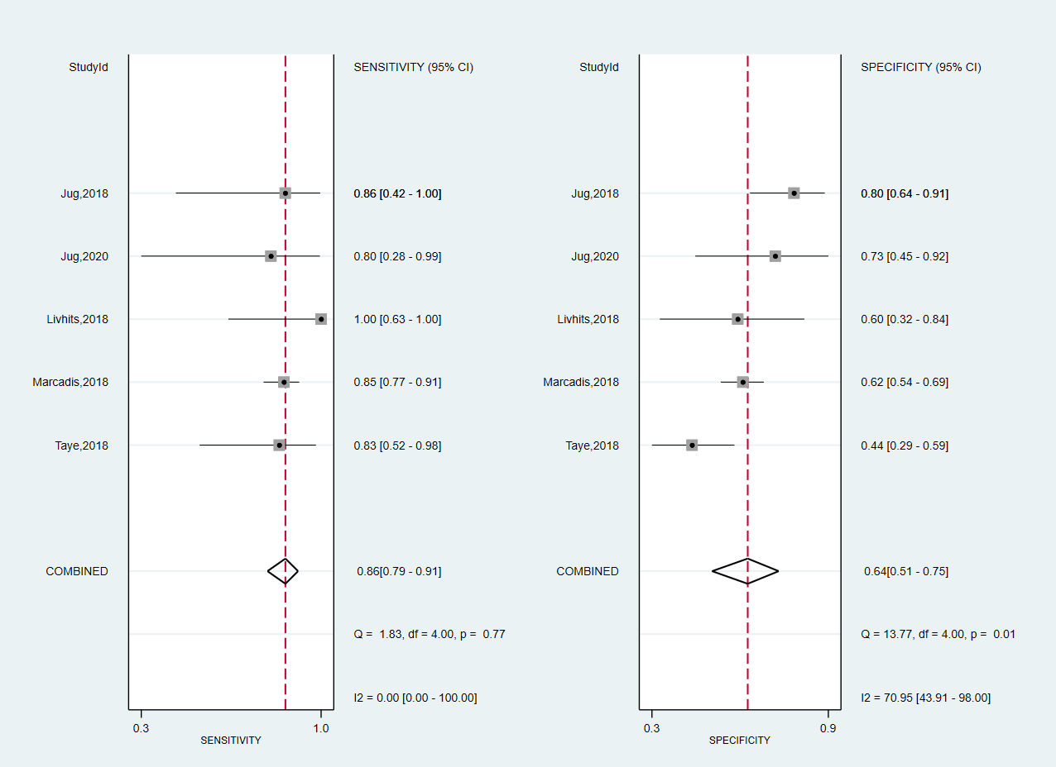
Supplementary Figure 9: Forest plot for Thyroseq 2 overall sensitivity and specificity including studies without declared conflicts of interests
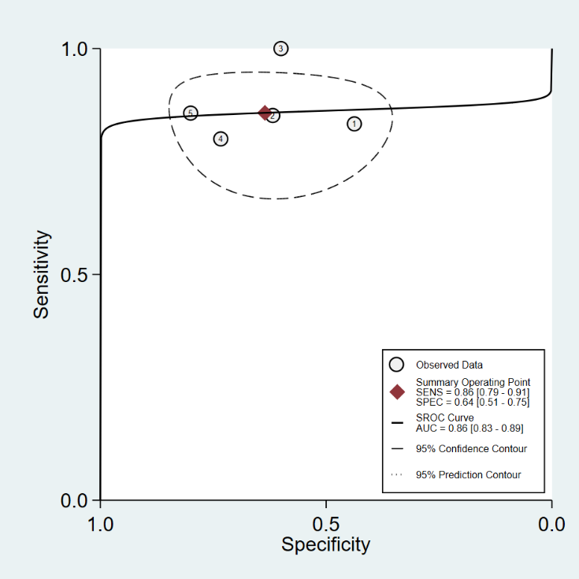
Supplementary Figure 10: SHROC curve for Thyroseq 2 overall sensitivity and specificity including studies without declared conflicts of interests
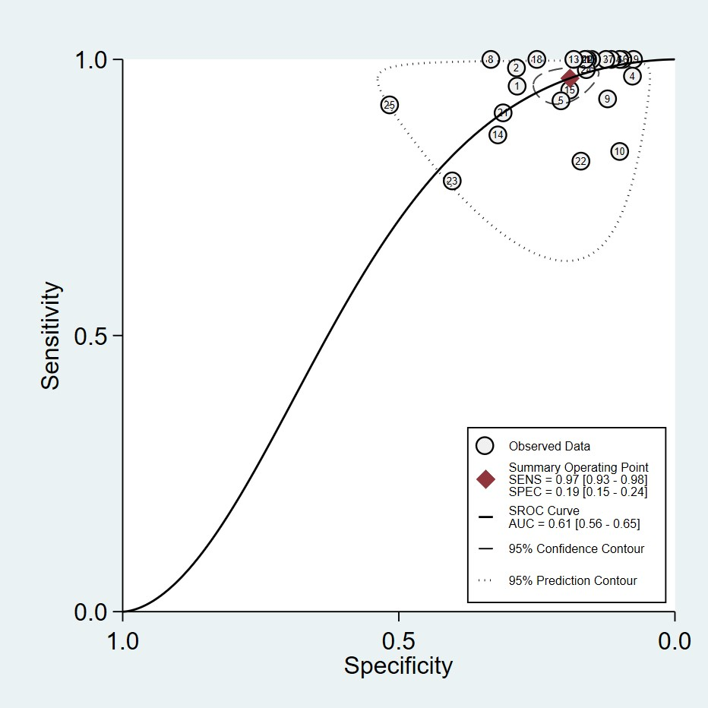
Supplementary Figure 11: Summary receiver operating curve for Afirma GEC panel

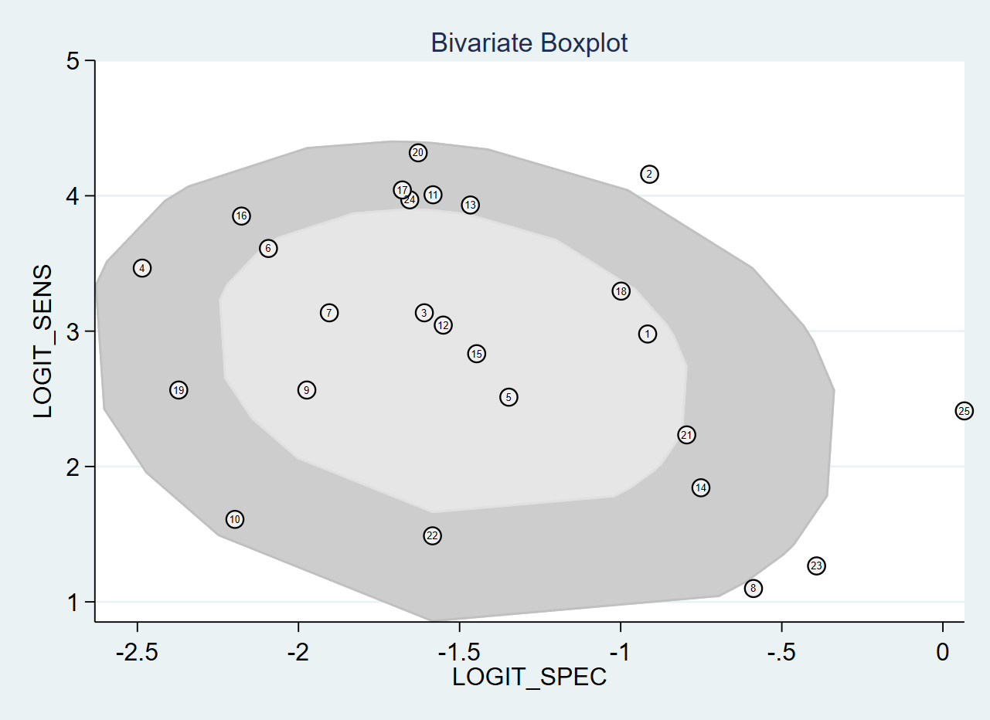
Supplementary Figure 12: Bivariate boxplot for Afirma GEC
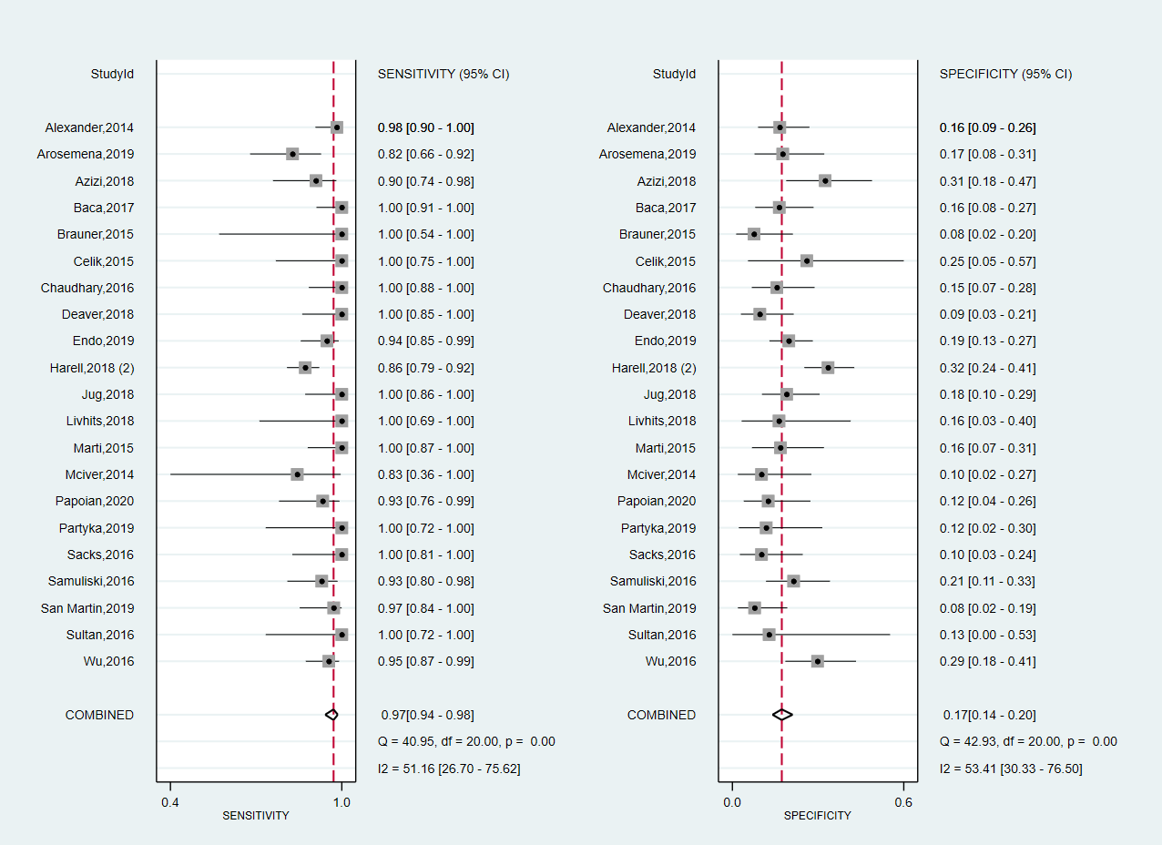
Supplementary Figure 13: Forest plot for Afirma GEC overall sensitivity and specificity excluding outliners
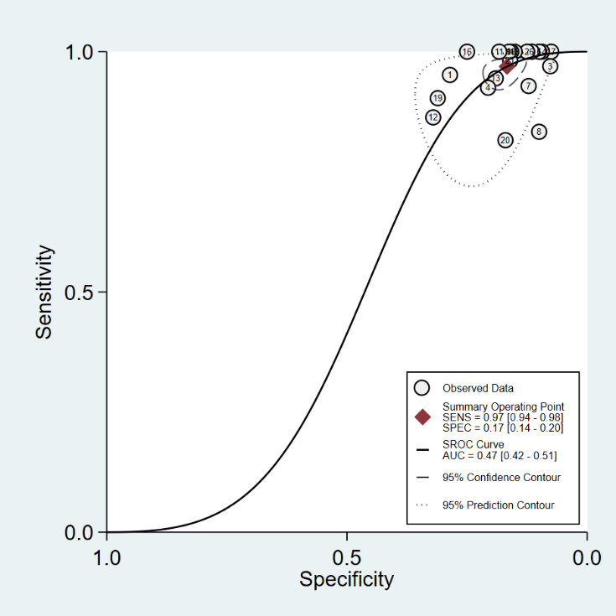
Supplementary Figure 14: SHROC curve for Afirma GEC overall sensitivity and specificity excluding outliners
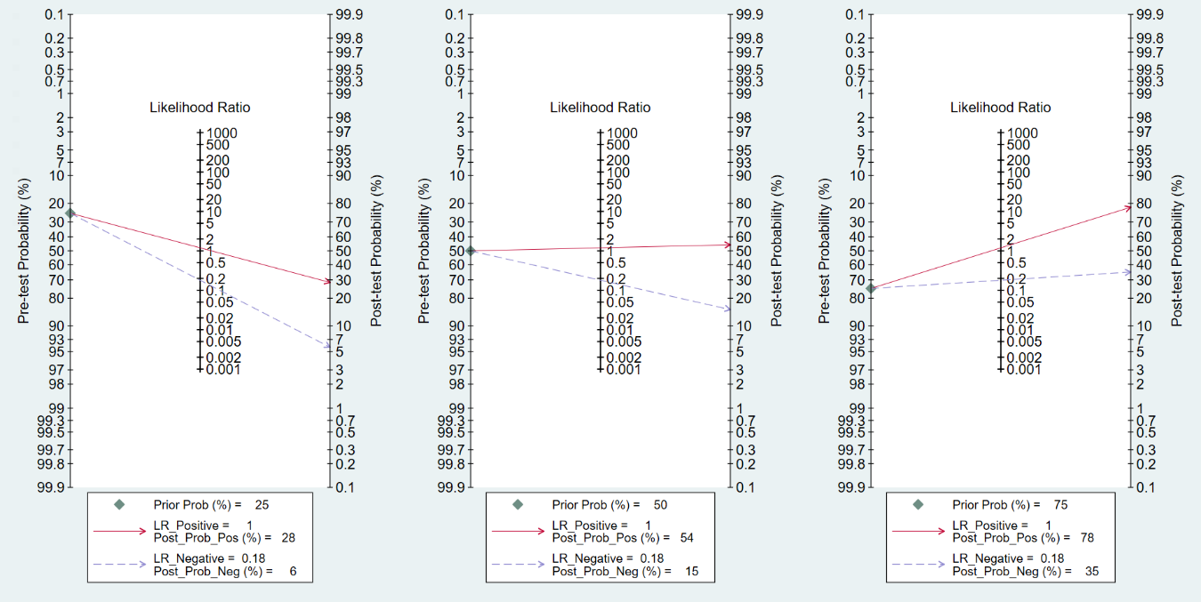
Supplementary Figure 15: Fagan’s nomogram for Afirma GEC
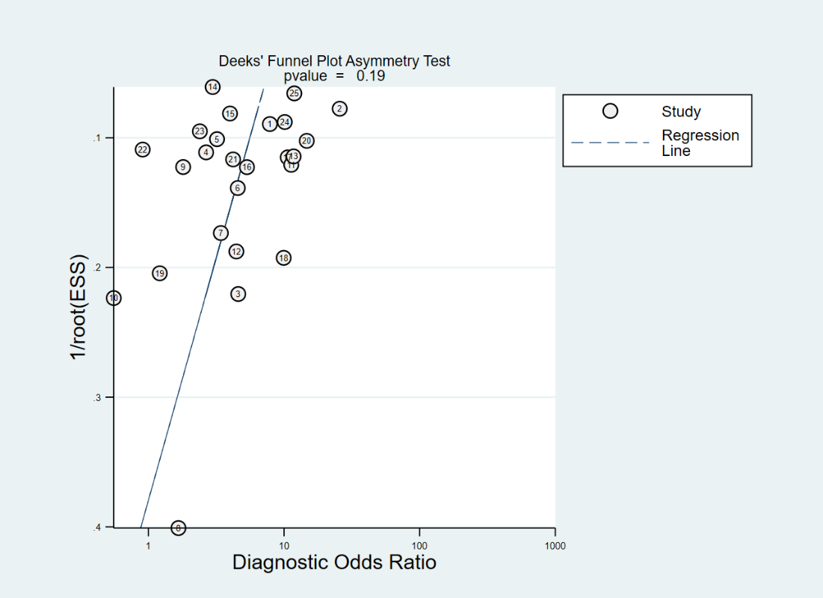
Supplementary Figure 16: Deek’s funnel plot asymmetry test for publication bias
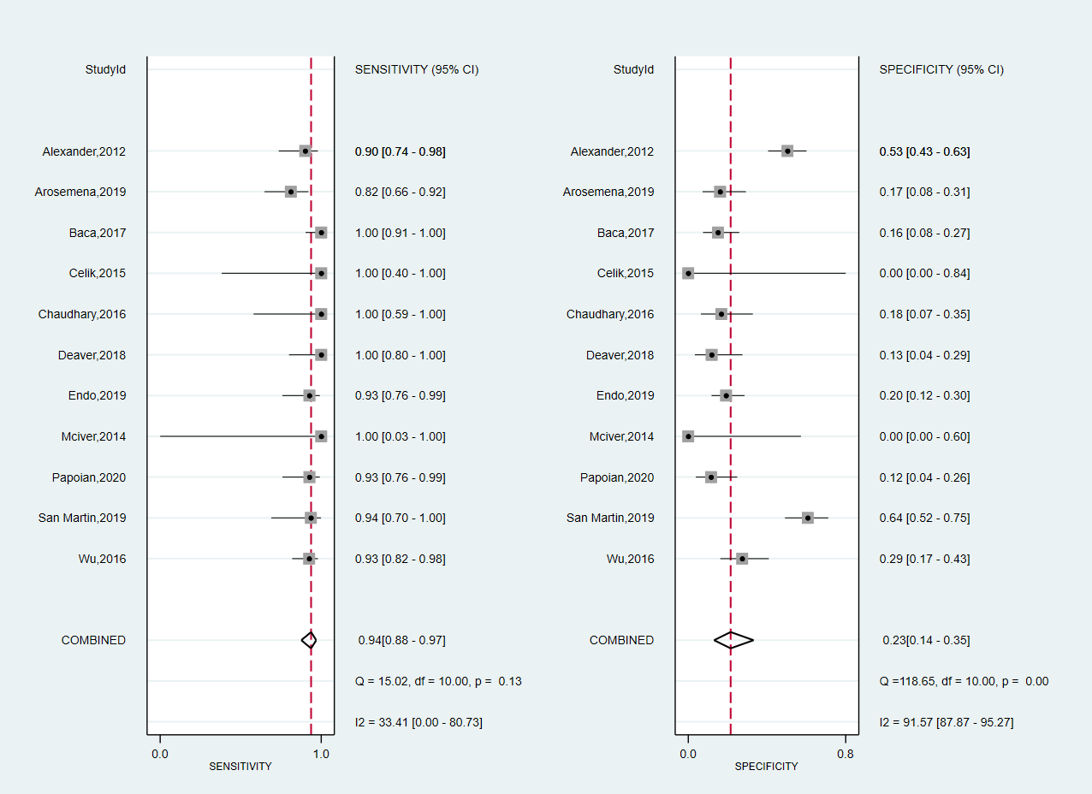
Supplementary Figure 17: Forest plot for Afirma GEC overall sensitivity and specificity in Bethesda III nodules
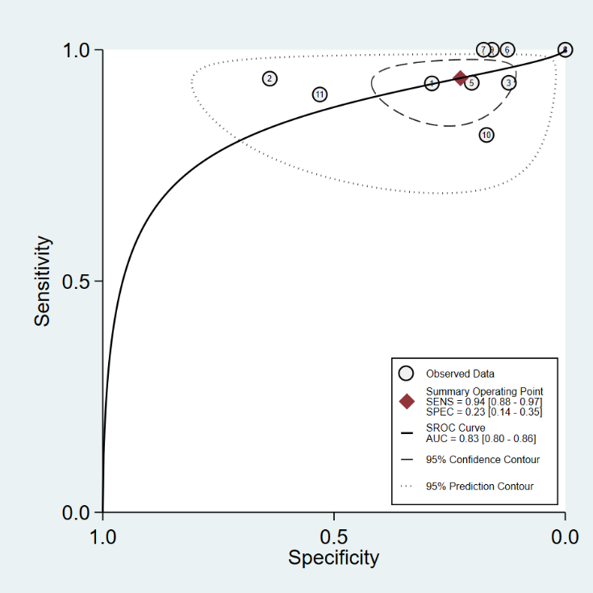
Supplementary Figure 18: SHROC curve for Afirma GEC overall sensitivity and specificity in Bethesda III nodules
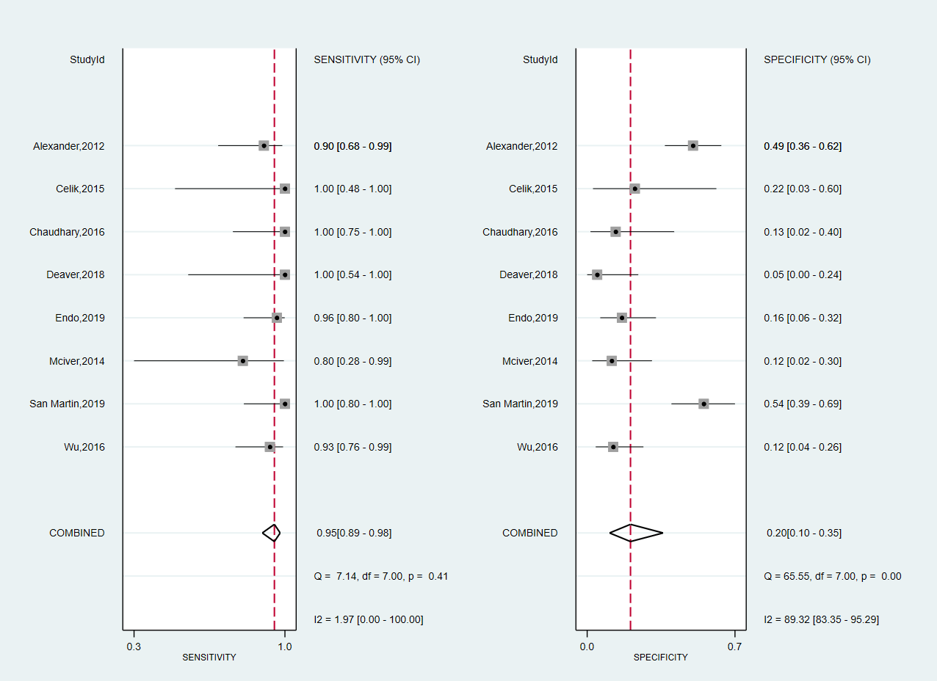
Supplementary Figure 19: Forest plot for Afirma GEC overall sensitivity and specificity in Bethesda IV nodules
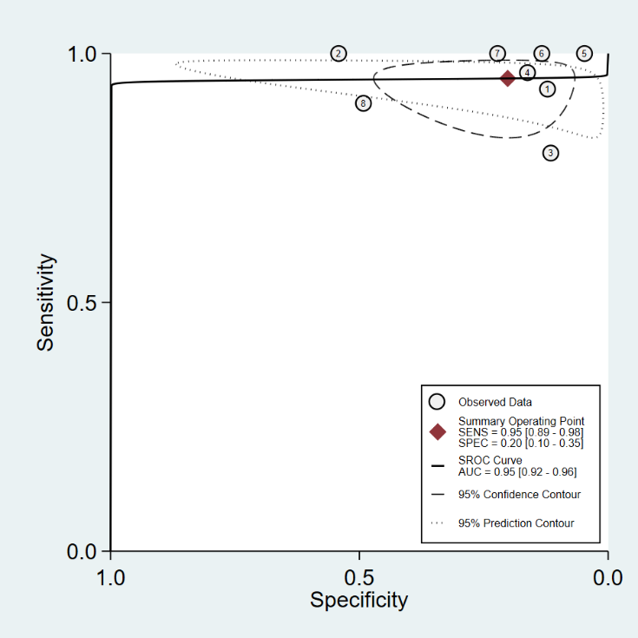
Supplementary Figure 20: SHROC curve for Afirma GEC overall sensitivity and specificity in Bethesda IV nodules
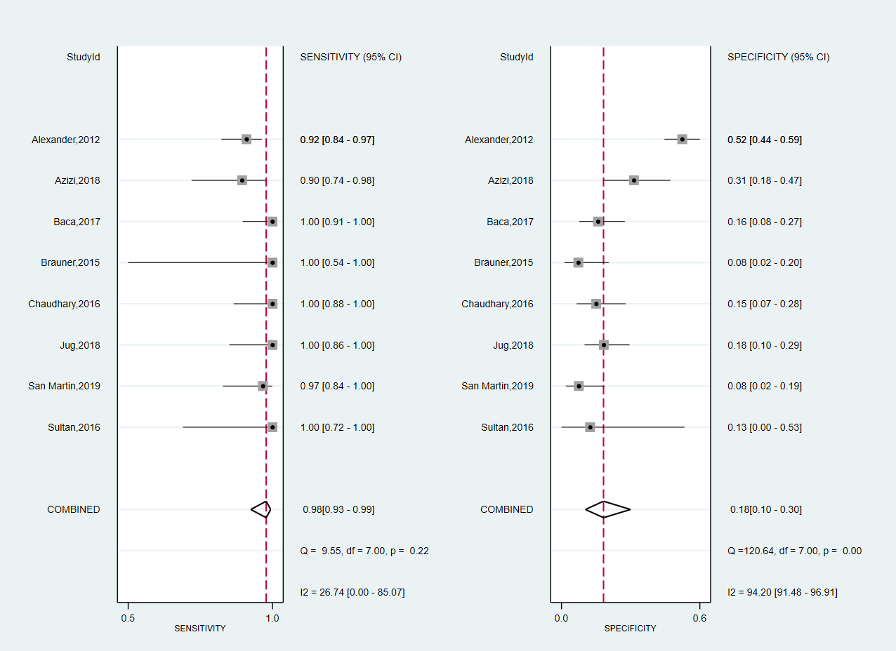
Supplementary Figure 21: Forest plot for Afirma GEC overall sensitivity and specificity including studies that confirmed ITNs by repeat FNA.
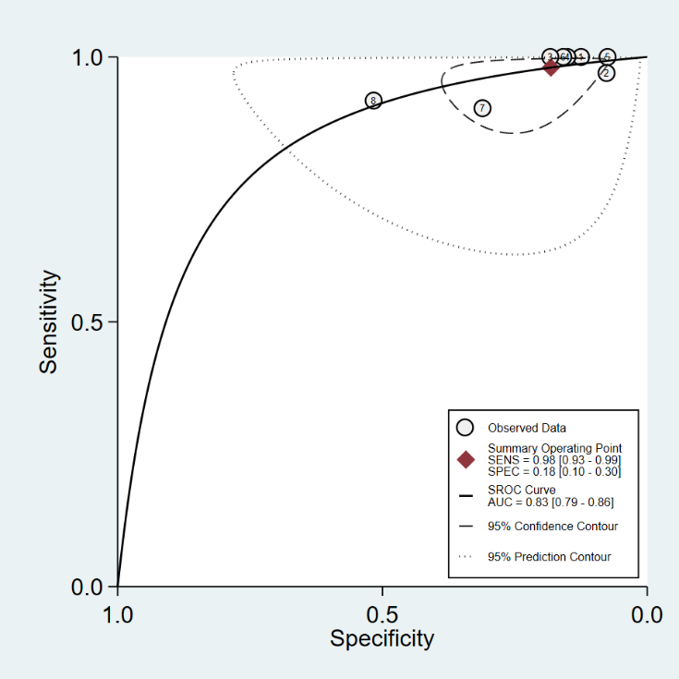
Supplementary Figure 22: SHROC curve for Afirma GEC overall sensitivity and specificity including studies that confirmed ITNs by repeat FNA.
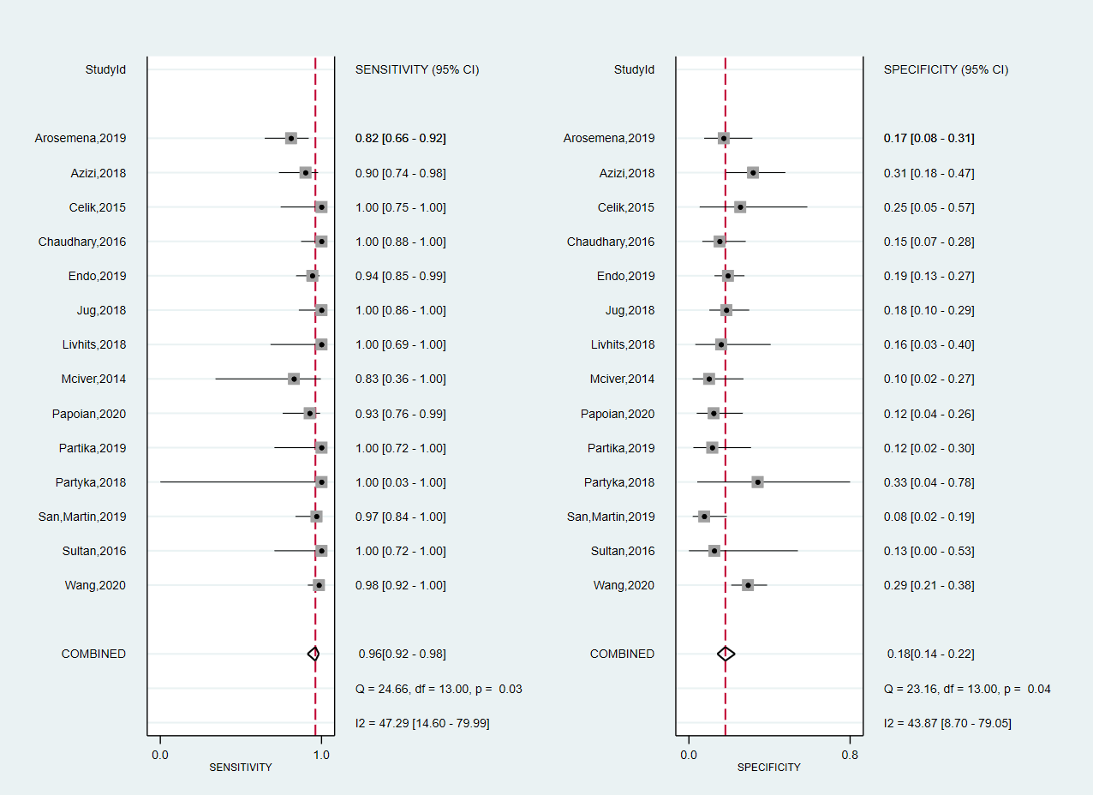
Supplementary Figure 23: Forest plot for Afirma GEC overall sensitivity and specificity including studies without declared conflicts of interests
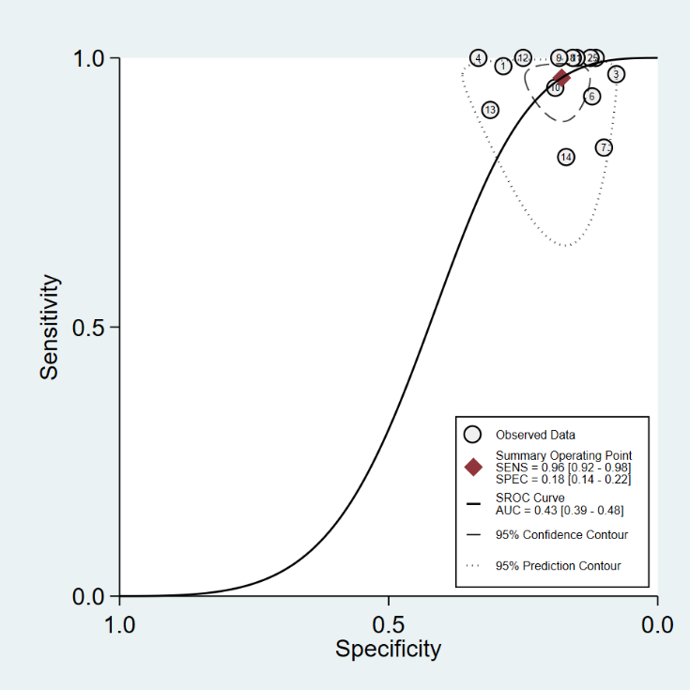
Supplementary Figure 24: SHROC curve for Afirma GEC overall sensitivity and specificity including studies without declared conflicts of interests
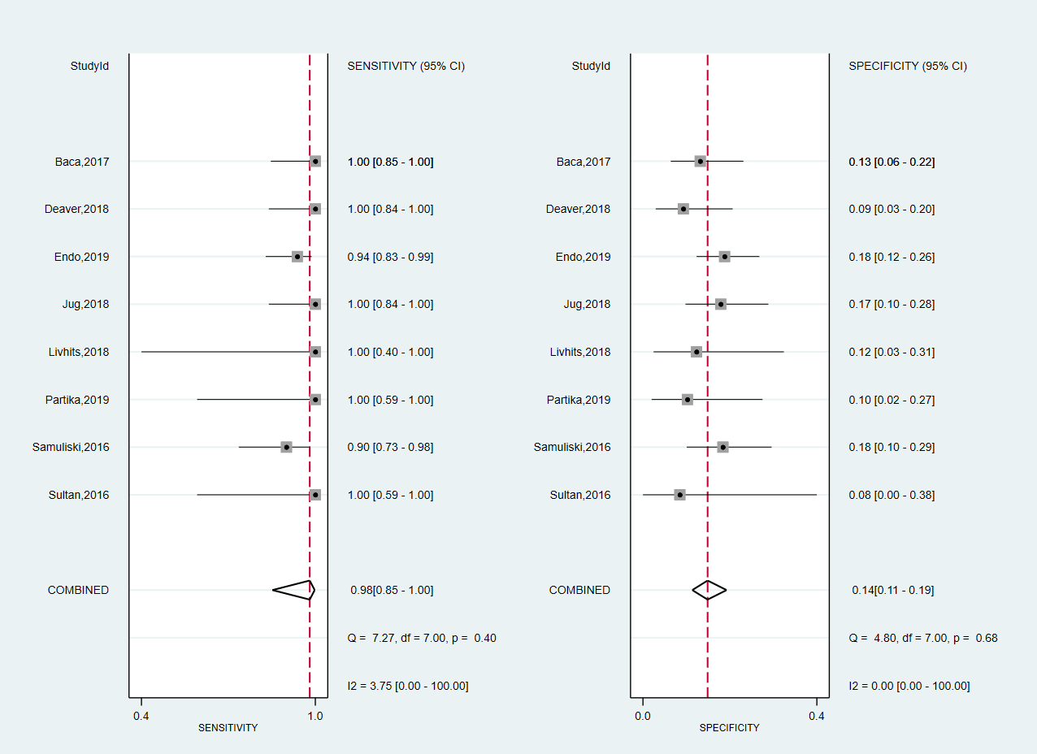
Supplementary Figure 25: Forest plot for Afirma GEC overall sensitivity and specificity when excluding NIFTPs from malignant tumors
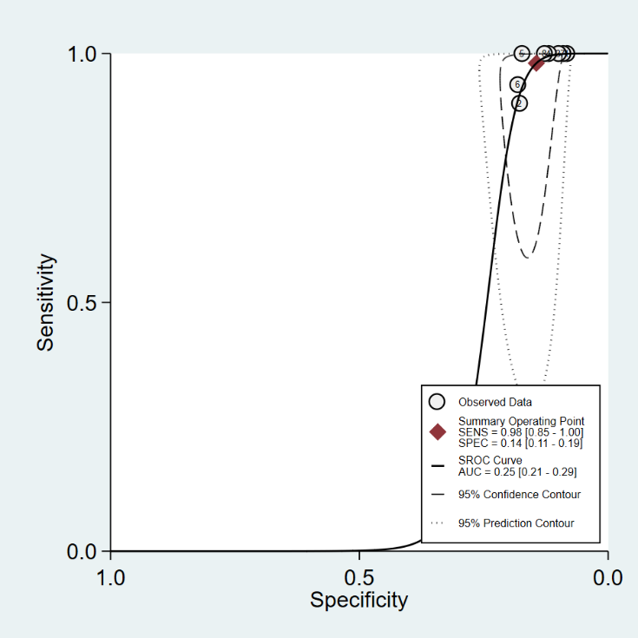
Supplementary Figure 26: SHROC curve for Afirma GEC overall sensitivity and specificity when excluding NIFTPs from malignant tumors
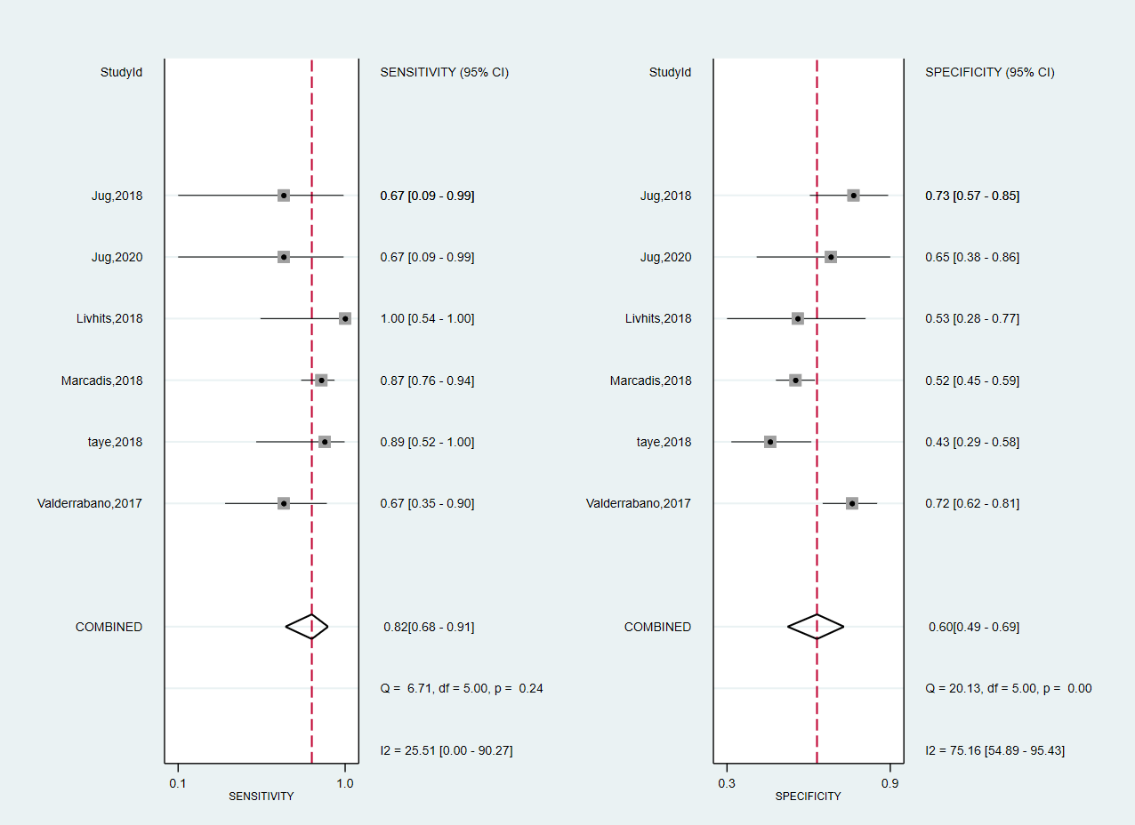
Supplementary Figure 27: Forest plot for Thyroseq 2 overall sensitivity and specificity when excluding NIFTPs from malignant tumors
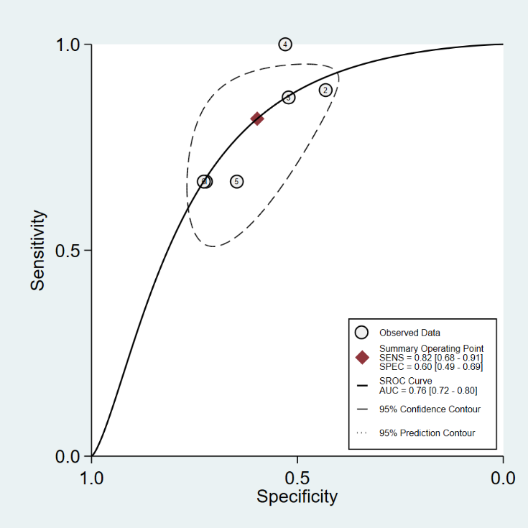
Supplementary Figure 28: SHROC curve for Thyroseq 2 overall sensitivity and specificity when excluding NIFTPs from malignant tumors

Supplementary Tables
Supplementary Table 1: QUAPAS questionnaire.
Domain | Description | Signaling question (yes, no, unclear) | Risk of bias (high, low, unclear) | Concerns about applicability (high, low, unclear)
Participant recruitment | Describe the method for recruiting participants. Describe participants (previous testing, presentation, the intended use of index test and setting) | Was a consecutive or random sample of patients enrolled?  Was a case-control design avoided?  Did the study avoid inappropriate exclusions? | Could the selection of participants have introduced bias? | Are there concerns that the participants do Not match the review question?
Index test | Describe the index test and how it was conducted and interpreted: | Were the index test results interpreted without knowledge of the results of the reference standard?  Were all results of the index test valid? | Could the conduct or interpretation of the index test have introduced bias? | Are there concerns that the index test, its conduct, or its interpretation differ from the review question?
Reference standard | Describe the reference standard and how it was conducted and interpreted: | Is the reference standard likely to correctly classify the target condition?  Were the reference standard results interpreted without knowledge of the results of the index test? | Could the measurement of the target event have introduced bias? | Are there concerns that the target condition as defined by the reference standard does Not match the review question?
Flow and timing | Describe any patients who did Not receive the index test(s) and/or reference standard or who were excluded from the 2x2 table (refer to flow diagram): | Did all patients receive a reference standard?  Was available the reference standard for all the enrolled patients? | Could the patient flow have introduced bias?

Supplementary Table 2: QUADAS-2 signaling questions for bias.
Question | Yes | Unclear | No
Participant recruitment

Consecutive  or random sample enrolled? | A consecutive or random sample of patients was enrolled in the  study. | It is unclear whether a consecutive or random sample of patients was enrolled in the study | There was No consecutive or random sample included in the study
Case-control  design avoided? | There was No case-control design | It is unclear if there was a case  control design | There was a case-control design
Inappropriate exclusions  avoided? | There are No patients inappropriate excluded | It is unclear if there was the avoidance of inappropriate exclusions | There is the inappropriate exclusion of patients (e.g. patients with inadequate or insufficient genetic material, patients with unkNown histology)
Index test

Index test results interpreted without knowledge results reference standard? | The evaluators of the index test were unaware of the histological result. | It is unclear whether the evaluators of the index test were aware of the histological result. | The evaluators of the index test were aware of the histological result.
Pre-specified threshold? | This item will be omitted as each index test sets its pre-specified threshold.
Were all results of the index test valid? | At least 95% of the index test result were valid. | It is unclear the proportion of valid index test results. | Less than 95% of the index test result were valid.
Reference standard

Reference  standard likely to correctly classify the target  condition? | There  is an adequate histopathological examination of thyroid tissue. | It is unclear how histopathological  the examination is performed. | The histopathological examination is Not  adequate.
Reference standard results  interpreted  without the knowledge results in the index test? | The outcome assessor of histopathological results was Not aware of molecular testing results | It is not clear if the outcome assessor of histopathological  results were aware of  molecular testing results | The outcome assessor of histopathological results was Not aware of molecular testing results
Flow and timing

The appropriate interval between index  test and reference standard? | This item will be omitted as we considered the time interval to be irrelevant to the topic.
All patients  received reference standard? | All patients received surgery and histological result. | It is not clear if the whole sample did receive surgery or follow-up. | Some patients did not receive surgery but instead had a clinical follow-up.
Patients received the same reference standard? | This item will be omitted as studies with reference standards other than histological evaluation were excluded.
All patients included in the analysis? | More than 80% of the enrolled patients were included in the analysis | It is not clear if all patients were included in the analysis. | Less than 80% of the enrolled patients were included in the analysis (e.g. patients lost to follow-up)

Supplementary Table 3: 'Risk of bias' and 'Applicability concerns' assessment according to QUADAS-2.
Molecular panel | Study | RISK OF BIAS |  |  |  | APPLICABILITY CONCERNS
Molecular panel | Study | PATIENT SELECTION | INDEX TEST | REFERENCE STANDARD | FLOW AND TIMING | PATIENT SELECTION | INDEX TEST | REFERENCE STANDARD
Afirma GEC | Alexander 2012 | â | â | á | â | á | á | á
Afirma GEC | Alexander 2014 | á | â | ? | â | á | á | á
Afirma GEC | Al-qurayshi 2016 | ? | ? | ? | â | á | á | á
Afirma GEC | Arosemena 2019 | â | ? | ? | â | á | á | á
Afirma GEC | Azizi 2018 | â | ? | ? | â | á | á | á
Afirma GEC | Baca 2017 | â | ? | ? | â | á | á | á
Afirma GEC | Brauner 2015 | â | ? | ? | â | á | á | á
Afirma GEC | Celik 2015 | ? | â | ? | â | á | á | á
Afirma GEC | Chaudhary 2016 | ? | â | ? | â | á | á | á
Afirma GEC | Deaver 2018 | ? | ? | ? | â | á | ? | á
Afirma GEC | Endo 2019 | â | â | ? | â | ? | á | ?
Afirma GEC | Harell 2018 (2) | ? | ? | ? | â | á | á | ?
Afirma GEC | Jug 2018 | ? | ? | ? | â | ? | á | ?
Afirma GEC | Livhits 2018 | á | â | á | â | á | á | á
Afirma GEC | Marti 2015 | â | ? | ? | â | á | á | á
Afirma GEC | Mciver 2014 | â | ? | ? | â | á | á | á
Afirma GEC | Partyka 2018 | â | á | ? | â | â | á | á
Afirma GEC | Partika 2019 | ? | ? | ? | â | á | ? | á
Afirma GEC | Papoian 2020 | ? | á | ? | â | ? | á | ?
Afirma GEC | Samuliski 2016 | á | ? | ? | â | á | á | á
Afirma GEC | Sacks 2016 | â | ? | ? | â | á | á | á
Afirma GEC | San Martin 2019 | á | ? | ? | â | á | á | á
Afirma GEC | Sultan 2016 | ? | ? | ? | â | á | á | á
Afirma GEC | Wang 2020 | â | ? | ? | â | á | á | á
Afirma GEC | Wu 2016 | â | â | á | â | á | á | á
Afirma GSC | Harell 2018 (2) | ? | ? | ? | â | á | á | ?
Afirma GSC | Endo 2019 | â | ? | ? | â | á | á | á
Afirma GSC | Patel 2018 | â | â | á | á | á | á | á
Afirma GSC | San Martin 2019 | á | ? | ? | â | á | á | á
Thyroseq v3 | Chen 2019 | ? | â | ? | â | ? | á | á
Thyroseq v3 | Jug 2020 | ? | ? | ? | â | ? | á | á
Thyroseq v3 | Nikiforova 2018 | â | ? | ? | á | á | á | á
Thyroseq v3 | Steward 2018 | â | â | á | á | á | á | á
Thyroseq v2 | Jug 2018 | ? | ? | ? | â | á | á | ?
Thyroseq v2 | Livhits 2018 | á | ? | ? | â | á | á | á
Thyroseq v2 | Jug 2020 | ? | ? | ? | â | á | á | á
Thyroseq v2 | Marcadis 2018 | â | ? | ? | á | á | á | á
Thyroseq v2 | Nikiforov 2014 | â | ? | á | á | á | á | á
Thyroseq v2 | Nikiforov 2015 | á | ? | â | â | á | á | á
Thyroseq v2 | Shrestha 2016 | â | ? | ? | á | á | ? | ?
Thyroseq v2 | Taye 2018 | â | ? | á | â | á | á | á
Thyroseq v2 | ValderrabaNo 2017 | á | ? | â | â | á | á | á
Thyramir/ Thygenext (Interpace) | Lupo 2018 | â | á | á | á | á | á | á
Thyramir/ Thygenext (Interpace) | Partyka 2018 | â | á | ? | á | á | á | á
Thyramir/ Thygenext (Interpace) | Partyka 2019 | ? | ? | ? | â | á | á | á
RosettaGX Reveal | Litwick 2016 | â | â | á | á | á | á | á
RosettaGX Reveal | Partyka 2018 | â | á | ? | á | á | á | á
RosettaGX Reveal | Partyka 2019 | â | ? | ? | á | á | á | á
miRInform | Labourier 2015 | â | ? | á | á | á | á | á
miRInform | ValderrabaNo 2016 | á | ? | â | â | á | á | á
áLow-Risk âHigh Risk ? Unclear Risk

