Additional file 1

Supplemental Table S1 Embase literature search terms
 | Embase search terms^{a,b,c}
1 | Recombinant Granulocyte colony stimulating factor.mp OR exp recombinant granulocyte colony stimulating factor/
2 | (G-CSF OR GCSF or granulocyte stimulating factor).mp
3 | Pegylat*.mp
4 | 1 or 2
5 | 3 and 4
6 | ($pegfilgrastim or SD01 or neulasta or neulastim or imupeg).mp
7 | Exp pegfilgrastim/
8 | (Peg-rmetHuG-CSF or polyethylene glycol-conjugated filgrastim).mp
9 | 5 or 6 or 7 or 8
10 | (Tumor$ OR tumour$ OR cancer OR malignant neoplasm).mp
11 | Cancer chemotherapy.mp. OR exp cancer chemotherapy/
12 | ABVD.mp
13 | Hyper-CVAD.mp
14 | (ACT or adoptive cellular therapy).mp
15 | (CHOP 14 OR R-CHOP-14).mp
16 | FOLFOX.mp
17 | FOLFIRI.mp
18 | (Leucovorin calcium and fluorouracil and irinotecan).mp
19 | (((Fluorouracil and leucovorin) or calcium) and oxaliplatin).mp
20 | (Cyclophosphamide and vincristine and doxorubicin and dexamethasone).mp
21 | Epirubicin and cyclophosphamide and methotrexate and fluorouracil and docetaxel).mp
22 | 10 or 11 or 12 or 13 or 14 or 15 or 16 or 17 or 18 or 19 or 20 or 21 or 22
23 | Exp neutropenia/ or neutropenia.mp or exp febrile neutropenia/
24 | 9 and 22 and 23
25 | Limit 24 to English language
ªAn asterisk at the end of the search term will retrieve publications with the search term or any other search terms for which that is the root
^{b}In search-term combinations OR will retrieve publications where there is at least one of the combined terms, and it does not exclude hits where more than one term is present
^{c}Search terms in the list will be combined with OR or AND search operators in order to retrieve relevant publications with combinations of content meeting the search objectives
ABVD doxorubicin hydrochloride, bleomycin sulfate, vinblastine sulfate, and dacarbazine, ACT adoptive cellular therapy, CHOP cyclophosphamide, doxorubicin, vincristine, and prednisone, FOLFIRI 5-fluorouracil, leucovorin, and irinotecan, FOLFOX 5-fluorouracil, leucovorin, and oxaliplatin, G-CSF granulocyte colony-stimulating factor, hyper-CVAD hyperfractionated cyclophosphamide, vincristine, doxorubicin, and dexamethasone

Supplementary Table S2: Initial Medline Search Terms, January 1, 2002 – June 30, 2019

 | Medline Search Terms^{a,b,c}
1 | Exp granulocyte colony stimulating factor OR recombinant granulocyte colony stimulating factor.mp
2 | (G-CSF OR GCSF or granulocyte stimulating factor).mp
3 | Pegylat*.mp
4 | 1 or 2
5 | 3 and 4
6 | ($pegfilgrastim or SD01 or neulasta or neulastim or imupeg).mp
7 | Pegfilgrastim.mp
8 | (Peg-rmetHuG-CSF or polyethylene glycol-conjugated filgrastim).mp
9 | 5 or 6 or 7 or 8
10 | (Tumor$ OR tumour$ OR cancer OR malignant neoplasm).mp
11 | Cancer chemotherapy.mp.
12 | ABVD.mp
13 | Hyper-CVAD.mp
14 | (ACT or adoptive cellular therapy).mp
15 | (CHOP 14 OR R-CHOP-14).mp
16 | FOLFOX.mp
17 | FOLFIRI.mp
18 | (Leucovorin calcium and fluorouracil and irinotecan).mp
19 | (((Fluorouracil and leucovorin) or calcium) and oxaliplatin).mp
20 | (Cyclophosphamide and vincristine and doxorubicin and dexamethasone).mp
21 | Epirubicin and cyclophosphamide and methotrexate and fluorouracil and docetaxel).mp
22 | 10 or 11 or 12 or 13 or 14 or 15 or 16 or 17 or 18 or 19 or 20 or 21
23 | Exp febrile neutropenia/ or neutropenia.mp or exp neutropenia/
25 | 9 and 22 and 23
26 | Limit 25 to English language
ªAn asterisk at the end of the search term will retrieve publications with the search term or any other search terms for which that is the root
^{b}In search-term combinations OR will retrieve publications where there is at least one of the combined terms, and it does not exclude hits where more than one term is present
^{c}Search terms in the list will be combined with OR or AND search operators in order to retrieve relevant publications with combinations of content meeting the search objectives
ABVD doxorubicin hydrochloride, bleomycin sulfate, vinblastine sulfate, and dacarbazine, ACT adoptive cellular therapy, CHOP cyclophosphamide, doxorubicin, vincristine, and prednisone, FOLFIRI 5-fluorouracil, leucovorin, and irinotecan, FOLFOX 5-fluorouracil, leucovorin, and oxaliplatin, G-CSF granulocyte colony-stimulating factor, hyper-CVAD hyperfractionated cyclophosphamide, vincristine, doxorubicin, and dexamethasone

Supplementary Table S3: Cochrane Library search string, January 1 2002 – June 30 2019

 | Cochrane Search Terms
1 | Recombinant Granulocyte colony stimulating factor.mp
2 | (G-CSF OR GCSF or granulocyte stimulating factor).mp
3 | Pegylat*.mp
4 | 1 or 2
5 | 3 and 4
6 | ($pegfilgrastim or SD01 or neulasta or neulastim or imupeg).mp
8 | (Peg-rmetHuG-CSF or polyethylene glycol-conjugated filgrastim).mp
9 | 5 or 6 or 7 or 8
10 | (Tumor$ OR tumour$ OR cancer OR malignant neoplasm).mp
11 | Cancer chemotherapy.mp.
12 | ABVD.mp
13 | Hyper-CVAD.mp
14 | (ACT or adoptive cellular therapy).mp
15 | (CHOP 14 OR R-CHOP-14).mp
16 | FOLFOX.mp
17 | FOLFIRI.mp
18 | (Leucovorin calcium and fluorouracil and irinotecan).mp
19 | (((Fluorouracil and leucovorin) or calcium) and oxaliplatin).mp
20 | (Cyclophosphamide and vincristine and doxorubicin and dexamethasone).mp
21 | Epirubicin and cyclophosphamide and methotrexate and fluorouracil and docetaxel).mp
22 | 10 or 11 or 12 or 13 or 14 or 15 or 16 or 17 or 18 or 19 or 20 or 21
23 | neutropenia.mp
24 | febrile neutropenia.mp
25 | 23 or 24
26 | 9 and 22 and 25
ªAn asterisk at the end of the search term will retrieve publications with the search term or any other search terms for which that is the root
^{b}In search-term combinations OR will retrieve publications where there is at least one of the combined terms, and it does not exclude hits where more than one term is present
^{c}Search terms in the list will be combined with OR or AND search operators in order to retrieve relevant publications with combinations of content meeting the search objectives
ABVD doxorubicin hydrochloride, bleomycin sulfate, vinblastine sulfate, and dacarbazine, ACT adoptive cellular therapy, CHOP cyclophosphamide, doxorubicin, vincristine, and prednisone, FOLFIRI 5-fluorouracil, leucovorin, and irinotecan, FOLFOX 5-fluorouracil, leucovorin, and oxaliplatin, G-CSF granulocyte colony-stimulating factor, hyper-CVAD hyperfractionated cyclophosphamide, vincristine, doxorubicin, and dexamethasone

Supplemental Table S4 Congresses in abstract literature search
Academy of Managed Care Pharmacy
American College of Clinical Pharmacy
American Pharmacists Association
American Society of Clinical Oncology
American Society of Hematology
American Society of Hospital Pharmacists
European Hematology Association
European Society for Medical Oncology
The European Multidisciplinary Cancer Congress
Hematology/Oncology Pharmacy Association
International Society for Pharmacoeconomics and Outcomes Research (ISPOR) including European, North American, and Latin American conferences
Multinational Association of Supportive Care in Cancer
Oncology Nursing Society
San Antonio Breast Cancer Symposium

Supplemental Table S5 Definitions and timing of febrile neutropenia and neutropenia assessment in included studies
Study | Definition of FN | Timing of FN assessment
Balducci ^{[19]} | N/a | N/a
Bozzoli ^{[20]} | N/a | N/a
Donkor ^{[21]} | Neutropenia was defined as ANC < 1500 neutrophils/μL. Severity of neutropenia was defined as mild neutropenia (ANC 1000–1500 neutrophils/μL), moderate neutropenia (ANC 500–999 neutrophils/μL), and severe neutropenia (ANC ≤ 500 neutrophils/μL) | Assessed by collecting and reviewing patients' white blood cell count and ANC before chemotherapy and prior to the next chemotherapy administration
Dragnev ^{[22]} | Grade 4 neutropenia was defined as a grade ≥ 2 fever or with documented infection/sepsis | N/a
Hecht ^{[23]} | FN was defined as ANC < 1.0 × 10⁹/L  Grade 3/4 FN was defined as temperature ≥ 38.2°C and ANC < 1.0 × 10⁹/L on the same day or the day after | Assessed during the first four cycles of treatment. FN was determined from reported temperatures and from observed ANCs and was not based on adverse event reports. At the start of each chemotherapy cycle, blood was drawn and temperature was taken by the patient's healthcare provider
Hendler ^{[24]} | FN was defined as neutrophil count ≤ 0.5 × 10⁹/L associated with temperature > 38°C measured twice over a 1-hour period, or one measurement > 38.5°C | FN episodes were defined as neutrophil count ≤ 0.5 × 10⁹/L associated with temperature > 38°C measured twice over a 1-hour period, or one measurement > 38.5°C
Kourlaba ^{[25]} | FN was defined as temperature > 38.2°C and neutrophil count < 0.5 × 10⁹/L | N/a
Kurbacher ^{[26]} | N/a | N/a
Lane ^{[27]} | FN was defined as temperature > 38°C with ANC < 500/μL  Grade 4 neutropenia was defined as ANC < 500/μL documented on available counts | Measured from the first day ANC < 500/μL until ANC > 500/μL
Lugtenburg ^{[28]} | N/a | N/a
Ng ^{[29]} | FN was defined as a single temperature > 38.3°C or a temperature > 38°C for > 1 hour, in the presence of severe neutropenia (ANC < 0.5 × 10⁹/L)  Breakthrough FN was defined as FN occurring in spite of pegfilgrastim prophylaxis | N/a
Pinter ^{[30]} | Grade 3/4 FN was initially defined as ANC < 1.0 × 10⁹/L measured within 1 calendar day of an oral temperature ≥ 38°C  Grade 4 FN was defined as ANC < 0.5 × 10⁹/L measured within 1 calendar day of an oral temperature ≥ 38°C  Grade 3/4 neutropenia was defined as ANC < 1.0 × 10⁹/L  Grade 4 neutropenia was defined as ANC < 0.5 × 10⁹/L | Patients recorded their oral temperature twice daily throughout the treatment period and whenever they felt feverish. Complete blood counts were measured at the start of every cycle, at the end of the treatment visit, and if a patient experienced a temperature of ≥ 38°C
Skarlos ^{[31]} | FN was defined as body temperature > 38.2°C and neutrophil count < 0.5 × 10⁹/L | N/a
ANC absolute neutrophil count, FN febrile neutropenia, n/a not available

Supplementary Table 6 Safety summary
Study | AEs
Balducci ^{[19]} | AEs |  | Combined CHOP and R-CHOP Q2W |  |  |  |  |  |  |  |  |  |  | Combined CHOP and R-CHOP Q3W
Balducci ^{[19]} |  |  | < 65 years  (n = 32) |  |  |  |  | 65–75 years  (n = 30) |  |  | > 75 years (n = 0) |  | Overall  (n = 62) | < 65 years  (n = 27) | 65–75 years  (n = 78) | > 75 years  (n = 32) |  | Overall  (n = 137)
Balducci ^{[19]} | Patients with any grade AE leading to dose alteration or treatment discontinuation, n (%) |  | 4 (12.5) |  |  |  |  | 8 (26.7) |  |  | – |  | 12 (19.4) | 4 (14.8) | 24 (30.8) | 7 (21.9) |  | 35 (25.5)
Balducci ^{[19]} | Patients with grade ≥ 3 AE leading to dose alteration or treatment discontinuation, n (%) |  | 3 (9.4) |  |  |  |  | 6 (20.0) |  |  | – |  | 9 (14.5) | 2 (7.4) | 10 (12.8) | 5 (15.6) |  | 17 (12.4)
Balducci ^{[19]} | Hematological, n (%) |  | 2 (6.3) |  |  |  |  | 2 (6.7) |  |  | – |  | 4 (6.5) | 0 (0) | 7 (9.0) | 2 (6.3) |  | 9 (6.6)
Balducci ^{[19]} | Neuropathy
Balducci ^{[19]} | Any grade, n (%) |  | 1 (3.1) |  |  |  |  | 4 (13.3) |  |  | – |  | 5 (8.1) | 1 (3.7) | 5 (6.4) | 0 (0) |  | 6 (4.4)
Balducci ^{[19]} | Grade ≥ 3, n (%) |  | 0 (0) |  |  |  |  | 1 (3.3) |  |  | – |  | 1 (1.6) | 0 (0) | 1 (1.3) | 0 (0) |  | 1 (0.7)
Balducci ^{[19]} | Infections
Balducci ^{[19]} | Any grade, n (%) |  | 0 (0) |  |  |  |  | 2 (6.7) |  |  | – |  | 2 (3.2) | 1 (3.7) | 3 (3.8) | 2 (6.3) |  | 6 (4.4)
Balducci ^{[19]} | Grade ≥ 3, n (%) |  | 0 (0) |  |  |  |  | 2 (6.7) |  |  | – |  | 2 (3.2) | 0 (0) | 0 (0) | 1 (3.1) |  | 1 (0.7)
Bozzoli ^{[20]} |  |  | Total  (n = 51) |  |  | Pegfilgrastim  (n = 27) |  |  | Filgrastim  (n = 24) |  |  |  | p value
Bozzoli ^{[20]} | ≥ 1 AE, n (%) |  | 19 (37) |  |  | 8 (30) |  |  | 11 (45) |  |  |  | p = 0.3
Bozzoli ^{[20]} | Gastrointestinal, n (%) |  | 7 (14) |  |  | 2 (7) |  |  | 5 (20) |  |  |  | p = 0.2
Bozzoli ^{[20]} | Neuropathy, n (%) |  | 4 (8) |  |  | 2 (7) |  |  | 2 (8) |  |  |  | p = 1
Bozzoli ^{[20]} | Respiratory, n (%) |  | 2 (4) |  |  | 1 (4) |  |  | 1 (4) |  |  |  | p = 1
Bozzoli ^{[20]} | Cardiovascular, n (%) |  | 1 (2) |  |  | 1 (4) |  |  | 0 (0) |  |  |  | p = 1.0
Dragnev ^{[22]} |  |  | Filgrastim (n = 25) |  |  |  | Pegfilgrastim (n = 10) |  |  |  |  | p value
Dragnev ^{[22]} | Bone pain, n |  | 2 |  |  |  | 2 |  |  |  |  | p = 0.56
Dragnev ^{[22]} | Fever, n |  | 7 |  |  |  | 2 |  |  |  |  | p = 0.7
Dragnev ^{[22]} | Sepsis, n |  | 7 |  |  |  | 2 |  |  |  |  | p = 0.7
Hecht ^{[23]} |  | Placebo (n = 117) |  |  |  |  |  |  |  |  |  | Pegfilgrastim (n = 124)
Hecht ^{[23]} | AEs, n (%) | All grades | Grade 3/4 |  | SAE |  |  |  |  |  |  | All grades |  |  | Grade 3/4 |  | SAE
Hecht ^{[23]} | Nausea | 56 (47.9) | 5 (4.3) |  | 7 (6.0) |  |  |  |  |  |  | 70 (56.5) |  |  | 5 (4.0) |  | 2 (1.6)
Hecht ^{[23]} | Diarrhea | 54 (46.2) | 8 (6.8) |  | 3 (2.6) |  |  |  |  |  |  | 64 (51.6) |  |  | 14 (11.3) |  | 7 (5.6)
Hecht ^{[23]} | Fatigue | 44 (37.6) | 4 (3.4) |  | 0 |  |  |  |  |  |  | 49 (39.5) |  |  | 3 (2.4) |  | 0
Hecht ^{[23]} | Anemia | 32 (27.4) | 6 (5.1) |  | 0 |  |  |  |  |  |  | 37 (29.8) |  |  | 3 (2.4) |  | 2 (1.6)
Hecht ^{[23]} | Vomiting | 26 (22.2) | 4 (3.4) |  | 6 (5.1) |  |  |  |  |  |  | 37 (29.8) |  |  | 1 (0.8) |  | 2 (1.6)
Hecht ^{[23]} | Anorexia | 14 (12.0) | 1 (0.9) |  | 1 (0.9) |  |  |  |  |  |  | 29 (23.4) |  |  | 2 (1.6) |  | 0
Hecht ^{[23]} | Dehydration | 14 (12.0) | 4 (3.4) |  | 6 (5.1) |  |  |  |  |  |  | 27 (21.8) |  |  | 10 (8.1) |  | 14 (11.3)
Hecht ^{[23]} | Abdominal pain | 18 (15.4) | 6 (5.1) |  | 3 (2.6) |  |  |  |  |  |  | 23 (18.5) |  |  | 3 (2.4) |  | 1 (0.8)
Hecht ^{[23]} | Asthenia | 6 (5.1) | 1 (0.9) |  | 0 |  |  |  |  |  |  | 23 (18.5) |  |  | 2 (1.6) |  | 1 (0.8)
Hecht ^{[23]} | Pyrexia | 11 (9.4) | 1 (0.9) |  | 2 (1.7) |  |  |  |  |  |  | 21 (16.9) |  |  | 4 (3.2) |  | 3 (2.4)
Hecht ^{[23]} | Decreased weight | 8 (6.8) | 0 |  | 0 |  |  |  |  |  |  | 19 (15.3) |  |  | 1 (0.8) |  | 0
Hecht ^{[23]} | Hypokalemia | 3 (2.6) | 1 (0.9) |  | 1 (0.9) |  |  |  |  |  |  | 18 (14.5) |  |  | 4 (3.2) |  | 1 (0.8)
Hecht ^{[23]} | Insomnia | 9 (7.7) | 0 |  | 0 |  |  |  |  |  |  | 18 (14.5) |  |  | 1 (0.8) |  | 0
Hecht ^{[23]} | Neutropenia | 57 (48.7) | 25 (21.4) |  | 2 (1.7) |  |  |  |  |  |  | 17 (13.7) |  |  | 13 (10.5) |  | 7 (5.6)
Hecht ^{[23]} | Constipation | 13 (11.1) | 0 |  | 0 |  |  |  |  |  |  | 16 (12.9) |  |  | 1 (0.8) |  | 2 (1.6)
Hecht ^{[23]} | Alopecia | 3 (2.6) | 1 (0.9) |  | 0 |  |  |  |  |  |  | 15 (12.1) |  |  | 1 (0.8) |  | 0
Hecht ^{[23]} | Bone pain | 1 (0.9) | 0 |  | 0 |  |  |  |  |  |  | 13 (10.5) |  |  | 1 (0.8) |  | 0
Hecht ^{[23]} | Dyspnea | 4 (3.4) | 0 |  | 0 |  |  |  |  |  |  | 12 (9.7) |  |  | 2 (1.6) |  | 0
Hecht ^{[23]} | Pain | 14 (12.0) | 0 |  | 0 |  |  |  |  |  |  | 9 (7.3) |  |  | 0 |  | 1 (0.8)
Hecht ^{[23]} | FN | 11 (9.4) | 5 (4.3) |  | 6 (5.1) |  |  |  |  |  |  | 4 (3.2) |  |  | 2 (1.6) |  | 3 (2.4)
Kurbacher ^{[26]} |  |  |  | Pegfilgrastim (n = 27) |  |  |  |  |  | Lipegfilgrastim (n = 26)
Kurbacher ^{[26]} | Fever, n % |  |  | 2 (7.4) |  |  |  |  |  | 1 (3.8)
Kurbacher ^{[26]} | Chills, n % |  |  | 2 (7.4) |  |  |  |  |  | 0 (0)
Kurbacher ^{[26]} | Bone pain, n % |  |  | 2 (7.4) |  |  |  |  |  | 4 (15.4)
Pinter ^{[30]} |  |  |  | Pegfilgrastim (n = 420) |  |  |  |  |  | Placebo (n = 421)
Pinter ^{[30]} | Any AE |  |  | 344 (81.9) |  |  |  |  |  | 355 (84.3)
Pinter ^{[30]} | Worse grade of ≥ 3 AE |  |  | 115 (27.4) |  |  |  |  |  | 119 (28.3)
Pinter ^{[30]} | Serious |  |  | 68 (16.2) |  |  |  |  |  | 55 (13.1)
Pinter ^{[30]} | Fatal |  |  | 10 (2.4) |  |  |  |  |  | 11 (2.6)
Pinter ^{[30]} | Led to discontinuation of investigational product |  |  | 3 (0.7) |  |  |  |  |  | 1 (0.2)
AE adverse event; CHOP cyclophosphamide, doxorubicin, vincristine, and prednisone, FN febrile neutropenia; Q2W every 2 weeks, Q3W every 3 weeks, R-CHOP rituximab, cyclophosphamide, doxorubicin, vincristine, and prednisone, SAE serious adverse event

Supplemental Table S7 Mortality summary
Study | Mortality
Hecht ^{[23]}, n (%) | Placebo (n = 117) | Pegfilgrastim (n = 124)
Hecht ^{[23]}, n (%) | 7 (6) | 7 (6)
Pinter ^{[30]}, n (%) | Placebo (n = 421) | Pegfilgrastim (n = 420)
Pinter ^{[30]}, n (%) | 11 (2.6) | 10 (2.4)

Supplemental Fig. S1 Risk of bias: randomized controlled trials assessed by the Cochrane Collaboration’s tool ^{[17]}
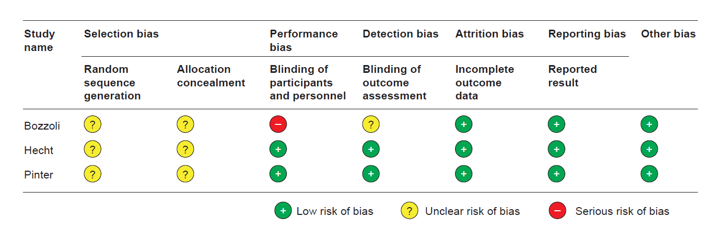
Bozzoli ^{[20]}; Hecht ^{[23]}; Pinter ^{[30]}

Supplemental Fig. S2 Risk of bias: observational trials assessed by the Cochrane ROBINS-I tool ^{[18]}
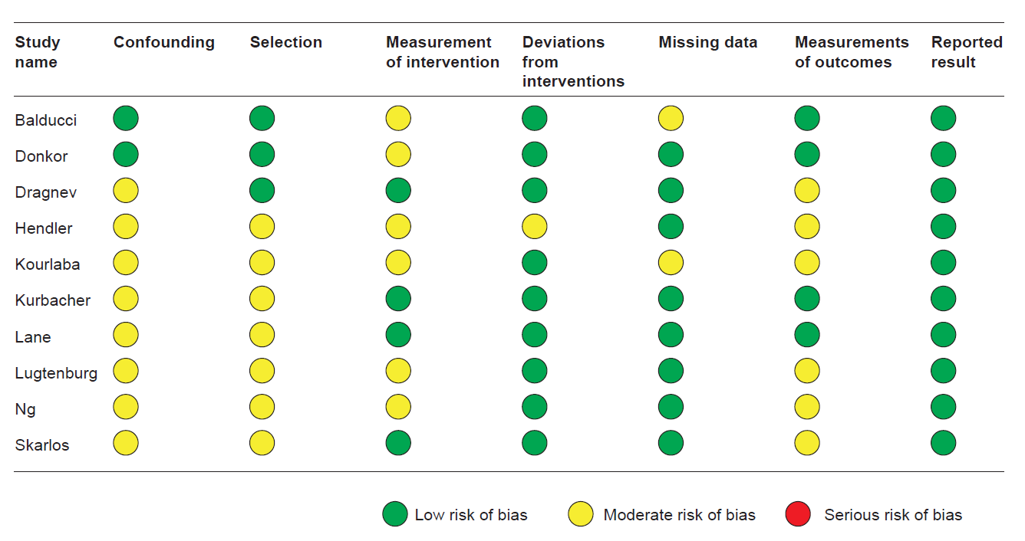
Balducci ^{[19]}; Donkor ^{[21]}; Dragnev ^{[22]}; Hendler ^{[24]}; Kourlaba ^{[25]}; Kurbacher ^{[26]}; Lane ^{[27]}; Lugtenburg ^{[28]}; Ng ^{[29]}; Skarlos ^{[31]}

Supplementary information
Supplementary information accompanies this paper
Additional file 1
Supplemental Table S1 Embase literature search terms
Supplemental Table S2 Medline literature search terms
Supplemental Table S3 Cochrane literature search terms
Supplemental Table S4 Congresses in abstract literature search
Supplemental Table S5 Definitions of febrile neutropenia and neutropenia in included studies
Supplemental Table S6 Adverse events
Supplemental Table S7 Mortality summary
Supplemental Fig. S1 Risk of bias: randomized controlled trials assessed by the Cochrane Collaboration’s tool
Risk of bias: observational trials assessed by the Cochrane ROBINS-I tool

