Supplementary material
Methods
Data synthesis and Analysis
After consensus among the investigators on the methodological quality propped by the QUADAS-2 tool, data consistency was measured via calculating K statistics. Data analysis for studies on MPI was performed using an exact binomial rendition of bivariate mixed-effects regression model[1]. Van Houwelingen et al. have developed this model for meta-analysis of therapeutic trials[2, 3] as well as a modified version for diagnostic test accuracy studies[4]. This model reports in-between studies variability in logit sensitivity and specificity, covariance, and mean logit sensitivity and specificity together with calculating their standard errors (SEs) and 95% confidence intervals (CIs). Nonetheless, it does not pool the sensitivity and specificity as separate indicators of the diagnostic accuracy, but rather it displays the correlation between them. STATA version 14.2 (StataCorp College Station, Texas) software was used to analyze this bivariate model using METANDI command. Also, METANDI PLOT command was used for hierarchical summary receiving operator curve (HSROC) to recapitulate operating points for sensitivity, specificity, and likelihood ratios; logit sensitivity and specificity and their respective variances were used for that purpose. Due to the low number of studies in DSE, the null hypothesis was rejected at 5% as a cut off point for significance (two-tailed) testing. Quality assessment graphs, forest plots, and univariate pooling were carried out using Review Manager (RevMan) computer program (version 5.3. Copenhagen: The Nordic Cochrane Centre, the Cochrane Collaboration, 2014).
Data extraction and quality assessment
Microsoft Excel was used for data extraction by two independent investigators who resolved conflicts via consensus or seeking an expert advisory opinion on their failure to agree. The documented data entailed author, the year of publication, country of the study, number of participants, and risk factors for CAD in the cohorts. Additionally, methodological items, relevant technical information on noninvasive imaging approaches, definitions of the reference standard, and the Quality Assessment of Diagnostic Accuracy Studies (QUADAS-2)[5] were also documented. The latter tool was used by two coauthors to scrutinize the methodological quality of included primary studies. This revised tool has a considerable advantage over the original tool for its efficacy in rating bias and applicability potential of primary diagnostic accuracy studies.

Quality assessment:
Quality assessment of all included studies in our systematic review based on the updated QUADAS-2 is shown in (Figure 3). Quality assessment of the included studies in meta-analysis based on the QUADAS-2 criteria are shown in (Figure 2).
Results
Other tests
Three studies (87 participants) [Kemmer 2014, Kong 2015, West 2019][6-8] compared coronary artery calcium score with coronary angiography for CAD diagnosis.[6-8] In the study by Kemmer et al [6], coronary artery calcium (CAC) scores were calculated with the use of Agatston method[9]. Those with CACS >100 underwent invasive coronary angiography, and those with CACS <100 underwent cardiac stress test and invasive coronary angiography was performed only if the stress test was positive. Kong et al [7] identified a sensitivity of 1.00 (95%CI 0.29, 1.00) and an inestimable specificity. Also, West et al calculated the CAC score using Agatston method[8]. Patients with CACS > 400 were considered positive for underlying CAD and had coronary angiography performed only on these patients. One study [Jodocy 2012] compared coronary CT angiography with invasive coronary angiography for CAD diagnosis. Patients with significant stenosis (>50% narrowing) or with a CACS of more than 300 were considered positive.[10] In all the above mentioned studies, since only index positive cases underwent coronary angiography, sensitivity and specificity cannot be ascertained in accordance to the inclusion criteria for our analysis. Study by Tsutsui et al (2006) investigated the diagnostic value of dobutamine stress myocardial contrast perfusion echocardiography (dobutamine stress RTMCE). This study examined both wall motion and MPI. Wall motion was considered abnormal if there were new or worsening abnormalities in two or more contiguous segments.[11] MPI was considered positive when perfusion defects were seen in two or more segments. 17 patients underwent invasive coronary angiography within three months of dobutamine stress RTMCE. Only seven were diagnosed to have CAD. While only two patients with confirmed CAD had wall motion abnormalities and all those seven patients had inducible perfusion defects. Tsuitsui et al in their analysis found abnormal MPI, assessed by RTMCE, to be an independent predictor of mortality (besides MELD score and advanced age) in patients with advanced liver disease. Interestingly, the analysis of wall motion did not seem to have any predictive value after adjusting for MPI in their study. The results were contrary to that of the prior studies that involved DSE in detecting CAD in patients with advanced liver disease. However, this study did not compare the efficacy of abnormal MPI assessed by myocardial scintigraphy with that obtained by the RTMCE. [11]
Supplementary references

[1] Chu H, Cole SR. Bivariate meta-analysis of sensitivity and specificity with sparse data: a generalized linear mixed model approach. Journal of Clinical Epidemiology. 2006;59:1331-2.
[2] Van Houwelingen HC, Zwinderman KH, Stijnen T. A bivariate approach to meta‐analysis. Statistics in Medicine. 1993;12:2273-84.
[3] Van Houwelingen HC, Arends LR, Stijnen T. Advanced methods in meta-analysis: Multivariate approach and meta-regression. Statistics in Medicine. 2002;21:589-624.
[4] Reitsma JB, Glas AS, Rutjes AWS, Scholten RJPM, Bossuyt PM, Zwinderman AH. Bivariate analysis of sensitivity and specificity produces informative summary measures in diagnostic reviews. Journal of Clinical Epidemiology. 2005;58:982-90.
[5] Whiting PF, Rutjes AWS, Westwood ME, Mallett S, Deeks JJ, Reitsma JB, et al. QUADAS-2: a revised tool for the quality assessment of diagnostic accuracy studies. Annals of Internal Medicine. 2011;155:529-36.
[6] Kemmer N, Case J, Chandna S, Neff GW. The role of coronary calcium score in the risk assessment of liver transplant candidates. Transplant Proc. 2014;46:230-3.
[7] Kong YG, Ha TY, Kang JW, Hwang S, Lee SG, Kim YK. Incidence and Predictors of Increased Coronary Calcium Scores in Liver Transplant Recipients. Transplant Proc. 2015;47:1933-8.
[8] West BH, Low CG, Bista BB, Yang EH, Vorobiof G, Busuttil RW, et al. Significance of Coronary Artery Calcium Found on Non-Electrocardiogram-Gated Computed Tomography During Preoperative Evaluation for Liver Transplant. Am J Cardiol. 2019;124:278-84.
[9] Agatston AS, Janowitz WR, Hildner FJ, Zusmer NR, Viamonte M, Detrano R. Quantification of coronary artery calcium using ultrafast computed tomography. 1990;15:827-32.
[10] Jodocy D, Abbrederis S, Graziadei IW, Vogel W, Pachinger O, Feuchtner GM, et al. Coronary computer tomographic angiography for pre-operative risk stratification in patients undergoing liver transplantation. Eur J Radiol. 2012;81:2260-4.
[11] Tsutsui JM, Mukherjee S, Elhendy A, Xie F, Lyden ER, O'Leary E, et al. Value of dobutamine stress myocardial contrast perfusion echocardiography in patients with advanced liver disease. Liver Transpl. 2006;12:592-9.
Supplementary figures
Supplementary figures
Figure. 1S Quality assessment of included studies in meta-analysis
Figure. 2S Quality assessment of included studies in review
Figure. 3S Hierarchical summary of ROC for MPI test
Figure. 4S Summary of ROC of dobutamine stress echocardiography studies

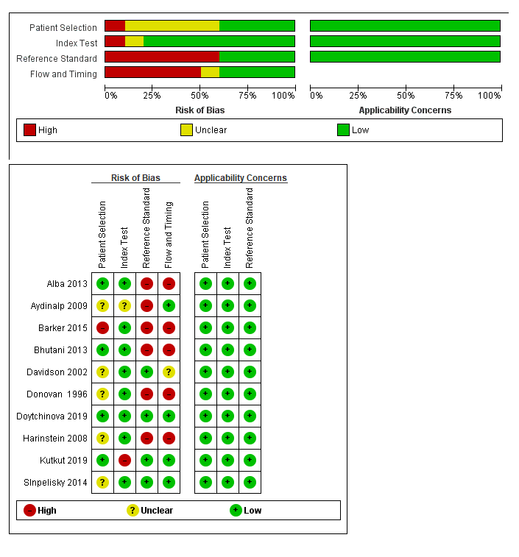
Figure. 1s Quality assessment of studies included in meta-analysis by QUADAS-2 criteria

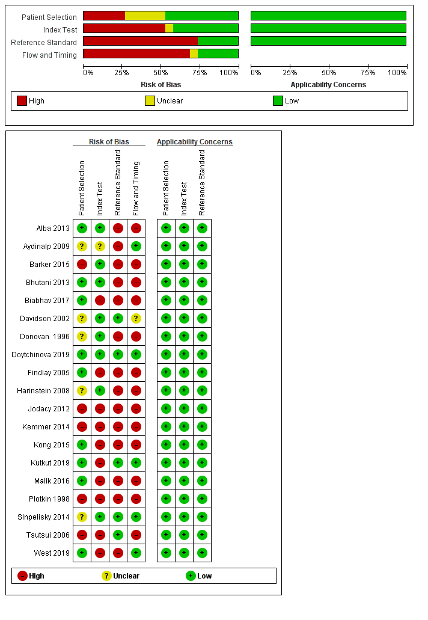
Figure. 2s Quality assessment of studies included in systemiatic review by QUADAS-2 criteria

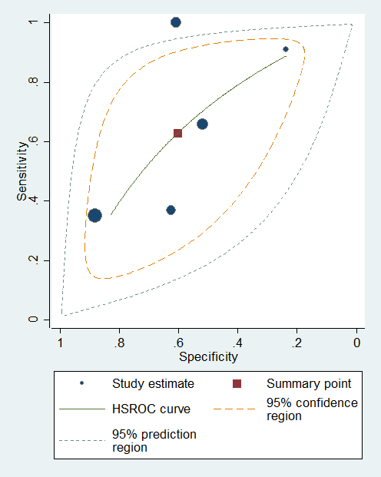
Figure. 3s Hierarchical summary of ROC for MPI test

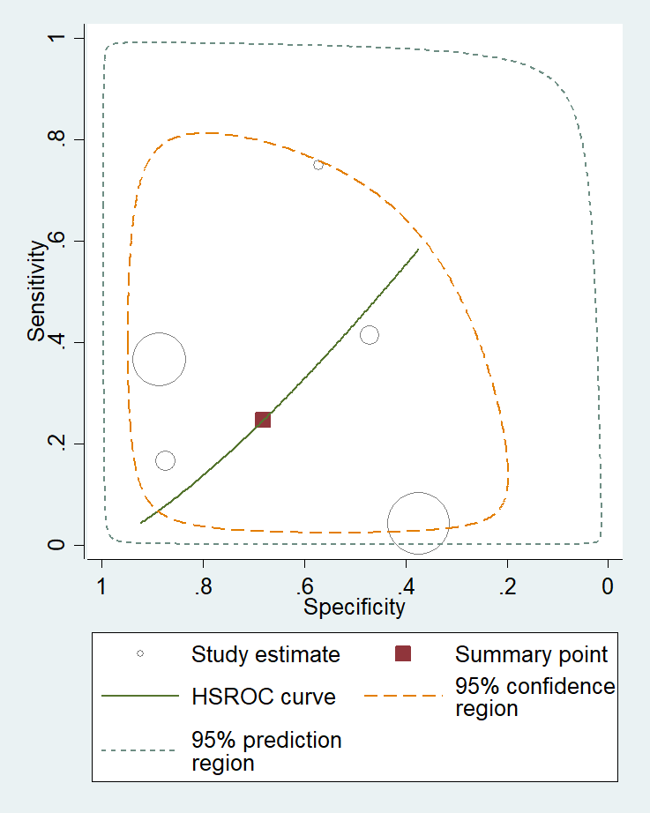
Figure. 4s Hierarchical summary of ROC for DSE test

