SUPPLEMENTARY RESULTS
Supplementary Table A: Characteristics of non-meta-analysed studies
Author (date) country | No. total participants | No. LGBQ (%)  No. TGNC (%) | Participant age range (years) | Setting | Outcome | Identified Risks | Quality
Antonio & Moleiro (2015)⁽⁵⁰⁾  Portugal | 211 | LGBQ: 148 (70.1)  TGNC: - | 12-20 | Community | Suicidal ideation | Low social support  Victimisation | Moderate
Baams et al., (2015)⁽⁴¹⁾  U.S.A | 876 | LGBQ: 876 (100)  TGNC: - | 15-21 | Community | Suicidal ideation | Coming-out stress  Perceived burdensome  Thwarted belongingness  Victimisation | Low
Baiden et al., (2019)⁽⁵¹⁾  U.S.A | 9,693 | LGBQ: 722 (7.5)  TGNC: - | 14-18 | School | Suicidal ideation; Suicidal attempt | Teen dating violence | Moderate
Ballard et al., (2017)⁽⁵²⁾  U.S.A | 1,550 | LGBQ: 155 (10)  TGNC: - | 14-18 | School | Suicidal ideation; Suicidal attempt | Victimisation | Moderate
Birkett et al., (2009)⁽⁵³⁾  U.S.A | 7,376 | LGBQ: 1,118 (15.1)  TGNC: - | 12-14 | School | Suicidal ideation | Negative perception of education  Victimisation | High/Moderate
Bostwick et al., (2014)⁽¹⁸⁾  U.S.A | 72,691 | LGBQ: 6,245 (8.6)  TGNC: - | 13-18 | Community | Self-harm;  Suicidal ideation;  Suicidal attempt | Gender (female)  Ethnic minority | Low
Burton et al., (2013)⁽⁵⁴⁾  U.S.A | 192 | LGBQ: 55 (29)  TGNC: - | 14-19 | Hospital/Clinic | Suicidal ideation; Suicidal attempt | Victimisation | Low
Button (2016)⁽⁵⁵⁾  U.S.A | 484 | LGBQ: 484 (100)  TGNC: - | 12-18 | School | Suicidal ideation; Suicidal attempt | Age (below 14)  Victimisation | High/Moderate
Cenat et al., (2015)⁽⁵⁶⁾  Canada | 8,194 | LGBQ: 1,426 (17.4)  TGNC: - | 14-20 | School | Suicidal ideation | Sexuality (bisexual)  Victimisation | Moderate
Consolacion et al., (2004)⁽¹⁶⁾  U.S.A | 13,205 | LGBQ: 1,189 (9)  TGNC: - | 12-18 | Community | Suicidal ideation | Gender (female)  Race (white) | Low
Coulter et al., (2015)⁽⁵⁷⁾  U.S.A | 75,192 | LGBQ: 6,558 (8.7)  TGNC: 175 (0.2) | 18-25 | School | Self-harm; Suicidal ideation | Alcohol-related problems | Moderate
Cutuli et al., (2020)⁽⁵⁸⁾  U.S.A | 77,559 | LGBQ: 6,903 (8.9)  TGNC: - | 14-18 | School | Suicidal ideation; Suicidal attempt | Homelessness | Moderate
D’Augelli et al., (2001)⁽⁵⁹⁾  U.S.A | 350 | LGBQ: 350 (100)  TGNC: - | 14-21 | Community | Suicidal attempt | Age (below 16)  Personal homonegativity  Parental rejection  LGB-friends suicide attempts | High/Moderate
D’Augelli et al., (2005)⁽⁶⁰⁾  U.S.A | 361 | LGBQ: 361 (100)  TGNC: - | 15-19 | Community | Suicidal attempt | Personal homonegativity  Parental discourage of childhood gender atypical behaviour  Parental labelling of sexual orientation  Parental psychological abuse  Family history of suicide  Victimisation | Moderate
De Assis et al., (2014)⁽⁶¹⁾  Brazil | 3,205 | LGBQ: 122 (3.8)  TGNC: - | 15-19 | School | Suicidal ideation | Problems with romantic relationship | Low
Duncan & Hatzenbuehler (2014)⁽⁶²⁾  U.S.A | 1,173 | LGBQ: 102 (8.7)  TGNC: - | 14-18 | School | Suicidal ideation; Suicidal attempt | LGBT hate crime – threat  LGBT hate crime – harassment  LGBT hate crime – assault or battery  LGBT hate crime – assault or battery with weapon | Moderate
DuRant et al., (1998)⁽⁶³⁾  U.S.A | 3,886 | LGBQ: 338 (8.7)  TGNC: - | 12-18 | School | Suicidal attempt | Higher number of male sexual partners | Moderate
Eisenberg et al., (2016)⁽⁶⁴⁾  U.S.A | 122,180 | LGBQ: 6,223 (5.1)  TGNC: - | 13-17 | School | Suicidal attempt | Gender (female)  Low levels of LGBQ peers  Victimisation | Moderate
Eisenberg et al., (2019)⁽⁶⁵⁾  U.S.A | 2,168 | LGBQ: -  TGNC: 2168 (100) | 14-17 | School | Self-harm;  Suicidal ideation;  Suicidal attempt | Location (rural areas) | Moderate
Espelage et al., (2008)⁽⁶⁶⁾  U.S.A | 13,921 | LGBQ: 1,997 (1.6)  TGNC: - | 14-18 | School | Suicidal ideation | Victimisation | High/Moderate
Espelage et al., (2018)⁽⁶⁷⁾  U.S.A | 11,794 | LGBQ: 767 (6.5)  TGNC: 212 (1.8) | 14-18 | School | Suicidal ideation; Suicidal attempt | Teen dating violence  Negative perception of school violence and crime  Victimisation | High/Moderate
Fraser et al., (2018)⁽⁶⁸⁾  New Zealand | 1,799 | LGBQ: 198 (11)  TGNC: 5 (0.3) | 13-18 | School | Self-harm | Sexuality (bisexual)  Sexuality concerns  Emotional regulation | Moderate
Friedman et al., (2006)⁽⁶⁹⁾  U.S.A | 96 | LGBQ: 96 (100)  TGNC: - | 18-25 | Community | Suicidal ideation; Suicidal attempt | High femininity during middle school  Masculinity during elementary school  Gender-role nonconformity  Victimisation | Moderate
Garofalo et al., (1999)⁽⁷⁰⁾  U.S.A | 3,365 | LGBQ: 129 (3.8)  TGNC: - | 14-18 | School | Suicidal attempt | Gender (male)  Drug and alcohol use  Sexual activity risk (against will)  Violence and victimisation risk | Moderate
Gibbs & Goldbach (2015)⁽⁷¹⁾  U.S.A | 2,949 | LGBQ: 2944 (99.8)  TGNC: 75 (2.5) | 18-24 | Community | Suicidal ideation | Parental anti-homosexual religious beliefs  Leaving religion of origin due to conflict  Internalised homophobia  Religious upbringing with unresolved conflict | Moderate
Grossman & Kerner (1998)⁽⁷²⁾  U.S.A | 90 | LGBQ: 90 (100)  TGNC: - | 14-21 | Community | Suicidal ideation | Low self-esteem  Emotional distress | Moderate
Grossman et al., (2007⁾⁽⁷³⁾  U.S.A | 55 | LGBQ: -  TGNC: 55 (100) | 15-21 | Community | Suicidal attempt | Transgender-related suicide negativity  Body esteem – weight  Body esteem – attribution  Other’s evaluation of body and appearance  Parental verbal abuse  Parental physical abuse | Moderate
Grossman et al., (2016)⁽⁷⁴⁾  U.S.A | 129 | LGBQ: -  TGNC: 129 (100) | 15-21 | Community | Suicidal ideation; Suicidal attempt | Gender (natal female)  Race (white)  High thwarted belongingness  High perceived burdensomeness  Previous experiences of painful and provocative events | Low
Halkitis et al., (2018)⁽⁷⁵⁾  U.S.A | 665 | LGBQ: 665 (100)  TGNC: - | 18-23 | Community | Suicidal ideation; Suicidal attempt | Loneliness  Low self-esteem | Moderate
Hee-Kim et al., (2016)⁽⁷⁶⁾  South Korea | 146,621 | LGBQ: 1,270 (0.9)  TGNC: - | 12-17 | School | Suicidal ideation; Suicidal attempt | STDs experience  Violence | Moderate
Higgins-Tejera et al., (2019)⁽⁷⁷⁾  U.S.A | 10,386 | LGBQ: 926 (8.9)  TGNC: | 16-17 | School | Suicidal ideation | Victimisation | Moderate
Hightow-Weidman et al., (2011)⁽⁷⁸⁾  U.S.A | 351 | LGBQ: 351 (100)  TGNC: 16 (4.6) | 13-24 | Community | Suicidal attempt | Sexual minority and disability status | Moderate
Huang et al., (2018a)⁽⁴⁹⁾  China | 123,459 | LGBQ: 6685 (5)  TGNC: - | 12-18 | School | Suicidal attempt | Poor sleep quality | Moderate
Huang et al., (2018b) ⁽⁷⁹⁾  China | 72,409 | LGBQ: 15,066 (19.9)  TGNC: - | 12-20 | School | Suicidal ideation;  Suicidal attempt | Obesity | Moderate
King et al., (2018)⁽⁸⁰⁾  U.S.A | 11,364 | LGBQ: 730 (6.4)  TGNC: - | 14-18 | School | Suicidal ideation | Low school connectedness  Victimisation | Moderate
Lardier et al., (2017)⁽⁸¹⁾  U.S.A | 538 | LGBQ: 70 (13)  TGNC: - | 14-18 | Community | Suicidal ideation | Depressive symptoms  Victimisation | Moderate
LeVasseur et al., (2013)⁽⁸²⁾  U.S.A | 11,887 | LGBQ: 939 (7.9)  TGNC: - | 14-18 | School | Suicidal attempt | Victimisation | Moderate
Li et al., (2019)⁽⁸³⁾  China | 1,810 | LGBQ: 310 (17.1) | 15-18 | School | Self-harm | Adverse childhood experiences | Moderate
Liu & Mustanski (2012)⁽⁸⁴⁾  U.S.A | 246 | LGBQ: 244 (99.2)  TGNC: 20 (8.1) | 16-20 | Community | Self-harm; Suicidal ideation | Gender (female)  Gender nonconformity  History of attempted suicide  Depressive symptoms  Impulsivity  Low social support  Sensation-seeking  Hopelessness  Victimisation | High
Lytle et al., (2018)⁽⁸⁵⁾  U.S.A | 203 | LGBQ: 73 (36)  TGNC: 18 (8.9) | 18-24 | Community | Suicidal ideation; Suicidal attempt | Sex assigned at birth  Depression/anxiety  Friend suicide attempt or complete  Family suicide attempt or complete  Less perceived family support | High/Moderate
Marx et al., (2019)⁽⁸⁶⁾  U.S.A | 16,292 | LGBQ: 2,786 (17.1)  TGNC: 610 (3.7) | 14-18 | School | Suicidal ideation | Problematic drug use  Victimisation | Moderate
Mendoza-Pérez et al., (2019)⁽⁴³⁾  Mexico | 23,496 | LGBQ: 2,350 (10)  TGNC: - | 14-19 | School | Suicidal ideation; Suicidal attempt | Negative attitudes towards homosexuality  Violent experience | Moderate
Mustanski et al., (2010)⁽⁸⁷⁾  U.S.A | 246 | LGBQ: 241 (98)  TGNC: 20 (8.1) | 16-20 | Community | Suicidal attempt | Gender (female) | Moderate
Mustanski et al., (2014)⁽⁸⁸⁾  U.S.A | 16,977 | LGBQ: 1,185 (7)  TGNC: - | 13-18 | Community | Suicidal attempt | Cocaine use  Feelings of sadness  Intimate partner violence  Victimisation | Moderate
Palm et al., (2016)⁽⁸⁹⁾  Sweden | 1,051 | LGBQ: 105 (10)  TGNC: - | 15-22 | Community | Suicidal ideation; Suicidal attempt | Multiple victimisations | Moderate
Poteat et al., (2009)⁽⁹⁰⁾  Unclear | 14,439 | LGBQ: 3,321 (23)  TGNC: - | 14-19 | Community | Suicidal ideation | Victimisation | Moderate
Proctor & Groze (1994)⁽⁹¹⁾  Multiple countries | 221 | LGBQ: 221 (100)  TGNC: - | - | Community | Suicidal attempt | Depressive symptoms  Poor parental relations  Poor school performance  Low self-esteem | Moderate
Puckett et al., (2017)⁽⁹²⁾  U.S.A | 61 | LGBQ: 61 (100)  TGNC: - | 14-23 | Community | Suicidal attempt | Gender (female)  Loss of friends due to sexual orientation  Guilt/shame due to sexual orientation  Internalised homophobia  Psychological maltreatment from caregivers | Moderate
Remafedi (2002)⁽⁹³⁾  U.S.A | 255 | LGBQ: 255 (100)  TGNC: - | 15-25 | Community | Suicidal attempt | Race (black/African-American)  Location (urban areas)  Fewer years in education  Lower enrolment in school | Moderate
Rimes et al., (2017)⁽⁹⁴⁾  U.K | 677 | LGBQ: 622 (91.9)  TGNC: 677 (100) | 16-25 | Community | Self-harm | Gender (natal female) | Moderate
Rotheram-Borus et al., (1994)⁽⁹⁵⁾  U.S.A | 131 | LGBQ: 127 (96.9)  TGNC: - | 14-19 | Community | Suicidal attempt | Dropped out of school  Lived outside of family home  Came out to parents  Came out to siblings  Parental discovery of sexuality  Friend or family suicide attempt | High/Moderate
Russell & Joyner (2001)⁽⁹⁶⁾  U.S.A | 11,940 | LGBQ: 836 (7)  TGNC: - | 12-15 | School | Suicidal ideation; Suicidal attempt | Alcohol abuse  Depression  Friend or family suicide attempt  Hopelessness  Victimisation | Moderate
Ryan et al., (2009)⁽⁹⁷⁾  U.S.A | 224 | LGBQ: 224 (100)  TGNC: - | 21-25 | Community | Suicidal attempt | Family rejection | Moderate
Savin-Williams & Ream (2003)⁽⁹⁸⁾  Multiple countries | 732 | LGBQ: 727 (99.3)  TGNC: - | 13-25 | Community | Suicidal attempt | Younger age of first sexual experience with male  More male partners  Mastery orientation  Earlier age at first disclosure  Higher rate of disclosure  Less acceptance of their sexual orientation  Alcohol use  Hard drug use  Depressive symptoms  Low self-esteem  Greater willingness to engage in risky sex  Victimisation | Moderate
Scheer et al., (2019)⁽⁹⁹⁾  U.S.A | 7,532 | LGBQ: 1089 (14.5)  TGNC: - | 14-18 | School | Suicidal ideation; Suicidal attempt | Sexual violence | Moderate
Shearer et al., (2018)⁽¹⁰⁰⁾  U.S.A | 129 | LGBQ: 41 (31.9)  TGNC: - | 12-18 | Community | Suicidal attempt | Religiosity  More religious parents | High/Moderate
Taliaferro et al., (2018a)⁽¹⁰¹⁾  U.S.A | 922 | LGBQ: 922 (100)  TGNC: - | 14-18 | School | Suicidal attempt | Same-sex sexual experience  Binge drinking  Marijuana use  Substance use  Relationship violence  Multiple sexual partners  Victimisation | Moderate
Taliaferro et al., (2019)⁽¹⁰²⁾  U.S.A | 1,635 | LGBQ: -  TGNC: 1,635 (100) | 14-17 | School | Self-harm; Suicidal attempt | Gender (natal female)  Mental health problem  Positive screen for depression  Alcohol use  Marijuana use  Physical or sexual abuse  Relationship violence  Run away from home  Bullying perpetrator  Victimisation | Moderate
Teasdale & Bradley-Engen (2010)⁽¹⁰³⁾  U.S.A | 11,911 | LGBQ: 787 (7)  TGNC: - | 12-18 | School | Suicidal ideation; Suicidal attempt | Gender (female)  Location (suburban)  Suicide of close friend  Suicide of family member  Run away from home  Victimisation | Moderate
Thoma & Huebner (2013)⁽¹⁰⁴⁾  U.S.A | 276 | LGBQ: 276 (100)  TGNC: 22 (8) | 14-19 | Community | Suicidal ideation | Antigay discrimination  Greater levels of perceived discrimination  Racial discrimination | Moderate
Waldo et al., (1998)⁽¹⁰⁵⁾  U.S.A | 248 | LGBQ: 248 (100)  TGNC: - | 15-21 | Community | Suicidal ideation; Suicidal attempt | Low self-esteem  Psychological distress  Victimisation | Moderate/Low
Walls et al., (2008)⁽¹⁰⁶⁾  U.S.A | 142 | LGBQ: 142 (100)  TGNC: - | 14-21 | Community | Suicidal ideation; Suicidal attempt | Gender (female)  Methamphetamine use  Hopelessness  Homelessness  Victimisation | High/Moderate
Walls et al., (2010)⁽¹⁰⁷⁾  U.S.A | 265 | LGBQ: 265 (100)  TGNC: 13 (4.9) | 13-22 | Community | Self-harm | Younger age  Sexuality (lesbian)  Sexuality (bisexual)  Gender identity (transgender)  Level of outness  Depression  History of attempted suicide  Daily smoking  Inhalant use  Homelessness  Friend suicide attempt or complete | High/Moderate
Yadegarfard et al., (2013)⁽¹⁰⁸⁾  Thailand | 190 | LGBQ: -  TGNC: 190 (100) | 15-25 | Community | Suicidal ideation | Number of sexual partners | Moderate
Yadegarfard et al., (2014)⁽¹⁰⁹⁾  Thailand | 260 | LGBQ: -  TGNC: 129 (49.6) | 15-25 | Community | Suicidal ideation; Suicidal attempt | Family rejection  Depression  PANSI-negative  Low social support  Loneliness | Moderate

Supplementary table B: Characteristics of meta-analysed studies
Author (date) country | No. total participants | No. LGBQ (%)  No. TGNC (%) | Participant age range (years) | Setting | Outcome | Quality | Multiple Reports
Almedia el al., (2009)⁽¹¹⁰⁾  U.S.A | 1,032 | LGBQ: 93 (9)  TGNC: 17 (1.7) | 13-19 | School | Self-harm;  Suicidal ideation | High/Moderate
Arcelus et al., (2016)⁽¹¹¹⁾  U.K. | 268 | LGBQ: -  TGNC: 268 (100) | - | Hospital/Clinic | Self-harm | Moderate
Berona et al., (2020)⁽¹¹²⁾  U.S.A | 285 | LGBQ: 119 (41.8)  TGNC: 7 (2.5) | 13-25 | Hospital/Clinic | Self-harm;  Suicidal ideation;  Suicidal attempt | Low/Moderate
Blosnich et al., (2012)⁽¹¹³⁾  U.S.A | 11,046 | LGBQ: 773 (7)  TGNC: - | 18-24 | Community | Self-harm;  Suicidal ideation;  Suicidal attempt | High/Moderate
Bontempo et al., (2002)⁽¹¹⁴⁾  U.S.A | 9,188 | LGBQ: 315 (3.4)  TGNC: - | 14-18 | School | Suicidal attempt | Moderate
Boyas et al., (2019)⁽¹⁶⁾  U.S.A | 451 | LGBQ: 451 (100)  TGNC: - | 12-18 | School | Suicidal ideation; Suicidal attempt | Low/Moderate
Butler et al., (2019)⁽¹¹⁵⁾  U.K. | 8,440 | LGBQ: -  TGNC: 282 (3.3) | 13-17 | School | Self-harm | Moderate
D’Augelli et al.,(1993)⁽⁴²⁾  U.S.A | 194 | LGBQ: 194 (100)  TGNC: - | 15-21 | Community | Suicidal attempt | Moderate | Hershberger et al., (1997)⁽⁴⁶⁾
Duong & Bradshaw (2014)⁽¹¹⁶⁾  U.S.A | 951 | LGBQ: 951 (100)  TGNC: - | 14-18 | School | Suicidal attempt | Moderate
Feinstein et al., (2019)⁽¹¹⁷⁾  U.S.A | 18,515 | LGBQ: 18,515 (100)  TGNC: - | 14-18 | School | Suicidal attempt | High/Moderate
Gnan et al., (2019)⁽¹¹⁸⁾  U.K. | 1,948 | LGBQ: 1927 (98.9)  TGNC: 214 (10.9) | 16-25 | Community | Self-harm;  Suicidal ideation;  Suicidal attempt | High/Moderate
Goldbach et al., (2017)⁽¹¹⁹⁾  U.S.A | 346 | LGBQ: 346 (100)  TGNC: - | 14-17 | Community | Self-harm; Suicidal ideation | Moderate
Goodenow et al., (2006)⁽¹²⁰⁾  U.S.A | 3,637 | LGBQ: 202 (5.6)  TGNC: - | 14-18 | School | Suicidal attempt | Low
Hatchel et al., (2019)⁽¹²¹⁾  U.S.A | 4,867 | LGBQ: 713 (14.6)  TGNC: 129 (1.5) | 12-18 | School | Suicidal ideation; Suicidal attempt | High/Moderate
Hatchel et al., (2019b)⁽¹²²⁾  U.S.A | 934 | LGBQ: 769 (82.3)  TGNC: 60 (6.4) | 14-18 | School | Suicidal ideation; Suicidal attempt | High/Moderate
Hatzenbuehler (2011)⁽¹²³⁾  U.S.A | 31,852 | LGBQ: 1,413 (4.4)  TGNC: - | 16-17 | School | Suicidal attempt | Moderate
Hegna &Wichstrøm (2007)⁽¹²⁴⁾  Norway | 407 | LGBQ: 407 (100)  TGNC: - | 16-25 | Community | Suicidal attempt | Moderate
Huang et al., (2018a)⁽⁴⁷⁾  China | 123,459 | LGBQ: 6685 (5)  TGNC: - | 12-18 | School | Suicidal attempt | Moderate | Huang et al., 2018d⁽⁴⁹⁾
Langhinrichsen-Rohling et al., (2011)⁽¹²⁵⁾  U.S.A | 1,533 | LGBQ: 200 (13)  TGNC: - | 13-18 | Community | Suicidal ideation; Suicidal attempt | Moderate
McDermott et al., (2018)⁽¹²⁶⁾ U.K. | 789 | LGBQ: 789 (100)  TGNC: 178 (22.6) | 13-25 | Community | Self-harm; Suicidal ideation; Suicidal attempt | Low
McKay et al., (2019)⁽¹²⁷⁾  U.S.A | 485 | LGBTQ: 175 (36.1) | 14-21 | Community | Suicidal ideation; Suicidal attempt | Moderate
Mustanski et al., (2013)⁽¹²⁸⁾  U.S.A | 237 | LGBQ: 237 (100)  TGNC: 21 (8.9) | 16-20 | Community | Suicidal attempt | Low
Peng et al., (2019)⁽¹²⁹⁾  China | 385 | LGBQ: -  TGNC: 385 (100) | 12-18 | Community | Suicidal ideation | High/Moderate
Perez-Brumer et al., (2017)⁽¹³⁰⁾  U.S.A | 25,493 | LGBQ: 2,440 (9.6)  TGNC: 280 (1.1) | 14-18 | School | Suicidal ideation | High/Moderate
Peterson et al., (2017)⁽¹³¹⁾  U.S.A | 96 | LGBQ: 96 (100)  TGNC: 96 (100) | 12-22 | Hospital/Clinic | Suicidal attempt | Moderate
Reisner et al., (2014)⁽¹³²⁾  U.S.A | 3,131 | LGBQ: 225 (7.2)  TGNC: - | 14-18 | School | Self-harm; Suicidal attempt | High
Remafedi et al., (1991)⁽²³⁾  U.S.A | 137 | LGBQ: 137 (100)  TGNC: - | 14-21 | Community | Suicidal attempt | Moderate
Rimes et al., (2019)⁽¹³³⁾  U.K. | 3,275 | LGBQ: 3275 (100)  TGNC: - | 16-25 | Community | Suicidal ideation; Suicidal attempt | High/Moderate
Shields et al., (2011)⁽¹³⁴⁾  U.S.A | 2,154 | LGBQ: 2,154 (100)  TGNC: - | 14-18 | School | Suicidal ideation | Moderate
Smith et al., (2016)⁽¹³⁵⁾  U.S.A | 68 | LGBQ: 68 (100)  TGNC: - | 16-24 | Community | Suicidal ideation | Moderate
Smith et al., (2019)⁽¹³⁶⁾  U.S.A | 252 | LGBQ: 179 (71)  TGNC: 73 (29) | 14-15 | Community | Self-harm; Suicidal ideation; Suicidal attempt | Low/Moderate
Taliaferro et al., (2016)⁽¹³⁷⁾  U.S.A | 77,758 | LGBQ: 4,960 (6.5)  TGNC: - | 14-18 | School | Self-harm; Suicidal ideation; Suicidal attempt | Moderate
Taliaferro et al., (2018b)⁽¹³⁸⁾  U.S.A | 2,168 | LGBQ: -  TGNC: 2,168 (100) | 14-17 | School | Self-harm | Moderate
Turpin et al., (2019)⁽¹³⁹⁾  U.S.A | 924 | LGBQ: 691 (74.8)  TGNC: - | 14-18 | School | Suicidal ideation | High/Moderate
Veale et al., (2017)⁽¹⁴⁰⁾  Canada | 923 | LGBQ: -  TGNC: 923 (100) | 14-25 | Community | Self-harm; Suicidal attempt | Moderate
Wang et al., (2019)⁽¹⁴¹⁾  Taiwan | 500 | LGBQ: 500 (100)  TGNC: - | 20-25 | Community | Suicidal ideation; Suicidal attempt | High
Whitaker et al., (2015)⁽¹⁴²⁾  U.S.A | 356 | LGBQ: 356 (100)  TGNC: 64 (16.9) | 14-18 | School | Suicidal ideation | High/Moderate
Wilson et al., (2016)⁽¹⁴³⁾  U.S.A | 216 | LGBQ: 147 (68.1)  TGNC: 105 (48.6) | 16-24 | Community | Suicidal ideation | Moderate
Ybarra et al., (2015)⁽¹⁴⁴⁾  U.S.A | 5,542 | LGBQ: 2,162 (39)  TGNC: 442 (7.8) | 13-18 | Community | Suicidal ideation | Moderate

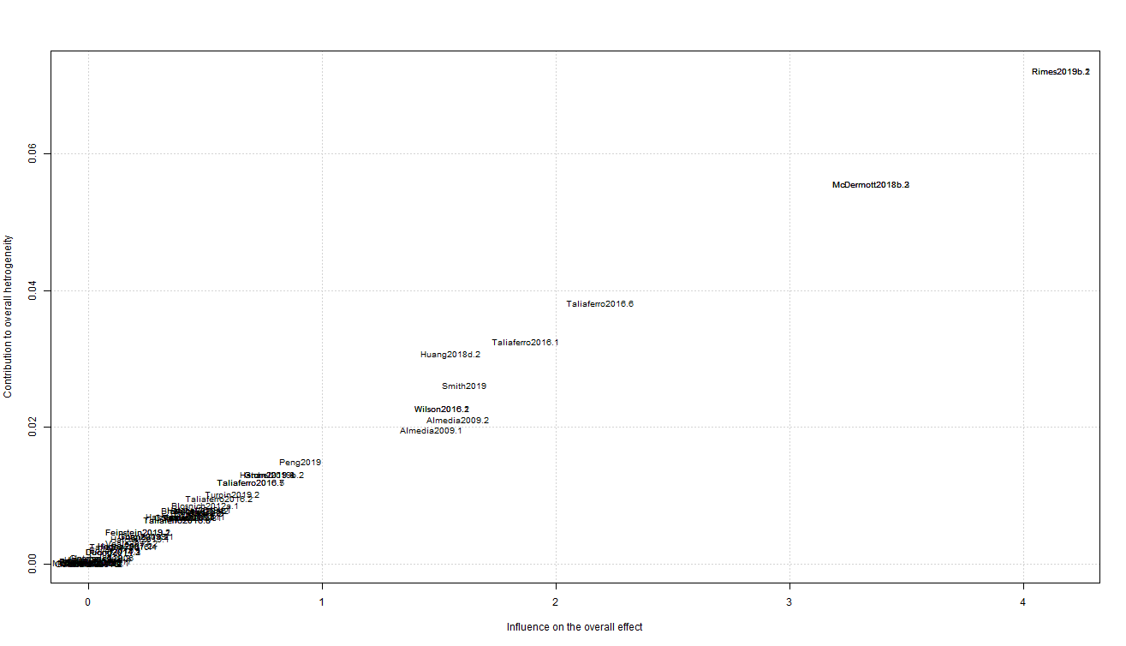
SUPPLEMENTARY FIGURES
Supplementary Figure A: Baujat chart of overall victimisation prevalence
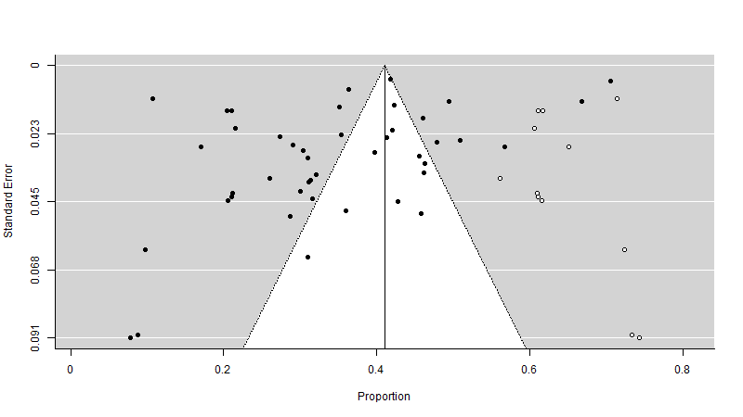

Supplementary Figure B: Victimisation prevalence funnel plot

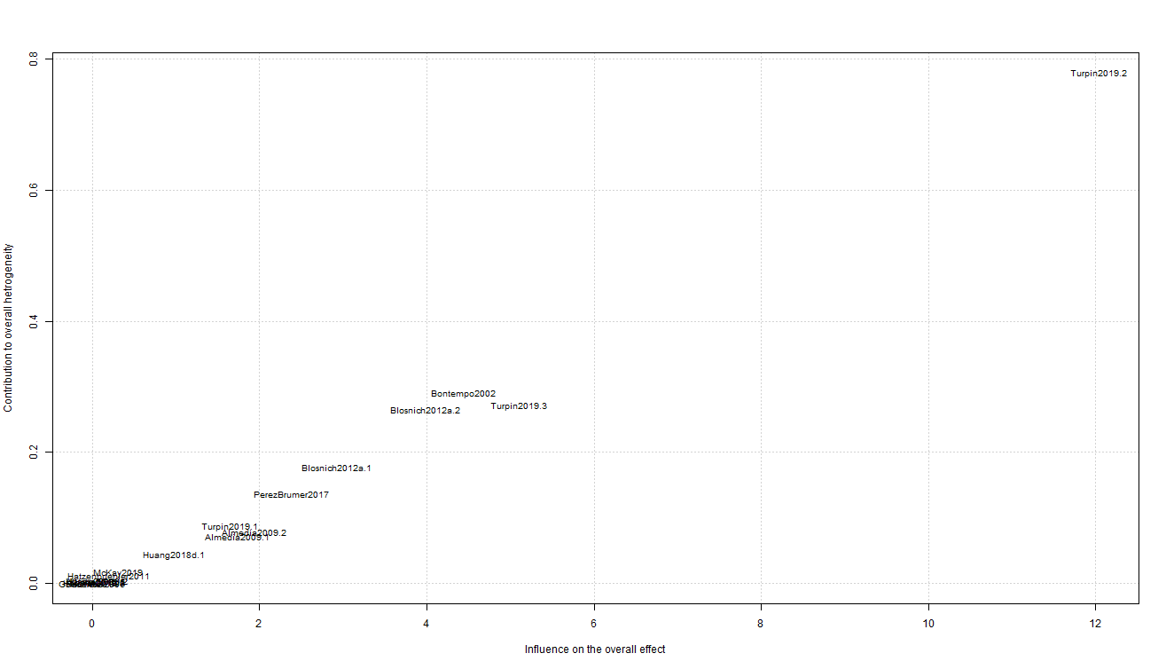
Supplementary Figure C: Baujat chart of victimisation odds ratio

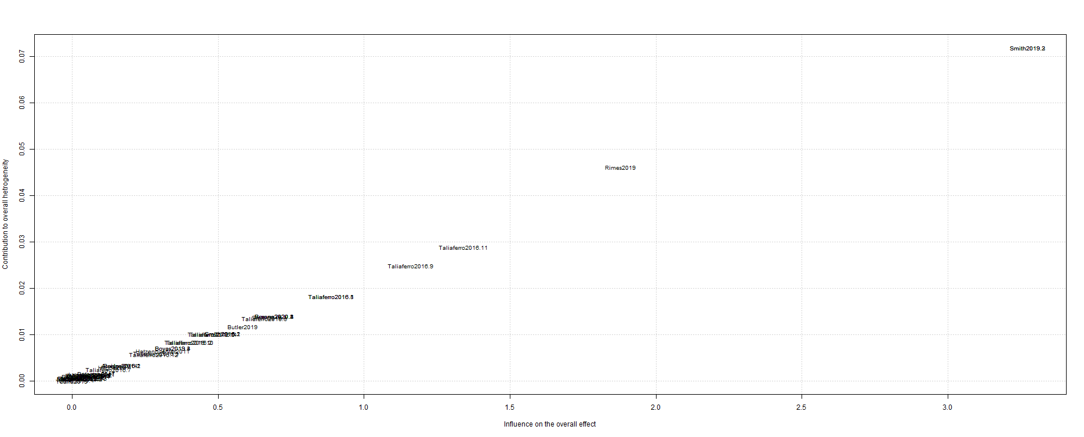
Supplementary Figure D: Baujat chart of mental health difficulties prevalence

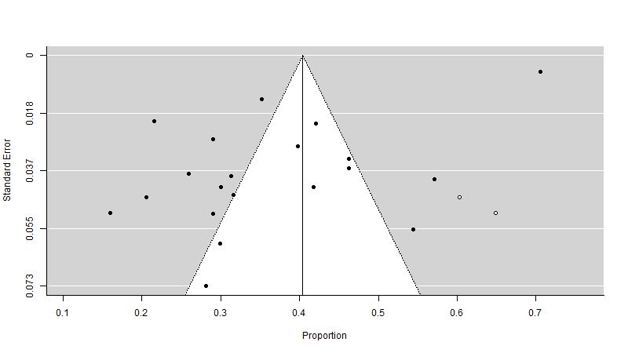

Supplementary Figure E: Mental health difficulties prevalence funnel plot

