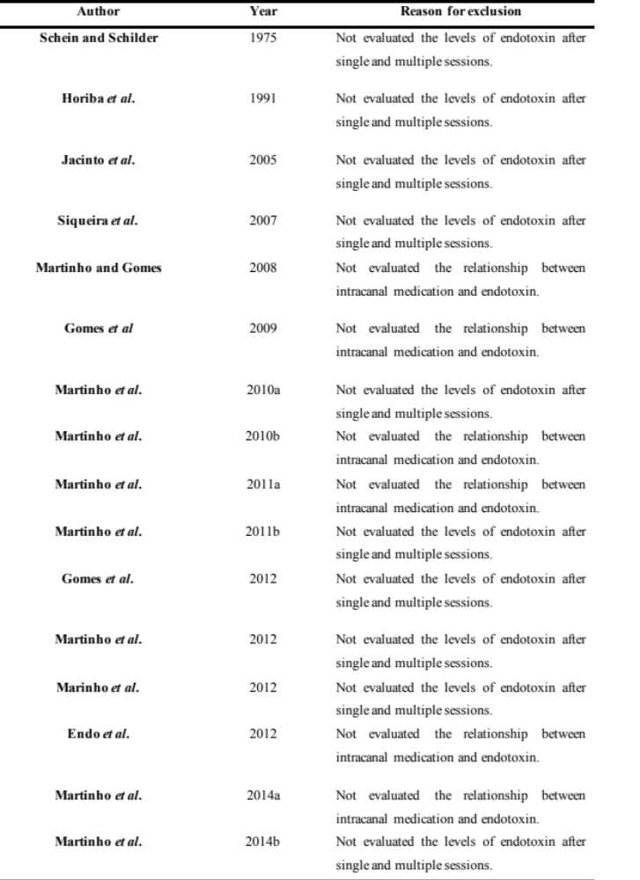
Table S1 - Excluded studies and reason for exclusion

