Prevalence and genotype distribution of viral hepatitis B in Cambodia between 1990 and 2020: A Systematic Review and Meta-analysis

Bunthen E^{1,2}, Pichetra Ou³, Serge Ouoba^{1,4}, Md Razeen Ashraf Hussain¹, Ko Ko¹, Shintaro Nagashima¹, Aya Sugiyama¹, Tomoyuki Akita¹, Junko Tanaka¹
Affiliations:
¹Department of Epidemiology, Infectious Disease Control and Prevention, Graduate School of Biomedical and Health Sciences, Hiroshima University, Japan
²Payment Certification Agency (PCA), Ministry of Health, Phnom Penh, Cambodia
³Fertility Clinic of Cambodia, Phnom Penh, Cambodia
⁴Unité de Recherche Clinique de Nanoro (URCN), Nanoro, Burkina Faso

Supplementary Table 1: Search strategy online databases
No. | Data Bases | Keys Words | Number
1 | PubMed | ("hepatitis b"[MeSH] OR "hepatitis b"[tw] OR "HBV"[tw] OR "hepatitis B surface antigen"[tw] OR "HbsAg"[tw])  AND  (("epidemiology"[MeSH] OR "prevalence"[MeSH] OR "prevalence"[tw] OR "seroprevalence" [tw] OR "seropositive"[tw]) OR ("dna, viral"[MeSH] OR "genotype"[Mesh]))  AND  "cambodia*"[All] | 40
2 | Web of Science | (TS="hepatitis B" OR TS= HBV OR TS=HbsAg)  AND  ((TS=prevalence OR TS=seroprevalence OR TS=seroepidemiology OR TS=epidemiology OR TS=survey) OR (TS=DNA OR TS=genotype OR TS= geno* OR TS=sequenc*))  AND  (TS=Cambodia*) | 54
3 | Scopus | ( ALL ( hepatitis AND b ) OR ALL ( hbv ) OR ALL ( hbsag )  AND  ALL ( prevalence ) OR ALL ( epidemiology ) OR ALL ( seropositive ) OR ALL ( seroprevalence ) OR ALL ( genotype ) OR ALL ( dna )  AND  TITLE-ABS-KEY ( cambodia ) ) | 252
4 | Google Scholar | ("hepatitis b virus" OR "HBV")  AND  ("HBV prevalence" OR " HBV genotype")  AND  ("Cambodia") | 317
Total |  |  | 663

Supplementary Table 2: PRISMA 2020 Main Checklist

Section and Topic | Item # | Checklist item | Location where item is reported
TITLE
Title | 1 | Identify the report as a systematic review. | 1
ABSTRACT
Abstract | 2 | See the PRISMA 2020 for Abstracts checklist.
INTRODUCTION
Rationale | 3 | Describe the rationale for the review in the context of existing knowledge. | 4-5
Objectives | 4 | Provide an explicit statement of the objective(s) or question(s) the review addresses. | 5
METHODS
Eligibility criteria | 5 | Specify the inclusion and exclusion criteria for the review and how studies were grouped for the syntheses. | 5
Information sources | 6 | Specify all databases, registers, websites, organisations, reference lists and other sources searched or consulted to identify studies. Specify the date when each source was last searched or consulted. | 5
Search strategy | 7 | Present the full search strategies for all databases, registers and websites, including any filters and limits used. | Supplementary Table 1
Selection process | 8 | Specify the methods used to decide whether a study met the inclusion criteria of the review, including how many reviewers screened each record and each report retrieved, whether they worked independently, and if applicable, details of automation tools used in the process. | 5-6
Data collection process | 9 | Specify the methods used to collect data from reports, including how many reviewers collected data from each report, whether they worked independently, any processes for obtaining or confirming data from study investigators, and if applicable, details of automation tools used in the process. | 6
Data items | 10a | List and define all outcomes for which data were sought. Specify whether all results that were compatible with each outcome domain in each study were sought (e.g. for all measures, time points, analyses), and if not, the methods used to decide which results to collect. | 6
Data items | 10b | List and define all other variables for which data were sought (e.g. participant and intervention characteristics, funding sources). Describe any assumptions made about any missing or unclear information. | 6
Study risk of bias assessment | 11 | Specify the methods used to assess risk of bias in the included studies, including details of the tool(s) used, how many reviewers assessed each study and whether they worked independently, and if applicable, details of automation tools used in the process. | 6
Effect measures | 12 | Specify for each outcome the effect measure(s) (e.g. risk ratio, mean difference) used in the synthesis or presentation of results. | 6-7
Synthesis methods | 13a | Describe the processes used to decide which studies were eligible for each synthesis (e.g. tabulating the study intervention characteristics and comparing against the planned groups for each synthesis (item #5)). | 6
Synthesis methods | 13b | Describe any methods required to prepare the data for presentation or synthesis, such as handling of missing summary statistics, or data conversions. | -
Synthesis methods | 13c | Describe any methods used to tabulate or visually display results of individual studies and syntheses. | -
Synthesis methods | 13d | Describe any methods used to synthesize results and provide a rationale for the choice(s). If meta-analysis was performed, describe the model(s), method(s) to identify the presence and extent of statistical heterogeneity, and software package(s) used. | 6-7
Synthesis methods | 13e | Describe any methods used to explore possible causes of heterogeneity among study results (e.g. subgroup analysis, meta-regression). | 7
Synthesis methods | 13f | Describe any sensitivity analyses conducted to assess robustness of the synthesized results. | -
Reporting bias assessment | 14 | Describe any methods used to assess risk of bias due to missing results in a synthesis (arising from reporting biases). | 7
Certainty assessment | 15 | Describe any methods used to assess certainty (or confidence) in the body of evidence for an outcome. | 7
RESULTS
Study selection | 16a | Describe the results of the search and selection process, from the number of records identified in the search to the number of studies included in the review, ideally using a flow diagram. | 7-8
Study selection | 16b | Cite studies that might appear to meet the inclusion criteria, but which were excluded, and explain why they were excluded. | -
Study characteristics | 17 | Cite each included study and present its characteristics. | Table 1
Risk of bias in studies | 18 | Present assessments of risk of bias for each included study. | 10  Supplementary Figure 3
Results of individual studies | 19 | For all outcomes, present, for each study: (a) summary statistics for each group (where appropriate) and (b) an effect estimate and its precision (e.g. confidence/credible interval), ideally using structured tables or plots. | Figure 1
Results of syntheses | 20a | For each synthesis, briefly summarise the characteristics and risk of bias among contributing studies. | 8-9
Results of syntheses | 20b | Present results of all statistical syntheses conducted. If meta-analysis was done, present for each the summary estimate and its precision (e.g. confidence/credible interval) and measures of statistical heterogeneity. If comparing groups, describe the direction of the effect. | Figure 2, Table 2, and Supplementary Figure 1 and 2
Results of syntheses | 20c | Present results of all investigations of possible causes of heterogeneity among study results. | 8-9
Results of syntheses | 20d | Present results of all sensitivity analyses conducted to assess the robustness of the synthesized results. | -
Reporting biases | 21 | Present assessments of risk of bias due to missing results (arising from reporting biases) for each synthesis assessed. | -
Certainty of evidence | 22 | Present assessments of certainty (or confidence) in the body of evidence for each outcome assessed. | Table 1
DISCUSSION
Discussion | 23a | Provide a general interpretation of the results in the context of other evidence. | 10
Discussion | 23b | Discuss any limitations of the evidence included in the review. | 12
Discussion | 23c | Discuss any limitations of the review processes used. | 12
Discussion | 23d | Discuss implications of the results for practice, policy, and future research. | 12-13
OTHER INFORMATION
Registration and protocol | 24a | Provide registration information for the review, including register name and registration number, or state that the review was not registered. | Not registered
Registration and protocol | 24b | Indicate where the review protocol can be accessed, or state that a protocol was not prepared. | Not prepared
Registration and protocol | 24c | Describe and explain any amendments to information provided at registration or in the protocol. | -
Support | 25 | Describe sources of financial or non-financial support for the review, and the role of the funders or sponsors in the review. | 14
Competing interests | 26 | Declare any competing interests of review authors. | 13
Availability of data, code and other materials | 27 | Report which of the following are publicly available and where they can be found: template data collection forms; data extracted from included studies; data used for all analyses; analytic code; any other materials used in the review. | 13

From: Page MJ, McKenzie JE, Bossuyt PM, Boutron I, Hoffmann TC, Mulrow CD, et al. The PRISMA 2020 statement: an updated guideline for reporting systematic reviews. BMJ 2021;372:n71. doi: 10.1136/bmj.n71

Supplementary Table 3: PRISMA Abstract Checklist

Topic | No. | Item | Reported?
TITLE
Title | 1 | Identify the report as a systematic review. | Yes
BACKGROUND
Objectives | 2 | Provide an explicit statement of the main objective(s) or question(s) the review addresses. | Yes
METHODS
Eligibility criteria | 3 | Specify the inclusion and exclusion criteria for the review. | Yes
Information sources | 4 | Specify the information sources (e.g. databases, registers) used to identify studies and the date when each was last searched. | Yes
Risk of bias | 5 | Specify the methods used to assess risk of bias in the included studies. | Yes
Synthesis of results | 6 | Specify the methods used to present and synthesize results. | Yes
RESULTS
Included studies | 7 | Give the total number of included studies and participants and summarise relevant characteristics of studies. | Yes
Synthesis of results | 8 | Present results for main outcomes, preferably indicating the number of included studies and participants for each. If meta-analysis was done, report the summary estimate and confidence/credible interval. If comparing groups, indicate the direction of the effect (i.e. which group is favoured). | Yes
DISCUSSION
Limitations of evidence | 9 | Provide a brief summary of the limitations of the evidence included in the review (e.g. study risk of bias, inconsistency and imprecision). | No
Interpretation | 10 | Provide a general interpretation of the results and important implications. | Yes
OTHER
Funding | 11 | Specify the primary source of funding for the review. | No
Registration | 12 | Provide the register name and registration number. | No

From: Page MJ, McKenzie JE, Bossuyt PM, Boutron I, Hoffmann TC, Mulrow CD, et al. The PRISMA 2020 statement: an updated guideline for reporting systematic reviews. MetaArXiv. 2020, September 14. DOI: 10.31222/osf.io/v7gm2. For more information, visit: www.prisma-statement.org
Supplementary Figure 1: Estimate prevalence of HBV infection in Cambodia by study area, 1990-2020
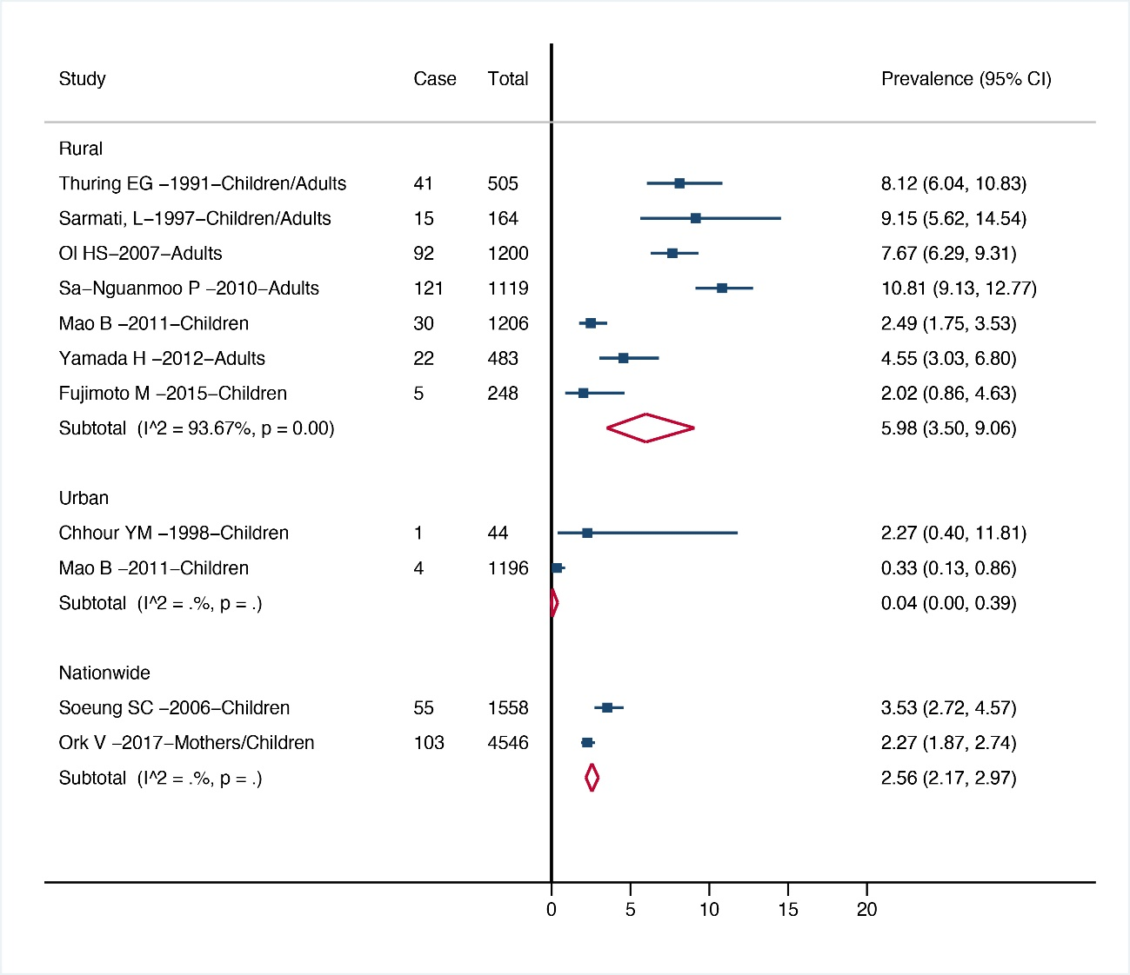

Supplementary Figure 2: Estimate prevalence of HBV infection prevalence among children (≤15 years old) by study area in Cambodia, 1990-2020

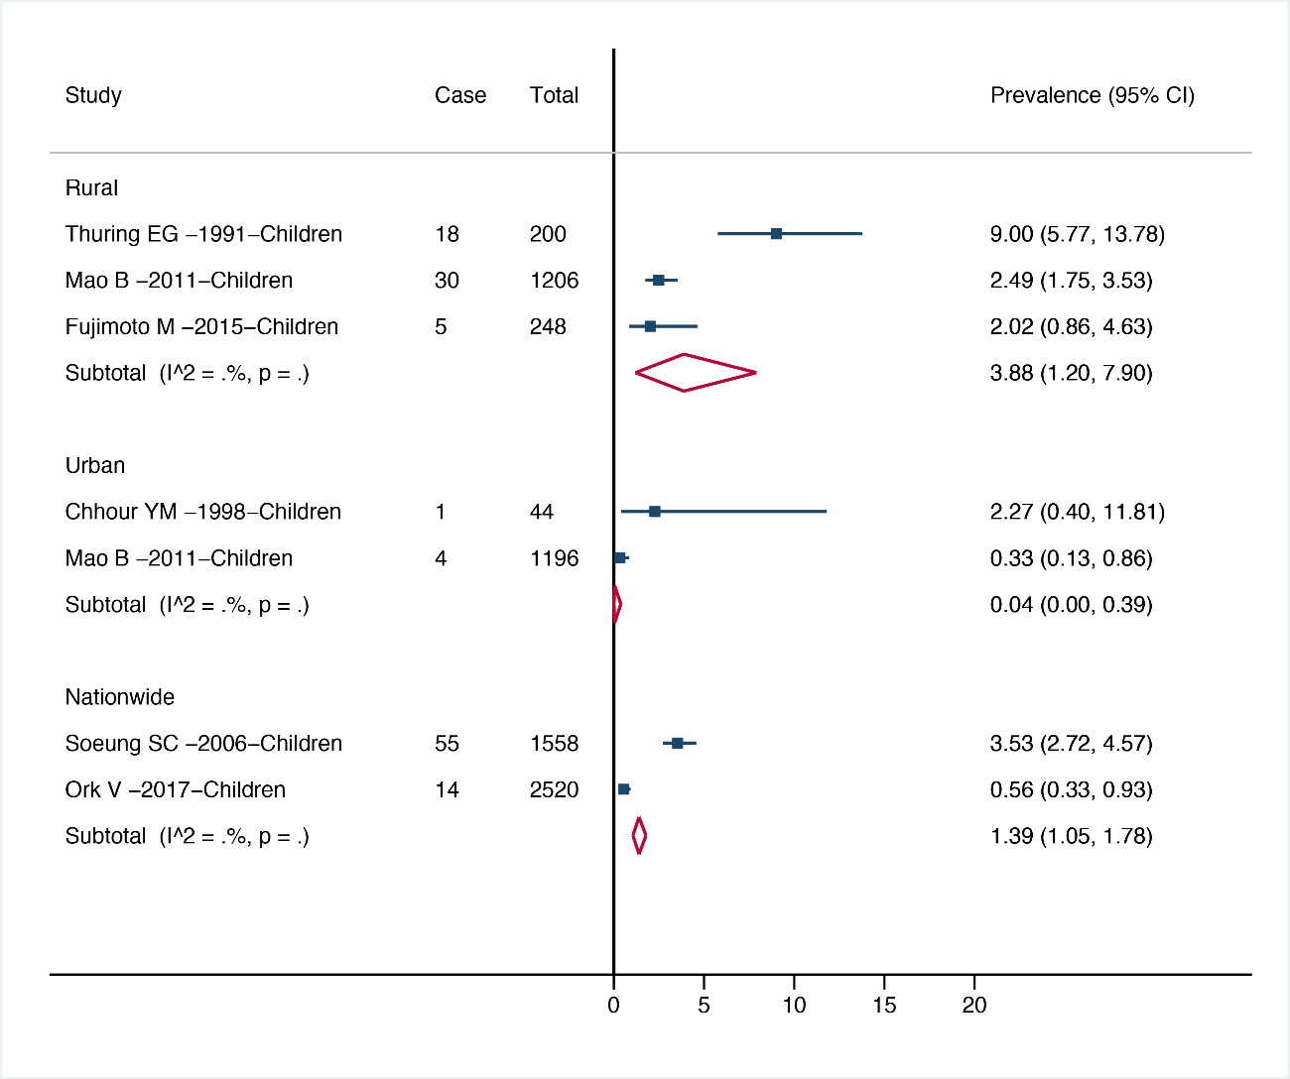

Supplementary Figure 3: Funnel plot for publication bias

Supplementary Figure Legend
Supplementary Figure 1: This figure shown the results of sub-group analysis among general population based on study area. The study area was divided into three groups, rural areas, urban area and nationwide. The blue square presented the prevalent of HBV infection in each individual study with 95% confident interval. The red diamond showed the HBV infection pooled prevalent of each population group.
Supplementary Figure 2: This figure shown the results of sub-group analysis among children aged equal or less than 15 years old based on study area. The study area was divided into three groups, rural areas, urban area and nationwide. The blue square presented the prevalent of HBV infection in each individual study with 95% confident interval. The red diamond showed the HBV infection pooled prevalent of each population group.
Supplementary Figure 3: This figure shown the Funnel plot of arcsine of the estimate HBV infection prevalence by its reverse variance. Each blue dot represents the prevalence of each study. SE, standard error.

