Supplementary

Comparison of Personal Sound Amplification Products and Conventional Hearing Aids for Patients with Hearing Loss: A Systematic Review with Meta-Analysis
Chih-Hao Chen, Chii-Yuan Huang, Hsiu-Lien Cheng, Heng-Yu Haley Lin, Yuan-Chia Chu, Chun-Yu Chang, Ying-Hui Lai, Mao-Che Wang and Yen-Fu Cheng

Supplementary file 1. Detailed search strategy
Database | Query
PubMed | ("Personal Sound Amplification Products"[Title/Abstract] OR "Personal Sound Amplification Product"[Title/Abstract] OR "PSAPs"[Title/Abstract] OR "PSAP"[Title/Abstract] OR "Sound amplification"[Title/Abstract] OR "Amplification products"[Title/Abstract] OR "Amplification product"[Title/Abstract] OR "Sound amplifier"[Title/Abstract] OR "Sound amplification"[Title/Abstract] OR "Amplification products"[Title/Abstract] OR "Personal Sound Amplification Products"[All Fields] OR "Personal Sound Amplification Product"[All Fields] OR "PSAPs"[All Fields] OR "PSAP"[All Fields] OR "Sound amplification"[All Fields] OR "Amplification products"[All Fields] OR "Amplification product"[All Fields] OR (("person s"[All Fields] OR "personable"[All Fields] OR "personableness"[All Fields] OR "personal"[All Fields] OR "personalisation"[All Fields] OR "personalise"[All Fields] OR "personalised"[All Fields] OR "personalising"[All Fields] OR "personality"[MeSH Terms] OR "personality"[All Fields] OR "personalities"[All Fields] OR "personality s"[All Fields] OR "personalization"[All Fields] OR "personalize"[All Fields] OR "personalized"[All Fields] OR "personalizes"[All Fields] OR "personalizing"[All Fields] OR "personally"[All Fields] OR "personals"[All Fields] OR "persons"[MeSH Terms] OR "persons"[All Fields] OR "person"[All Fields]) AND ("sound"[MeSH Terms] OR "sound"[All Fields] OR "sounded"[All Fields] OR "soundings"[All Fields] OR "sounds"[All Fields] OR "sound s"[All Fields] OR "sounding"[All Fields]) AND ("amplifiability"[All Fields] OR "amplifiable"[All Fields] OR "amplified"[All Fields] OR "amplifier s"[All Fields] OR "amplifiers, electronic"[MeSH Terms] OR ("amplifiers"[All Fields] AND "electronic"[All Fields]) OR "electronic amplifiers"[All Fields] OR "amplifier"[All Fields] OR "amplifiers"[All Fields] OR "amplifies"[All Fields] OR "amplify"[All Fields] OR "amplifying"[All Fields])) OR (("person s"[All Fields] OR "personable"[All Fields] OR "personableness"[All Fields] OR "personal"[All Fields] OR "personalisation"[All Fields] OR "personalise"[All Fields] OR "personalised"[All Fields] OR "personalising"[All Fields] OR "personality"[MeSH Terms] OR "personality"[All Fields] OR "personalities"[All Fields] OR "personality s"[All Fields] OR "personalization"[All Fields] OR "personalize"[All Fields] OR "personalized"[All Fields] OR "personalizes"[All Fields] OR "personalizing"[All Fields] OR "personally"[All Fields] OR "personals"[All Fields] OR "persons"[MeSH Terms] OR "persons"[All Fields] OR "person"[All Fields]) AND ("sound"[MeSH Terms] OR "sound"[All Fields] OR "sounded"[All Fields] OR "soundings"[All Fields] OR "sounds"[All Fields] OR "sound s"[All Fields] OR "sounding"[All Fields]) AND ("amplifiability"[All Fields] OR "amplifiable"[All Fields] OR "amplified"[All Fields] OR "amplifier s"[All Fields] OR "amplifiers, electronic"[MeSH Terms] OR ("amplifiers"[All Fields] AND "electronic"[All Fields]) OR "electronic amplifiers"[All Fields] OR "amplifier"[All Fields] OR "amplifiers"[All Fields] OR "amplifies"[All Fields] OR "amplify"[All Fields] OR "amplifying"[All Fields])) OR "Sound amplifier"[All Fields] OR (("sound"[MeSH Terms] OR "sound"[All Fields] OR "sounded"[All Fields] OR "soundings"[All Fields] OR "sounds"[All Fields] OR "sound s"[All Fields] OR "sounding"[All Fields]) AND ("amplifiability"[All Fields] OR "amplifiable"[All Fields] OR "amplified"[All Fields] OR "amplifier s"[All Fields] OR "amplifiers, electronic"[MeSH Terms] OR ("amplifiers"[All Fields] AND "electronic"[All Fields]) OR "electronic amplifiers"[All Fields] OR "amplifier"[All Fields] OR "amplifiers"[All Fields] OR "amplifies"[All Fields] OR "amplify"[All Fields] OR "amplifying"[All Fields])) OR (("amplifiability"[All Fields] OR "amplifiable"[All Fields] OR "amplified"[All Fields] OR "amplifier s"[All Fields] OR "amplifiers, electronic"[MeSH Terms] OR ("amplifiers"[All Fields] AND "electronic"[All Fields]) OR "electronic amplifiers"[All Fields] OR "amplifier"[All Fields] OR "amplifiers"[All Fields] OR "amplifies"[All Fields] OR "amplify"[All Fields] OR "amplifying"[All Fields]) AND ("economics"[MeSH Terms] OR "economics"[All Fields] OR "production"[All Fields] OR "productions"[All Fields] OR "efficiency"[MeSH Terms] OR "efficiency"[All Fields] OR "productivity"[All Fields] OR "product"[All Fields] OR "product s"[All Fields] OR "productive"[All Fields] OR "productively"[All Fields] OR "productivities"[All Fields] OR "products"[All Fields])) OR (("amplifiability"[All Fields] OR "amplifiable"[All Fields] OR "amplified"[All Fields] OR "amplifier s"[All Fields] OR "amplifiers, electronic"[MeSH Terms] OR ("amplifiers"[All Fields] AND "electronic"[All Fields]) OR "electronic amplifiers"[All Fields] OR "amplifier"[All Fields] OR "amplifiers"[All Fields] OR "amplifies"[All Fields] OR "amplify"[All Fields] OR "amplifying"[All Fields]) AND ("economics"[MeSH Terms] OR "economics"[All Fields] OR "production"[All Fields] OR "productions"[All Fields] OR "efficiency"[MeSH Terms] OR "efficiency"[All Fields] OR "productivity"[All Fields] OR "product"[All Fields] OR "product s"[All Fields] OR "productive"[All Fields] OR "productively"[All Fields] OR "productivities"[All Fields] OR "products"[All Fields])) OR "Sound amplification"[All Fields] OR "Amplification products"[All Fields]) AND ("hearing aids/classification"[MeSH Terms] OR "hearing aids/economics"[MeSH Terms] OR "hearing aids/education"[MeSH Terms] OR "hearing aids/instrumentation"[MeSH Terms] OR "hearing aids/methods"[MeSH Terms] OR "hearing aids/rehabilitation"[MeSH Terms] OR "hearing aids/statistics and numerical data"[MeSH Terms] OR "hearing aids/therapeutic use"[MeSH Terms] OR "hearing aids/therapy"[MeSH Terms] OR "Hearing Aids"[MeSH Terms] OR "Hearing Aid"[Title/Abstract] OR "Hearing Aids"[Title/Abstract] OR "Ear Molds"[Title/Abstract] OR "Ear Mold"[Title/Abstract] OR "Hearing Aid"[All Fields] OR "Hearing Aids"[All Fields] OR "Ear Molds"[All Fields] OR "Ear Mold"[All Fields])
Embase | ('personal sound amplification products' OR 'personal sound amplification product' OR psaps OR psap OR 'amplification product' OR 'personal sound amplifier' OR 'personal sound amplifiers' OR 'sound amplifier' OR 'sound amplifiers' OR 'amplifier product' OR 'amplifier products' OR 'sound amplification' OR 'amplification products') AND ('hearing aid'/exp OR 'hearing aids' OR 'ear molds' OR 'ear mold' OR 'earmold'/exp)
Web of Science | TS=(("Personal Sound Amplification Products" OR "Personal Sound Amplification Product" OR "PSAPs" OR "PSAP" OR "Sound amplification" OR "Amplification products" OR "Amplification product" OR "Personal sound amplifier" OR "Personal sound amplifiers" OR "Sound amplifier" OR "Sound amplifiers" OR "Amplifier product" OR "Amplifier products" OR " Sound amplification" OR " Amplification products")AND("Hearing Aid" OR "Hearing Aids" OR "Ear Molds" OR "Ear Mold"))
Scopus | (TITLE-ABS-KEY("Personal Sound Amplification Products" OR "Personal Sound Amplification Product" OR "PSAPs" OR "PSAP" OR "Sound amplification" OR "Amplification products" OR "Amplification product" OR "Personal sound amplifier" OR "Personal sound amplifiers" OR "Sound amplifier" OR "Sound amplifiers" OR "Amplifier product" OR "Amplifier products" OR " Sound amplification" OR " Amplification products") AND TITLE-ABS-KEY("Hearing Aid" OR "Hearing Aids" OR "Ear Molds" OR "Ear Mold")
Cochrane Library | ID Search  #1 Personal Sound Amplification Products  #2 Personal Sound Amplification Product  #3 PSAPs  #4 PSAP  #5 Sound amplification  #6 Amplification products  #7 Amplification product  #8 Personal sound amplifier  #9 Personal sound amplifiers  #10 Sound amplifier  #11 Sound amplifiers  #12 Amplifier product  #13 Amplifier products  #14 Sound amplification  #15 Amplification products  #16 {OR #1-#15}  #17 MeSH descriptor: [Hearing Aids] explode all trees and with qualifier(s): [classification - CL]  #18 MeSH descriptor: [Hearing Aids] explode all trees and with qualifier(s): [economics - EC]  #19 MeSH descriptor: [Hearing Aids] explode all trees  #20 MeSH descriptor: [Hearing Aids] explode all trees and with qualifier(s): [statistics & numerical data - SN]  #21 Hearing Aid  #22 Hearing Aids  #23 Ear Molds  #24 Ear Mold  #25 {OR #17-#24}  #26 #16 AND #25

Supplementary file 2. Evaluation of Risk of Bias.

- Risk of Bias of each included study
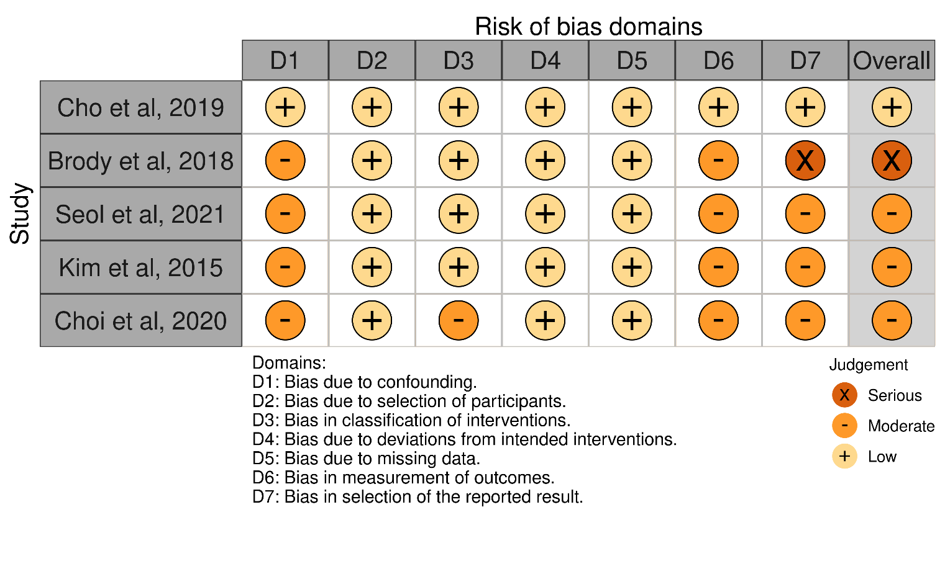
The Risk of Bias in Non-randomized Studies - of Interventions (ROBINS-I) was used to evaluate to quality of included studies.

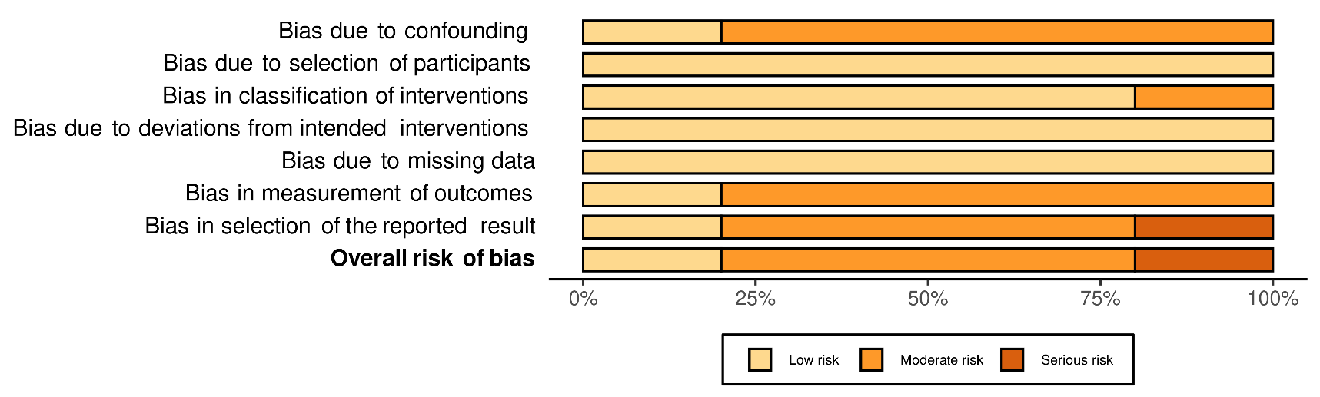
2. Summary of Risk of Bias. Overall, 60% of the studies are subject to moderate risk of bias while another 20% are subject to serious risk of bias. 80% of studies have moderate risk in bias due to confounding. 20% of studies have moderated risk of bias in classification of interventions. 80% of studies have moderate risk in bias in meaurement of outcomes. 60% of studies have moderate risk in bias in selection of the reported result.

Supplementary file 3. Sensitivity test

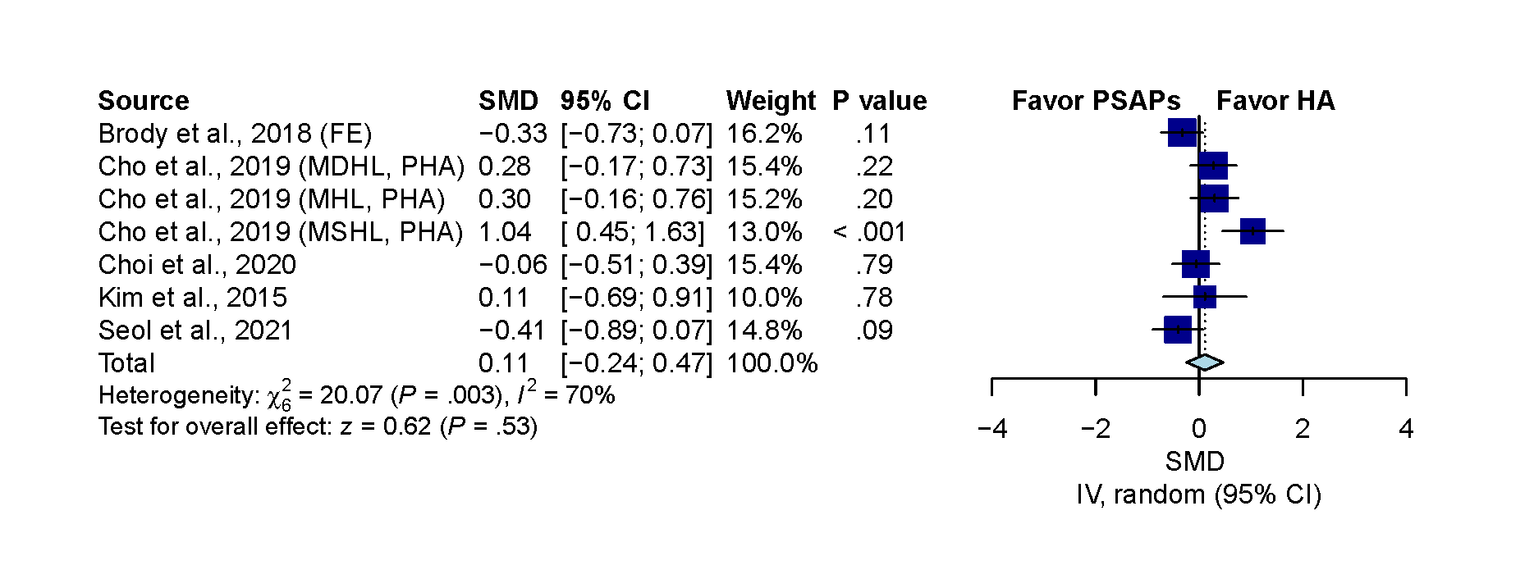
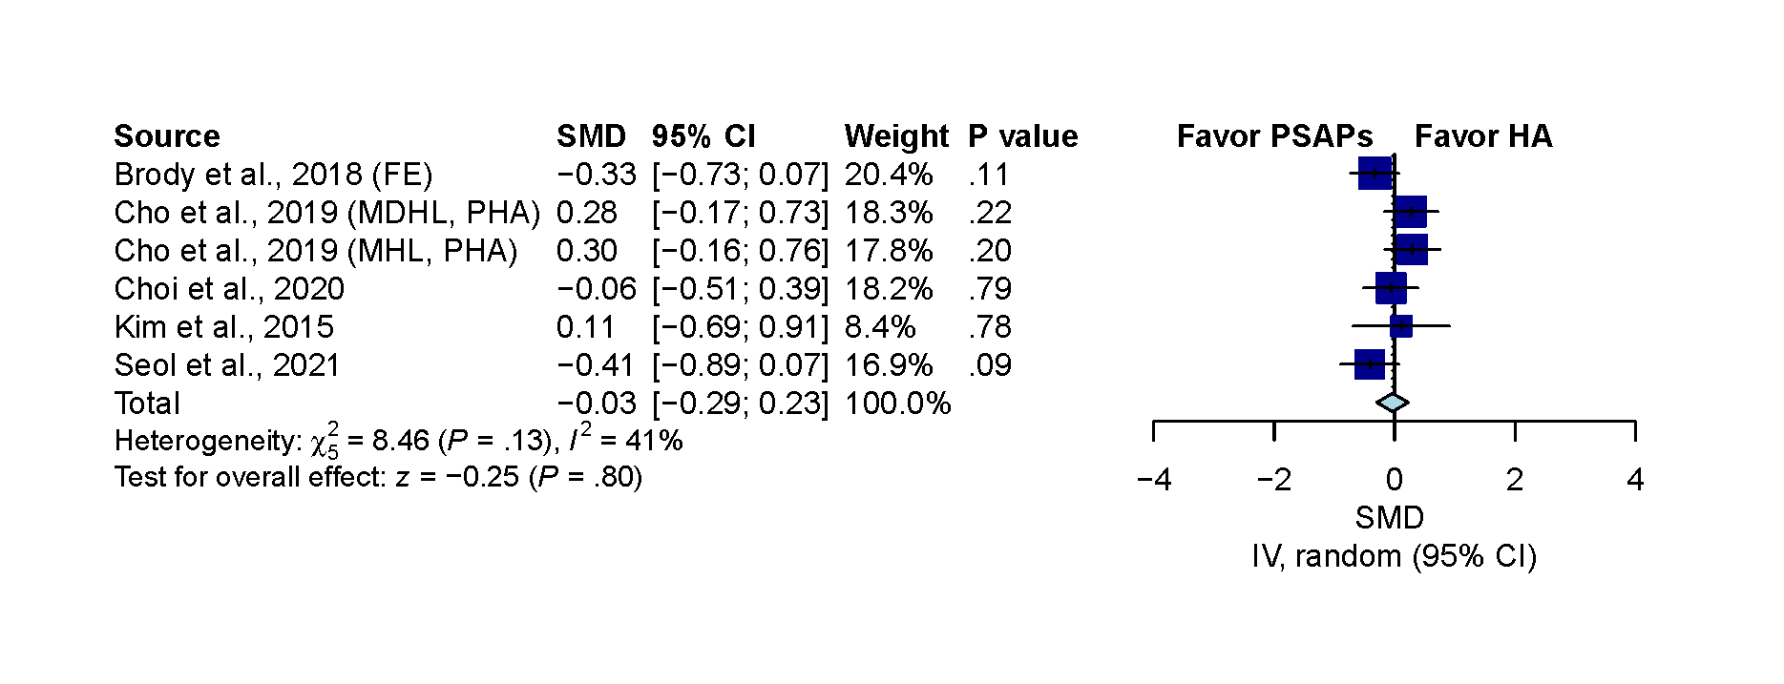
Figure 1. Sensitivity analysis for overall comparison by FocusEar personal sound amplification product (PSAP) in Brody et al and premium hearing aid in Cho et al. (A)The pooled result showed non-significant difference. (SMD, 0.11; 95% CI, -0.24 to 0.47; P=.53; I²=70%). (B) After excluding moderate severe hearing loss patient in Cho et al, the result remained non-significant (SMD, -0.03; 95% CI, -0.29 to 0.23; P=.80; I²=41%). IV indicates the inverse variance method; FE indicates that the analysis adopted FocusEar PSAP used in Brody et al; MHL indicates mild hearing loss; MDHL indicates moderate hearing loss; MSHL indicates moderately severe hearing loss. PHA indicates premium hearing aid used in Cho et al.
A
B
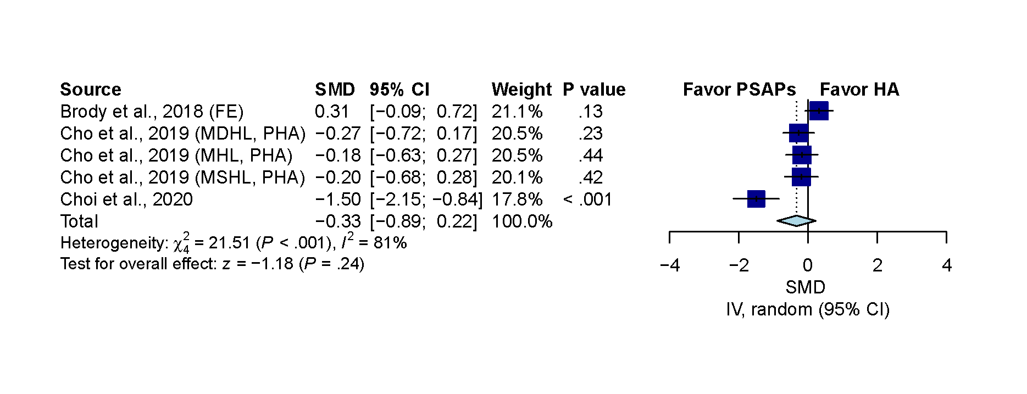
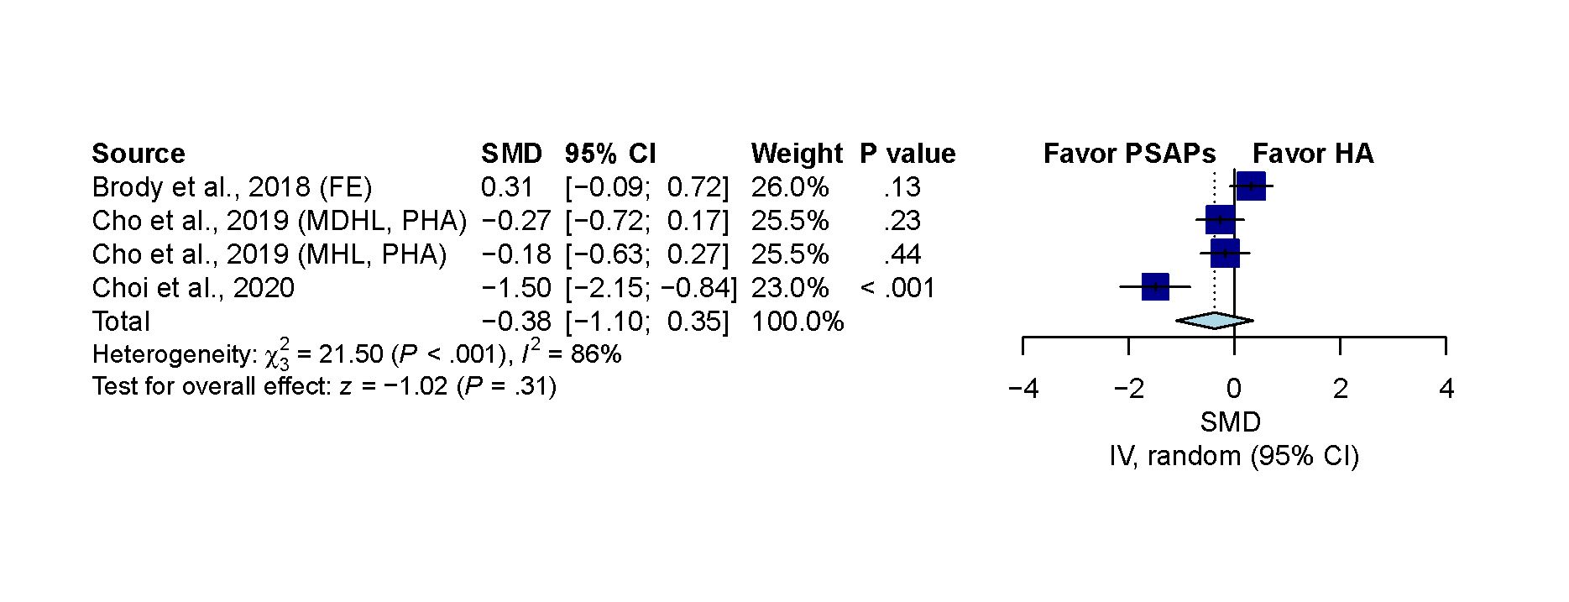
Figure 2. Sensitivity analysis for sound quality comparison by FocusEar PSAP in Brody et al and premium hearing aid in Cho et al. (A)The pooled result showed non-significant difference. (SMD, -0.33; 95% CI, -0.89 to 0.22; P=.24; I²=81%). (B) After excluding moderate severe hearing loss patient in Cho et al, the result remained non-significant (SMD, -0.38; 95% CI, -1.10 to 0.35; P=.31; I²=86%). IV indicates the inverse variance method; FE indicates that the analysis adopted FocusEar PSAP used in Brody et al; MHL indicates mild hearing loss; MDHL indicates moderate hearing loss; MSHL indicates moderately severe hearing loss. PHA indicates premium hearing aid used in Cho et al.
A
B

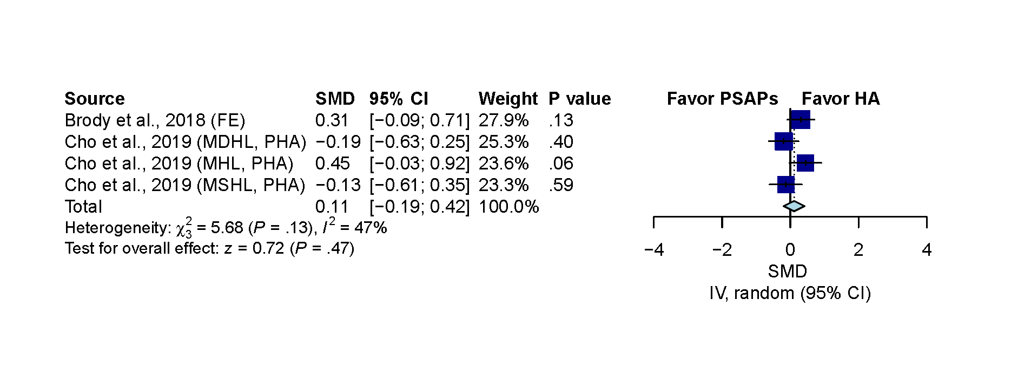
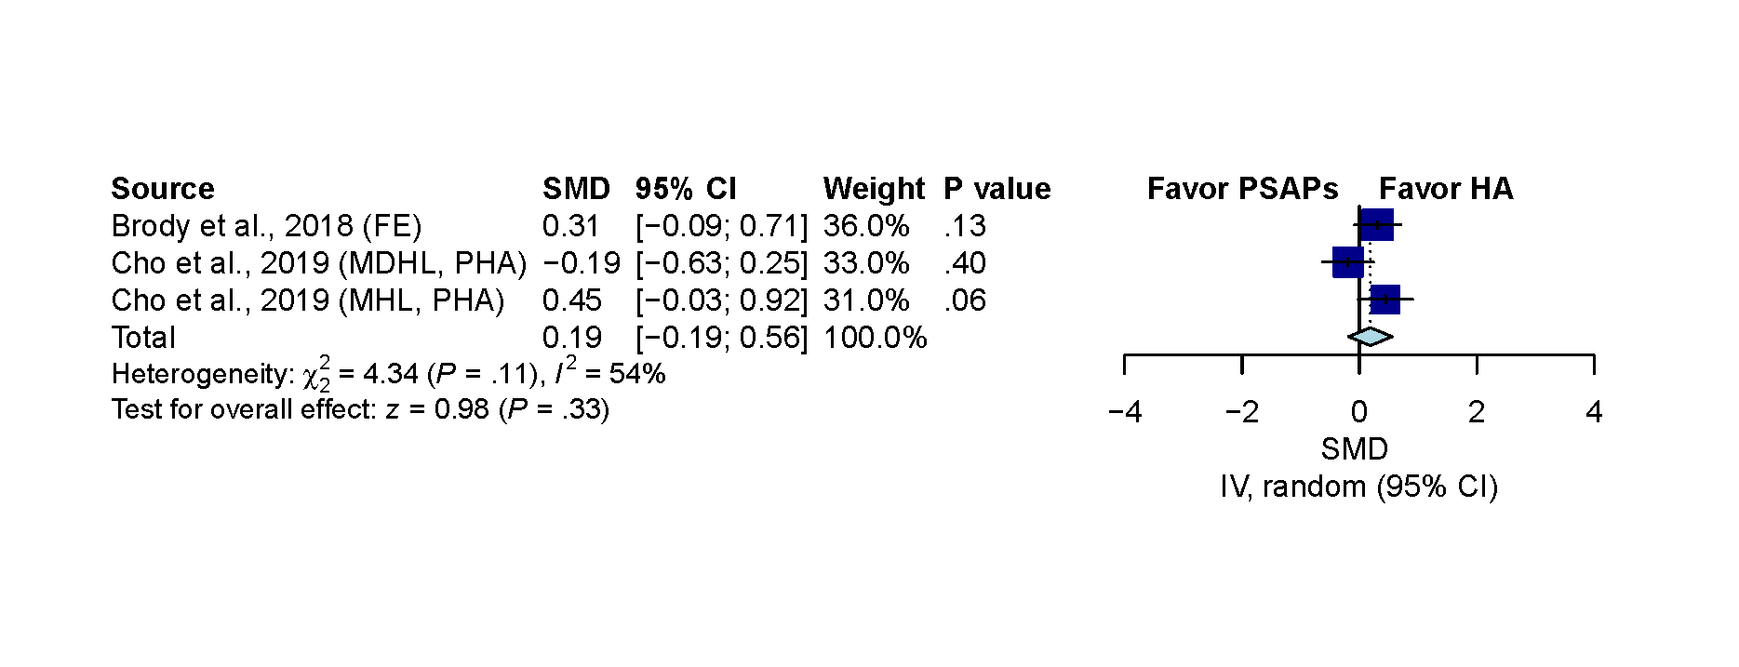
Figure 3. Sensitivity analysis for listening effort comparison by FocusEar PSAP in Brody et al and premium hearing aid in Cho et al. (A)The pooled result showed non-significant difference. (SMD, 0.11; 95% CI, -0.19 to 0.42; P=.47; I²=47%). (B) After excluding moderate severe hearing loss patient in Cho et al, the result remained non-significant (SMD, 0.19; 95% CI, -0.19 to 0.56; P=.33; I²=54%). IV indicates the inverse variance method; FE indicates that the analysis adopted FocusEar PSAP used in Brody et al; MHL indicates mild hearing loss; MDHL indicates moderate hearing loss; MSHL indicates moderately severe hearing loss. PHA indicates premium hearing aid used in Cho et al.
A
B

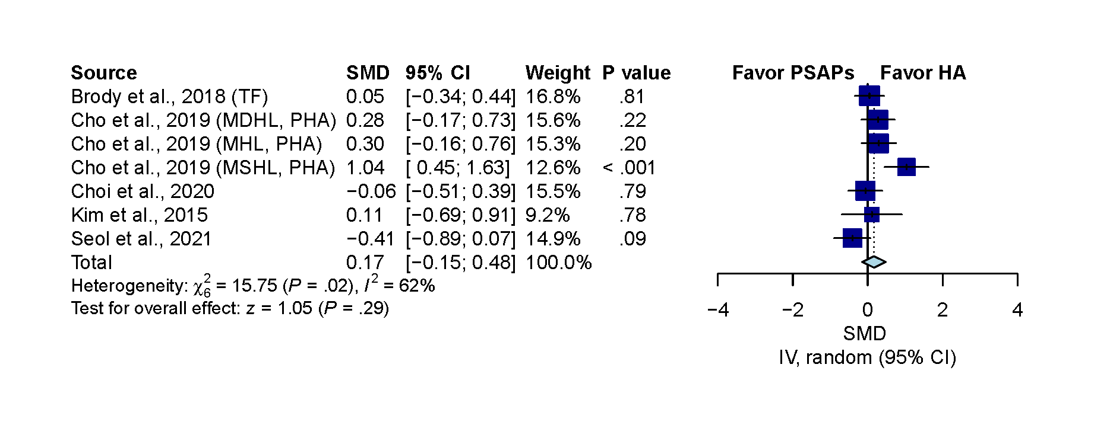
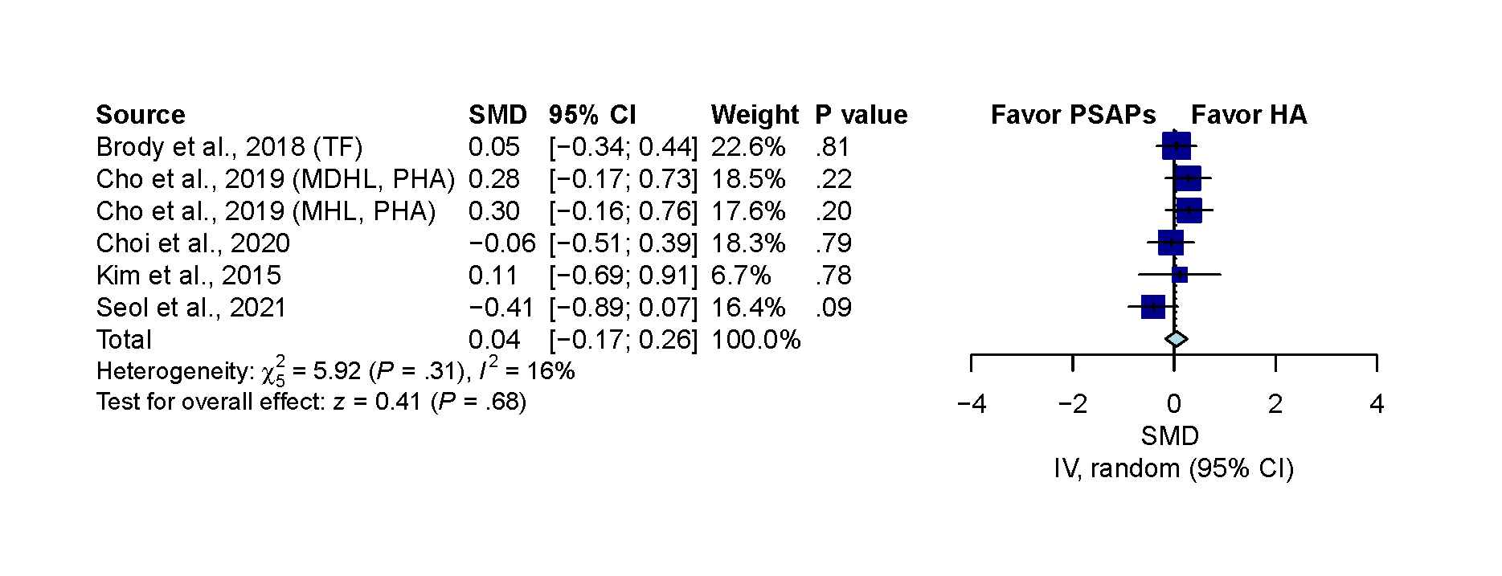
Figure 4. Sensitivity analysis for overall comparison by Tweak Focus PSAP in Brody et al and premium hearing aid in Cho et al. (A)The pooled result showed non-significant difference. (SMD, 0.17; 95% CI, -0.15 to 0.48; P=.29; I²=62%). (B) After excluding moderate severe hearing loss patient in Cho et al, the result remained non-significant (SMD, 0.04; 95% CI, -0.17 to 0.26; P=.68; I²=16%). IV indicates the inverse variance method; TF indicates that the analysis adopted Tweak Focus PSAP used in Brody et al; MHL indicates mild hearing loss; MDHL indicates moderate hearing loss; MSHL indicates moderately severe hearing loss. PHA indicates premium hearing aid used in Cho et al.
A
B
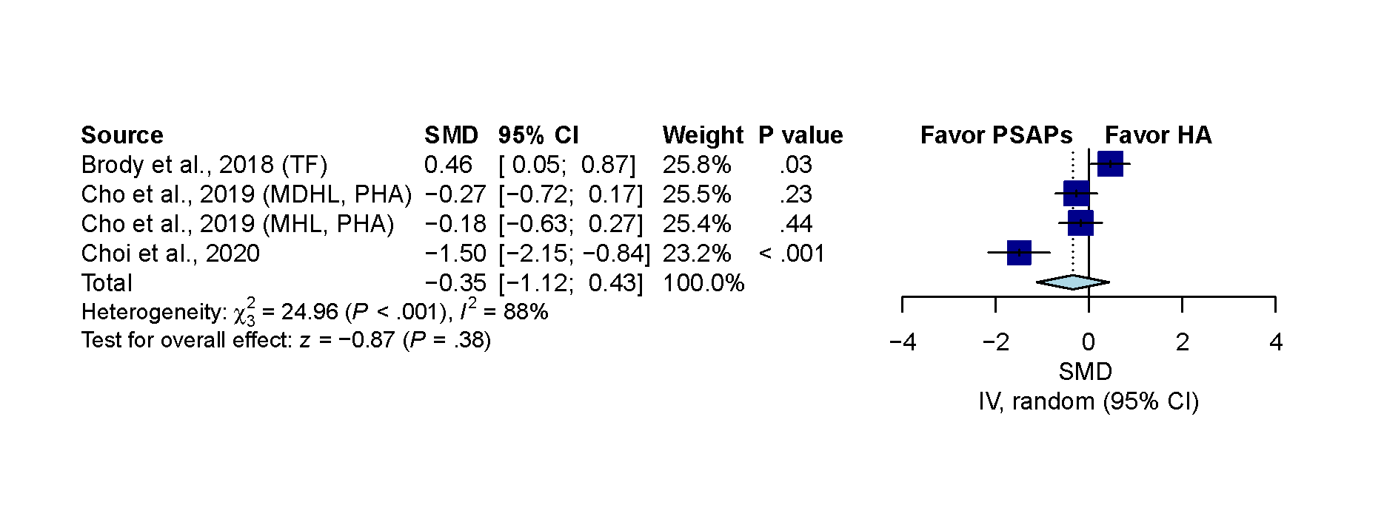
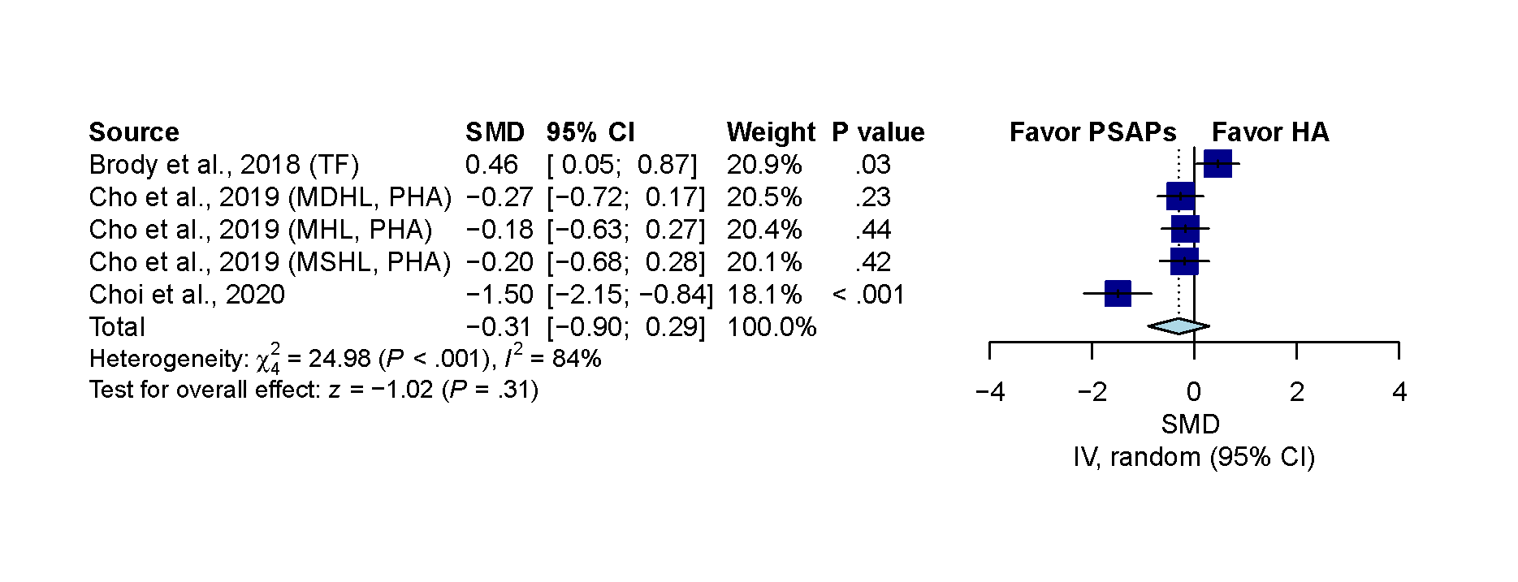
Figure 5. Sensitivity analysis for sound quality comparison by Tweak Focus PSAP in Brody et al and premium hearing aid in Cho et al. (A)The pooled result showed non-significant difference. (SMD, -0.31; 95% CI, -0.90 to 0.29; P=.31; I²=84%). (B) After excluding moderate severe hearing loss patient in Cho et al, the result remained non-significant (SMD, -0.35; 95% CI, -1.12 to 0.43; P=.38; I²=88%). IV indicates the inverse variance method; TF indicates that the analysis adopted Tweak Focus PSAP used in Brody et al; MHL indicates mild hearing loss; MDHL indicates moderate hearing loss; MSHL indicates moderately severe hearing loss. PHA indicates premium hearing aid used in Cho et al.
A
B

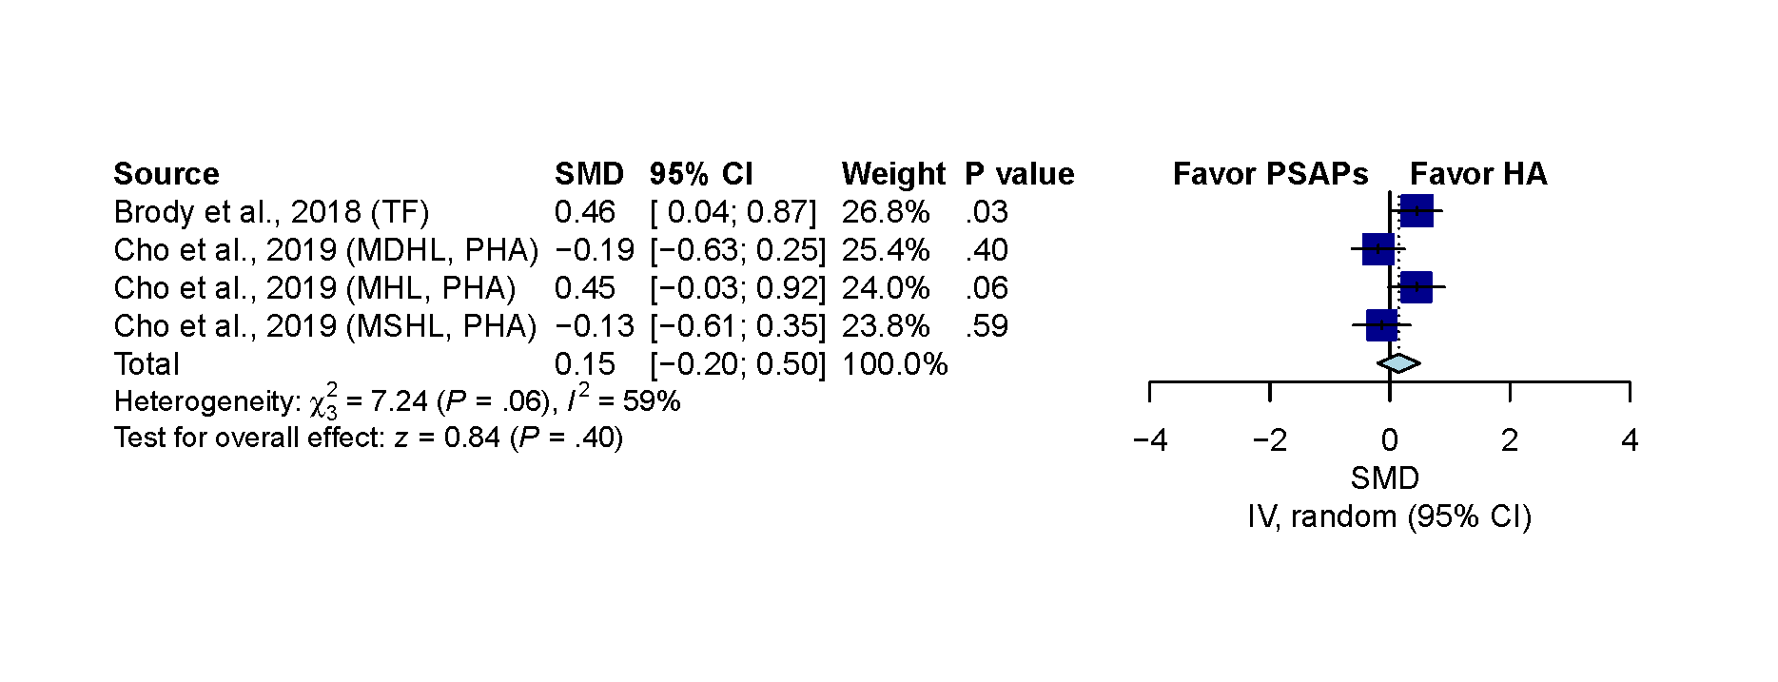
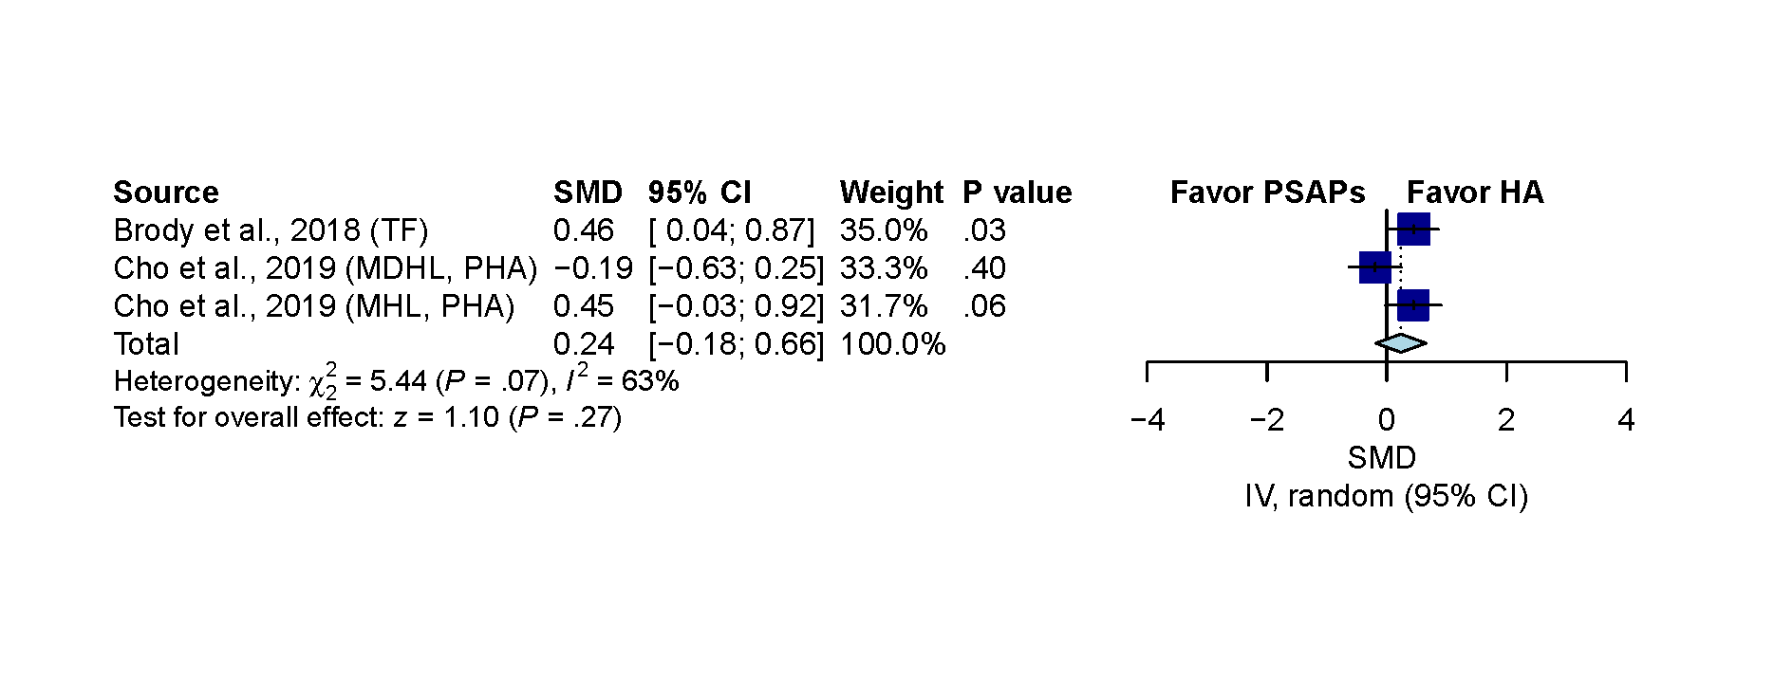
Figure 6. Sensitivity analysis for listening effort comparison by Tweak Focus PSAP in Brody et al and premium hearing aid in Cho et al. (A)The pooled result showed non-significant difference. (SMD, 0.15; 95% CI, -0.20 to 0.50; P=.40; I²=59%). (B) After excluding moderate severe hearing loss patient in Cho et al, the result remained non-significant (SMD, 0.24; 95% CI, -0.18 to 0.66; P=.27; I²=63%). IV indicates the inverse variance method; TF indicates that the analysis adopted Tweak Focus PSAP used in Brody et al; MHL indicates mild hearing loss; MDHL indicates moderate hearing loss; MSHL indicates moderately severe hearing loss. PHA indicates premium hearing aid used in Cho et al.
A
B

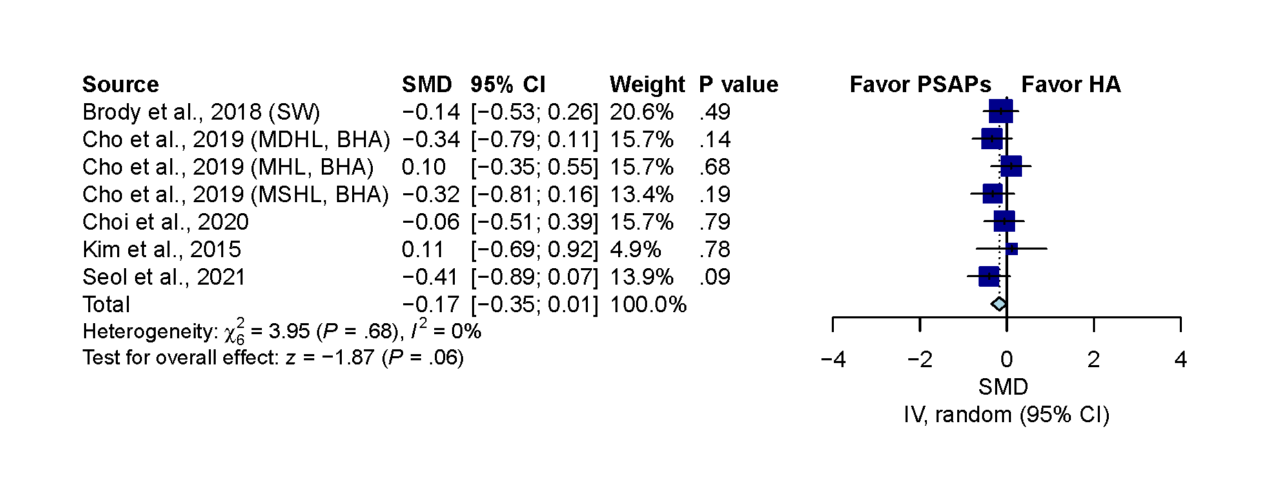
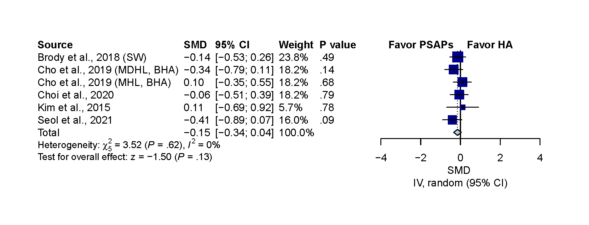
Figure 7. Sensitivity analysis for overall comparison by Sound world solution CS50+ PSAP in Brody et al and basic hearing aid in Cho et al. (A)The pooled result showed non-significant difference. (SMD, -0.17; 95% CI, -0.35 to 0.01; P=.06; I²=0%). (B) After excluding moderate severe hearing loss patient in Cho et al, the result remained non-significant (SMD, -0.15; 95% CI, -0.34 to 0.04; P=.13; I²=0%). IV indicates the inverse variance method; SW indicates that the analysis adopted Sound Would Solution CS50+ PSAP used in Brody et al; MHL indicates mild hearing loss; MDHL indicates moderate hearing loss; MSHL indicates moderately severe hearing loss. BHA indicates basic hearing aid used in Cho et al.
A
B

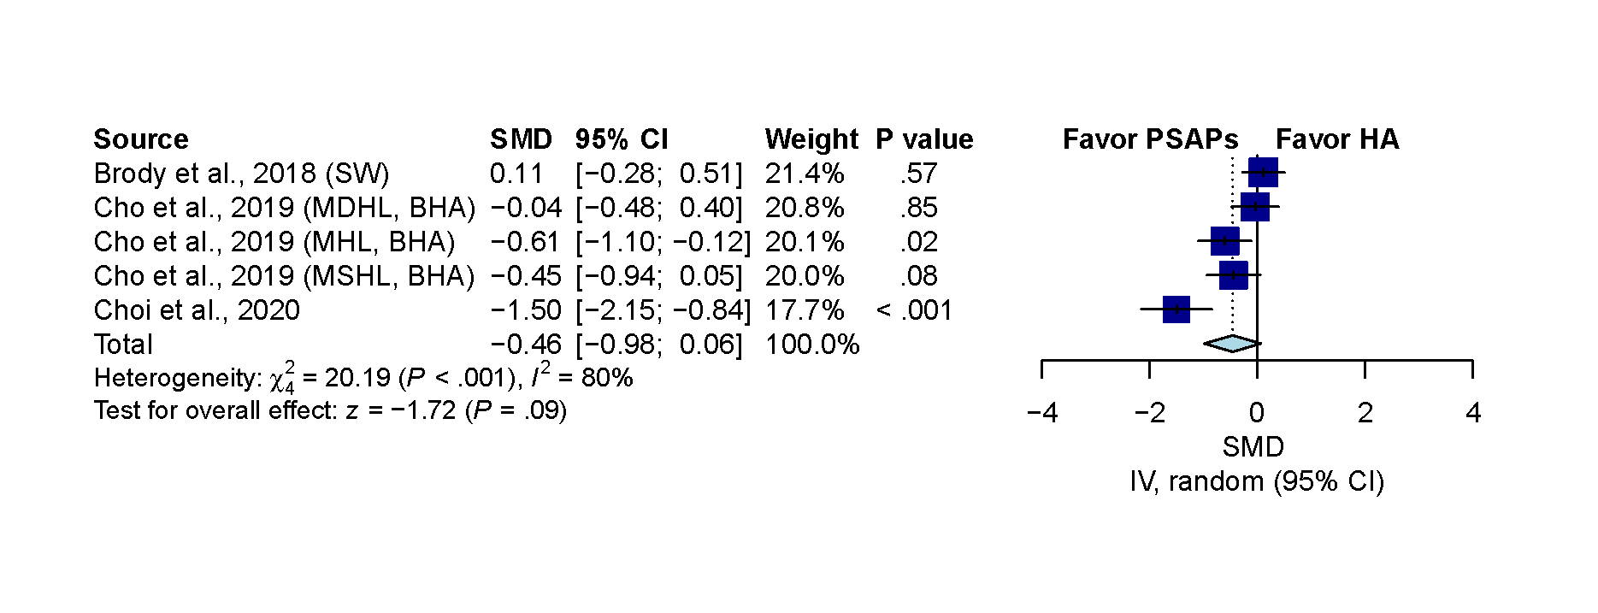
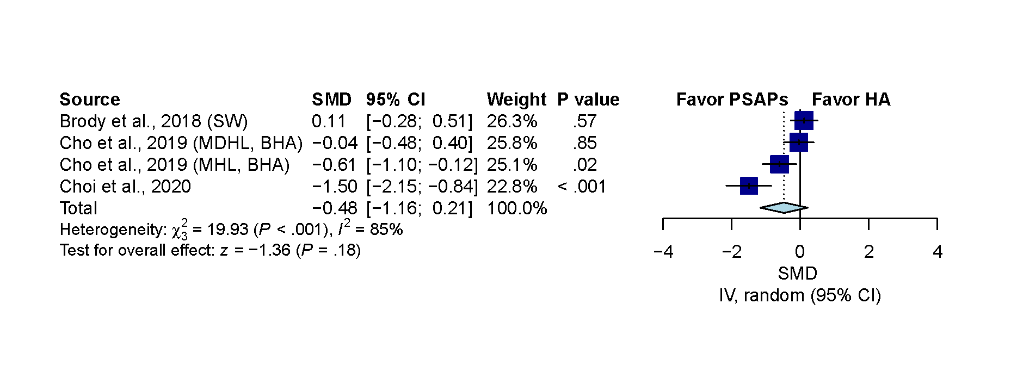
Figure 8. Sensitivity analysis for sound quality comparison by Sound world solution CS50+ PSAP in Brody et al and basic hearing aid in Cho et al. (A)The pooled result showed non-significant difference. (SMD, -0.46; 95% CI, -0.98 to 0.06; P=.09; I²=80%). (B) After excluding moderate severe hearing loss patient in Cho et al, the result remained non-significant (SMD, -0.48; 95% CI, -1.16 to 0.21; P=.18; I²=85%). IV indicates the inverse variance method; SW indicates that the analysis adopted Sound Would Solution CS50+ PSAP used in Brody et al; MHL indicates mild hearing loss; MDHL indicates moderate hearing loss; MSHL indicates moderately severe hearing loss. BHA indicates basic hearing aid used in Cho et al.
A
B
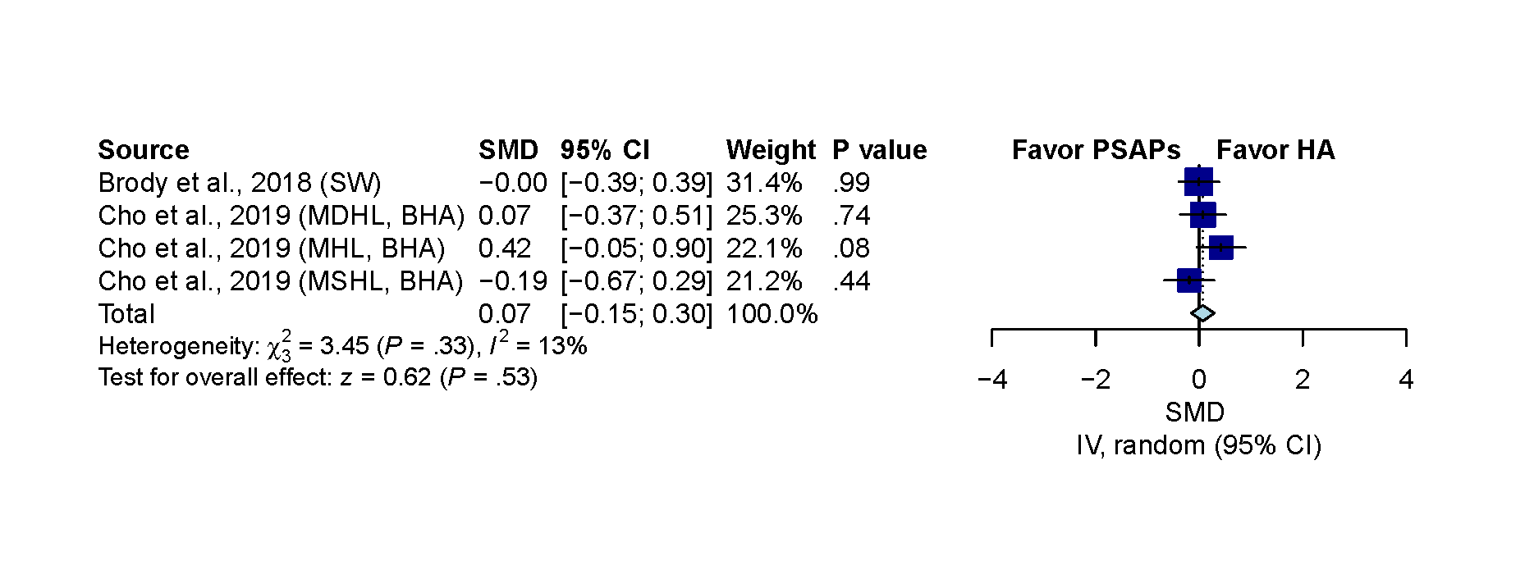
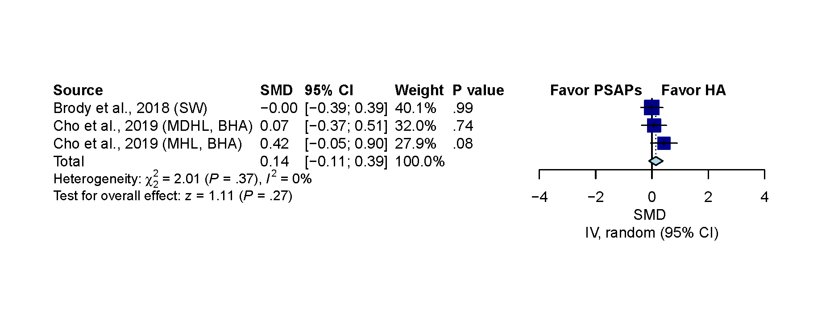
Figure 9. Sensitivity analysis for listening effort comparison by Sound world solution CS50+ PSAP in Brody et al and basic hearing aid in Cho et al. (A)The pooled result showed non-significant difference. (SMD, 0.07; 95% CI, -0.15 to 0.30; P=.53; I²=13%). (B) After excluding moderate severe hearing loss patient in Cho et al, the result remained non-significant (SMD, 0.14; 95% CI, -0.11 to 0.39; P=.27; I²=0%). IV indicates the inverse variance method; SW indicates that the analysis adopted Sound Would Solution CS50+ PSAP used in Brody et al; MHL indicates mild hearing loss; MDHL indicates moderate hearing loss; MSHL indicates moderately severe hearing loss. BHA indicates basic hearing aid used in Cho et al.
A
B

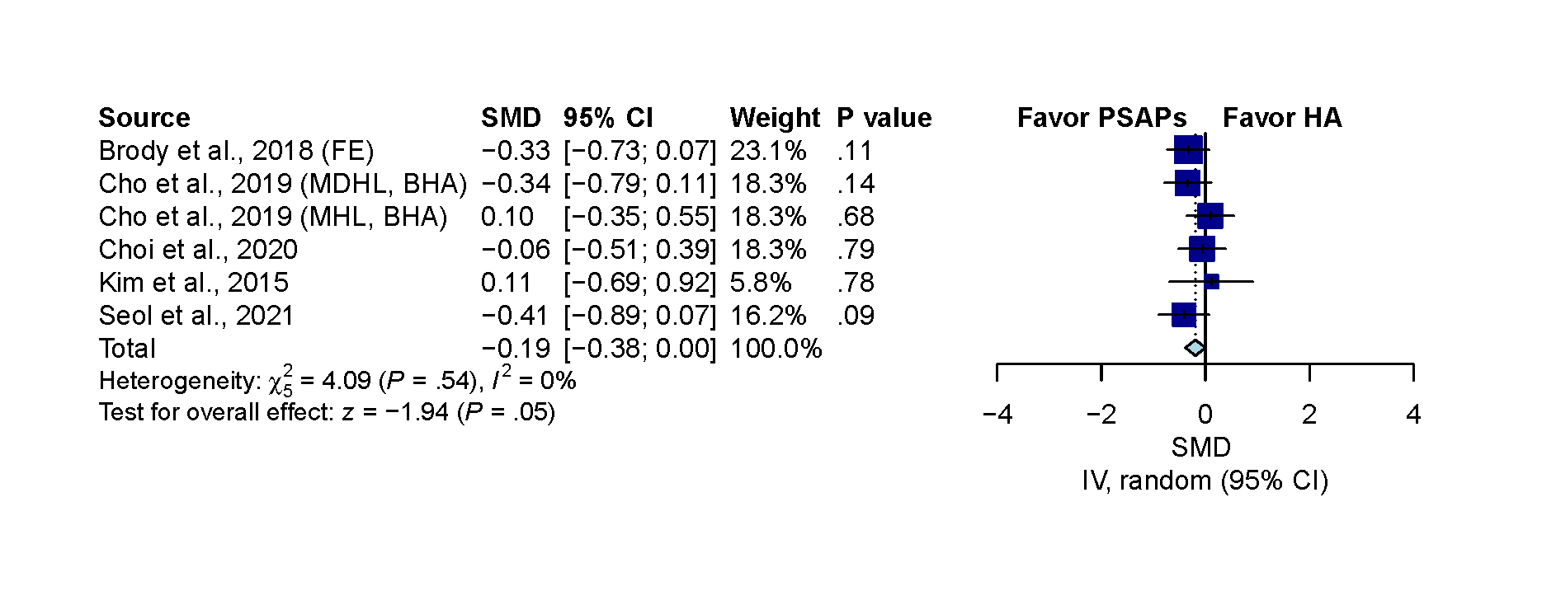
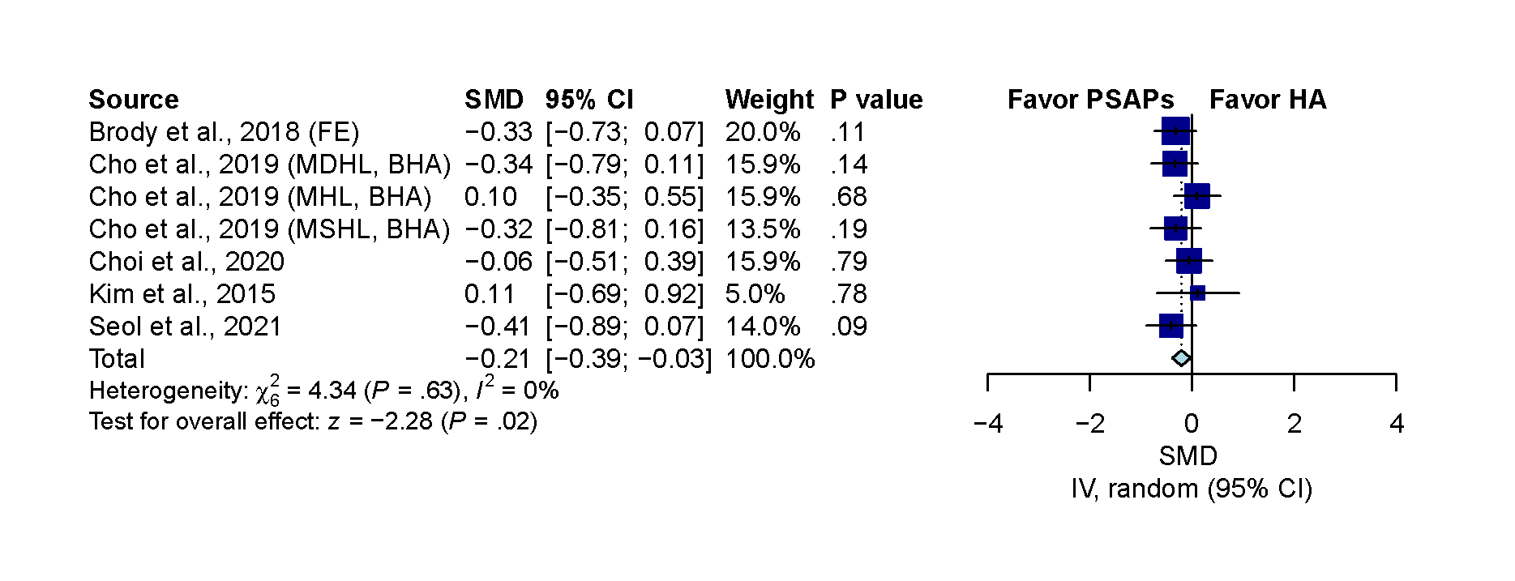
Figure 10. Sensitivity analysis for overall comparison by FocusEar PSAP in Brody et al and basic hearing aid in Cho et al. (A)The pooled result showed significant difference. (SMD, -0.21; 95% CI, -0.39 to -0.03; P=.02; I²=0%). (B) After excluding moderate severe hearing loss patients in Cho et al, the result showed non-significant (SMD, -0.19; 95% CI, -0.38 to -0.00; P=.05; I²=0%). IV indicates the inverse variance method; FE indicates that the analysis adopted FocusEar PSAP used in Brody et al; MHL indicates mild hearing loss; MDHL indicates moderate hearing loss; MSHL indicates moderately severe hearing loss. BHA indicates basic hearing aid used in Cho et al.
A
B
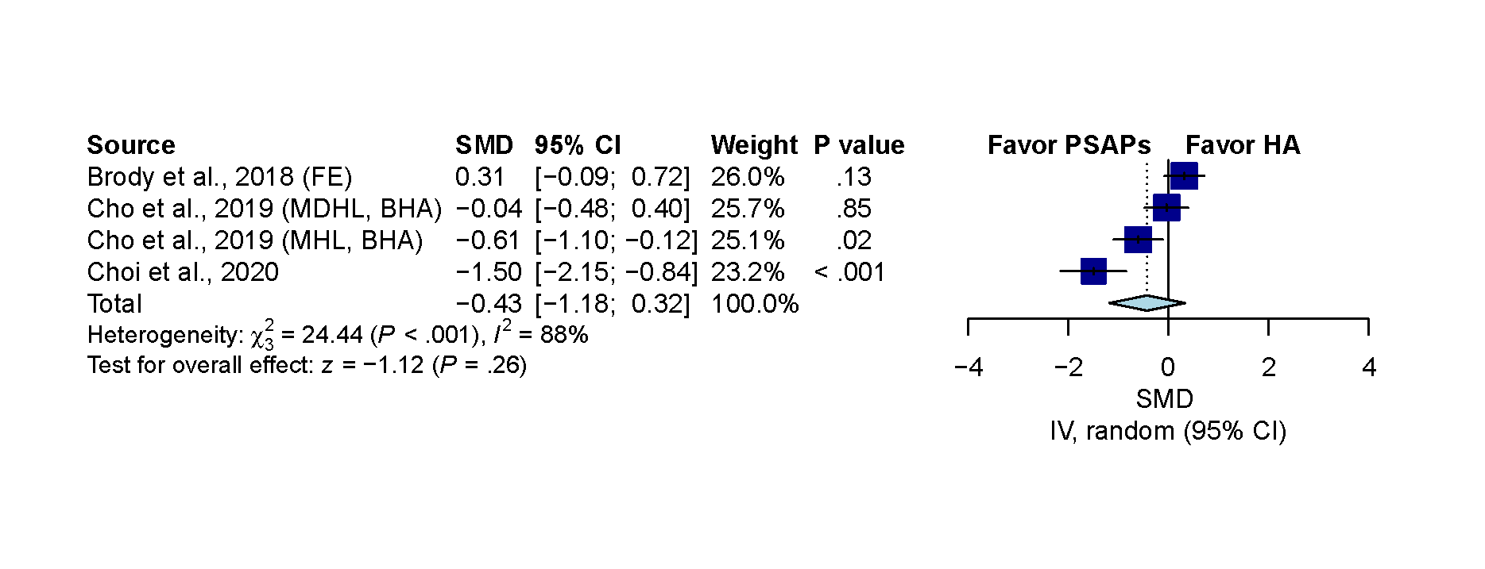
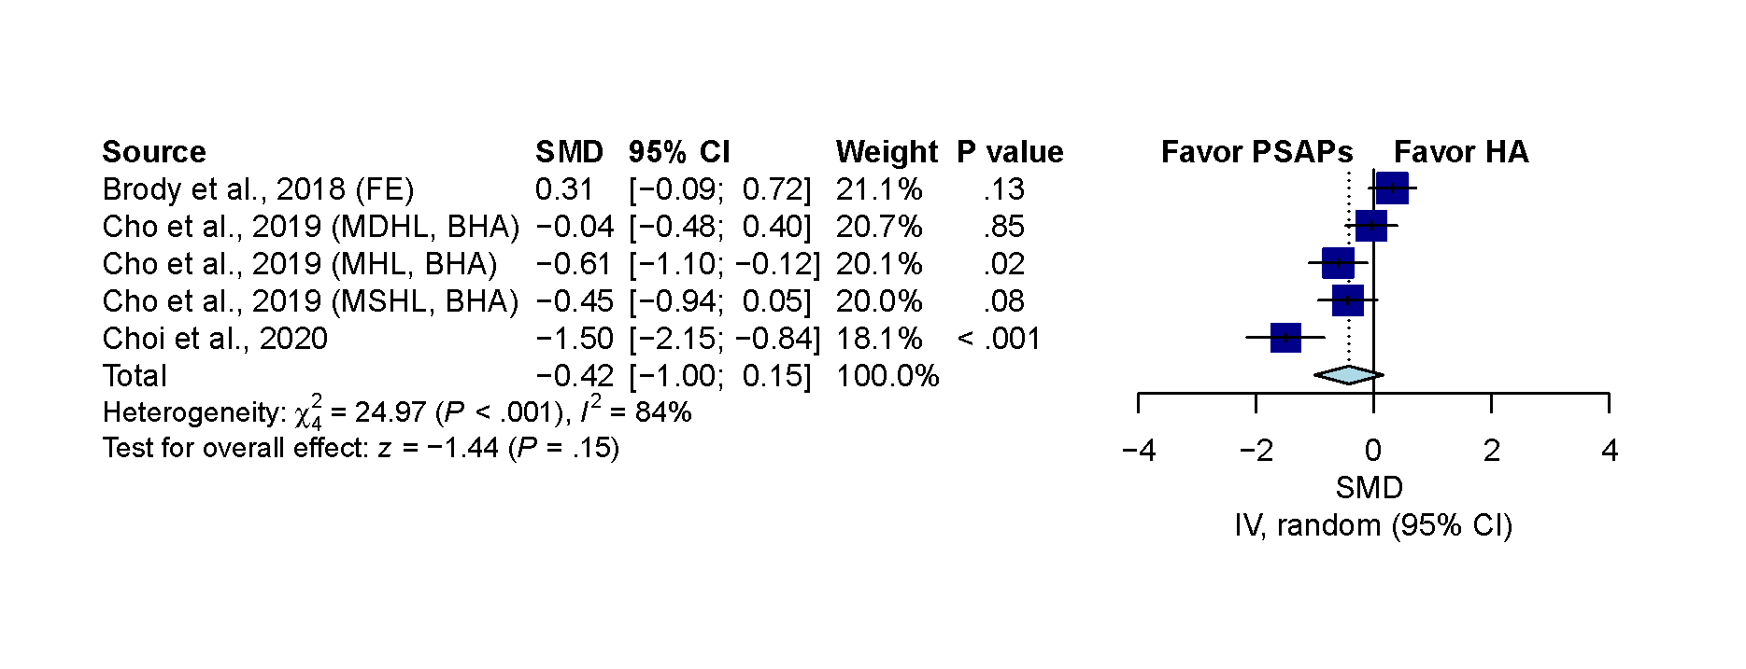
Figure 11. Sensitivity analysis for sound quality comparison by FocusEar PSAP in Brody et al and basic hearing aid in Cho et al. (A)The pooled result showed non-significant difference. (SMD, -0.42; 95% CI, -1.00 to 0.15; P=.15; I²=84%). (B) After excluding moderate severe hearing loss patient in Cho et al, the result remained non-significant (SMD, -0.43; 95% CI, -1.18 to 0.32; P=.26; I²=88%). IV indicates the inverse variance method; FE indicates that the analysis adopted FocusEar PSAP used in Brody et al; MHL indicates mild hearing loss; MDHL indicates moderate hearing loss; MSHL indicates moderately severe hearing loss. BHA indicates basic hearing aid used in Cho et al.
A
B

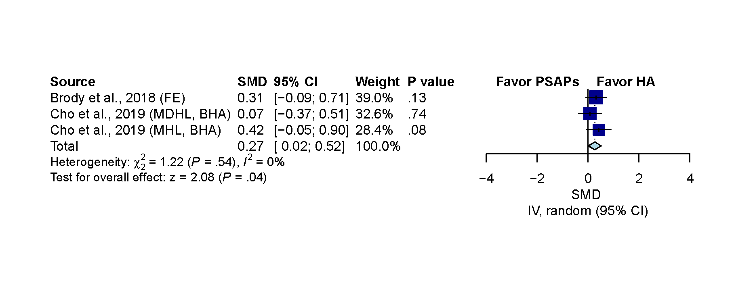
Figure 12. Sensitivity analysis for listening effort comparison by FocusEar PSAP in Brody et al and basic hearing aid in Cho et al. (A)The pooled result showed non-significant difference. (SMD, 0.17; 95% CI, -0.08 to 0.42; P=.19; I²=24%). (B) After excluding moderate severe hearing loss patient in Cho et al, the result showed slightly significant in favor of hearing aid (SMD, 0.27; 95% CI, 0.02 to 0.52; P=.04; I²=0%). IV indicates the inverse variance method; FE indicates that the analysis adopted FocusEar PSAP used in Brody et al; MDHL indicates moderate hearing loss; MSHL indicates moderately severe hearing loss. BHA indicates basic hearing aid used in Cho et al.
A
B
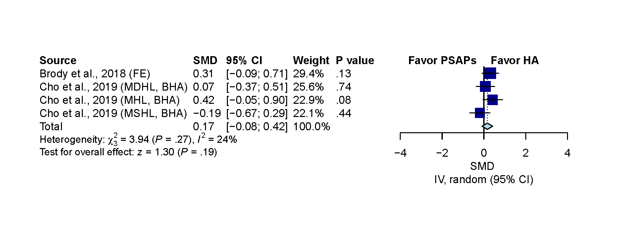

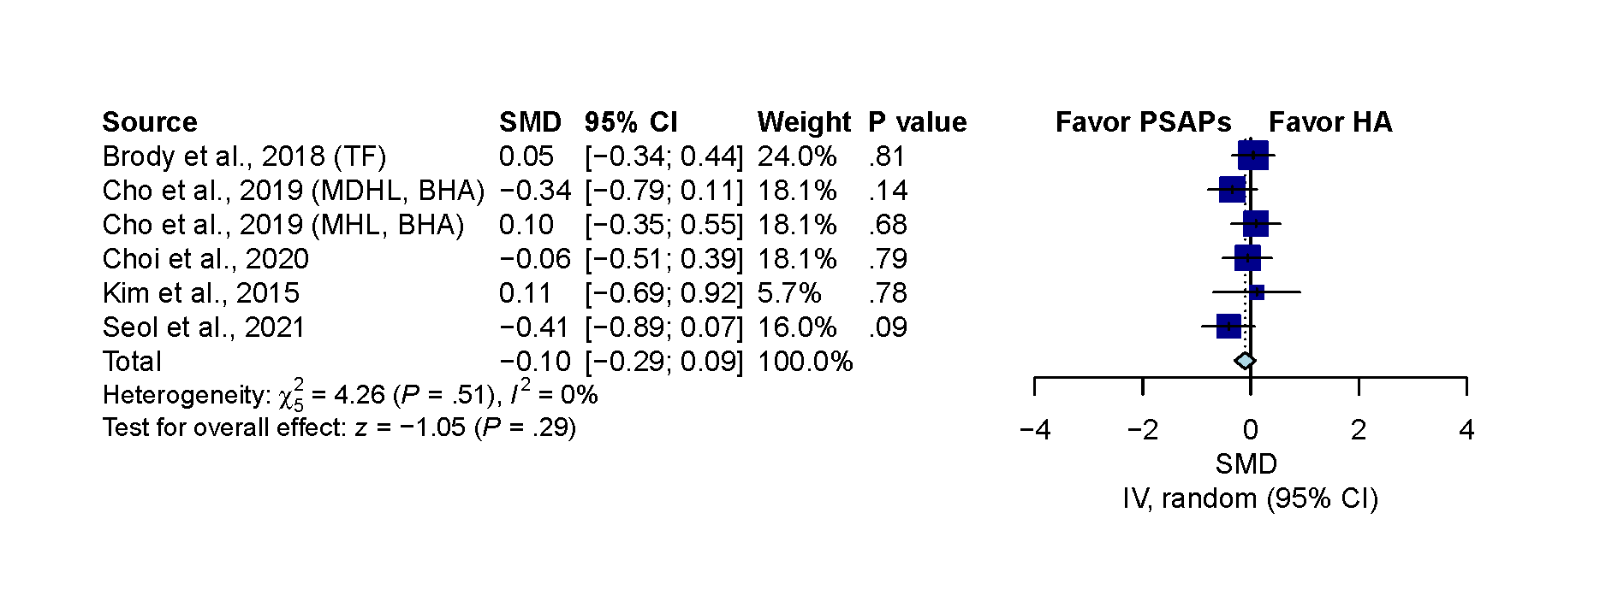
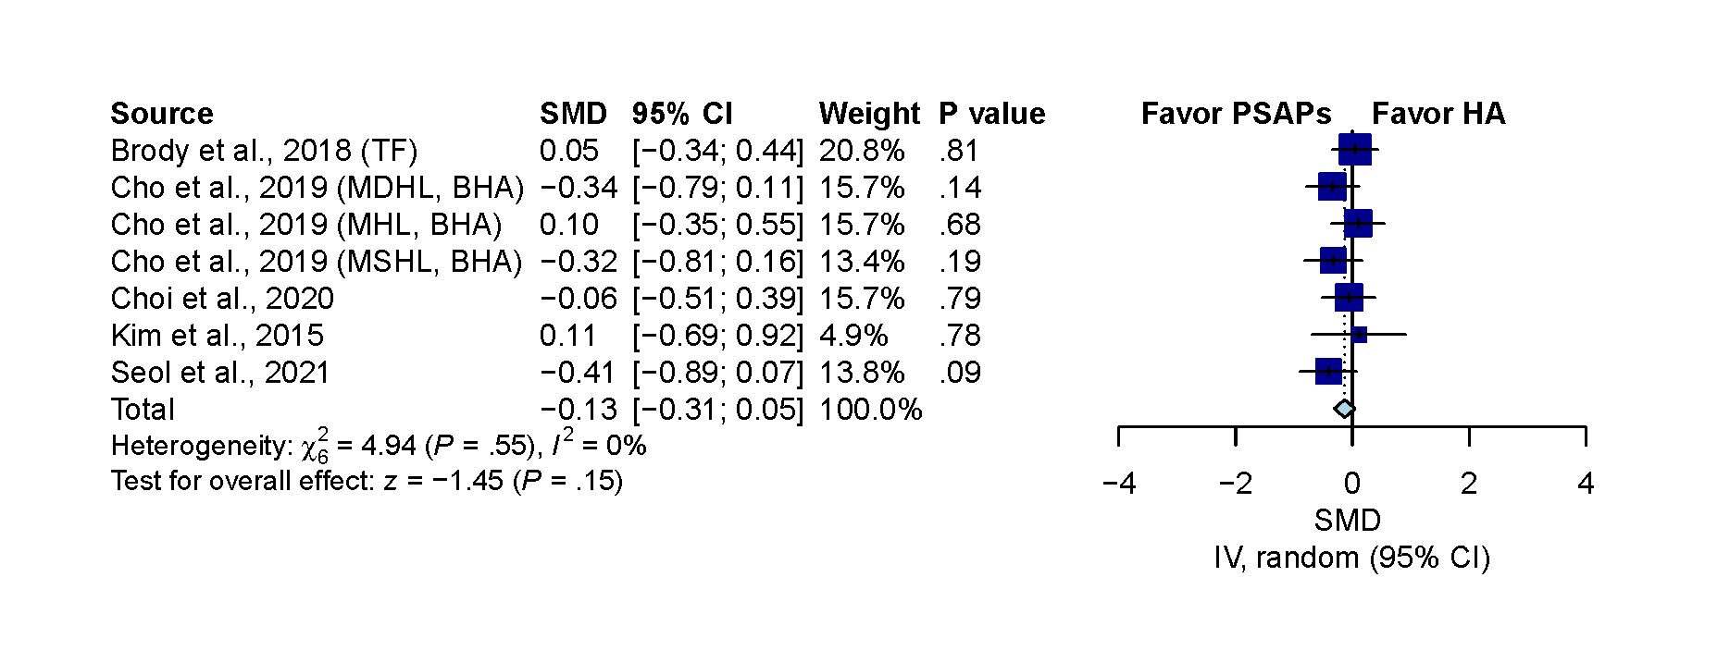
Figure 13. Sensitivity analysis for overall comparison by Tweak Focus PSAP in Brody et al and basic hearing aid in Cho et al. (A)The pooled result showed non-significant difference. (SMD, -0.13; 95% CI, -0.31 to 0.05; P=.15; I²=0%). (B) After excluding moderate severe hearing loss patient in Cho et al, the result remained non-significant (SMD, -0.10; 95% CI, -0.29 to 0.09; P=.29; I²=0%). IV indicates the inverse variance method; TF indicates that the analysis adopted Tweak Focus PSAP used in Brody et al; MHL indicates mild hearing loss; MDHL indicates moderate hearing loss; MSHL indicates moderately severe hearing loss. BHA indicates basic hearing aid used in Cho et al..
A
B
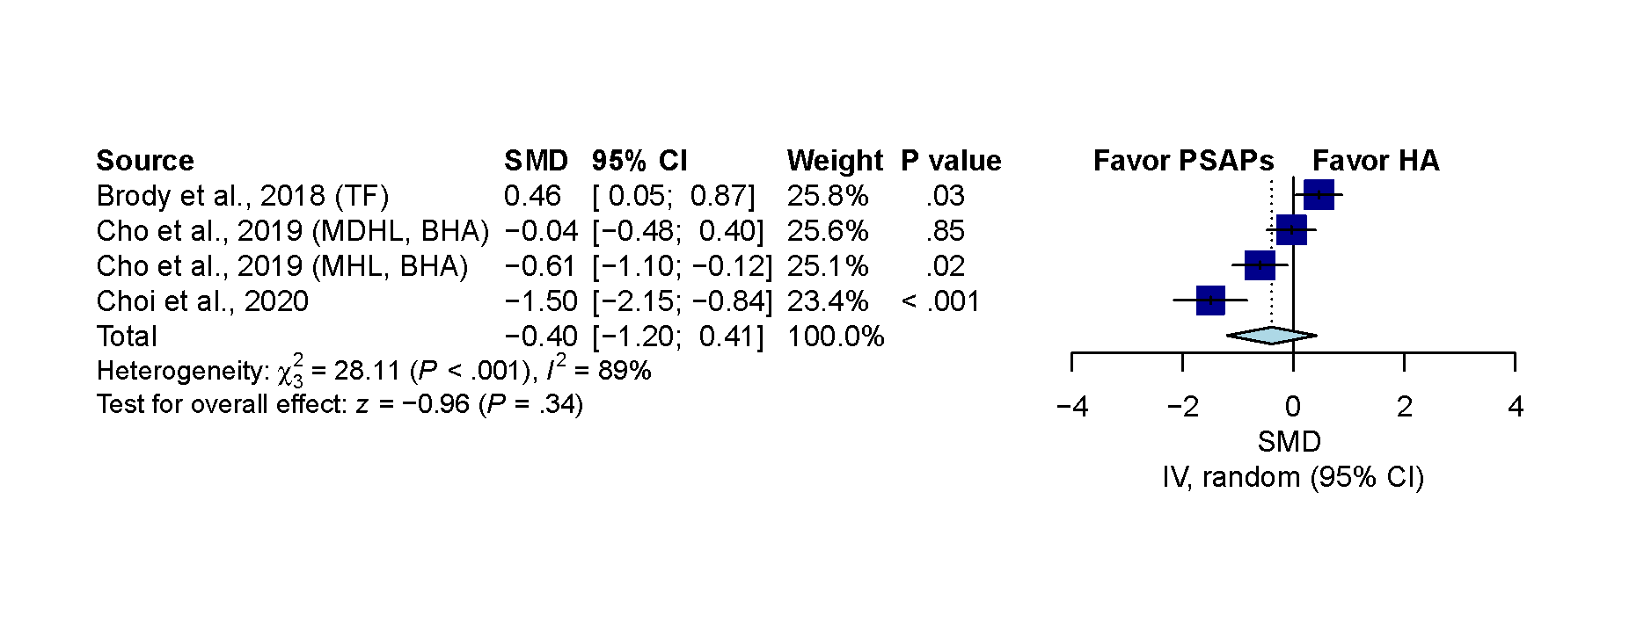
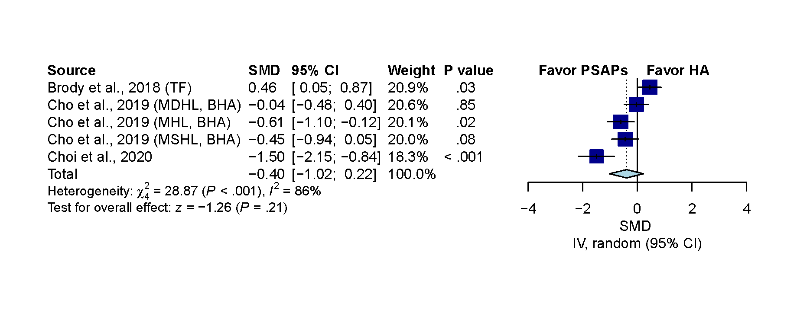
Figure 14. Sensitivity analysis for sound quality comparison by Tweak Focus PSAP in Brody et al and basic hearing aid in Cho et al. (A)The pooled result showed non-significant difference. (SMD, -0.40; 95% CI, -1.02 to 0.22; P=.21; I²=86%). (B) After excluding moderate severe hearing loss patient in Cho et al, the result remained non-significant (SMD, -0.40; 95% CI, -1.20 to 0.41; P=.34; I²=89%). IV indicates the inverse variance method; TF indicates that the analysis adopted Tweak Focus PSAP used in Brody et al; MHL indicates mild hearing loss; MDHL indicates moderate hearing loss; MSHL indicates moderately severe hearing loss. BHA indicates basic hearing aid used in Cho et al.
A
B

Figure 15. Sensitivity analysis for listening effort comparison by Tweak Focus PSAP in Brody et al and basic hearing aid in Cho et al. (A)The pooled result showed non-significant difference. (SMD, 0.20; 95% CI, -0.09 to 0.50; P=.18; I²=42%). (B) After excluding moderate severe hearing loss patient in Cho et al, the result showed significant result toward hearing aid (SMD, 0.20; 95% CI, -0.09 to 0.50; P=.18; I²=42%). IV indicates the inverse variance method; TF indicates that the analysis adopted Tweak Focus PSAP used in Brody et al; MHL indicates mild hearing loss; MDHL indicates moderate hearing loss; MSHL indicates moderately severe hearing loss. BHA indicates basic hearing aid used in Cho et al.
A
B
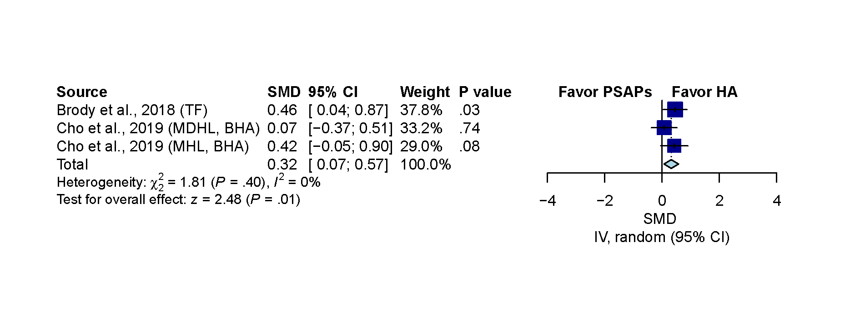
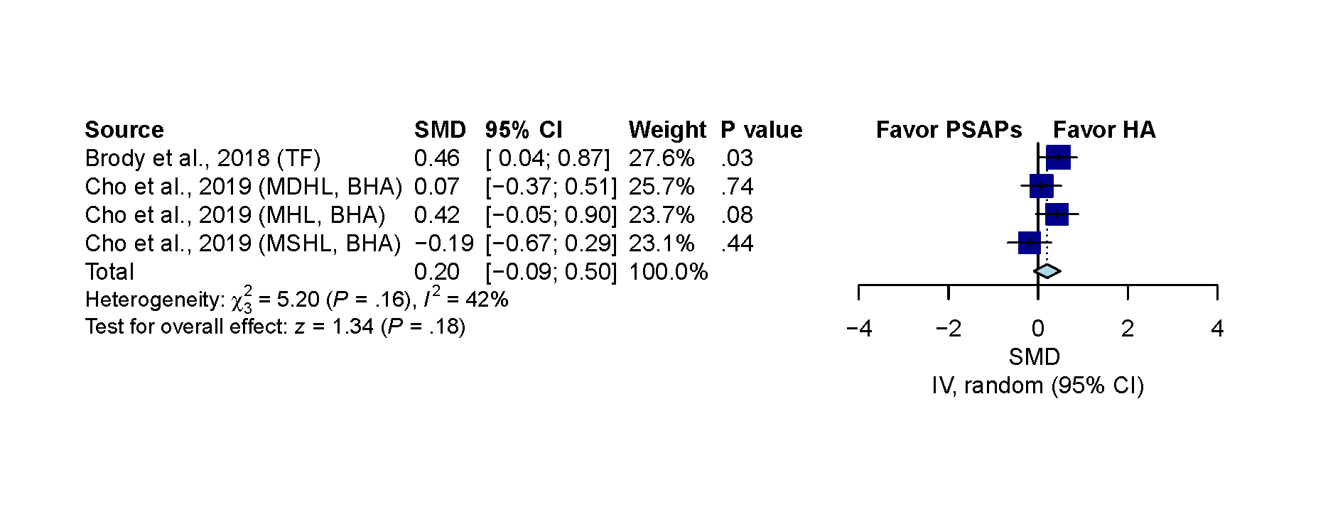
Supplementary file 4. Evaluation of publication bias

- Evaluation of publication bias on outcome of hearing gain.
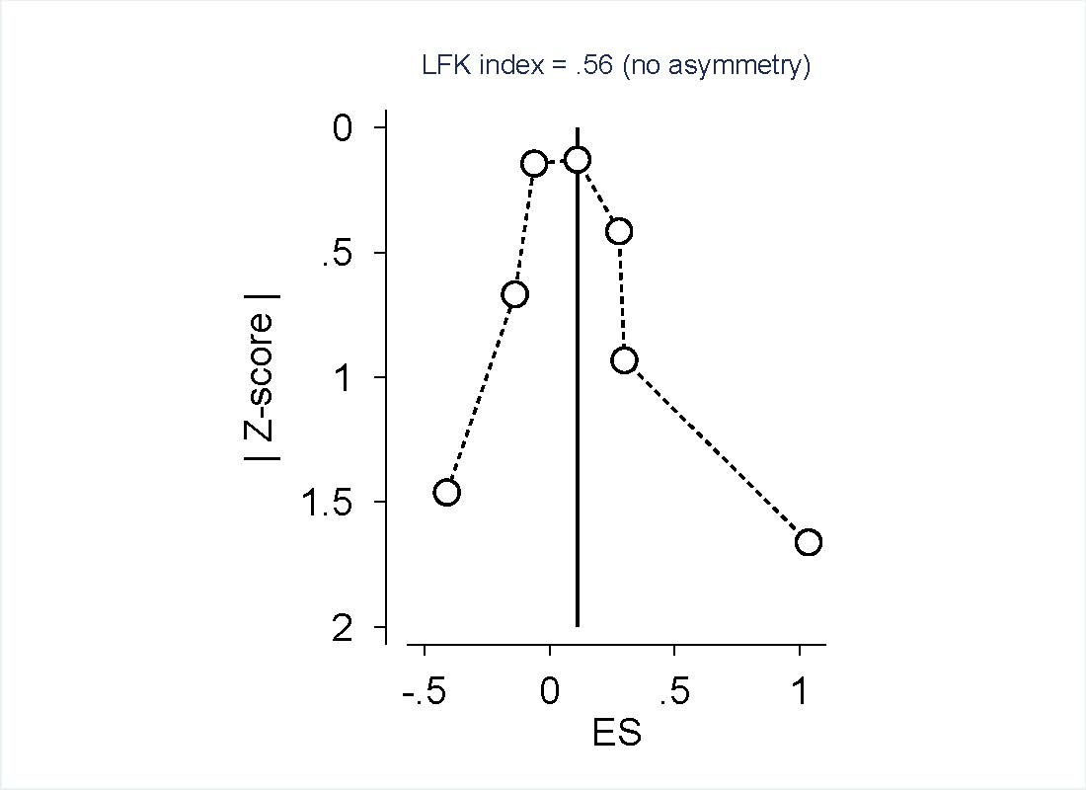
The DOI plot and LFK index demonstrated no asymmetry on the included studies. ES indicated the effect estimate.

- Evaluation of publication bias on outcome of sound quality.
The DOI plot and LFK index demonstrated minor asymmetry on the included studies. ES indicated the effect estimate.
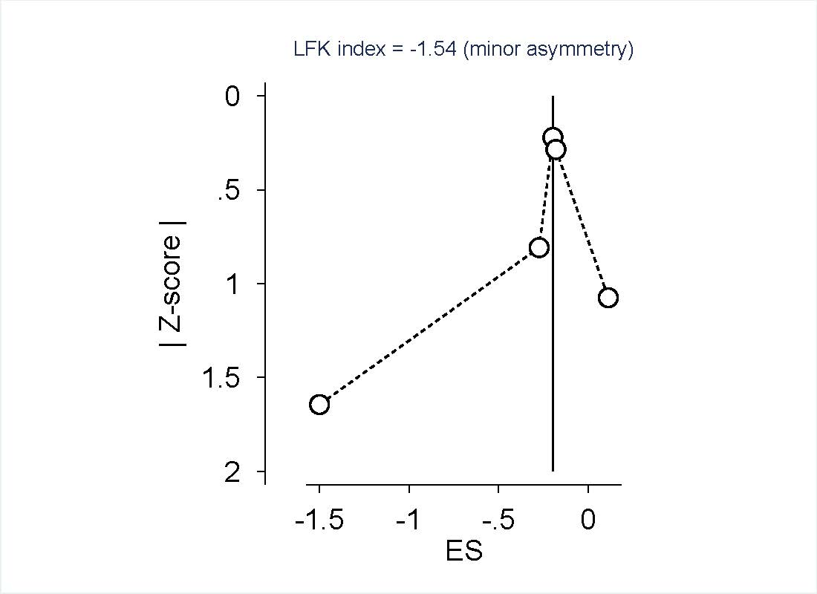

- Evaluation of publication bias on outcome of listening effort.
The DOI plot and LFK index demonstrated no asymmetry on the included studies. ES indicated the effect estimate.


