Supplementary figures
Infertility prevalence and the methods of estimation from 1990 - 2021: a systematic review and meta-analysis

Carie M. Cox, Marie E. Thoma, Nedelina Tchangalova, Gitau Mburu, Marta J. Bornstein,
Courtney L. Johnson & James Kiarie

Table of contents
Supplementary figure S1: Funnel plot – studies reporting lifetime prevalence of infertility 2
Supplementary figure S2: Funnel plot – studies reporting period prevalence of infertility 3
Supplementary figure S3: Lifetime and period prevalence of 12-month infertility by methodologic approach 4
Supplementary figure S4: Lifetime and period prevalence of 12-month infertility by country income level 5
Supplementary figure S5: Lifetime and period prevalence of 12-month infertility by WHO region 6
Supplementary figure S6: Forest plot of primary 12-month infertility prevalence 7
Supplementary figure S7: Forest plot of secondary 12-month infertility prevalence 8

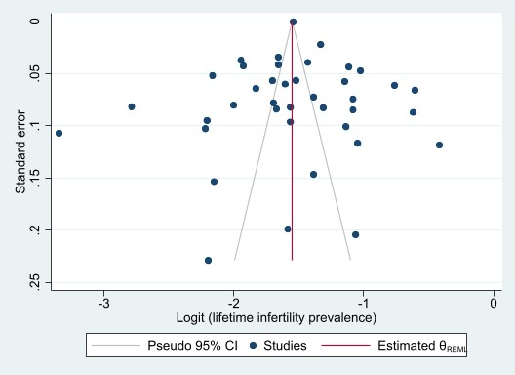

Supplementary figure S1: Funnel plot – studies reporting lifetime prevalence of infertility

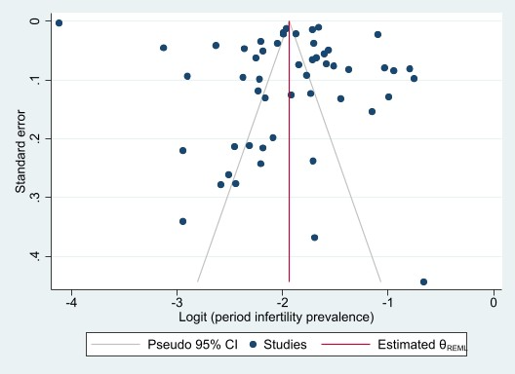

Supplementary figure S2: Funnel plot – studies reporting period prevalence of infertility

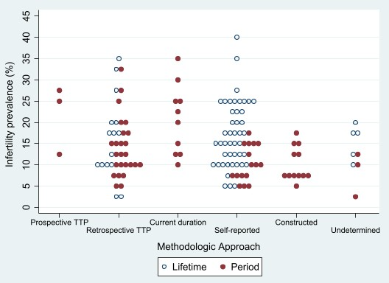

Supplementary figure S3: Lifetime and period prevalence of 12-month infertility by methodologic approach

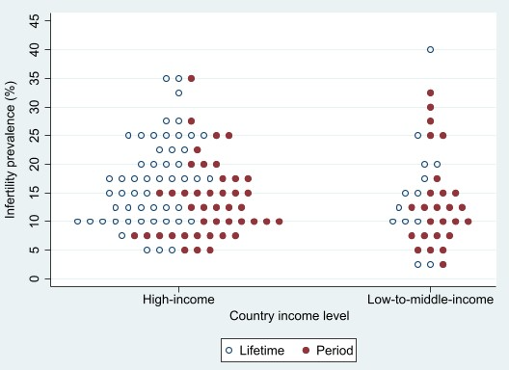

Supplementary figure S4: Lifetime and period prevalence of 12-month infertility by country income level

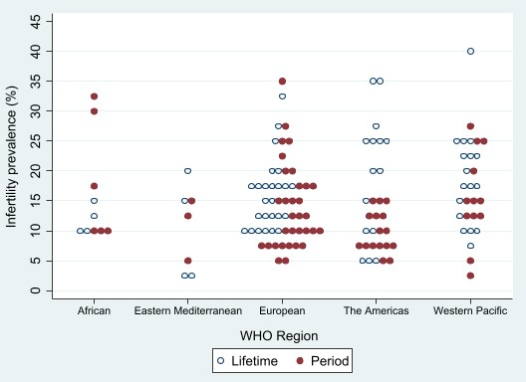

Supplementary figure S5: Lifetime and period prevalence of 12-month infertility by WHO region

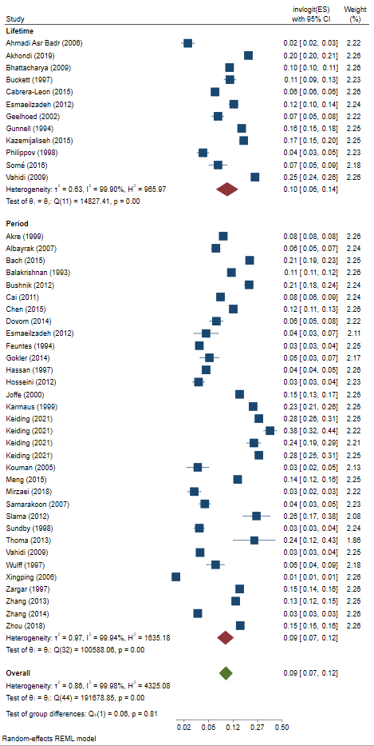

Supplementary figure S6: Forest plot of primary 12-month infertility prevalence

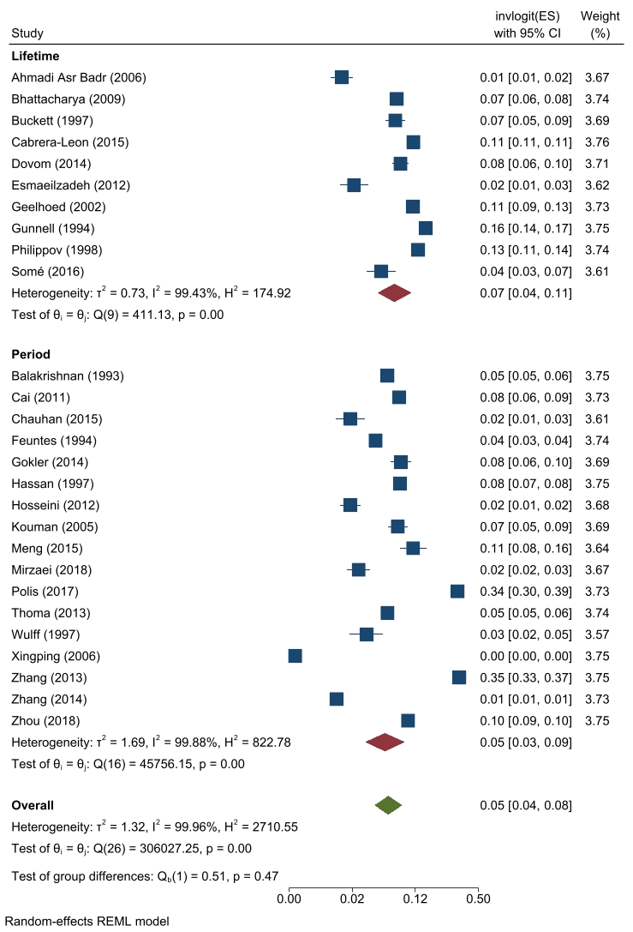

Supplementary figure S7: Forest plot of secondary 12-month infertility prevalence

