SUPPLEMENTAL MATERIAL

Appendix 1. Search strategies

Ovid MEDLINE(R) 1946 to April 01, 2021
# | Searches | Results | Type
1 | exp Ovarian Neoplasms/ | 86164 | Advanced
2 | (ovar* adj5 (cancer* or neoplas* or carcinom* or tumor* or tumour* or malignan*)).mp. [mp=title, abstract, original title, name of substance word, subject heading word, floating sub-heading word, keyword heading word, organism supplementary concept word, protocol supplementary concept word, rare disease supplementary concept word, unique identifier, synonyms] | 104673 | Advanced
3 | 1 or 2 | 107592 | Advanced
4 | debulk*.mp. | 6439 | Advanced
5 | cytoreduc*.mp. | 9346 | Advanced
6 | 4 or 5 | 14494 | Advanced
7 | exp Surgical Procedures, Operative/ | 3232079 | Advanced
8 | surg*.mp. | 2975892 | Advanced
9 | "surgery".fs. | 2039118 | Advanced
10 | 7 or 8 or 9 | 4365367 | Advanced
11 | “randomized controlled trial”.pt. | 526759 | Advanced
12 | "controlled clinical trial".pt. | 94101 | Advanced
13 | randomly.ab. | 298764 | Advanced
14 | randomized.ab. | 441240 | Advanced
15 | trial.ab. | 464626 | Advanced
16 | groups.ab. | 1843346 | Advanced
17 | exp Cohort Studies/ | 2114576 | Advanced
18 | cohort*.mp. | 644091 | Advanced
19 | 11 or 12 or 13 or 14 or 15 or 16 or 17 or 18 | 4406003 | Advanced
20 | 3 and 6 and 10 | 4672 | Advanced
21 | 19 and 20 | 2574 | Advanced

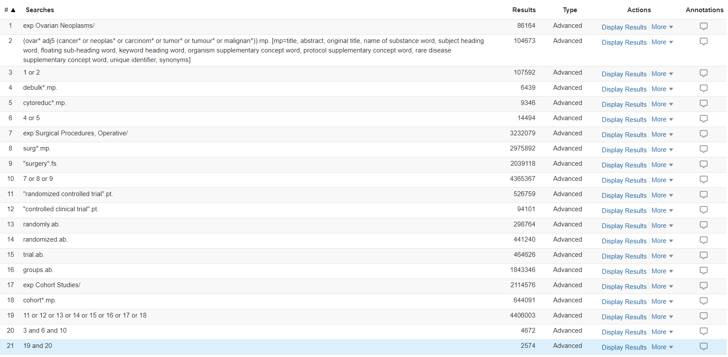

Embase 1974 to 2021 April 01
# | Searches | Results | Type
1 | exp ovary tumor/ | 152476 | Advanced
2 | (ovar* adj5 (cancer* or neoplas* or carcinom* or tumor* or tumour* or malignan*)).mp. [mp=title, abstract, heading word, drug trade name, original title, device manufacturer, drug manufacturer, device trade name, keyword, floating subheading word, candidate term word] | 176221 | Advanced
3 | 1 or 2 | 182222 | Advanced
4 | exp surgery/ | 5092379 | Advanced
5 | surg*.mp. | 4341668 | Advanced
6 | 4 or 5 | 6128623 | Advanced
7 | exp controlled clinical trial/ | 855345 | Advanced
8 | random*.mp. | 1913149 | Advanced
9 | trial*.mp. | 2647519 | Advanced
10 | group*.mp. | 5762976 | Advanced
11 | exp cohort analysis/ | 705524 | Advanced
12 | cohort*.mp. | 1260895 | Advanced
13 | series.mp | 860919 | Advanced
14 | 7 or 8 or 9 or 10 or 11 or 12 or 13 | 9269834 | Advanced
15 | debulk*.mp. | 13226 | Advanced
16 | cytoreduc*.mp. | 26241 | Advanced
17 | 15 or 16. | 33777 | Advanced
18 | 6 and 17 | 30519 | Advanced
19 | recurrent.mp. | 578680 | Advanced
20 | recurrence.mp | 637554 | Advanced
21 | 19 or 20 | 1051586 | Advanced
22 | 3 and 14 and 18 and 21 | 1988 | Advanced

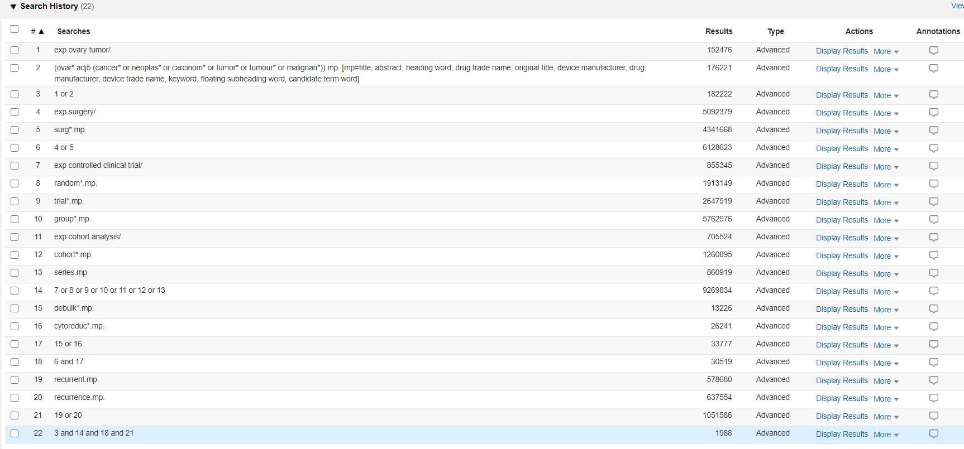

CENTRAL search strategy
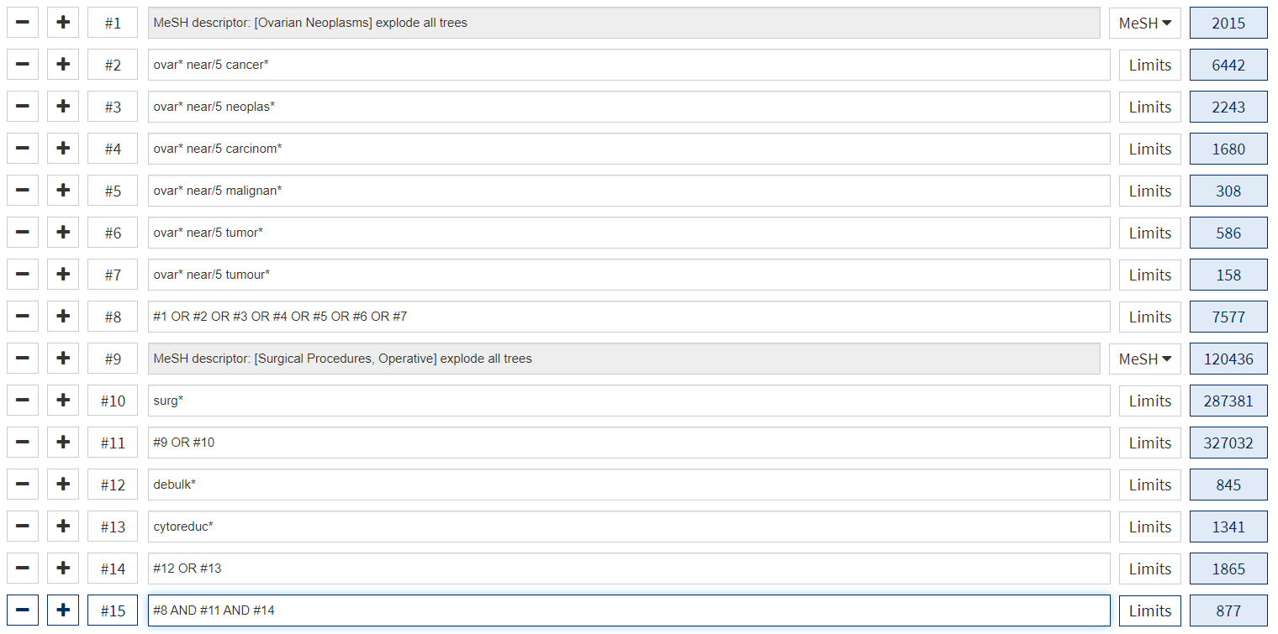

Appendix 2. Risk of bias assessment results for cohort studies using the Newcastle Ottawa Scale (>7=low, 4-6=moderate, <3=high)
Study | Selection | Comparability | Outcome | Total | Risk of bias
Gockley，2019 | ★★★ | ★ | ★★★ | 7 | Low
Felsinger , 2018 | ★★★ | ★ | ★★ | 6 | Moderate
Szczesny, 2018 | ★★★ | ★ | ★★ | 6 | Moderate
Lee, 2015 | ★★★ | ★ | ★★★ | 7 | Low
Oksefjell, 2009 | ★★ | ★ | ★★ | 5 | Moderate
Ortega, 2020 | ★★★ | ★ | ★★★ | 7 | Low
So M, 2019 | ★★★ | ★ | ★★★ | 7 | Low
Güngör, 2005 | ★★★ | ★ | ★★ | 6 | Moderate
Takahashi,2017 | ★★★ | ★ | ★★ | 6 | Moderate
Kajiyama, 2019 | ★★ | ★ | ★★ | 5 | Moderate

Appendix 3. Risk of bias assessment results for cohort studies using the Minors Scale
 | Gockley, 2019 | Felsinger, 2018 | Szczesny, 2018 | Lee, 2015 | Oksefjell , 2009 | Ortega, 2020 | So M, 2019 | Güngör, 2005 | Takahashi, 2017 | Kajiyama, 2019
The hypothesis/aim/objective of the study was clearly stated | 2 | 2 | 2 | 2 | 2 | 2 | 2 | 2 | 2 | 2
Patients were recruited consecutively | 2 | 1 | 1 | 2 | 1 | 2 | 1 | 1 | 1 | 1
Collection of expected data | 2 | 2 | 2 | 2 | 2 | 2 | 2 | 2 | 2 | 2
Endpoint indicators can appropriately reflect the purpose of the study | 2 | 2 | 2 | 2 | 2 | 2 | 2 | 2 | 2 | 2
Objectivity of endpoint evaluation | 1 | 1 | 1 | 1 | 1 | 1 | 1 | 1 | 1 | 1
Is the follow-up time sufficient? | 2 | 1 | 2 | 2 | 2 | 2 | 2 | 2 | 2 | 2
Lost to follow-up rate is less than 5% | 2 | 2 | 2 | 2 | 1 | 2 | 2 | 2 | 2 | 2
Has the sample size been estimated? | 0 | 0 | 0 | 0 | 0 | 0 | 0 | 0 | 0 | 0
Whether the selection of the control group is appropriate? | 2 | 2 | 1 | 2 | 1 | 2 | 2 | 1 | 2 | 1
Whether the control group is synchronized | 1 | 1 | 1 | 2 | 1 | 1 | 2 | 1 | 1 | 1
Is baseline comparable between groups? | 2 | 2 | 2 | 1 | 1 | 2 | 2 | 1 | 2 | 1
Whether the statistical analysis is appropriate | 2 | 2 | 2 | 2 | 2 | 2 | 2 | 2 | 2 | 2
Total | 20 | 18 | 18 | 20 | 16 | 20 | 20 | 17 | 19 | 17
Risk of bias | Low | Moderate | Moderate | Low | Moderate | Low | Low | Moderate | Moderate | Moderate

Study | Randomization | Concealment of allocation | Double blinding | Withdrawals and dropouts | Total | Risk of bias
Coleman, 2019 | 2 | 2 | 0 | 1 | 5 | Low
du Bois,  2020 | 2 | 2 | 0 | 1 | 5 | Low
Shi,  2021 | 2 | 2 | 0 | 1 | 5 | Low
Appendix 4. Risk of bias assessment results for randomized studies using the Jadad Scale

Appendix 5. Risk of bias assessment results for randomized studies using Cochrane Risk of Bias Tool
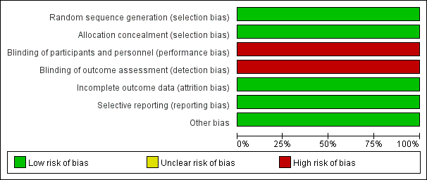

Table S1. Baseline characteristics of included patients
study | PS 0 | FIGO（III or IV） | Histology  (serous) | CA125  (≤105) | absence of ascites | Residual disease | NAC | No. of tumors  (No.≤3) | location of tumors  (intra-abdominal)
Coleman
SCS | - | - | 211 | - | - | - | - | - | -
CT | - | - | 207 | - | - | - | - | - | -
du Bois
SCS | - | - | - | - | - | - | - | - | -
CT | - | - | - | - | - | - | - | - | -
Shi
SCS | 134 | 148 | 158 | 128 | 181 | 83 | 182 | 59 | 136
CT | 144 | 146 | 145 | 115 | 173 | 77 | 173 | 47 | 139
Gockley
SCS | 100 | 96 | - | - | 98 | 115 | 10 | - | 146
CT | 335 | 405 | - | - | 278 | 382 | 90 | - | 486
Felsinger
SCS |  | 19 | 24 | - | - | 3 | - | 22 | 29
CT |  | 25 | 22 | - | - | 4 | - | 2 | 29
Szczesny
SCS |  | 40 | 55 | - | - | - | - | 43 | -
CT |  | 200 | 228 | - | - | - | - | 61 | -
Lee
SCS | 98 | 160 | - | - | - | - | - | - | -
CT | 501 | 707 | - | - | - | - | - | - | -
Ortega
SCS | - | 21 | 25 | - | 36 | - | - | 21 | 21
CT | - | 34 | 32 | - | 30 | - | - | 1 | 31
So M
SCS | 22 | 13 | 10 | 18 | 22 | 15 | 8 | 6 | -
CT | 28 | 25 | 22 | 24 | 30 | 19 | 14 | 5 | -
Güngör
SCS | - | - | - | - | - | - | - | 28 | -
CT | - | - | - | - | - | - | - | 9 | -
Oksefjell
SCS | - | 160 | 140 | - | - | 104 | - | - | -
CT | - | 506 | 428 | - | - | 202 | - | - | -
Takahashi
SCS | - | 25 | 26 | 30 | - | - | - | 25 | -
CT | - | 62 | 57 | 50 | - | - | - | 39 | -
Kajiyama
SCS | - | 4 | - | - | - | - | - | - | 15
CT | - | 48 | - | - | - | - | - | - | 93
P value | 0.32 | 0.0001 | 0.43 | 0.07 | 0.44 | 0.24 | 0.76 | 0.0001 | 0.48
The number is shown for SCS versus CT. Abbreviations: SCS= secondary cytoreductive surgery; CT= chemotherapy; PS= Performance status; NAC= Neoadjuvant chemotherapy; No.= number.

Table S2. Complications and toxicity
 | Coleman | Shi | Gockley | Felsinger | Ortega | So M | Güngör | Oksefjell | Takahashi | Total
Intraoperative blood loss | 192 | - | - | 1 | - | - | - | - | - | 193
Bowel resection | 62 | 36 | 59 | 18 | 23 | 20 | 19 | 109 | 1 | 347
Postoperative death | 1 | - | - | - | - | - | - | - | - | 1
Adverse events 30 days after surgery
Pleural effusion | - | 4 | - | 1 | 3 | - | - | - | - | 8
Bowel obstruction | - | 9 | - | 2 | 3 | 4 | 2 | 66 | - | 86
Deep vein thrombosis | 3 | 1 | 2 | - | - | 1 | - | - | - | 7
Reoperation | 20 | - | - | - | 1 | - | 4 | - | - | 7
Infection | - | 18 | - | - | 3 | 1 | 5 | - | - | 27
Cardiac event | - | 4 | - | - | - | - | - | - | - | 4
Other | 17 | 2 | 2 | 3 | - | - | 5 | 0 | 5 | 34
Total N | 40 | 38 | 4 | 6 | 10 | 6 | 16 | 66 | 5 | 191
Chemotoxicity (SCS VS CT)
Total N | 183:194 | 41:31 | - | - | - | - | - | - | - | -
P value | P = 0.44 | P> 0.5 | - | - | - | - | - | - | - | -
Only the data reported in the article is recorded. Abbreviations: SCS= secondary cytoreductive surgery; CT= chemotherapy.

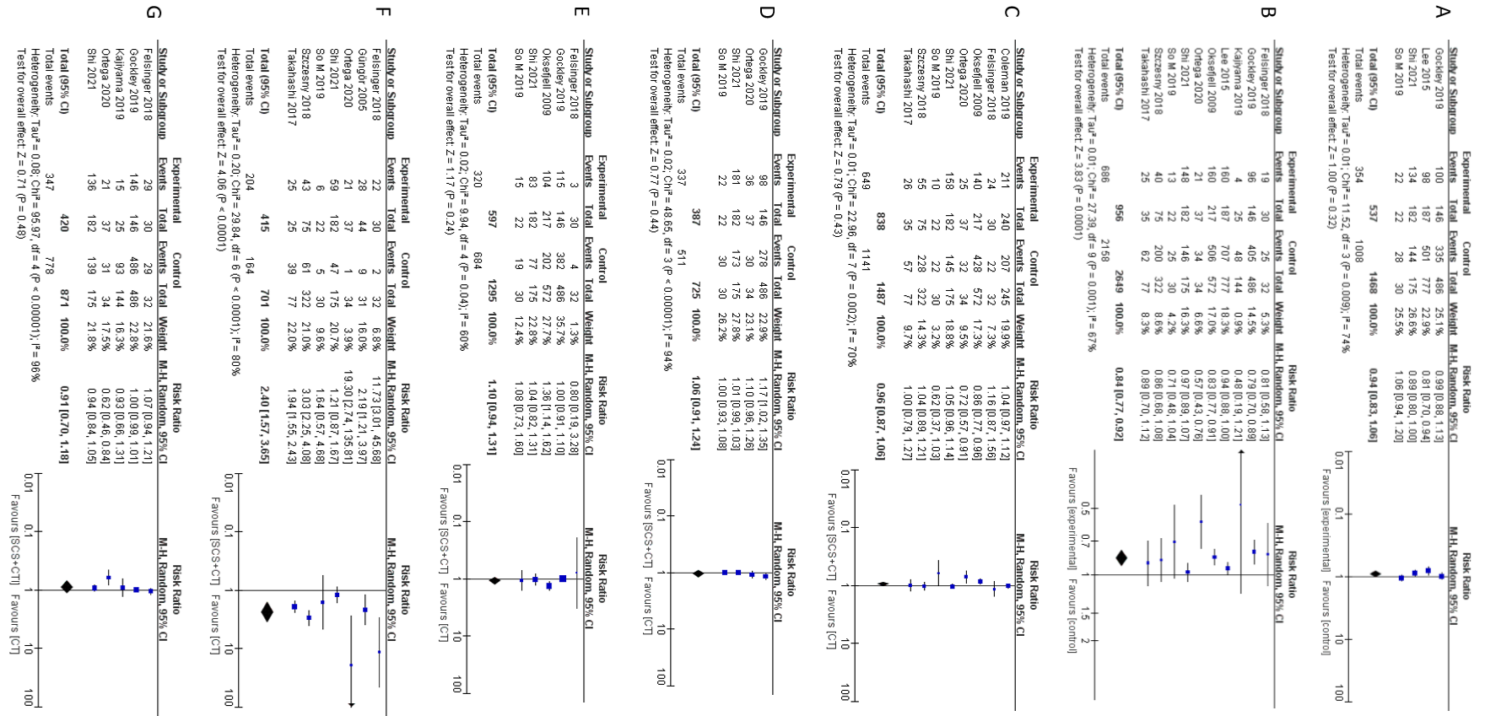
Figure S1. Forest plot for included in the patient's baseline analysis. A: ECOG performance status (PS); B: the initial diagnosis of FIGO staging; C: the type of tumor histology; D: ascites; E: residual disease after the initial operation; F: the number of recurring tumors; G: the location of recurrent tumors.

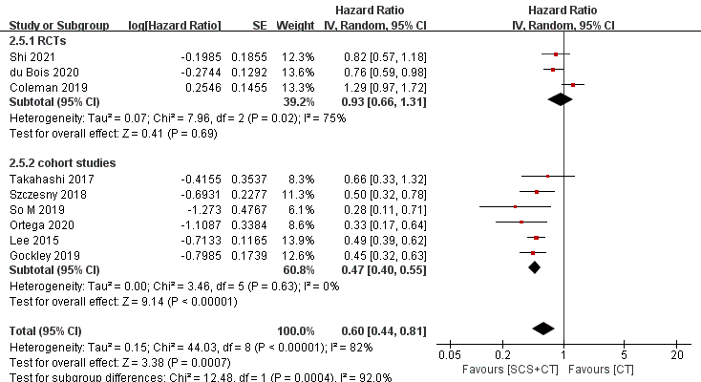
Figure S2. Forest plot for OS subgroup analysis of recurrent ovarian cancer. Abbreviations: SCS, secondary cytoreductive surger; CT, chemotherapy.

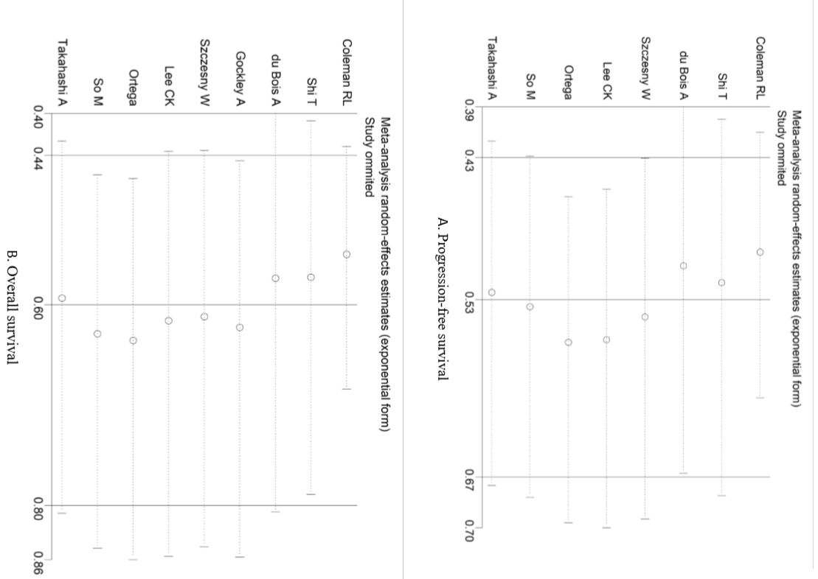
Figure S3. Sensitivity analysis of PFS and OS. (Secondary cytoreductive surgery plus chemotherapy versus chemotherapy alone)

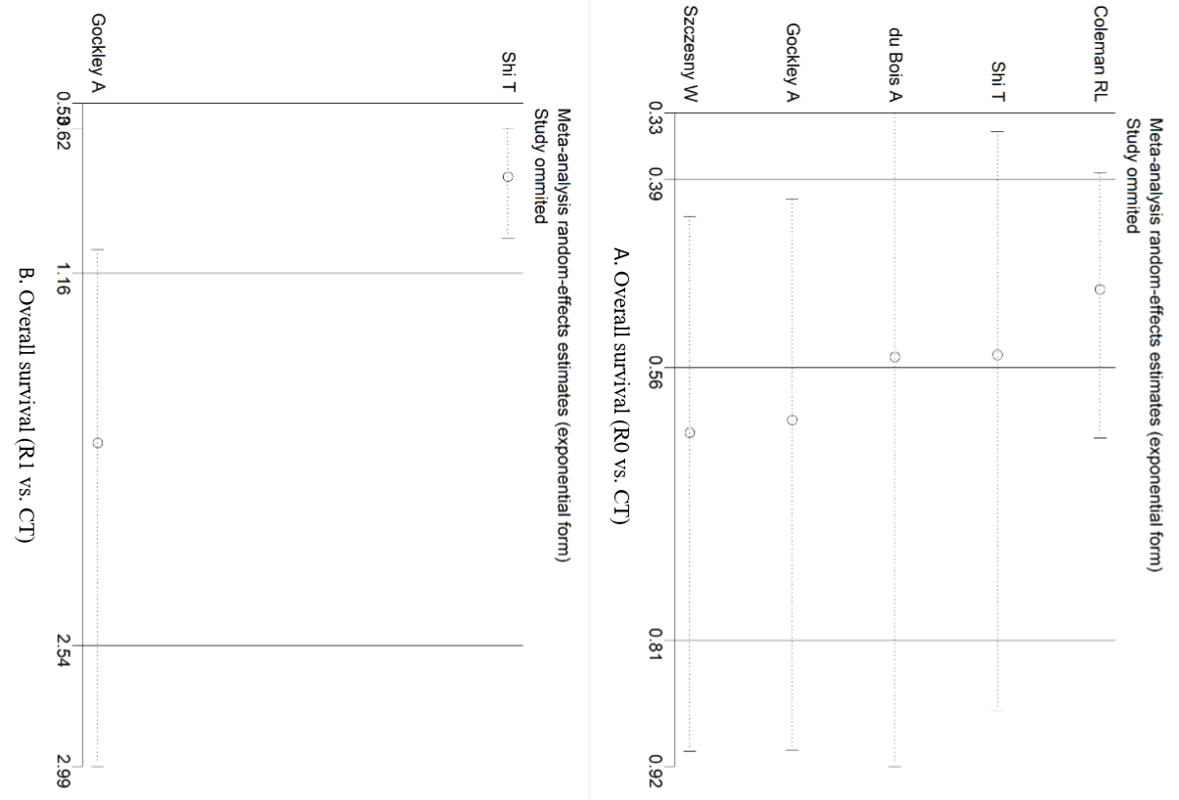
Figure S4. Sensitivity analysis of OS. A: complete resection versus chemotherapy alone; B: incomplete resection versus chemotherapy alone.

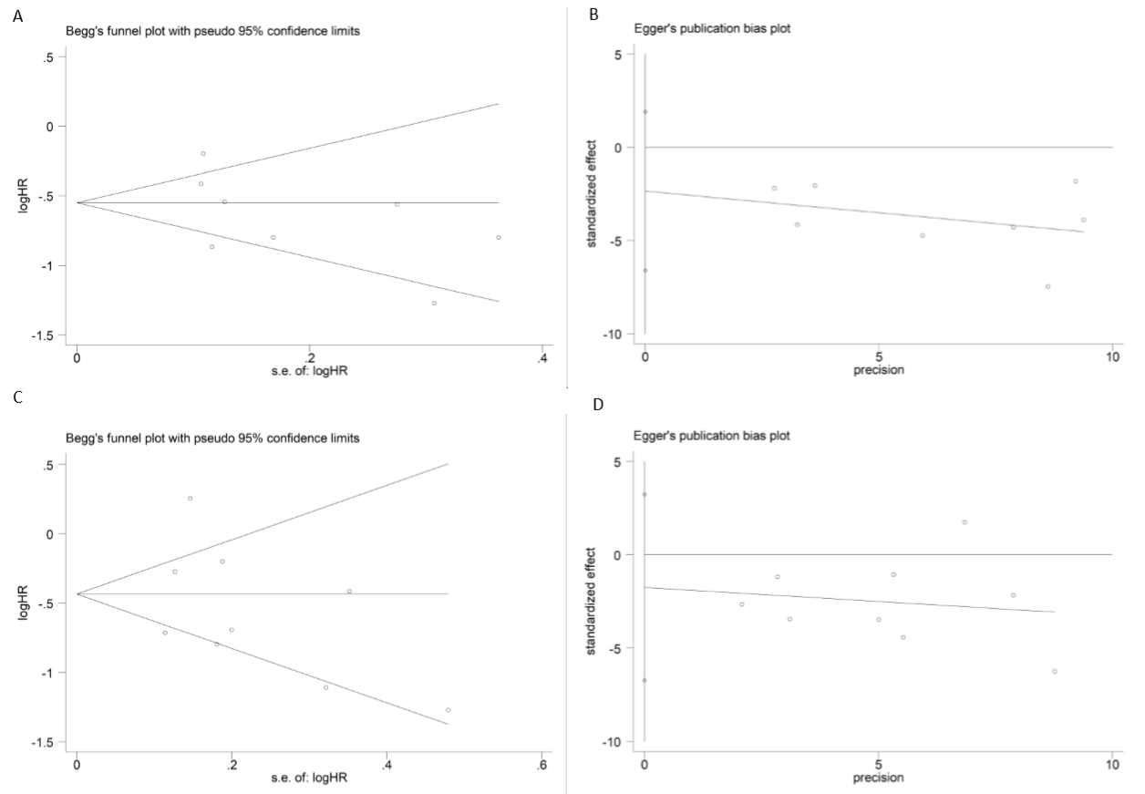
Figure S5. Begg’s and Egger’s test of PFS and OS. A: Begg’s test of PFS; B: Egger’s test of PFS; C: Begg’s test of OS; D: Egger’s test of OS.

