Psychiatry Research
The prevalence of depression, anxiety and sleep disturbances in higher education students during the COVID-19 pandemic: A meta-analysis

Table S1 | PRISMA checklist | p.2
Table S2 | English search strategy (MEDLINE) | p.4
Table S3 | Chinese search strategy (CNKI) | p.5
Figure S1 | Funnel plots | p.6
Figure S2 | Subgroup by validated scale, depression prevalence | p.8
Figure S3 | Subgroup by validated scale, anxiety prevalence | p.9
Figure S4 | Subgroup by gender, depression prevalence | p.10
Figure S5 | Subgroup by gender, anxiety prevalence | p.11
Figure S6 | Subgroup by gender, sleep disturbance prevalence | p.12
Figure S7 | Subgroup by financial difficulties, depression prevalence | p.13
Figure S8 | Subgroup by financial difficulties, anxiety prevalence | p.14
Figure S9 | Subgroup by living arrangements, depression prevalence | p.15
Figure S10 | Subgroup by living arrangements, anxiety prevalence | p.16
Figure S11 | Subgroup by education level, depression prevalence | p.17
Figure S12 | Subgroup by education level, anxiety prevalence | p.18
Figure S13 | Subgroup by education level, sleep disturbance prevalence | p.19
Figure S14 | Subgroup by undergraduate years, depression prevalence | p.20
Figure S15 | Subgroup by undergraduate years, anxiety prevalence | p.21
Figure S16 | Severity subgroups, depression prevalence | p.22
Figure S17 | Severity subgroups, anxiety prevalence | p.25
Figure S18 | Subgroup by country, depression prevalence | p.28
Figure S19 | Subgroup by country, anxiety prevalence | p.29
Figure S20 | Subgroup by country, sleep disturbance prevalence | p.30

Table S1 PRISMA checklist
Section/topic |  |  | # | Checklist item | Reported on page #
 | TITLE
Title |  |  | 1 | Identify the report as a systematic review, meta-analysis, or both. | Title Page
 | ABSTRACT
Structured summary |  |  | 2 | Provide a structured summary including, as applicable: background; objectives; data sources; study eligibility criteria, participants, and interventions; study appraisal and synthesis methods; results; limitations; conclusions and implications of key findings; systematic review registration number. | Abstract
 | INTRODUCTION
Rationale |  |  | 3 | Describe the rationale for the review in the context of what is already known. | 1
Objectives |  |  | 4 | Provide an explicit statement of questions being addressed with reference to participants, interventions, comparisons, outcomes, and study design (PICOS). | 1-2
 | METHODS
Protocol and registration |  |  | 5 | Indicate if a review protocol exists, if and where it can be accessed (e.g., Web address), and, if available, provide registration information including registration number. | 2
Eligibility criteria |  |  | 6 | Specify study characteristics (e.g., PICOS, length of follow-up) and report characteristics (e.g., years considered, language, publication status) used as criteria for eligibility, giving rationale. | 2
Information sources |  |  | 7 | Describe all information sources (e.g., databases with dates of coverage, contact with study authors to identify additional studies) in the search and date last searched. | 2
Search |  |  | 8 | Present full electronic search strategy for at least one database, including any limits used, such that it could be repeated. | 2
Study selection |  |  | 9 | State the process for selecting studies (i.e., screening, eligibility, included in systematic review, and, if applicable, included in the meta-analysis). | 2
Data collection process |  |  | 10 | Describe method of data extraction from reports (e.g., piloted forms, independently, in duplicate) and any processes for obtaining and confirming data from investigators. | 2-3
Data items |  |  | 11 | List and define all variables for which data were sought (e.g., PICOS, funding sources) and any assumptions and simplifications made. | 2-3
Risk of bias in individual studies |  |  | 12 | Describe methods used for assessing risk of bias of individual studies (including specification of whether this was done at the study or outcome level), and how this information is to be used in any data synthesis. | 3
Summary measures |  |  | 13 | State the principal summary measures (e.g., risk ratio, difference in means). | 3
Synthesis of results |  |  | 14 | Describe the methods of handling data and combining results of studies, if done, including measures of consistency (e.g., I²) for each meta-analysis. | 3
Risk of bias across studies |  |  | 15 | Specify any assessment of risk of bias that may affect the cumulative evidence (e.g., publication bias, selective reporting within studies). | 3
Additional analyses |  |  | 16 | Describe methods of additional analyses (e.g., sensitivity or subgroup analyses, meta-regression), if done, indicating which were pre-specified. | 3-4
 | RESULTS
Study selection |  |  | 17 | Give numbers of studies screened, assessed for eligibility, and included in the review, with reasons for exclusions at each stage, ideally with a flow diagram. | 4
Study characteristics |  |  | 18 | For each study, present characteristics for which data were extracted (e.g., study size, PICOS, follow-up period) and provide the citations. | 4
Risk of bias within studies |  |  | 19 | Present data on risk of bias of each study and, if available, any outcome level assessment (see item 12). | 5
Results of individual studies |  |  | 20 | For all outcomes considered (benefits or harms), present, for each study: (a) simple summary data for each intervention group (b) effect estimates and confidence intervals, ideally with a forest plot. | 6
Synthesis of results |  |  | 21 | Present results of each meta-analysis done, including confidence intervals and measures of consistency. | 6
Risk of bias across studies |  |  | 22 | Present results of any assessment of risk of bias across studies (see Item 15). | 6
Additional analysis |  |  | 23 | Give results of additional analyses, if done (e.g., sensitivity or subgroup analyses, meta-regression [see Item 16]). | 7-11
 | DISCUSSION
Summary of evidence |  |  | 24 | Summarize the main findings including the strength of evidence for each main outcome; consider their relevance to key groups (e.g., healthcare providers, users, and policy makers). | 11
Limitations |  |  | 25 | Discuss limitations at study and outcome level (e.g., risk of bias), and at review-level (e.g., incomplete retrieval of identified research, reporting bias). | 14
Conclusions |  |  | 26 | Provide a general interpretation of the results in the context of other evidence, and implications for future research. | 14
 | FUNDING
Funding |  |  | 27 | Describe sources of funding for the systematic review and other support (e.g., supply of data); role of funders for the systematic review. | 14
Table S2 English search strategy (MEDLINE)
Ovid MEDLINE(R) and Epub Ahead of Print, In-Process & Other Non-Indexed Citations, Daily and Versions(R)
Line Number | Search Statement
1 | Coronavirus Infections/ or Severe Acute Respiratory Syndrome/ or Disease Outbreaks/
2 | (COVID-19 or 2019-nCoV or coronavirus or 2019nCoV or SARS-CoV-2 or (Wuhan and Coronavirus)).ti,ab,kf.
3 | Pneumonia, Viral/
4 | 1 or 2 or 3
5 | depression.ti,ab,kf. or Depression/
6 | sleep.ti,ab,kf. or Sleep/
7 | "Sleep Initiation and Maintenance Disorders"/
8 | anxiety.ti,ab,kf. or Anxiety/
9 | Anxiety Disorders/
10 | Mental Disorders/
11 | Mental Health/
12 | insomnia.ti,ab,kf.
13 | sleep disturbances.ti,ab,kf.
14 | mood disorders.ti,ab,kf. or Mood Disorders/
15 | affective disorders.ti,ab,kf.
16 | or/5-15
17 | 4 and 16
18 | limit 17 to yr="2020 -Current"

Table S3 Chinese search strategy (CNKI)
Line Number | Search Statement
1 | ((SU='疫情'+'病毒'+'COVID-19' + '2019-nCoV' + 'coronavirus' + '2019nCoV' + 'SARS-CoV-2') OR (TI='疫情'+'病毒'+'COVID-19' + '2019-nCoV' + 'coronavirus' + '2019nCoV' + 'SARS-CoV-2') OR (KY='疫情'+'病毒'+'COVID-19' + '2019-nCoV' + 'coronavirus' + '2019nCoV' + 'SARS-CoV-2')) AND ((SU='睡眠'+'心理'+'情绪'+'焦虑'+'抑郁'+'忧郁'+'沮丧') OR (TI='睡眠'+'心理'+'情绪'+'焦虑'+'抑郁'+'忧郁'+'沮丧') OR (KY='睡眠'+'心理'+'情绪'+'焦虑'+'抑郁'+'忧郁'+'沮丧'))

SU Subject, TI Title, KY Keyword. “+” is equivalent to “OR”, “*” is equivalent to “AND”.

Figure S1 Funnel plots
- Depression prevalence (Egger’s test, p=0.42)
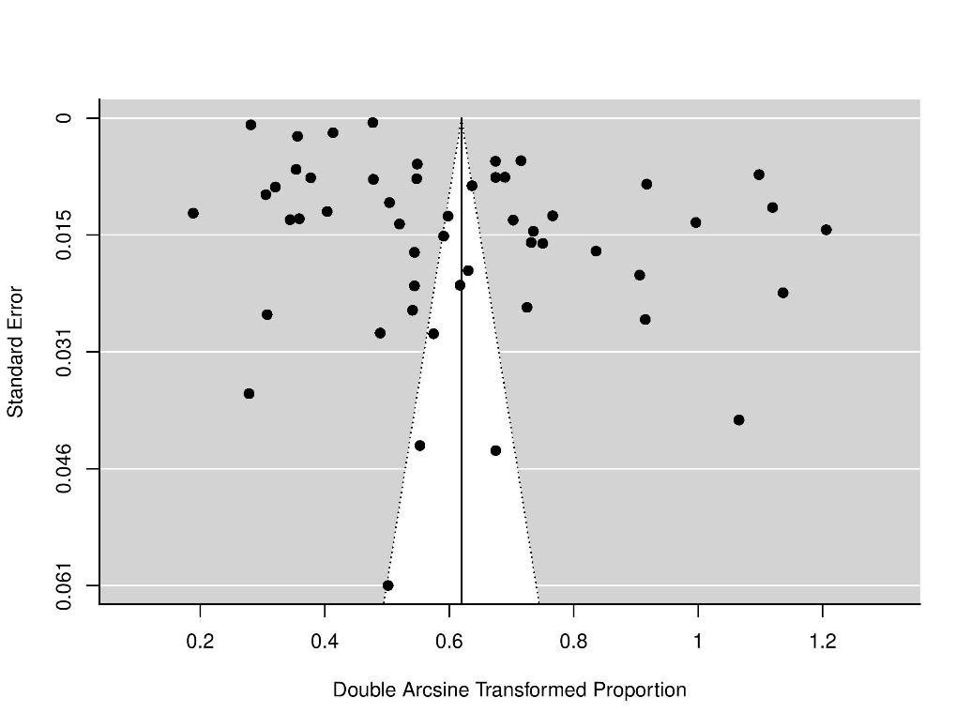
- Anxiety prevalence (Egger’s test, p=0.46)
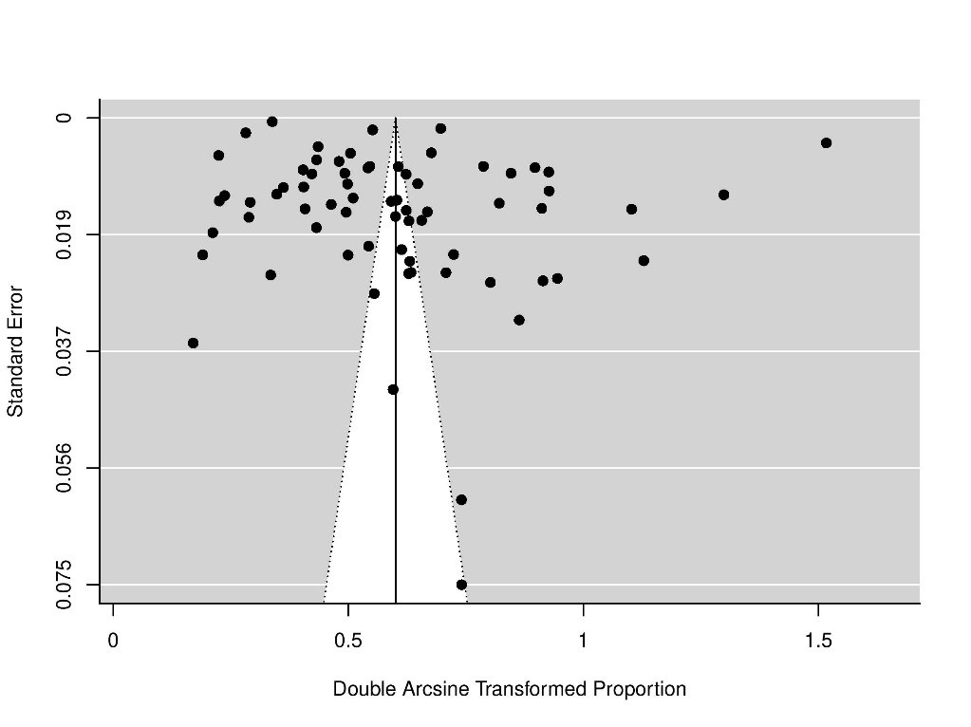

- Sleep disturbance prevalence (Egger’s test, p=0.45)
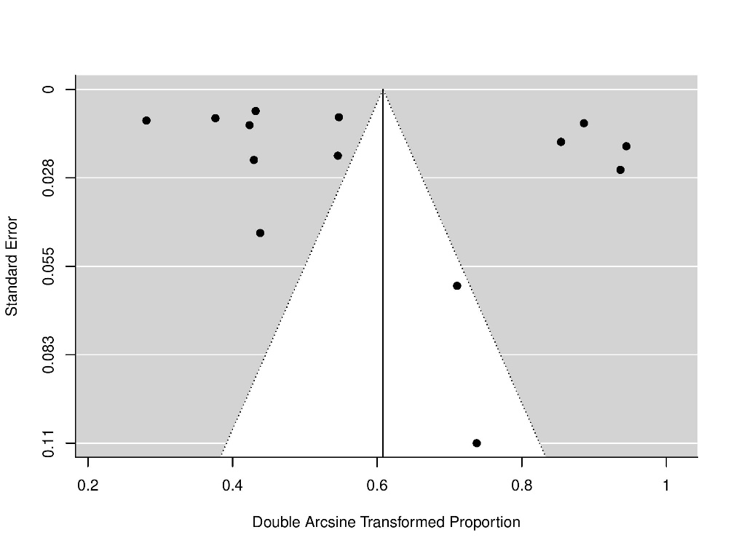

Figure S2 Subgroup by validated scale, depression prevalence
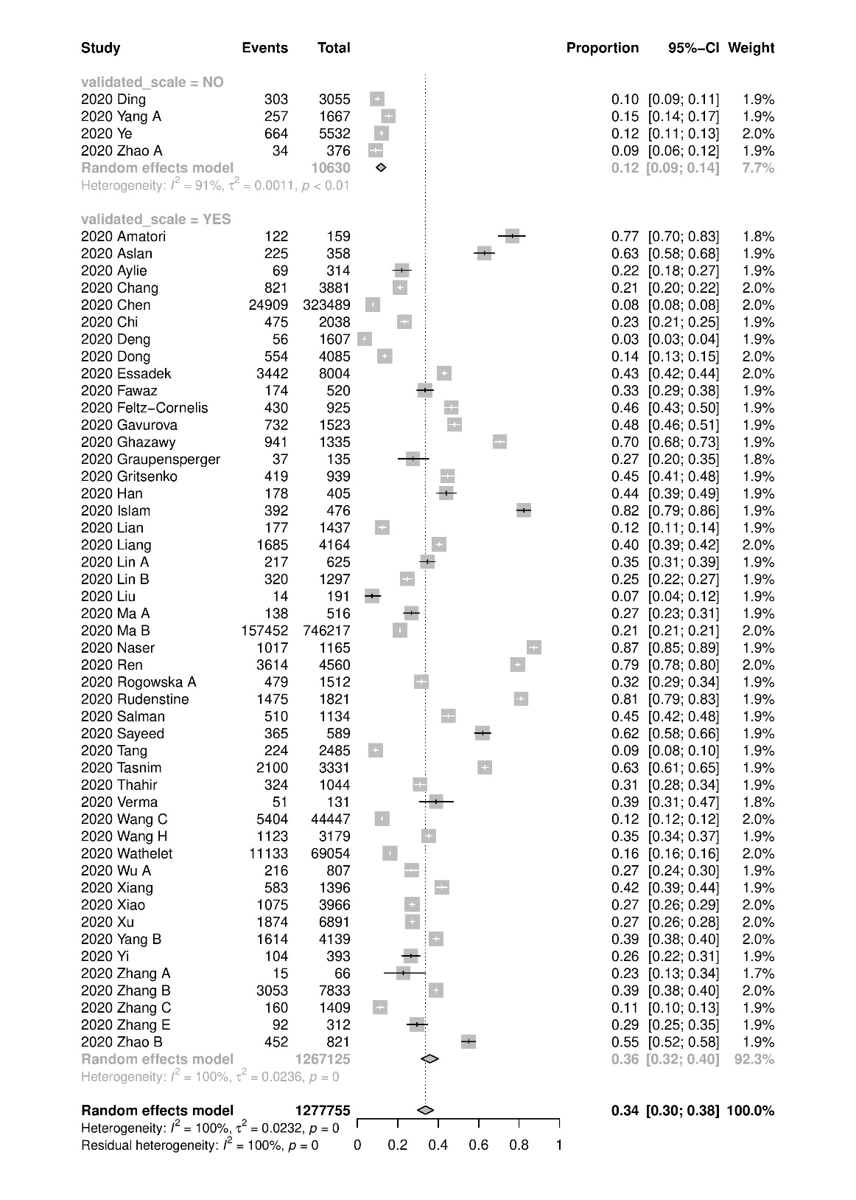

Figure S3 Subgroup by validated scale, anxiety prevalence
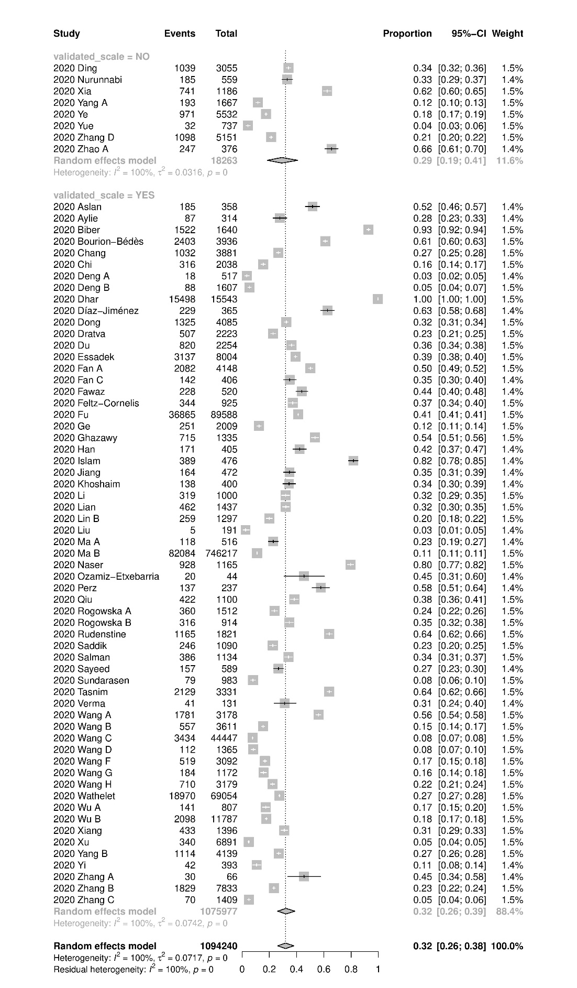
Figure S4 Subgroup by gender, depression prevalence
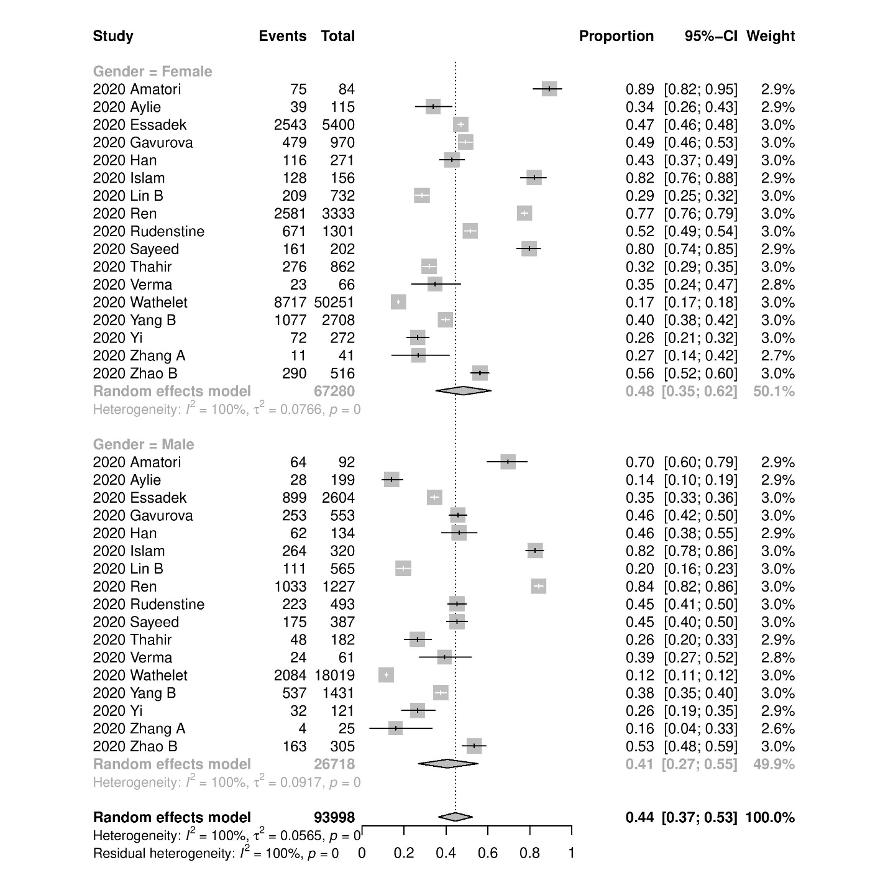

Figure S5 Subgroup by gender, anxiety prevalence
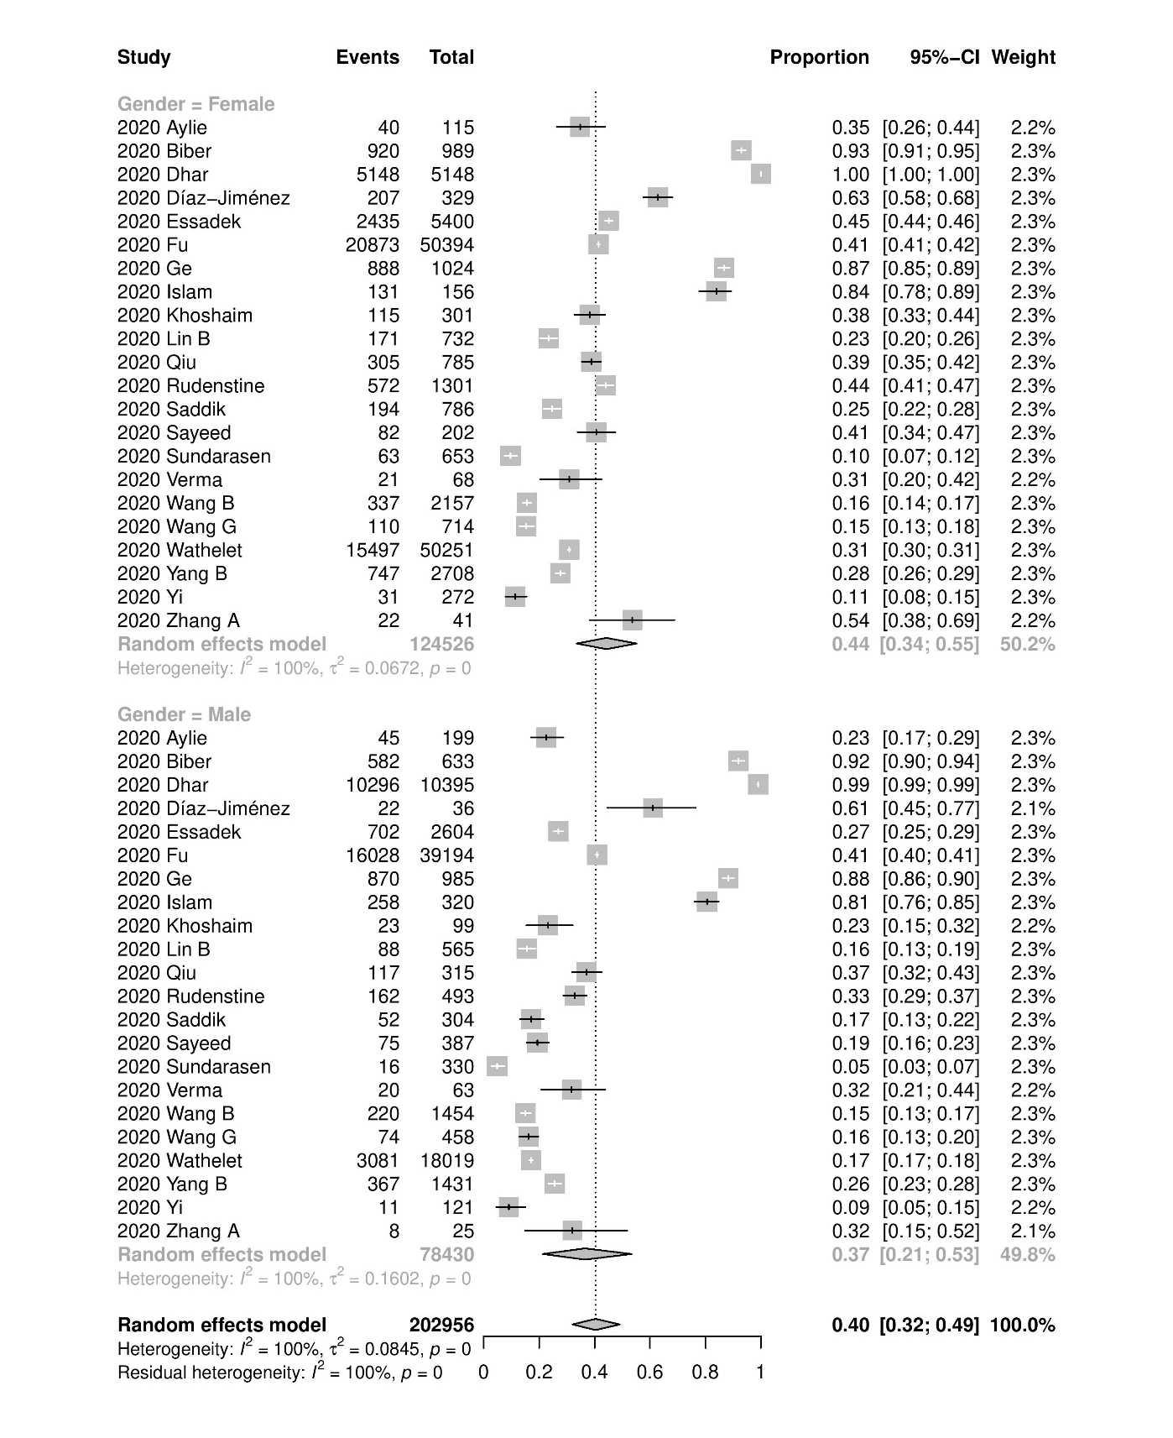

Figure S6 Subgroup by gender, sleep disturbance prevalence
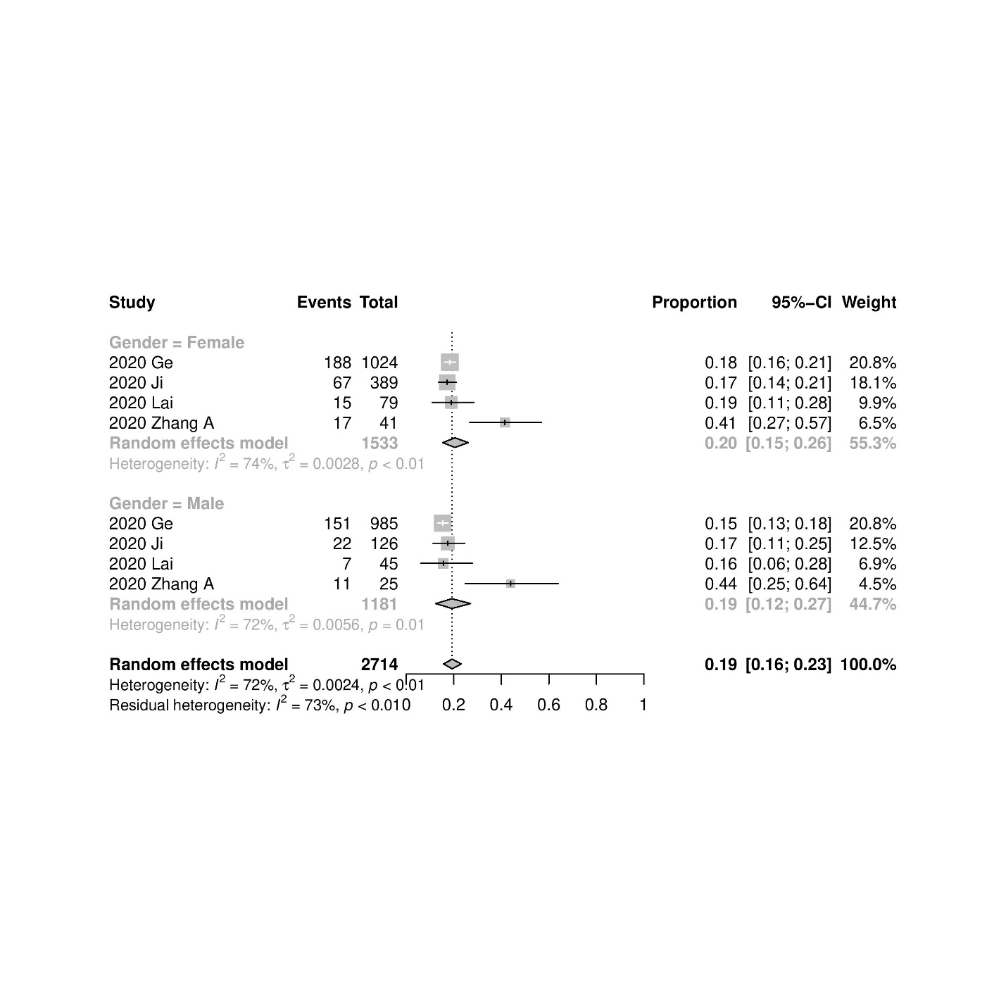

Figure S7 Subgroup by financial difficulties, depression prevalence

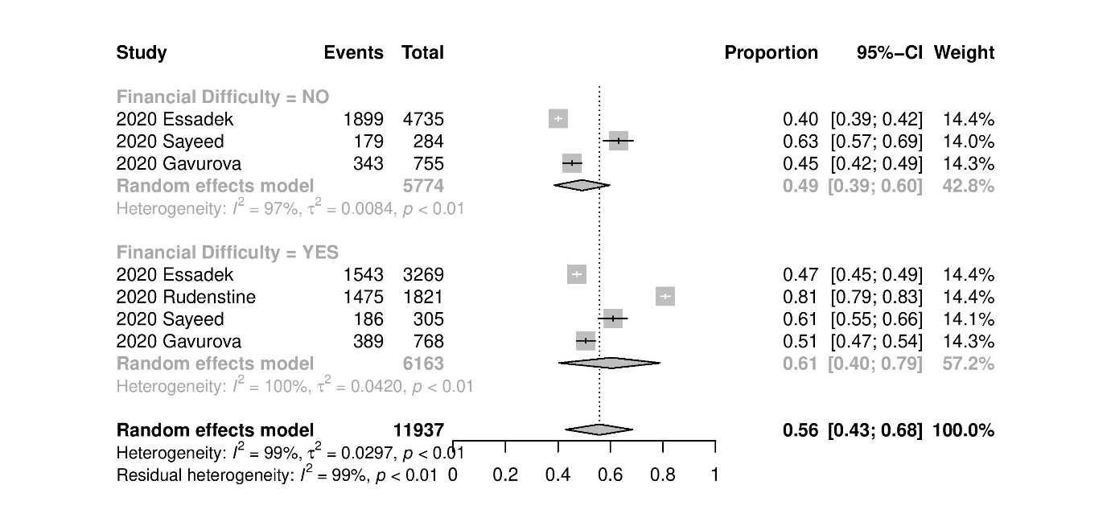

Figure S8 Subgroup by financial difficulties, anxiety prevalence
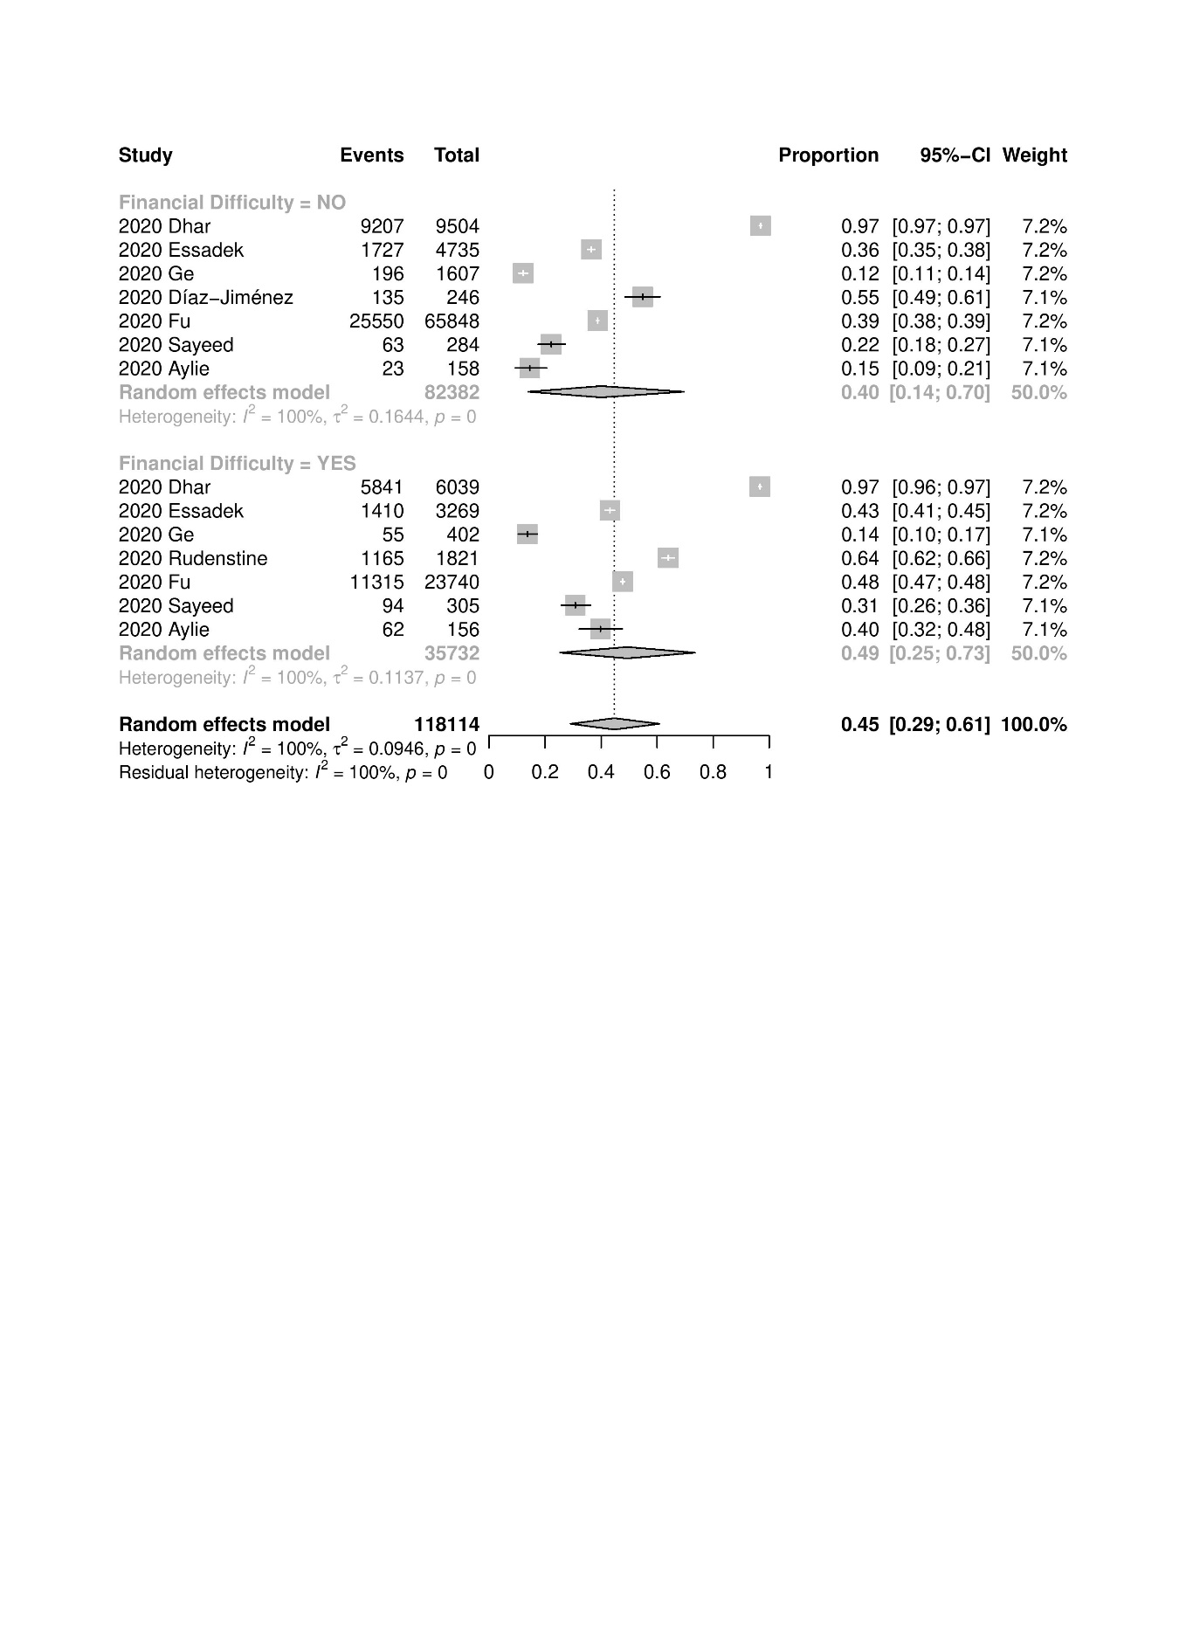
Figure S9 Subgroup by living arrangements, depression prevalence
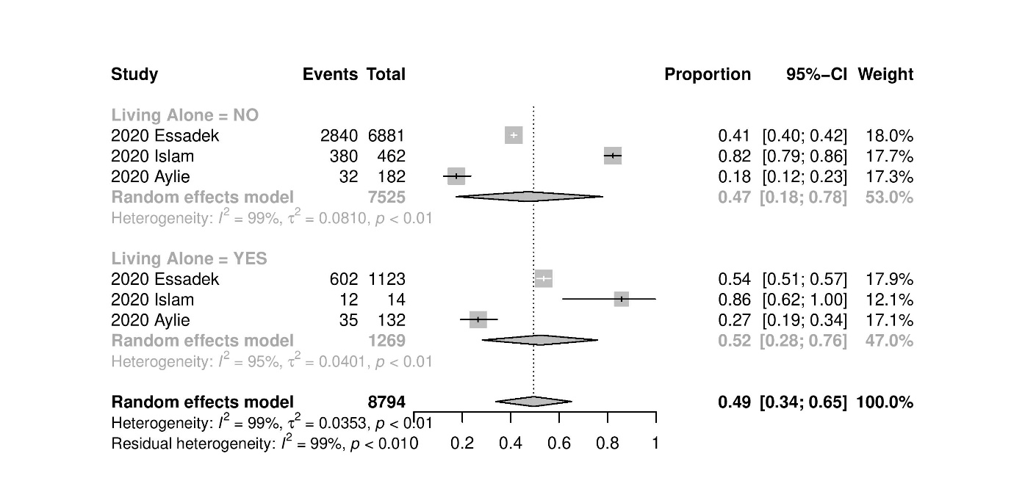

Figure S10 Subgroup by living arrangements, anxiety prevalence

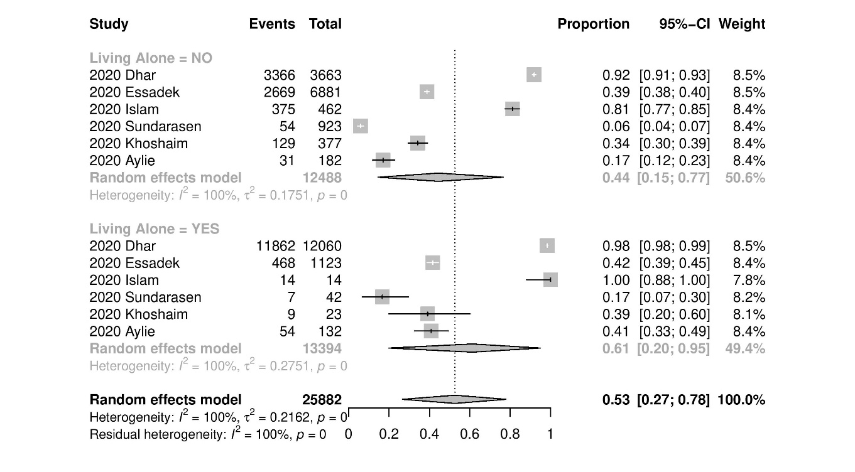

Figure S11 Subgroup by education level, depression prevalence

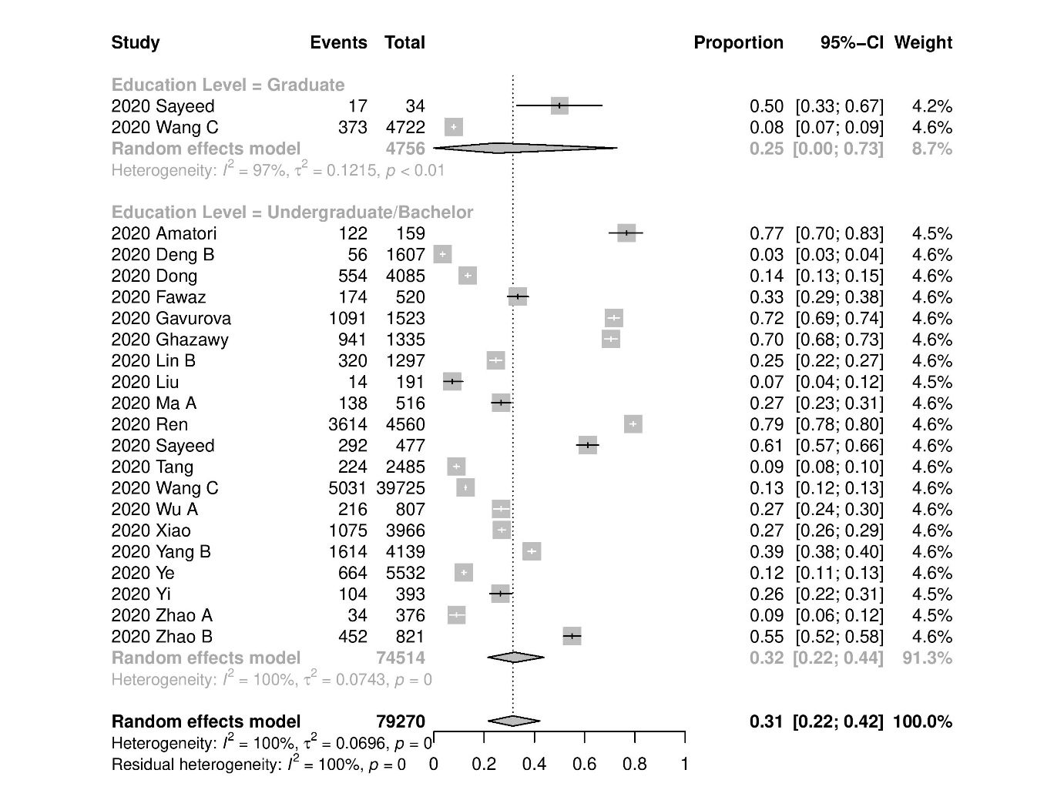

Figure S12 Subgroup by education level, anxiety prevalence

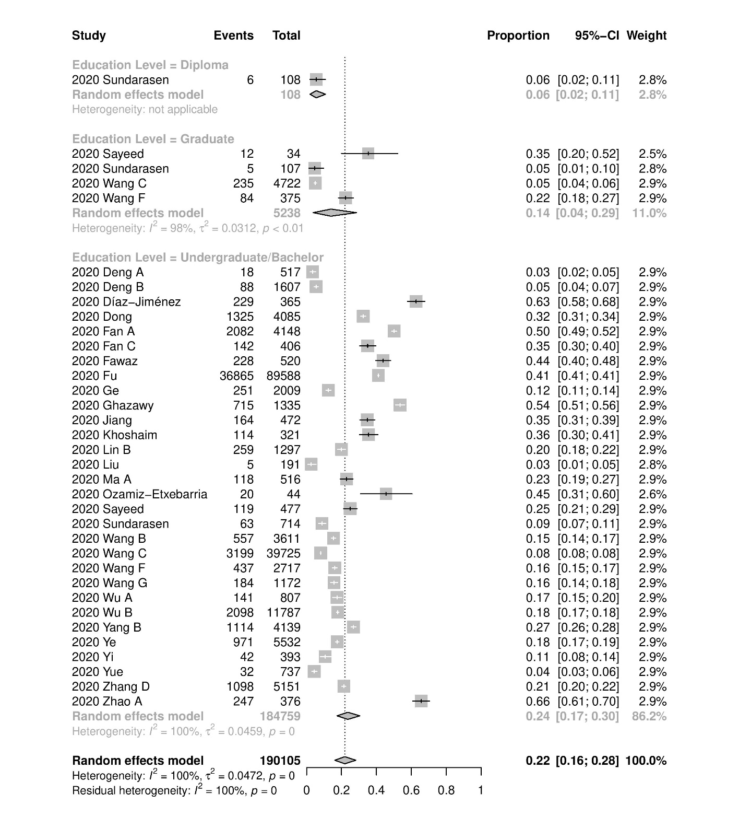

Figure S13 Subgroup by education level, sleep disturbance prevalence
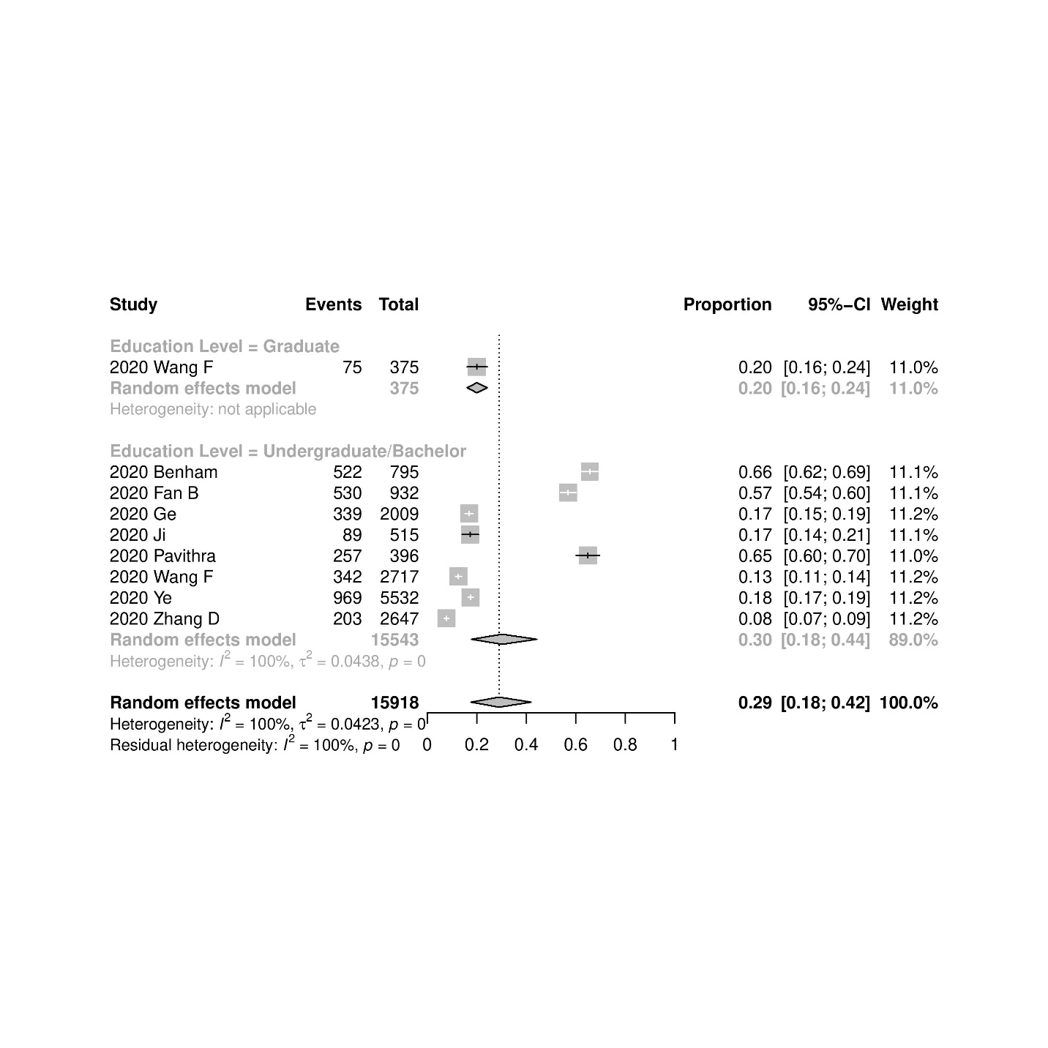

Figure S14 Subgroup by undergraduate year of study, depression prevalence

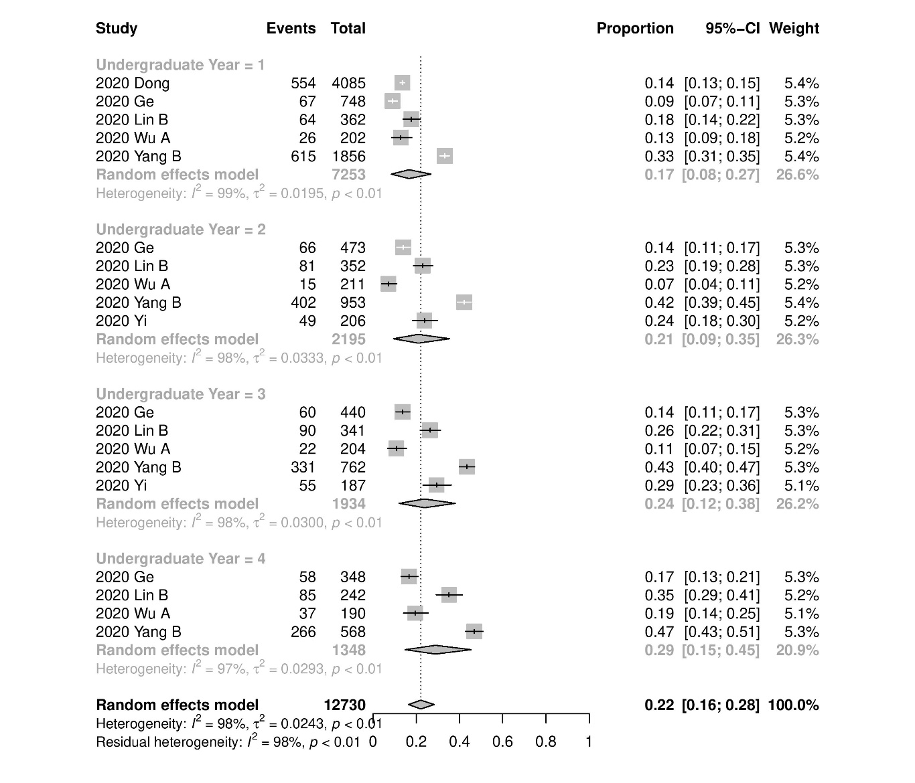

Figure S15 Subgroup by undergraduate year of study, anxiety prevalence
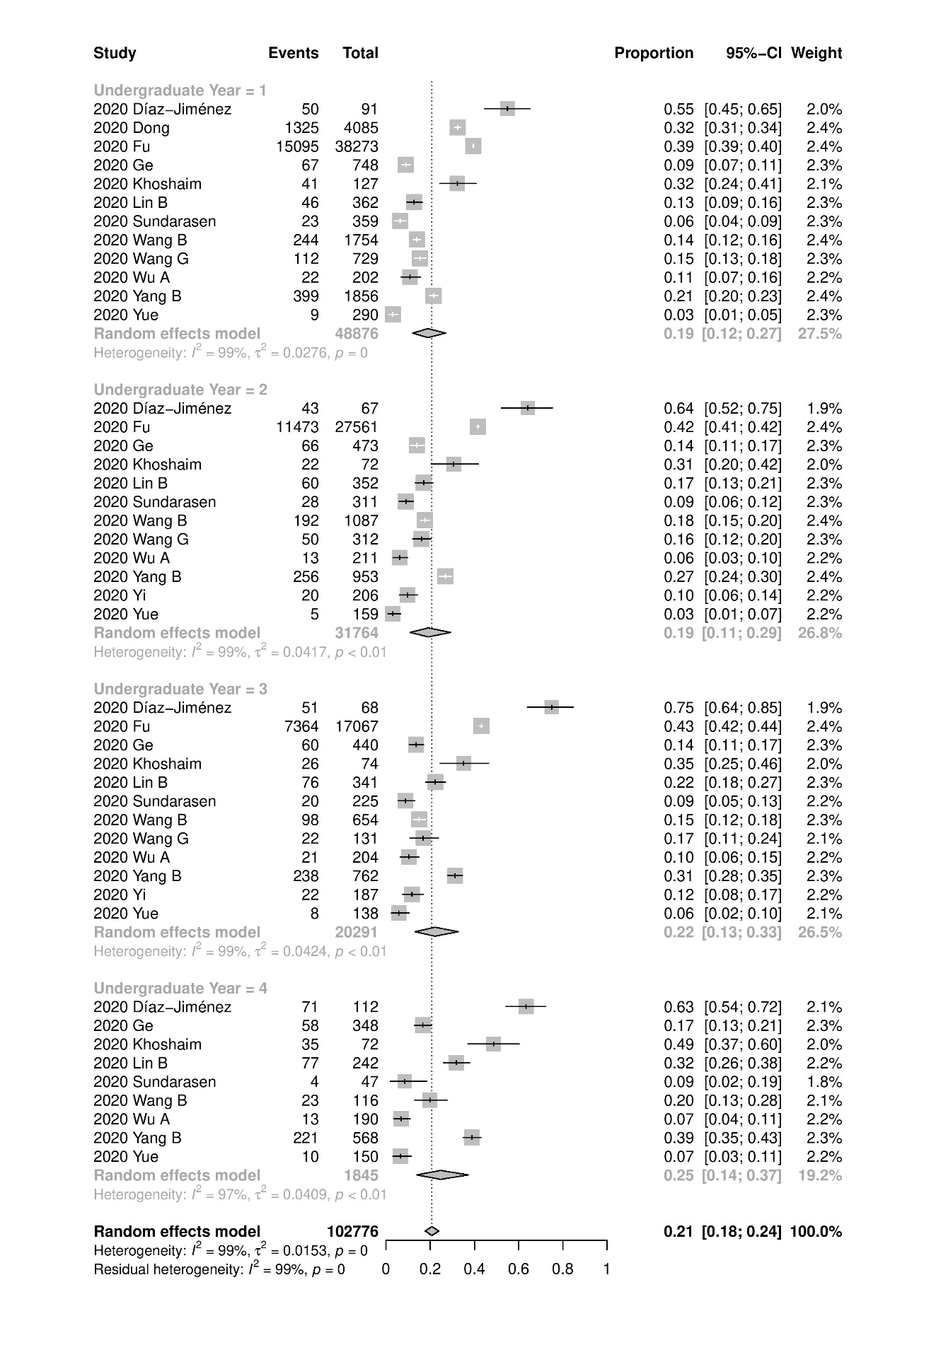
Figure S16 Severity subgroups, depression prevalence

- Mild depression
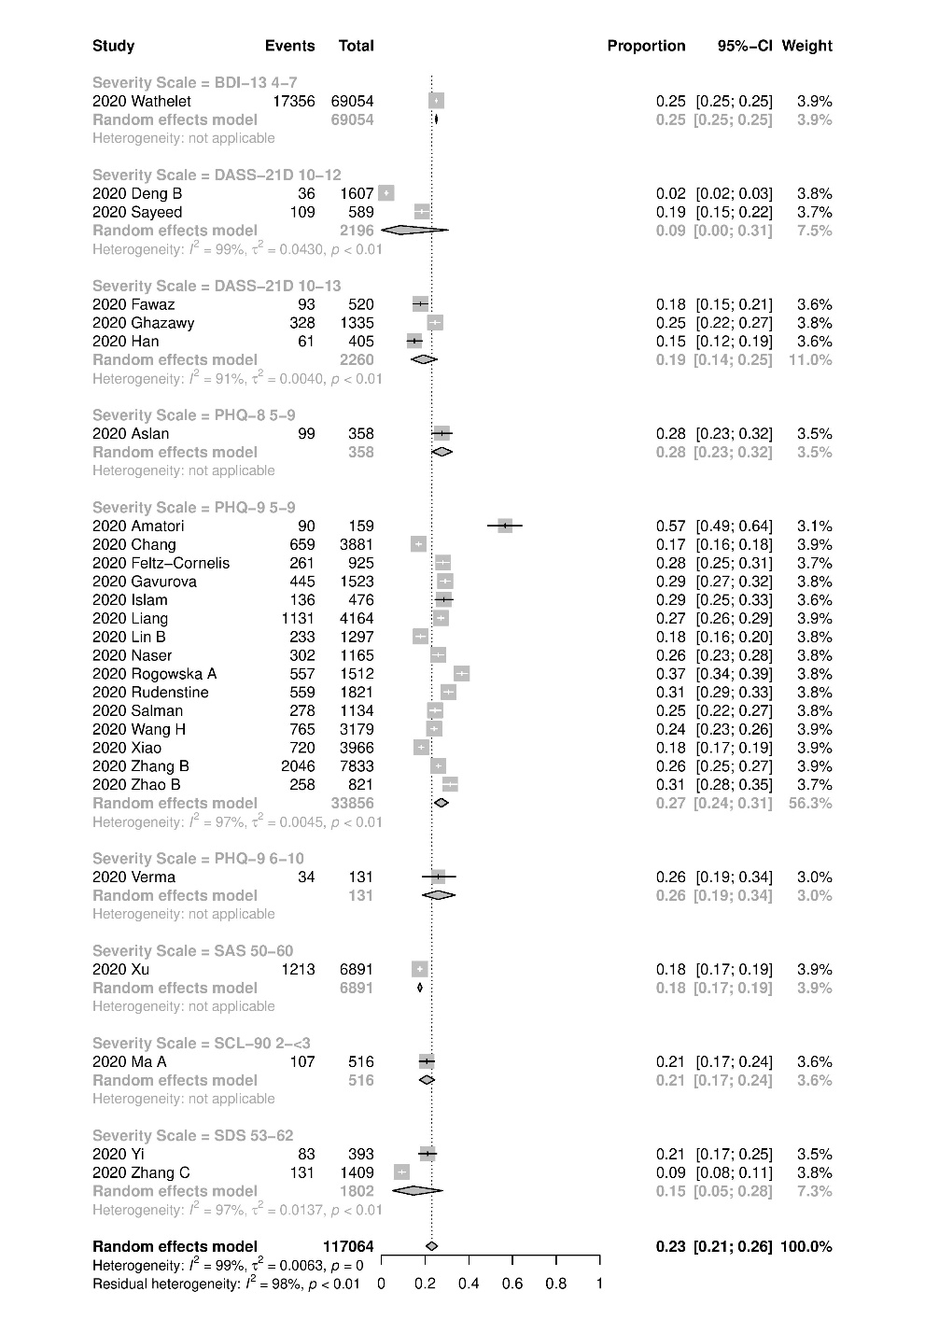

- Moderate depression

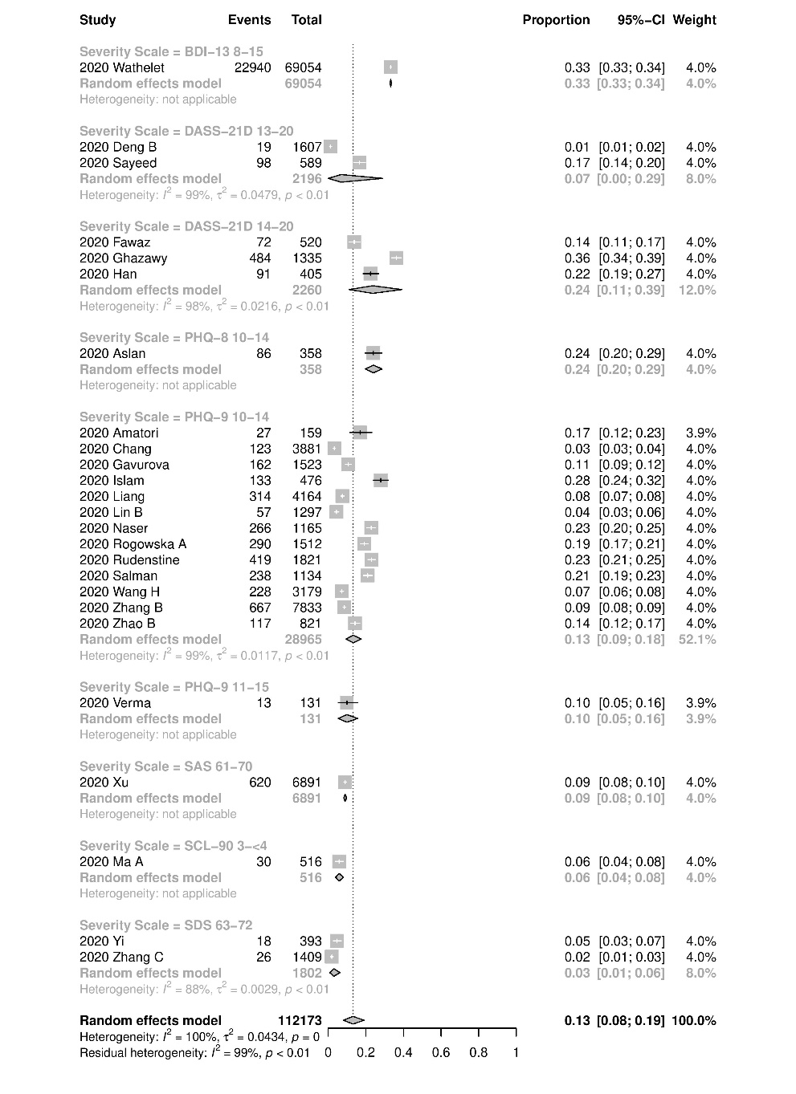

- Severe depression
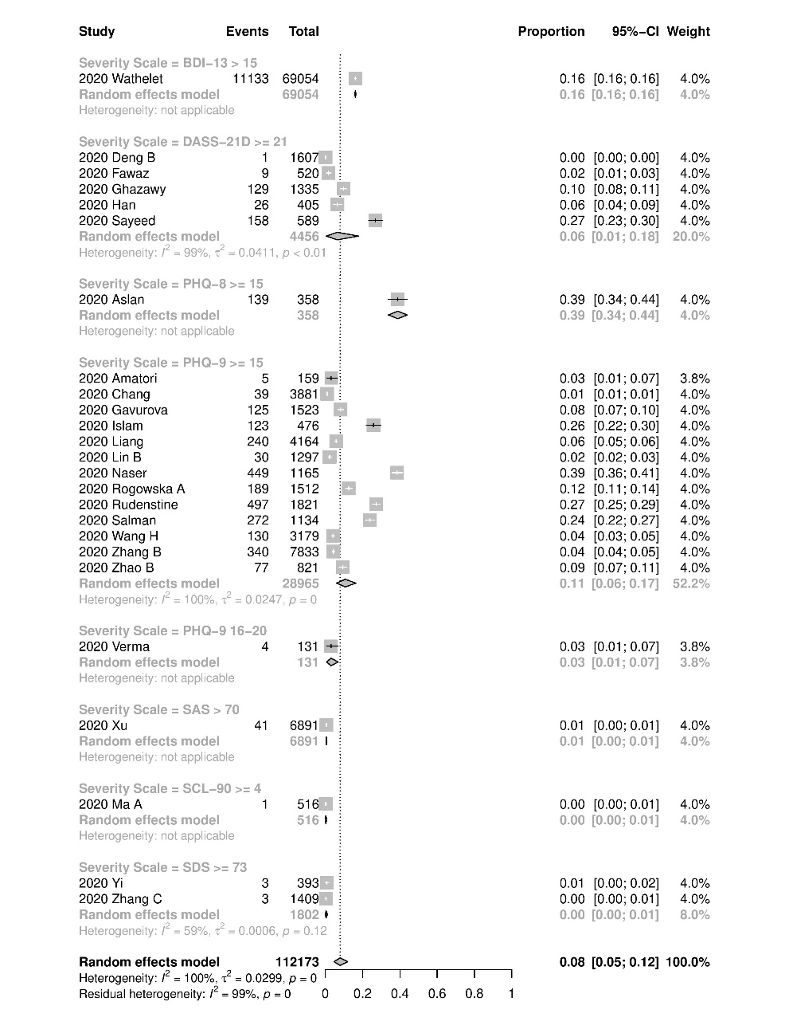

Figure S17 Severity subgroups, anxiety prevalence
- Mild anxiety
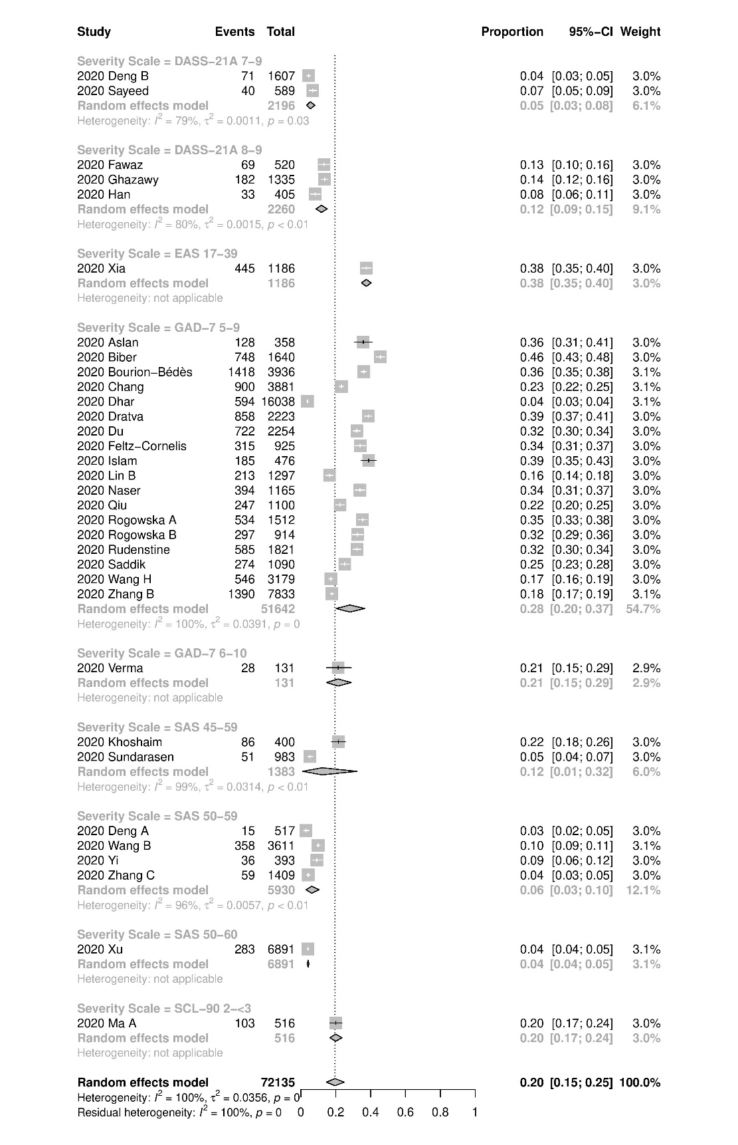

- Moderate anxiety
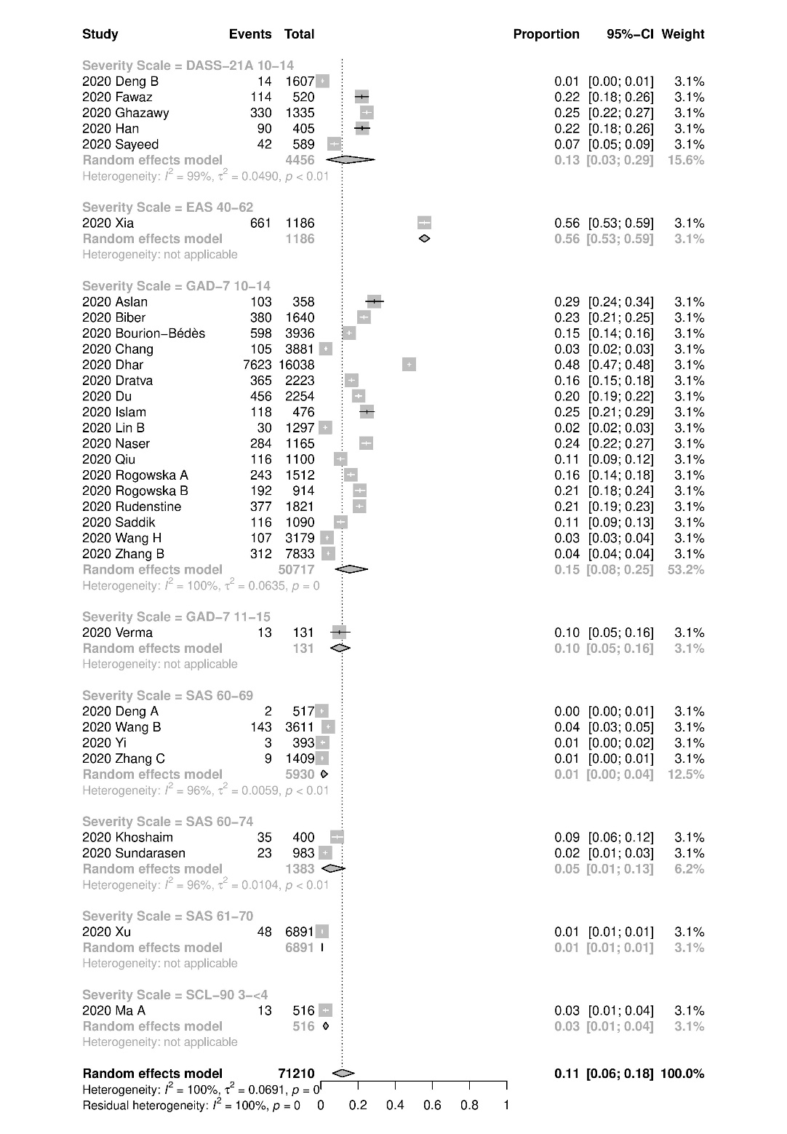

- Severe anxiety
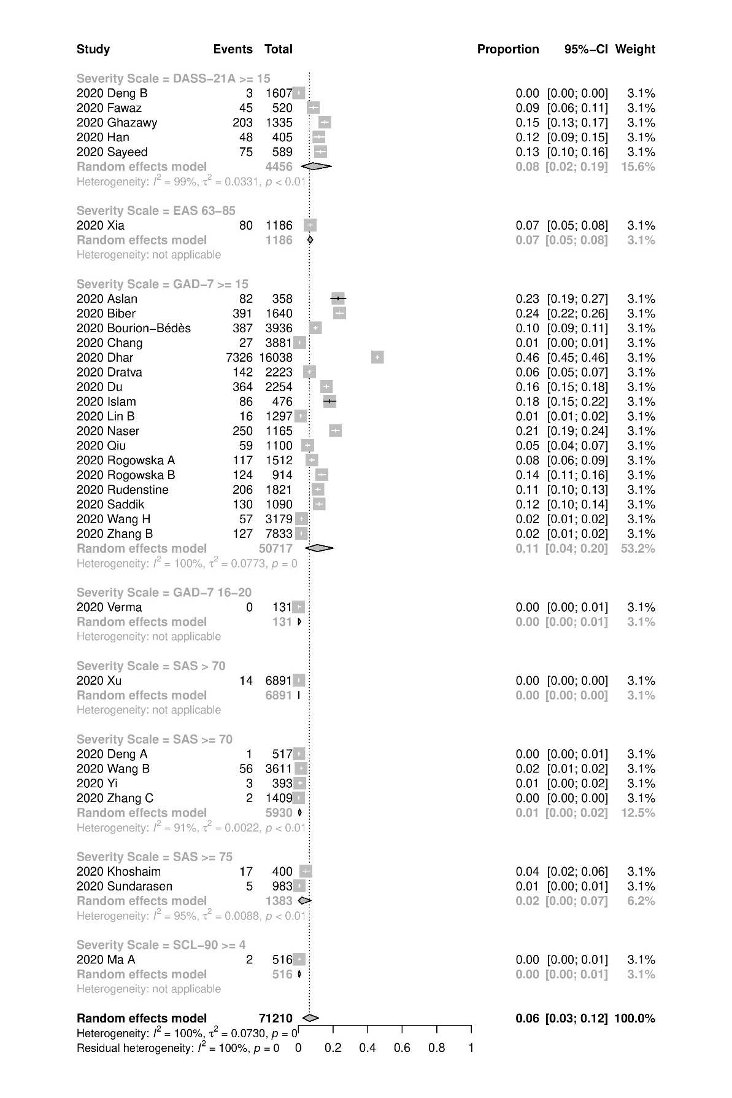

Figure S18 Subgroup by country, depression prevalence
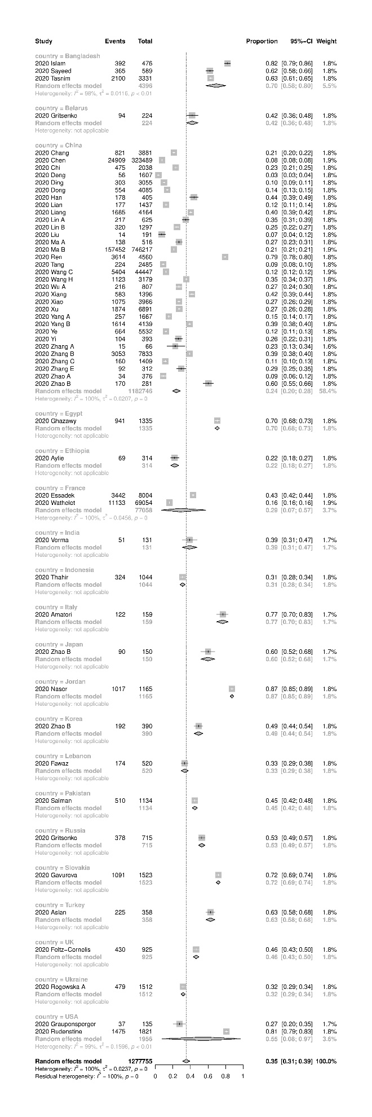
Figure S19 Subgroup by country, anxiety prevalence
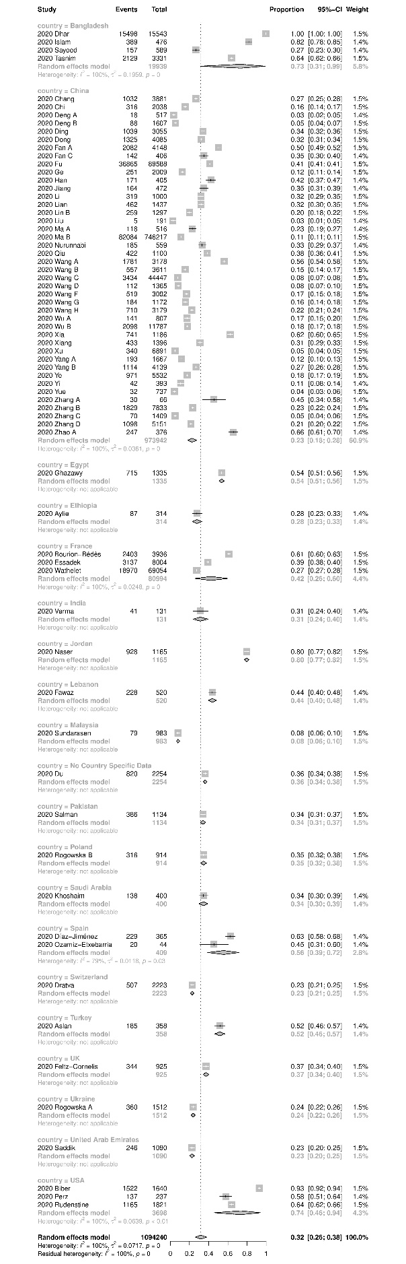
Figure S20 Subgroup by country, sleep disturbance prevalence


