Supplementary figures and tables

A.
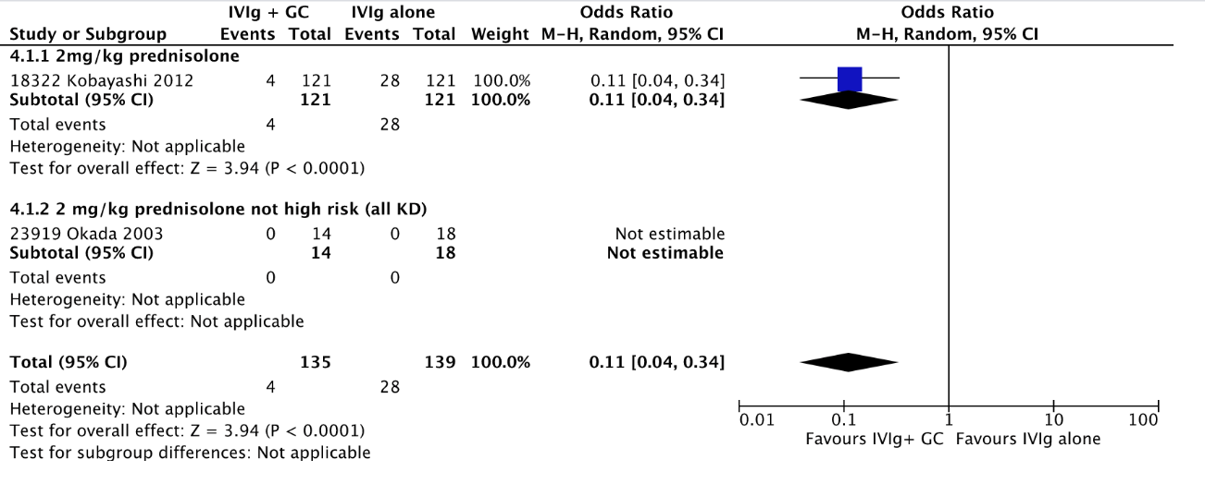
B.
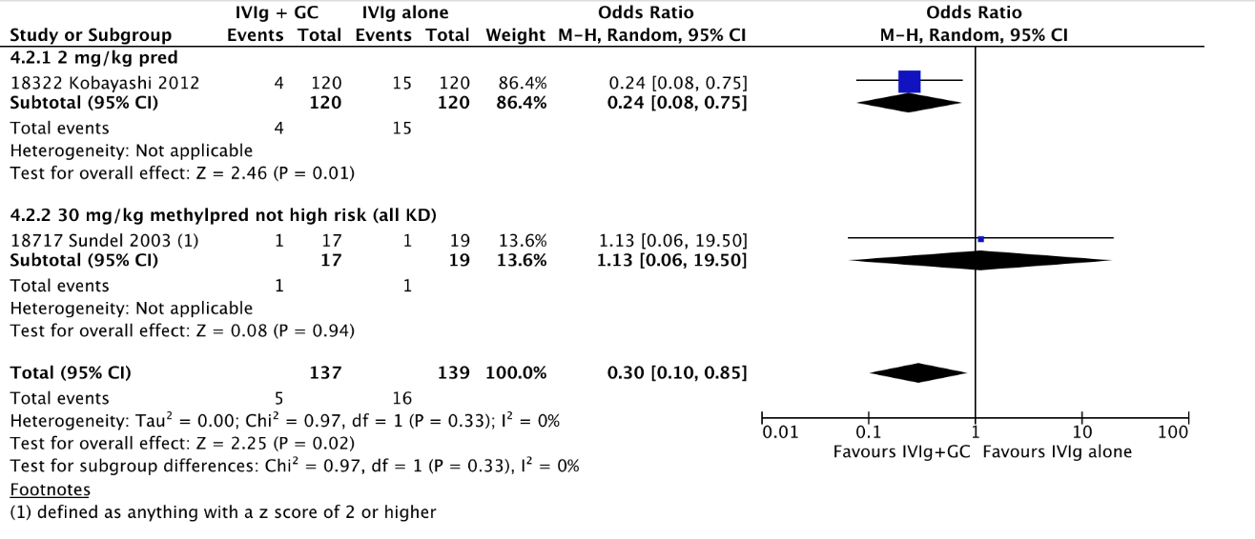

Supplementary Figure 1: Forest plots of studies comparing IVIG vs IVIG plus glucocorticoids for initial therapy in high-risk Kawasaki Disease (KD). Glucocorticoids (GC). A. Coronary artery abnormality at any point; B. Coronary artery abnormality at the 4-6 week time point.

Certainty assessment |  |  |  |  |  |  | № of patients |  | Effect |  | Certainty
№ of studies | Study design | Risk of bias | Inconsistency | Indirectness | Imprecision | Other considerations | initial treatment with IVIG and glucocorticoids | IVIG alone | Relative  (95% CI) | Absolute  (95% CI) | Certainty
Any coronary abnormality (any point), none at baseline
2^{13,14} | randomised trials | serious ª | not serious | not serious | serious ^{b} | none | 4/135 (3.0%) | 28/139 (20.1%) | OR 0.11  (0.04 to 0.34) | 174 fewer per 1,000  (from 191 fewer to 122 fewer) | ⨁⨁◯◯  LOW
Any coronary Abnormality week 4-6, none at baseline
2^{13,15} | randomised trials | serious ª | not serious | not serious | serious ^{b} | none | 5/137 (3.6%) | 16/139 (11.5%) | OR 0.30  (0.10 to 0.85) | 78 fewer per 1,000  (from 102 fewer to 16 fewer) | ⨁⨁◯◯  LOW
duration of fevers
6¹³⁻¹⁸ | randomised trials | serious ª | not serious | not serious | serious ^{b} | none | 366 | 371 | - | SMD 0.97 lower  (1.64 lower to 0.31 lower) | ⨁⨁◯◯  LOW
Duration of hospital stay
1¹⁵ | randomised trials | serious ª | not serious | not serious | serious ^{b} | none | 18 | 21 | - | MD 1.4 lower  (2.35 lower to 0.45 lower) | ⨁⨁◯◯  LOW
Coronary Aneurysm week 4-6
2^{16,17} | randomised trials | serious ª | not serious | not serious | serious ^{b} | none | 2/112 (1.8%) | 13/114 (11.4%) | OR 0.15  (0.04 to 0.65) | 95 fewer per 1,000  (from 109 fewer to 37 fewer) | ⨁⨁◯◯  LOW
Re-treatment
5^{13,15-18} | randomised trials | serious ª | not serious | not serious | serious ^{b} | none | 42/352 (11.9%) | 106/353 (30.0%) | OR 0.30  (0.14 to 0.64) | 186 fewer per 1,000  (from 244 fewer to 85 fewer) | ⨁⨁◯◯  LOW
Serious Adverse Events
3^{13,16,17} | randomised trials | serious ª | not serious | not serious | very serious ^{b} | none | 6/233 (2.6%) | 3/235 (1.3%) | OR 1.97  (0.48 to 8.12) | 12 more per 1,000  (from 7 fewer to 82 more) | ⨁◯◯◯  VERY LOW

Supplemental Table 1: Grading of evidence addressing the question of use of IVIG + glucocorticoids vs IVIG alone as initial therapy in high-risk disease.
CI: Confidence interval; OR: Odds ratio; SMD: Standardised mean difference; MD: Mean difference
^{a.} Patients and treating providers were not blinded in some studies, Patients and investigators not blinded to treatment in some studies
^{b.} Clinical action would differ if the upper versus the lower boundary of the CI represented the truth

Certainty assessment |  |  |  |  |  |  | № of patients |  | Effect |  | Certainty
№ of studies | Study design | Risk of bias | Inconsistency | Indirectness | Imprecision | Other considerations | treatment with glucocorticoids | another course of IVIG | Relative  (95% CI) | Absolute  (95% CI)
clinical response to therapy
3²⁷⁻²⁹ | observational studies | not serious | serious ª | not serious | serious ^{b} | none | 42/61 (68.9%) | 50/81 (61.7%) | OR 0.83  (0.37 to 1.87) | 45 fewer per 1,000  (from 244 fewer to 134 more) | ⨁◯◯◯  VERY LOW
Failure to respond to rescue therapy
1 ¹³ | observational studies | not serious | not serious | not serious | serious ^{b} | none | 23/72 (31.9%) | 51/136 (37.5%) | OR 0.78  (0.43 to 1.43) | 56 fewer per 1,000  (from 170 fewer to 87 more) | ⨁◯◯◯  VERY LOW
coronary aneurysms until 1 month
1 ¹³ | observational studies | not serious | not serious | not serious | serious ^{b} | none | 22/72 (30.6%) | 39/136 (28.7%) | OR 1.09  (0.59 to 2.04) | 18 more per 1,000  (from 95 fewer to 164 more) | ⨁◯◯◯  VERY LOW
Supplemental Table 2. Grading of evidence of addressing the question of using an additional dose of IVIG vs glucocorticoids in patients failing initial treatment
CI: Confidence interval; OR: Odds ratio
^{a.} The effect estimate (OR) in [28] does not meet with the confidence interval of the OR in [29]
^{b.} Clinical action would differ if the upper versus the lower boundary of the CI represented the truth

A.
Certainty assessment |  |  |  |  |  |  | № of patients |  | Effect |  | Certainty
№ of studies | Study design | Risk of bias | Inconsistency | Indirectness | Imprecision | Other considerations | No Aspirin | Any dose of Aspirin | Relative  (95% CI) | Absolute  (95% CI) | Certainty
Duration of Fever to IVIG
1³⁹ | observational studies | not serious | not serious | not serious | very serious ª | none | 51 | 129 | - | MD 0.2 higher  (0.6 lower to 1 higher) | ⨁◯◯◯  VERY LOW
Response to IVIG
1³⁹ | observational studies | not serious | not serious | not serious | very serious ª | none | 43/51 (84.3%) | 107/129 (82.9%) | OR 1.11  (0.46 to 2.67) | 14 more per 1,000  (from 138 fewer to 99 more) | ⨁◯◯◯  VERY LOW
Incidence of Coronary Artery Lesion
2^{39,40} | observational studies | not serious | not serious | not serious | serious ª | none | 25/203 (12.3%) | 138/887 (15.6%) | OR 0.83  (0.52 to 1.31) | 23 fewer per 1,000  (from 68 fewer to 39 more) | ⨁⨁⨁◯  MODERATE

B.
Certainty assessment |  |  |  |  |  |  | № of patients |  | Effect |  | Certainty
№ of studies | Study design | Risk of bias | Inconsistency | Indirectness | Imprecision | Other considerations | low-dose aspirin | high-dose or moderate dose aspirin | Relative  (95% CI) | Absolute  (95% CI) | Certainty
Any coronary abnormality
4^{40-42,46} | observational studies | not serious | not serious | not serious | serious ª | none | 287/1592 (18.0%) | 2157/8905 (24.2%) | OR 0.88  (0.61 to 1.26) | 23 fewer per 1,000  (from 79 fewer to 45 more) | ⨁◯◯◯  VERY LOW
coronary artery aneurysm subacute phase (6-8 weeks)
2 ^{43,44} | observational studies | not serious | not serious | not serious | serious ª | strong association | 3/141 (2.1%) | 26/321 (8.1%) | OR 0.36  (0.10 to 1.28) | 50 fewer per 1,000  (from 72 fewer to 20 more) | ⨁⨁◯◯  LOW
Giant Aneurysm
2 ^{41,42} | observational studies | not serious | not serious | not serious | serious ª | none | 9/874 (1.0%) | 76/8795 (0.9%) | OR 0.71  (0.34 to 1.46) | 2 fewer per 1,000  (from 6 fewer to 4 more) | ⨁◯◯◯  VERY LOW
Total Duration of Fever (D)
3 ^{42,45,46} | observational studies | not serious | not serious | not serious | serious ª | none | 581 | 8000 | - | SMD 0.82 SD lower  (2.08 lower to 0.45 higher) | ⨁◯◯◯  VERY LOW
Refractory disease (requiring retreatment)
2^{44,46} | observational studies | not serious | not serious | not serious | serious ª | strong association | 30/168 (17.9%) | 14/151 (9.3%) | OR 1.18  (0.13 to 10.87) | 15 more per 1,000  (from 80 fewer to 434 more) | ⨁⨁◯◯  LOW
B

Supplemental Table 3: Grading of evidence of addressing the question of A. No Aspirin compared to Any dose of Aspirin for patients with acute KD and B. Low-dose aspirin compared to high-dose or moderate dose aspirin for patients with acute KD

CI: Confidence interval; OR: Odds ratio; SMD: Standardised mean difference
^{a.} Clinical action would differ if the upper versus the lower boundary of the CI represented the truth

