Assessment of Publication Bias using Funnel Plot and Egger’s Regression Test

- The pooled prevalence of all amino acid changes in anti-malarial drug resistance genes
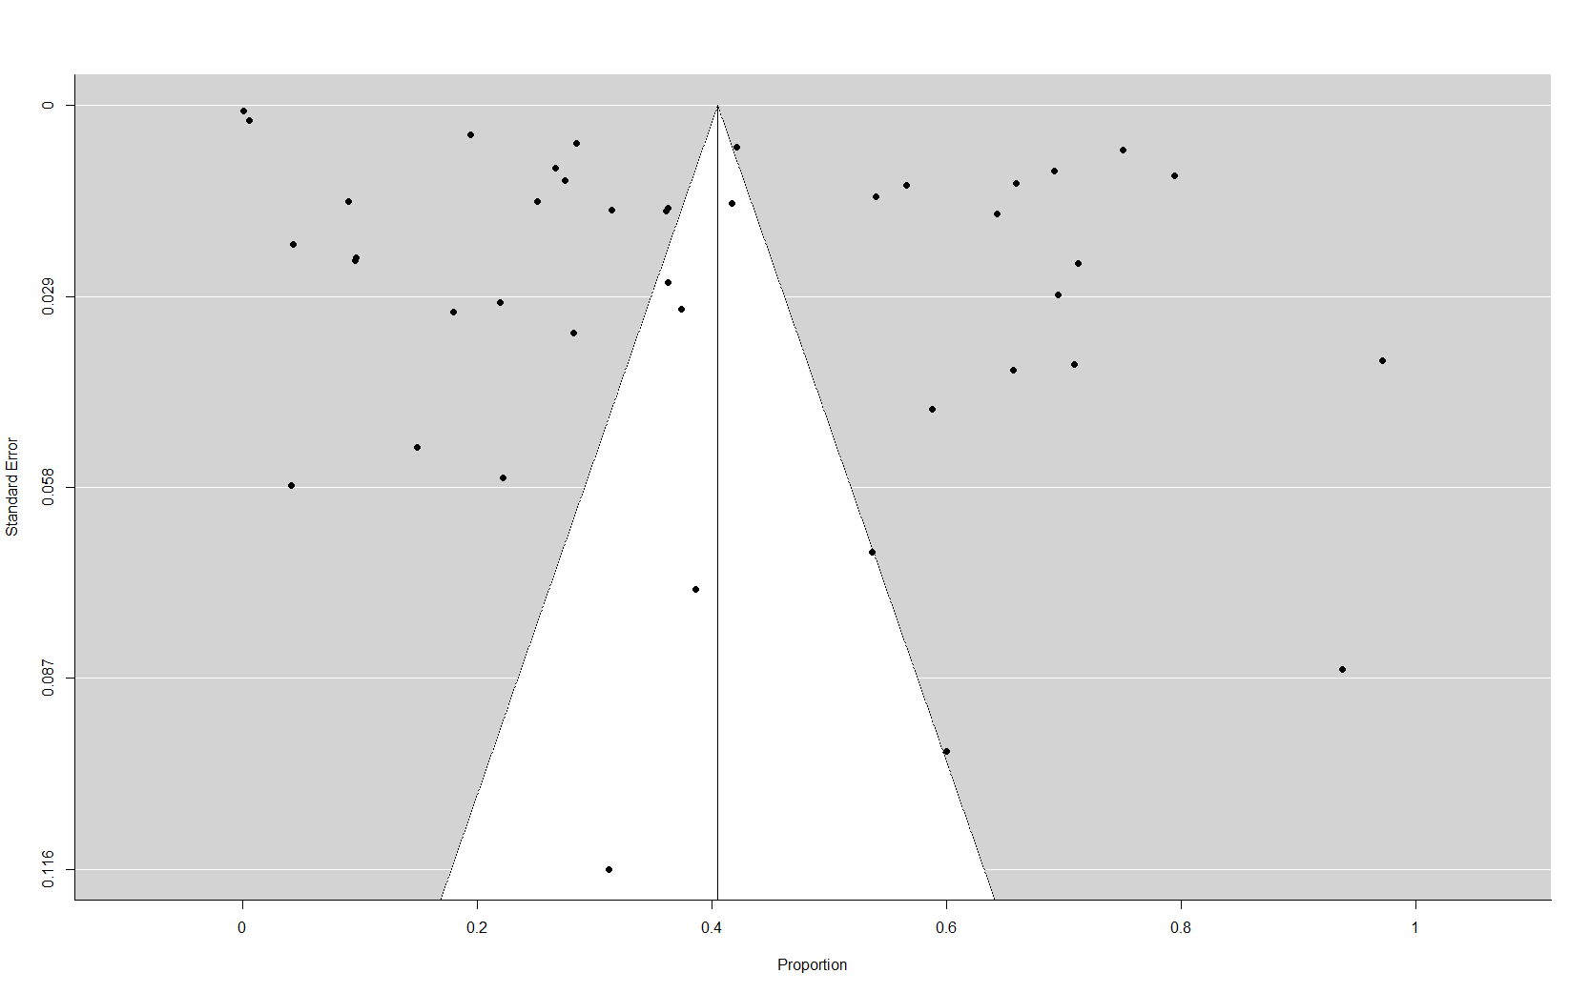

Figure 1: Funnel plot for pooled prevalence of all amino acid changes in anti-malarial drug resistance genes
Egger’s regression test for funnel plot asymmetry: t=5.6113, df=40, P<0.0001

- The pooled prevalence of Pfcrt K76T mutations

Figure 2: Funnel plot for pooled prevalence of Pfcrt K76T mutations
Egger’s regression test for funnel plot asymmetry: t=-0.8754, df =19, P=0.3923

- The pooled prevalence of Pfcrt CVIET mutations

Figure 3: Funnel plot for pooled prevalence of Pfcrt CVIET mutations
Egger’s regression test for funnel plot asymmetry: t=1.1479, df=7, P= 0.2887

- Pool prevalence of Pfmdr1 N86Y mutations

Figure 4: Funnel plot for pool prevalence of Pfmdr1 N86Y mutations
Egger’s regression test for funnel plot asymmetry: t=-1.3608, df=14, P = 0.1951

- Aggregate prevalence of Pfdhfr IRN haplotype mutations
Figure 5: Funnel plot for pooled prevalence of Pfdhfr IRN mutations
Egger’s regression test for funnel plot asymmetry: t=-3.5659, df=24, P= 0.0016

- Pooled prevalence of Pfdhfr-Pfdhps IRNG haplotype mutations

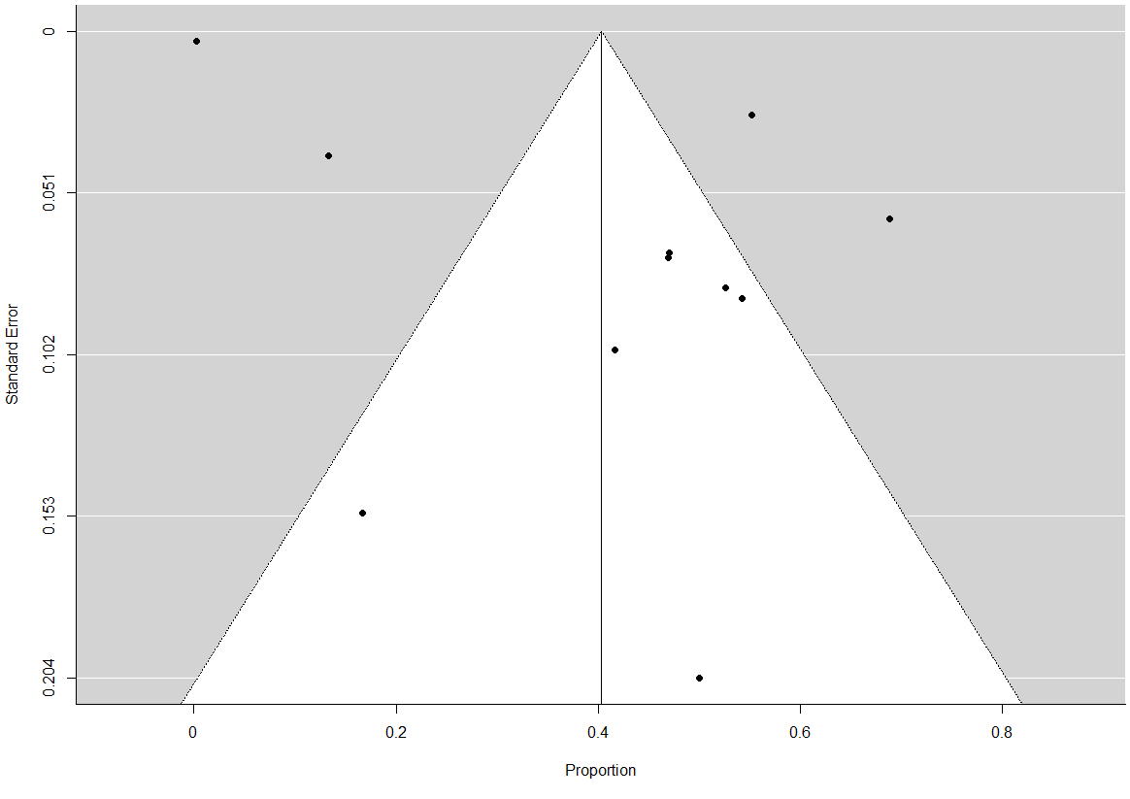

Figure 6: Forest plot pooled prevalence of Pfdhfr-Pfdhps IRNG haplotype mutations
Egger’s regression test for funnel plot asymmetry: t = 3.6156, df = 9, P = 0.0056

- Pooled prevalence of Pfk13 mutations
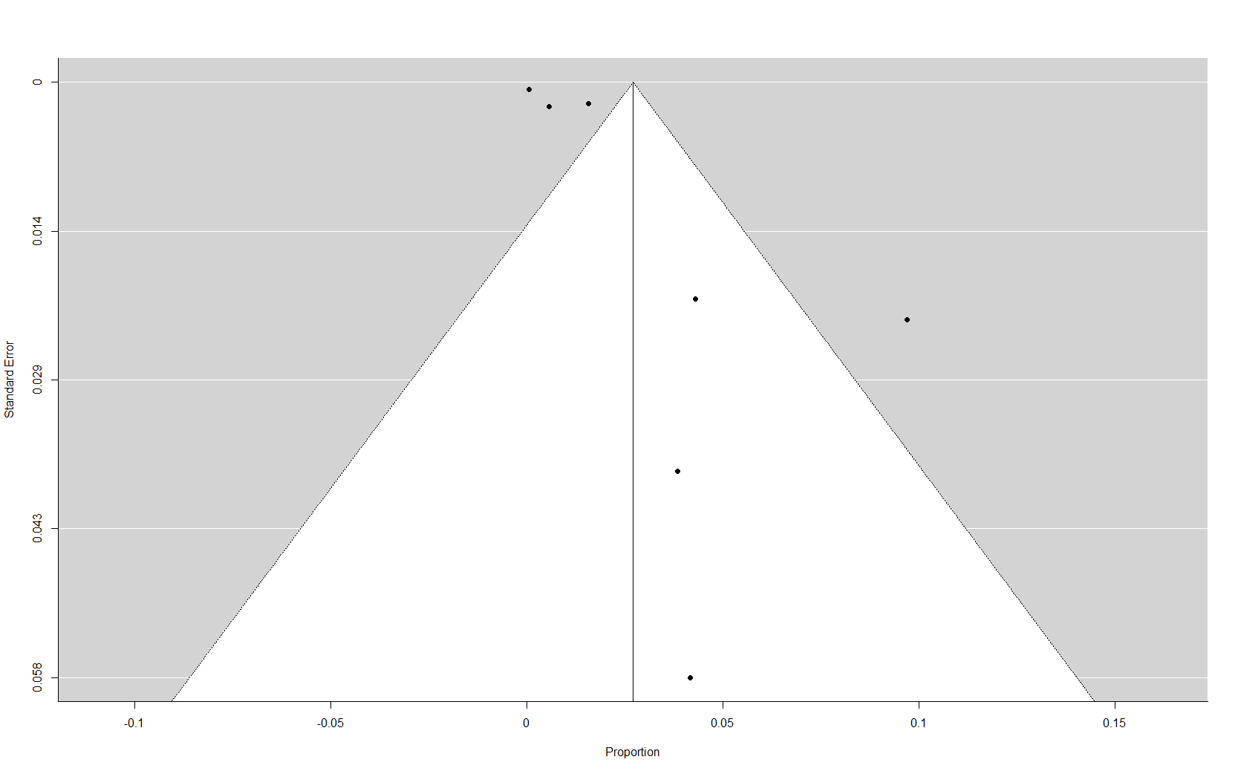

Figure 7: Funnel plot for pool prevalence of Pfk13 mutations
Egger’s regression test for funnel plot asymmetry: t = 2.1973, df = 5, P=0.0794

