Supplementary 1. Search strategy
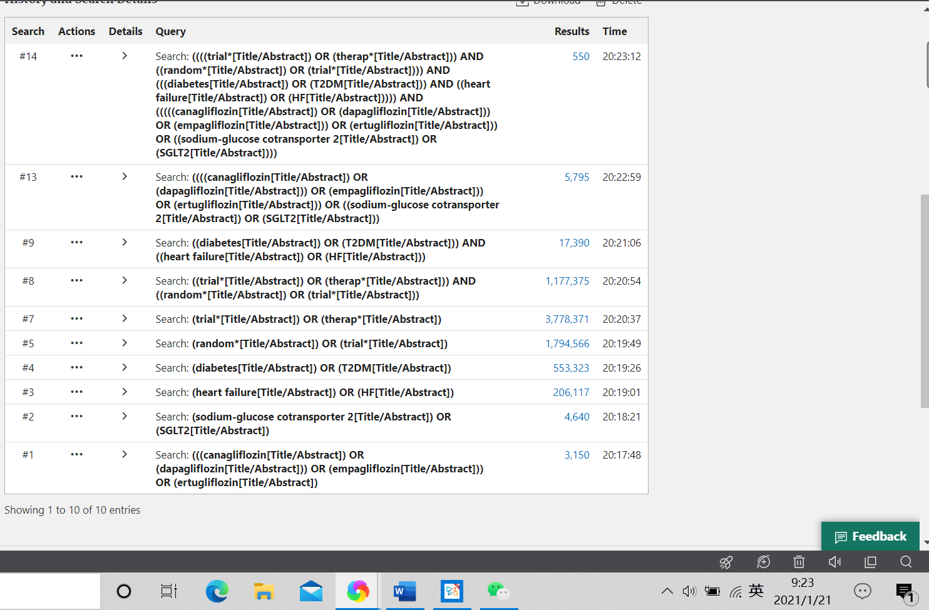
1.1 Search strategy in PubMed, we also recorded the time we performed electronic search

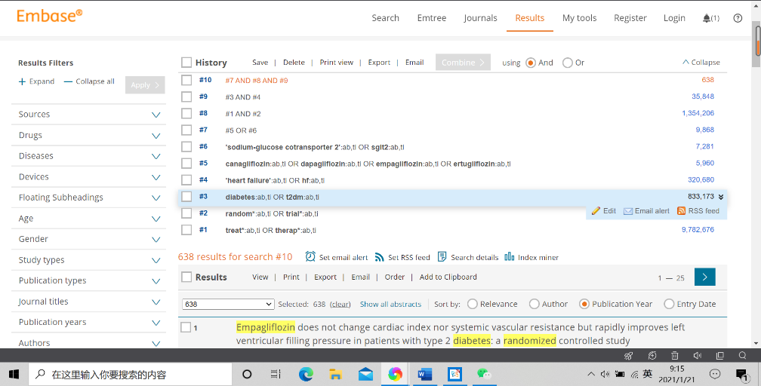
1.2 Search strategy in Embase, we also recorded the time we performed electronic search

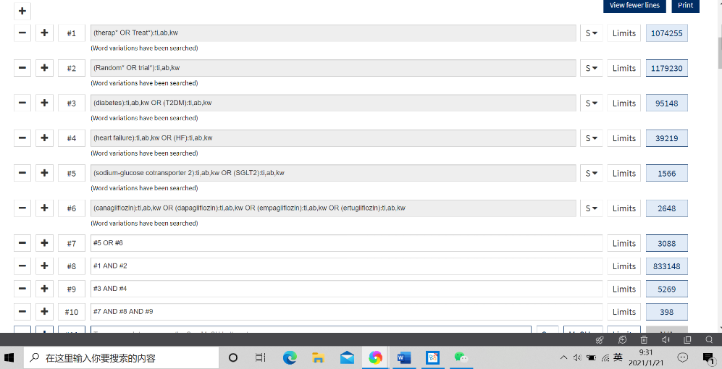
1.3 Search strategy in Cochrane database of clinical trials, we also recorded the time we performed electronic search. The number of records is 398, including one review record.

