Supplementary 3. Sensitive analysis
3.1 Sensitive analyses of the DECLARE-TIMI 58 trial, we collected the data combined existing HF and with HF history but not existing reduced EF.
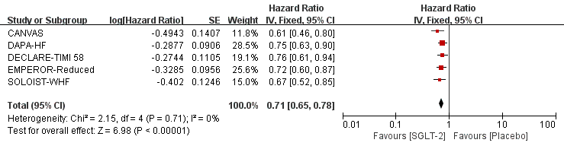
Figure 3.1.1. Forest plot-- DECLARE-TIMI 58 trial-- CV death or HHF

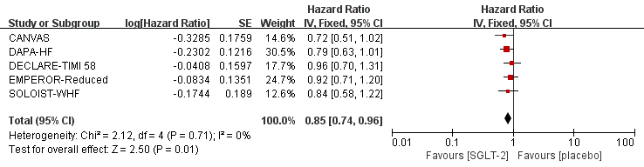
Figure 3.1.2. Forest plot-- DECLARE-TIMI 58 trial-- CV death

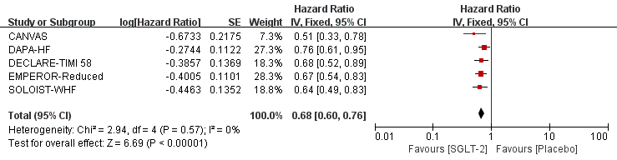
Figure 3.1.3. Forest plot-- DECLARE-TIMI 58 trial-- HHF

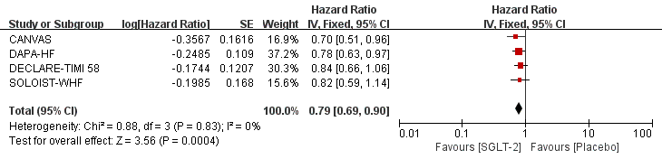
Figure 3.1.4. Forest plot-- DECLARE-TIMI 58 trial-- all caused mortality

3.2 Sensitive analyses of HHF including first and recurrent HHF, or time to first HHF only
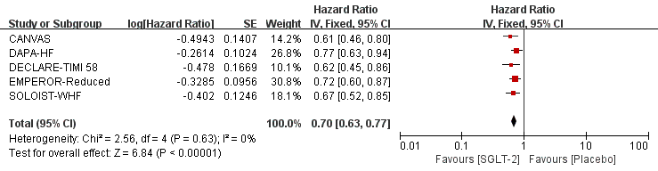
3.2.1 Forest plot-- DAPA-HF-- CV death or HHF (first and recurrent HHF)

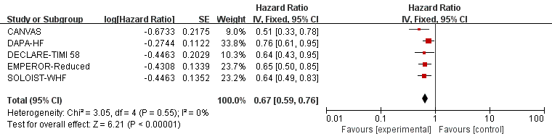
3.2.2 Forest plot-- EMPEROR-Reduced-- first and recurrent HHF

3.3 Sensitive analyses of different type of HF that only included HF with reduced EF, and different status of HF that only included existing HF. We did not repeat these processes because they had the same data.
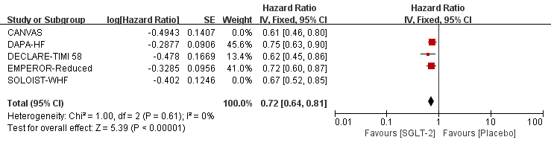
3.3.1 Forest plot--HF with reduced EF/existing HF only--CV death or HHF

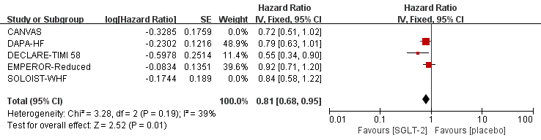
3.3.2 Forest plot--HF with reduced EF/existing HF only--CV death

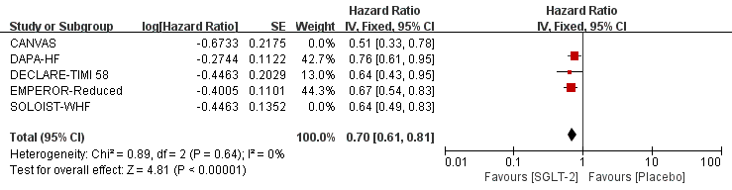
3.3.3 Forest plot--HF with reduced EF/existing HF only--HHF

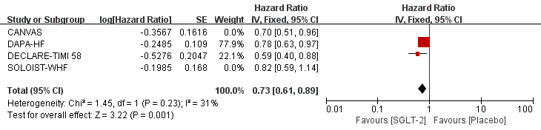
3.3.4 Forest plot--HF with reduced EF/existing HF only—all caused mortality

