Supplementary 4
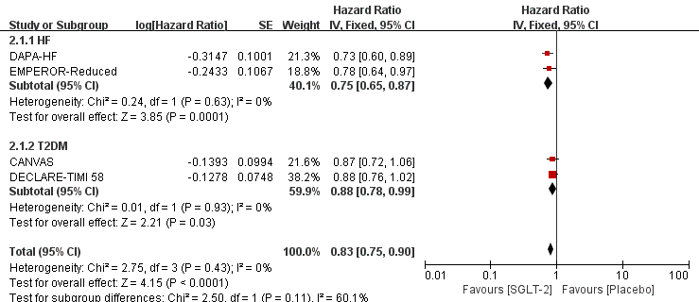

Supplementary 4.1. subgroup analysis of CV death or HHF in participants with T2DM or HF only.

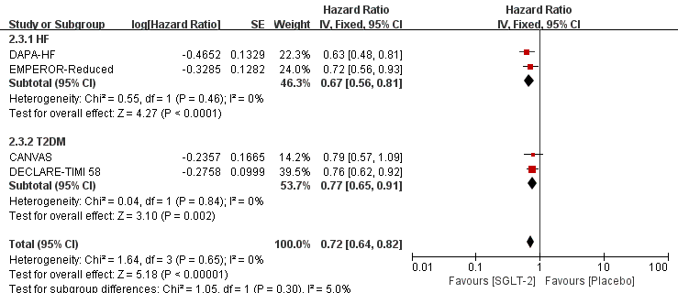

Supplementary 4.2. subgroup analysis of HHF in participants with T2DM or HF only.

