Online Supplementary Material

Example combination of search terms (PubMed)
(COVID* OR coronavirus OR SARS-COV-2) AND (Longitudinal OR prospective) AND (Mental health OR mental illness OR mental disorder OR depression OR anxiety OR emotion OR well-being OR distress OR suicide* OR PTSD OR trauma)

Risk of bias indicators
We reviewed methodological quality scales and risk of bias measures (1-3) to develop a list of bias indicators relevant to included studies:
1) Was the sample recruited to be representative of the population being studied (e.g. use of quota or probability sampling to reflect demographics of wider population) or was the sample likely non-representative (e.g. use of convenience and snowball sampling)? Studies with non-representative sampling (convenience, snowball) were considered higher in risk of bias.
2) Was the study reported in a journal article or pre-print? Pre-print articles were considered higher in risk of bias as study methods have not yet been subject to formal peer review.
3) Is attrition likely to have substantially influenced study results? E.g. confirmation that attrition occurred at random, and if not, weighting in analyses was used to account for selective attrition or attrition was very minimal, i.e. no more than 5% (4). Studies in which attrition is likely to have had a substantial influence on study results were considered higher in risk of bias. Too few studies had ≤5% attrition, therefore we deviated from planned analyses and conducted meta-regression to examine the association between attrition and study outcomes, as well as comparing studies with <25% vs. ≥25% attrition.
4) Did the study have a smaller sample size? Sampling error is problematic when examining prevalence estimates in small sample sizes. Because sampling error tends to be minimal at sample sizes of ≥1000, studies that were <1000 were considered smaller in sample size and higher in risk of bias.
5) Was the pre-pandemic measure of mental health symptomology collected more than 12 months prior to the post-pandemic measure? Studies with measurement of pre-vs.-post mental health symptomology that are separated by a larger period of time may be confounded by other factors (e.g. developmental and age differences in mental health symptomology), therefore we considered studies with a >12 month gap as being higher in risk of bias.
6) Was the survey delivery mode (e.g. online) consistent across pre and post outbreak waves of data collection? Because how surveys are administered may affect responses and who takes part, we deemed a change in survey delivery mode (e.g. going from paper-based or face to face interviews pre-pandemic to online post-pandemic outbreak) as increasing risk of bias. This risk of bias indicator was not outlined in our pre-registered protocol and included during eligibility assessment and prior to data extraction and analysis.
7) Were conflicts of interests reported? Studies that provided no conflicts of interest statement or report relevant conflicts of interest were considered higher in risk of bias.

Influential case and publication bias planned analyses
We characterised outliers as: any effect sizes for which the upper bound of the 95% confidence interval is lower than the lower bound of the pooled effect confidence interval (i.e., extremely small effects) or for which the lower bound of the 95% confidence interval is higher than the upper bound of the pooled effect confidence interval (i.e., extremely large effects). If any outliers are identified we planned to also report the results of meta-analyses with the outliers removed. To address influential cases, we computed DFBETAS values for each effect size. Influential cases were identified as DFBETAS values > 1 (indicative of a >1 change in the standard deviation of the estimated co-efficient after removal of the study (5). To increase sensitivity, we conducted leave-one-out analyses by removing each study (k) from the primary analyses, and refitting the model. If the removal of k substantially influenced the model (statistical significance of the model changes from p < .05 to p > .05 (or p >.05 to p < .05), this was classed as an influential case. We examined evidence for publication bias in our main analyses by examining asymmetry of the effect sizes. We plotted and visually inspected funnel plots for potential publication bias. Next, we conducted an Egger’s test of asymmetry and Trim and Fill procedure. For Egger’s test, if the intercept is significantly different from 0 at p >.10 this is indicative of bias (6). Trim and Fill procedure removes less precise studies which might cause any asymmetry (‘trim’), re-estimates the overall effect size, and then replaces removed studies and missing counterparts (‘fill’) required for symmetry (7). We planned to report i) the number of missing (‘filled’) studies, and ii) the estimate of the effect size following their inclusion.

National COVID-19 data
Oxford COVID-19 Government Response Tracker (OxCGRT)
For each eligible study we extracted the level of severity of social restrictions (e.g. stay at home orders), number of health measures (e.g. contact tracing) and level of economic support (e.g. income support schemes) in place during the month post-pandemic outbreak mental health was assessed as measured by the OxCGRT. (8). OxCGRT systematically collects information on policy responses and interventions that national governments have taken during the pandemic. For each index, governments are scored on an ordinal scale gauging the extent to which a common policy or intervention has been implemented and a sum score is produced, whereby higher scores indicate the extent of the governmental response in a given policy area. Composite indices for each area of policy response are produced for each day of the pandemic for nearly all countries in the world. For each study included in the meta-analysis we examine the governmental response to the pandemic in that country by taking an average of the OxCGRT composite indicators for all days in the month(s) of the pandemic for which mental health data was recorded. For the United States we aggregated OxCGRT composite indicators from the state-level dataset to produce an overall account of the pandemic response in the U.S. for each month examined. In OxCGRT, level of economic support (Economic Support Index) is scored on two criteria; presence of income support policies (i.e. to what extent is the government supporting income or providing cash payments to people unable to work), and presence of debt / contract relief policies (i.e. to what extent is the government freezing financial obligations). Severity of social restrictions (Stringency index) was assessed across 9 areas gauging the; use of school closures, workplace closures, cancellation of public events, restrictions on gatherings, closure of public transport, use of stay-at-home requirements, restrictions on internal travel, international travel controls, and use of public health information campaigns. A higher total score on the ‘Stringency Index’ indicates more severe social restrictions. We computed a measure of comprehensiveness of health policies by taking an average of OxCGRT health response components; testing policies, facial covering policies, and vaccination policy in place, whereby a higher total score indicated a great number of COVID-19 health policies in place. For full information on OxCGRT data collection and scoring of individual components, see https://www.bsg.ox.ac.uk/sites/default/files/2020-12/BSG-WP-2020-032-v10.pdf

Number of cases and deaths
For each eligible study we used the OxCGRT (9) to extract the number of recorded cases and deaths (by country) for the month that post-pandemic outbreak mental health was measured. Data on COVID-19 attributed deaths in the OxCGRT is collected from the COVID-19 Data Repository by the Center for Systems Science and Engineering (CSSE) at Johns Hopkins University. To account for differences in country population size, we calculated the number of cases and deaths per million population for the month(s) in which post-pandemic outbreak mental health measures were collected in each country.

Meta-analyses methodology
For our main analysis on continuous data, we computed standardised mean change (SMC) in pooled SD units, using the ‘escalc:SMCC’ function in the R ‘metafor’ package (9). For analyses examining questionnaire cut-off data we computed Marginal Odds Ratios to quantify size of change (‘escalc:MPOR’ function). As studies contributed multiple comparisons to analyses, we conducted a multi-level meta-analysis (using the ‘rma.mv’ function of metafor) to account for heterogeneity within and across studies. We used restricted maximum likelihood models. We planned to determine whether a multi-level meta-analysis was a better fit of the data by a significant loglikelihood ratio test (when compared to a model with study held constant, i.e. a single level model). To calculate standard mean change for our primary analyses we required the correlation between the pre and post pandemic outbreak measure of mental health and we were able to obtain this for 131/177 (74%) of included comparisons. In instances in which data was missing and authors did not respond, we imputed missing correlations based on the average of the obtained correlations (r ~.54). For continuous studies, if the raw data was not available but an effect size was reported (e.g. SMD/C or Odds ratio, we converted if necessary and included it in our analyses). For analyses examining questionnaire cut-offs we computed marginal odds ratios to quantify size of change. Marginal odds ratios were calculated based on the number of individuals who did not meet the questionnaire cut off pre and post pandemic outbreak, number who met the cut off post-pandemic outbreak but not pre-pandemic, number who met the cut-off pre-pandemic outbreak but not post, and the number of individuals who met the cut off at both pre-and post-pandemic outbreak. One study reported a 0 frequency in a cell (Chiaravaolloti), therefore we added 0.5 to each cell in line with the Haldane correction(10).
Use of multi-level vs. single-level meta-analysis in primary analyses
The multi-level model demonstrated that 33.7% of the heterogeneity in effect sizes was attributed to studies and was a better fit of the data than a single level meta-analysis (AIC multi-level model = 30.4, AIC single level model = 82.5: loglikelihood ratio test = 54.09, p < .001). Note: results from a single level analysis produced similar results to the main analyses [SMC = .086 [95% CI: .041 to .131], z = 3.72, p < .001). We retained use of multi-level model analyses for subsequent analyses unless stated otherwise.

Publication bias and influential cases in main analyses
There were no influential cases (DFBETAs ranged -.216 to .216, Cooks’ distance < .045). Leave-one-out analysis did not substantially influence the model (ps < .003). Egger’s test was significant, suggesting some funnel plot asymmetry (z = 2.13, p = .032). See figure S1a for funnel plot symmetry (funnel plot). Trim and Fill did not impute any studies and no outliers were identified (visual inspection).

Publication bias and influential cases in depression and mood disorder effects only
For depression symptoms only, there were no influential cases (DFBETAs ranged -.305 to .249). Leave-one-out analysis did not substantially influence the model (ps < .001). Egger’s test was not significant (z = 1.62, p = .104). See figure S1b for funnel plot symmetry. Trim and Fill did not impute any studies and no outliers were identified.

Publication bias and influential cases in anxiety disorder effects only
For anxiety symptoms only, there were no influential cases (DFBETAs ranged -.407 to .284, Cooks’ distance < .138). Leave-one-out analysis did not substantially influence the model (ps. < .006). Egger’s test was not significant (z = 1.26, p = .207). See figure S1c for funnel plot symmetry. Trim and fill did not impute any studies and no outliers were identified.

Meta-regressions examining attrition and country level predictors of SMC (primary analyses)
There was no significant association between level of attrition and change in mental health symptoms characterised by SMC (coefficient = .092 [95% CI: -.185 to .370] z = .653, p =.514). No country level predictors were significantly associated with SMC; Cases per month (p = .265), cases per million (p = .525), deaths per month (p = .831), deaths per million (p = .510), Stringency Index (p = .211), level of economic support (p = .797) or country health response index (p = .402).

Meta-regressions examining attrition and country level predictors of depression and mood disorder symptoms
For depression symptoms only, there was no significant association between level of attrition and change in mental health symptoms (coefficient = -.120 [95% CI: -.473 to .233] z = 0.667, p = .505). There were no significant associations with SMC for; Cases per month (p = .856), cases per million (p = .939), deaths per month (p = .663), deaths per million (p = .912), Stringency index (p = .746), level of economic support (p = .287) or country health response index (p = .386).

Meta-regressions examining attrition and country level predictors of anxiety disorder symptoms
For anxiety symptoms only, there was no significant association between level of attrition and change in mental health symptoms (coefficient = .073 [95% CI: -.495 to .640] z= 0.251, p = .802). There were no significant associations with SMC for; Cases per month (p = .387), cases per million (p = .836), deaths per month (p = .514), Stringency Index (p = .062), level of economic support (p = .466) or country health response index (p = .206). There was a significant positive association between anxiety and deaths per million (coefficient = .001 [95% CI = .000 to .001], z = 2.62, p < .009).

Figure S1a: A funnel plot of all effect sizes in primary meta-analysis.
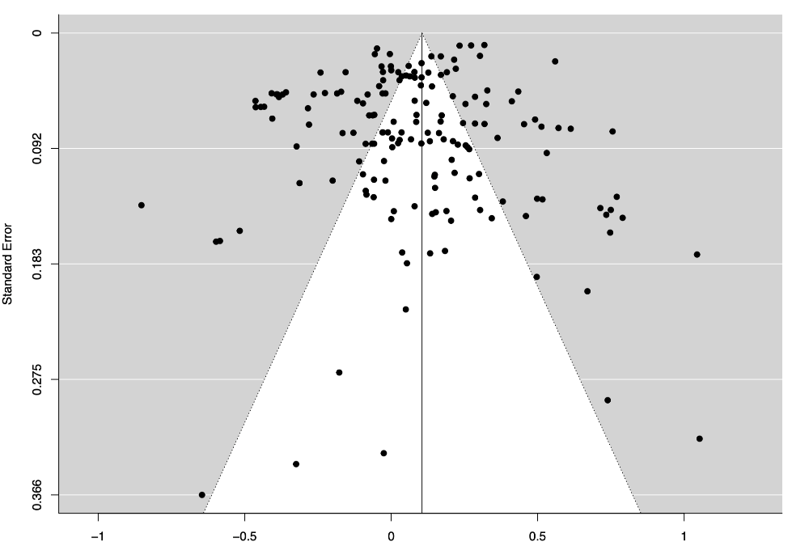

Figure S1b: A funnel plot of depression and mood disorder effects

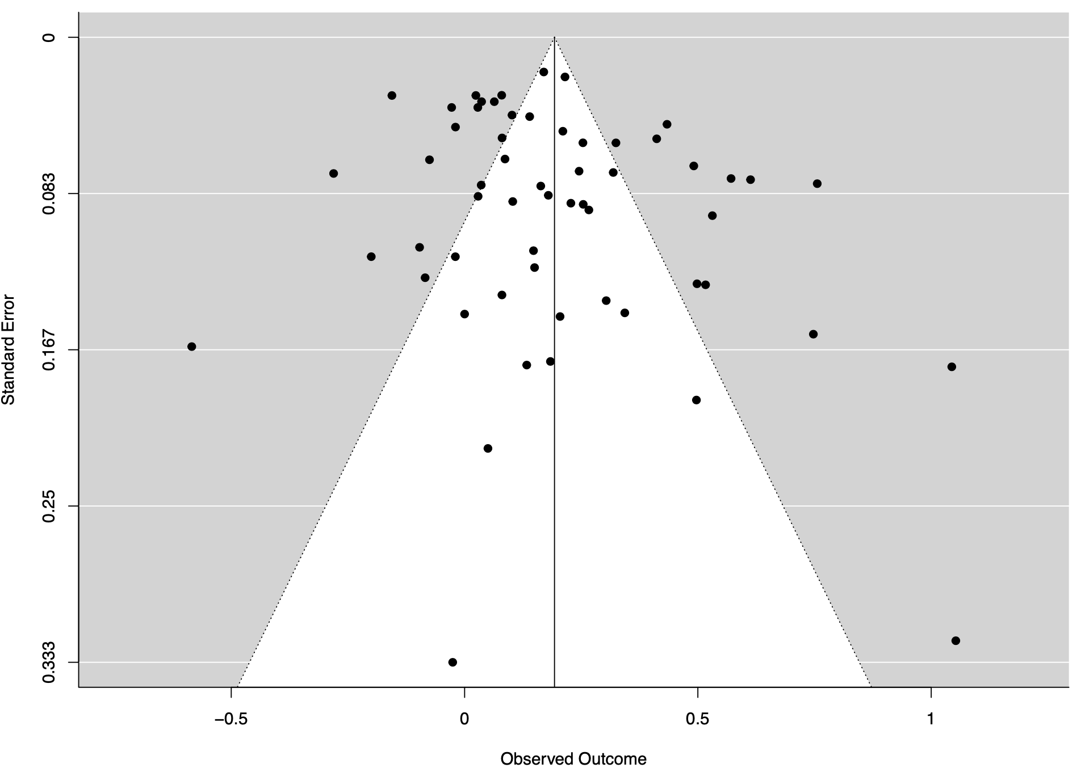
Figure S1c: A funnel plot of anxiety disorder effects

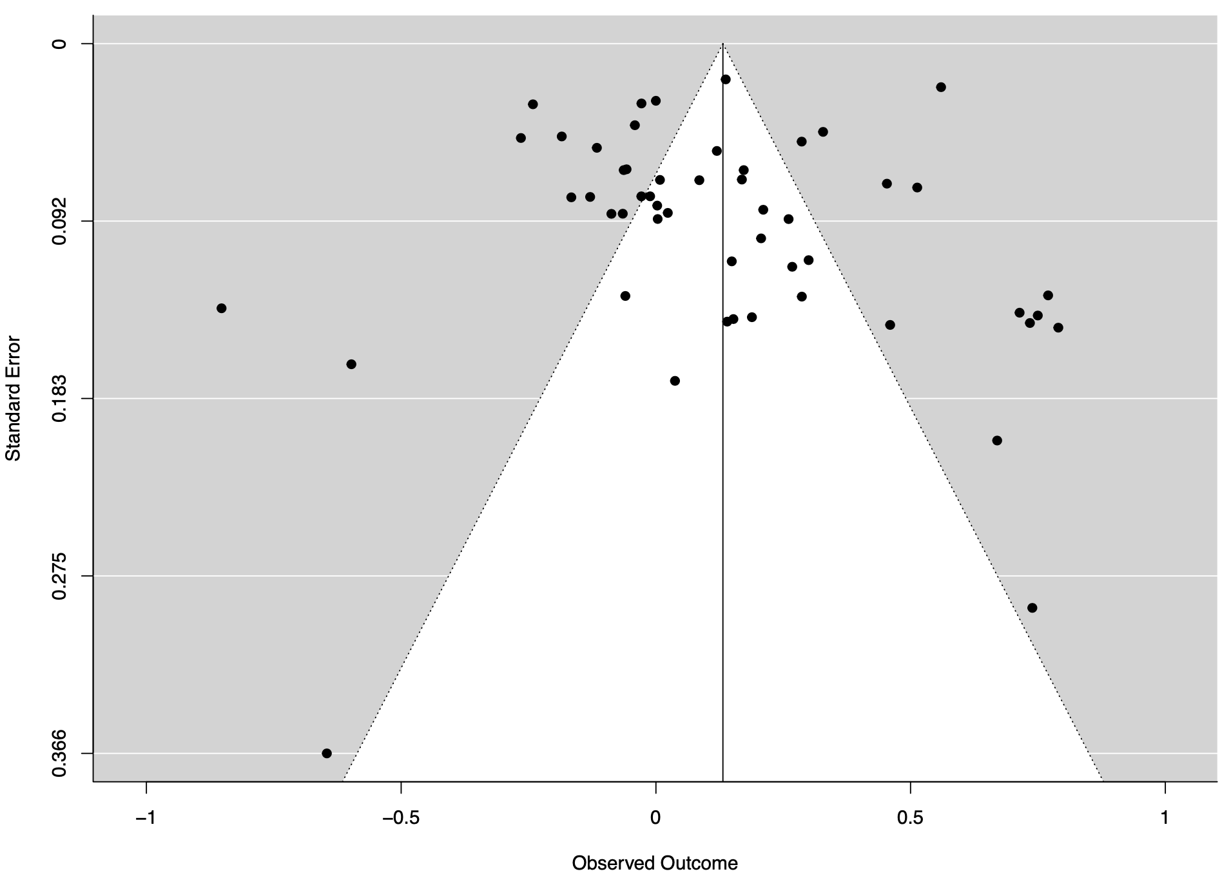

Figure S2. Forest plot of symptom level comparisons: anxiety disorder symptoms

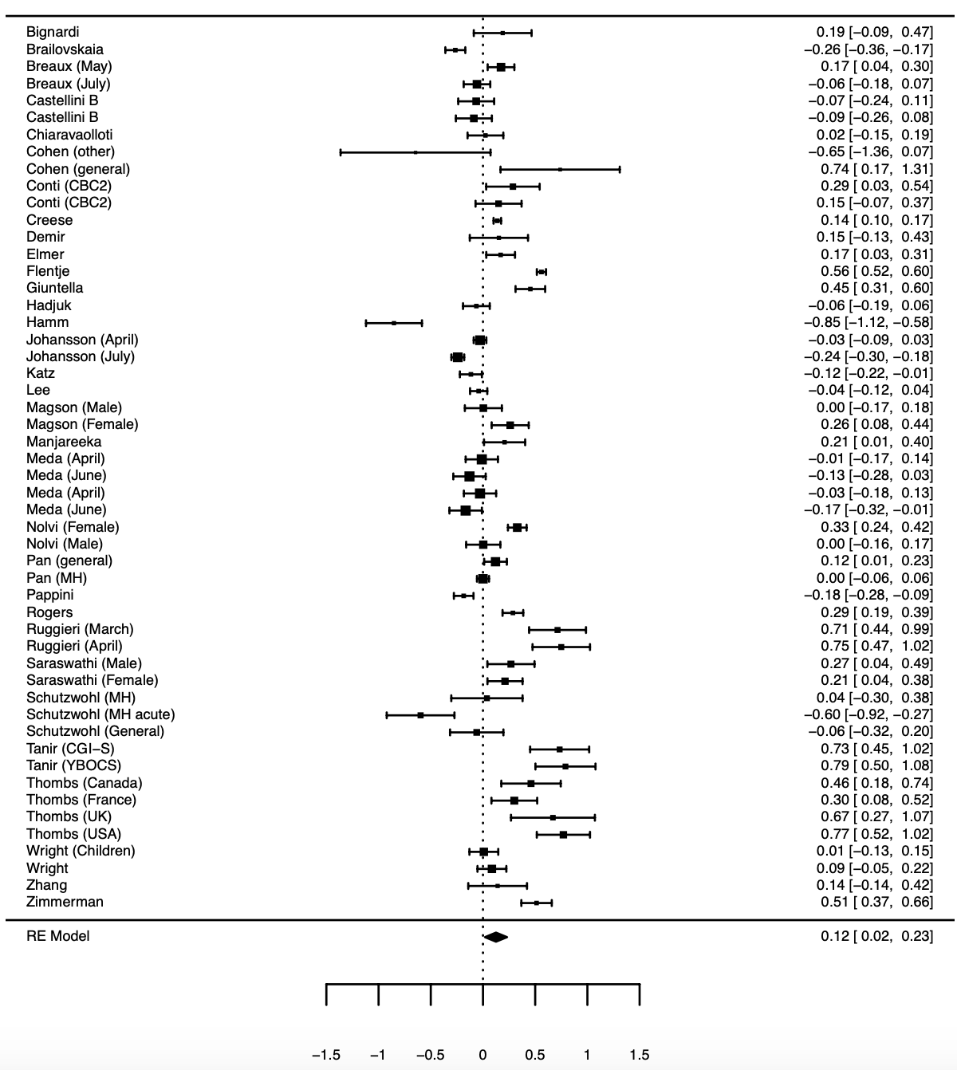

General (general population sample), MH (sample with pre-existing mental health condition), Other (sample from ‘other category’), CBC (Child behaviour checklist), CGI-S (Clinical Global Impression Scale), YBOCS (Children’s Yale-Brown Obsessive Compulsive Scale)

Figure S3. Forest plot of symptom level comparisons: depression and mood disorder symptoms

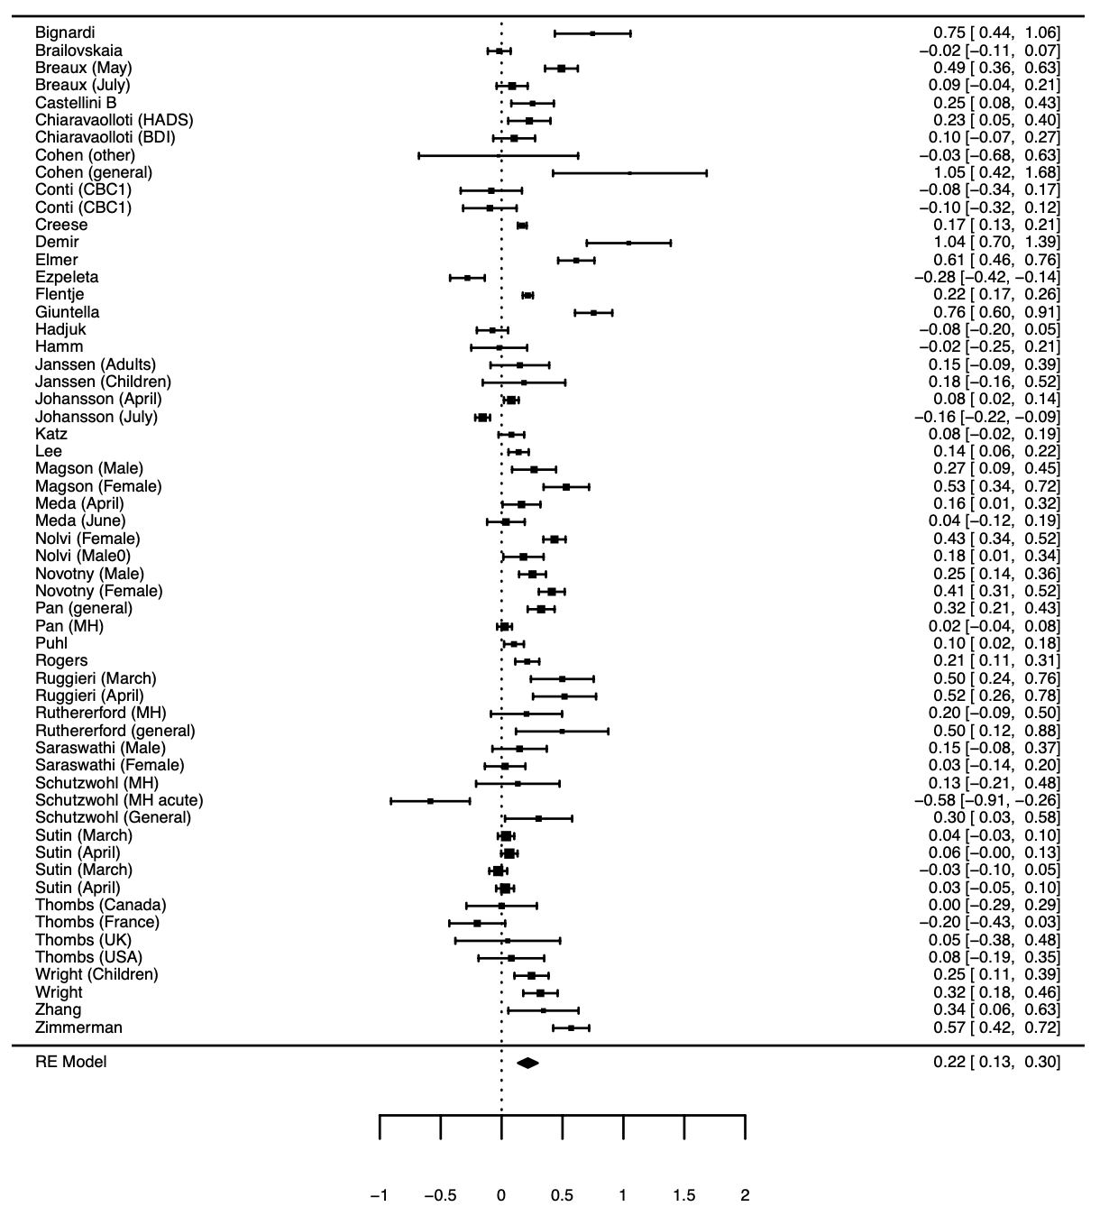

HADS (Hospital Anxiety and Depression scale), BDI (Beck Depression Inventory), General (general population sample), MH (sample with pre-existing mental health condition), Other (sample from ‘other category’), CBC (Child behaviour checklist)

Figure S4. Forest plot of symptom level comparisons: general mental health measures (including distress)

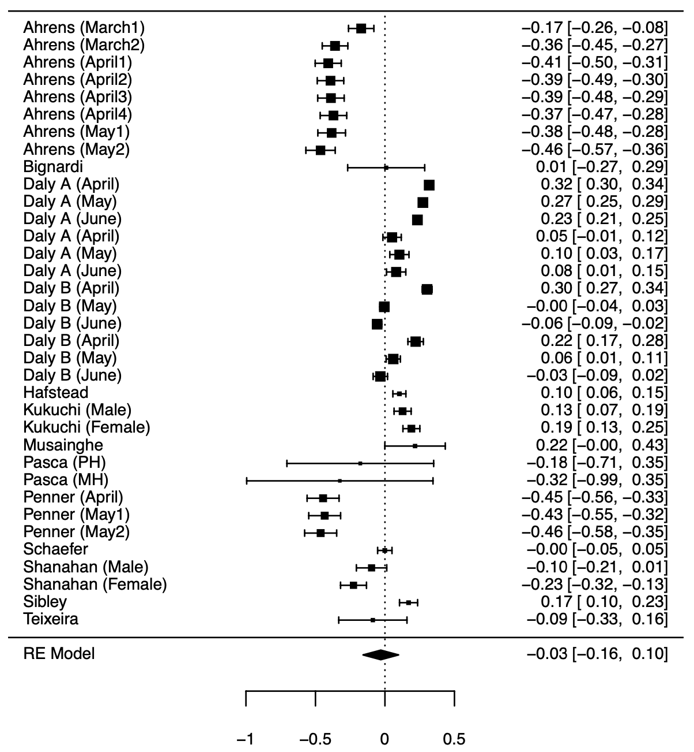

Figure S5. Forest plot of symptom level comparisons: well-being

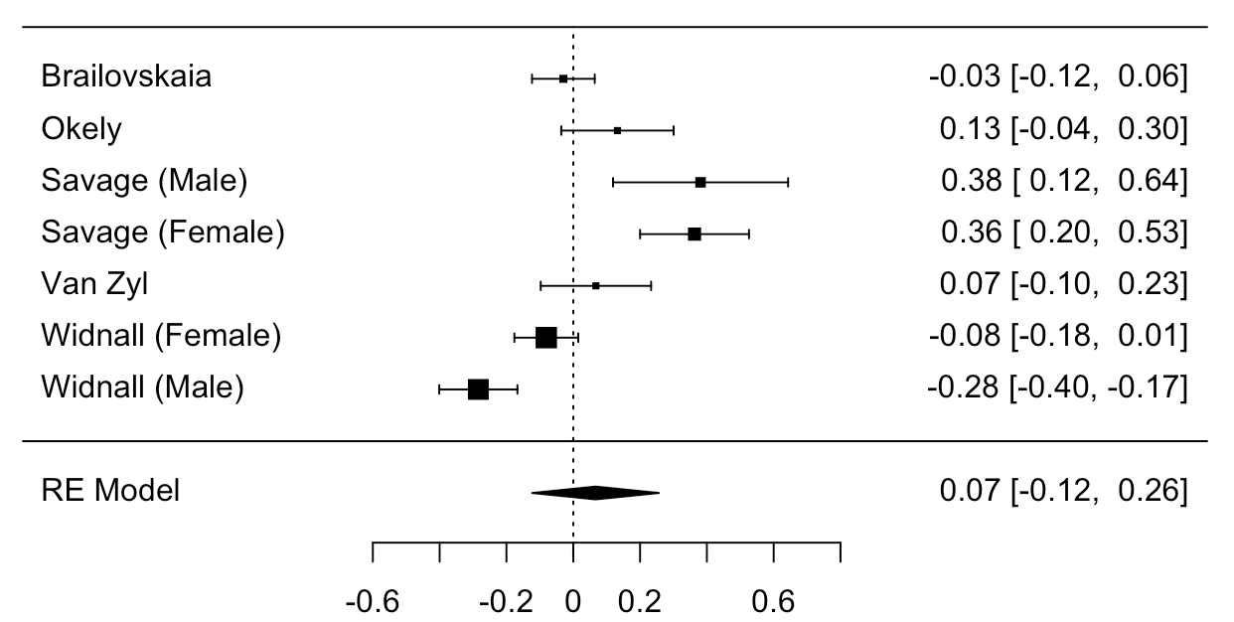

Figure S6. Forest plot of symptom level comparisons: psychotic symptoms

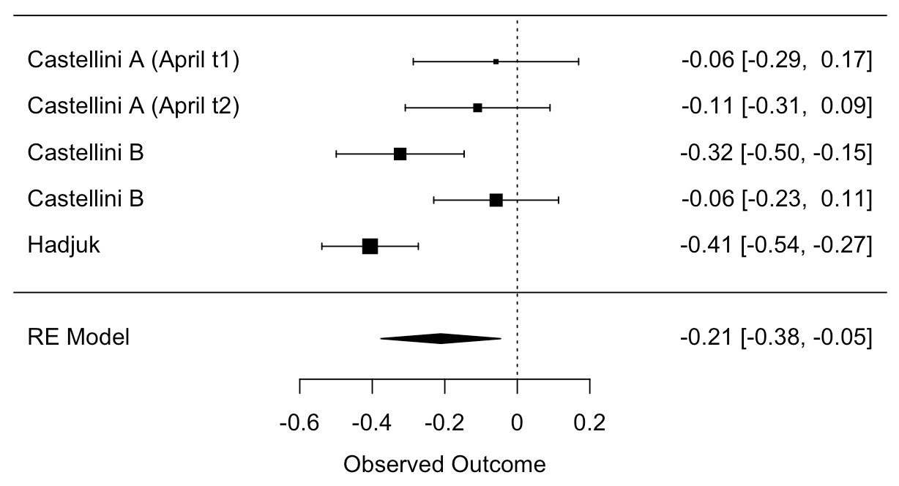

Figure S7. Forest plot of symptom level comparisons: other mental health symptoms
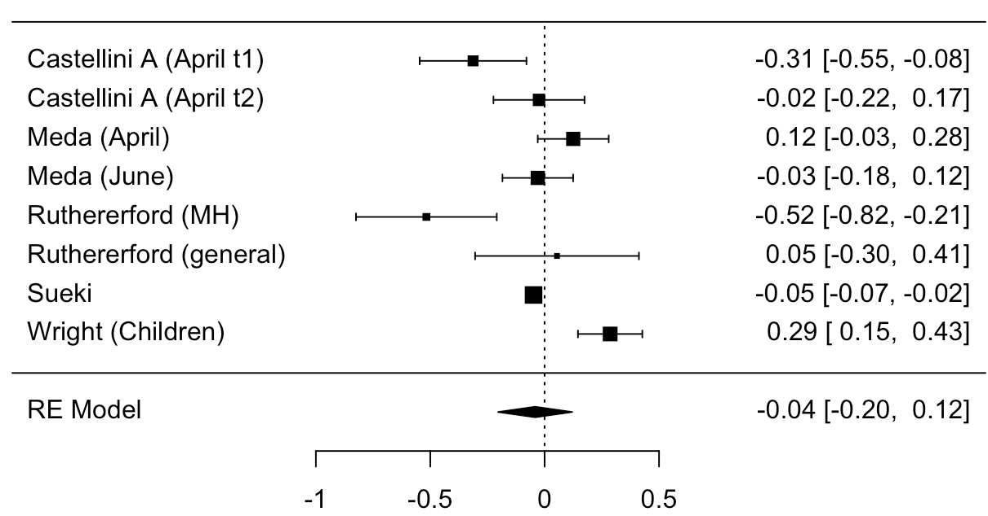

Other symptoms were eating disorder symptoms (Castellini, Meda), PTSD (Rutherford, Wright) and Suicide ideation (Sueki)

Change in numbers exceeding questionnaire cut-offs for mental health problems analysis
A total of 24 comparisons across 12 studies were included in meta-analysis. Sample sizes ranged from 50-7445. Comparisons examined depression and mood disorder symptoms (N=9), anxiety (N=7), general mental-health (N=4), distress (N=2), well-being (N=2). Most comparisons were of adult samples (N=19), as opposed to children/adolescent samples (N=5). The majority of samples were from the general population (N=16), followed by university students (N=6), pre-existing physical health conditions (N=2) and one community sample of Latinx sexual minority men and transgender women. Ten of the 24 comparisons were from March-April 2020 and the remaining 14 comparisons were from May-June. The majority of comparisons were from European samples (N=14), with the remaining samples being mixed (N=2), US (N=1), India (N=5) and Japan (N=2). Attrition ranged from 5%-83%. It was rare for studies to have a consistent mode of delivery (N = 4, 17%) or adopt representative sampling (N=7, 29%). Multilevel meta-analysis was not a better fit of the data than a single level meta-analysis (AIC single level = 31.04, AIC multilevel = 31.72: loglikelihood ratio test = 1.31, p = .252). There was a significant effect (single level meta-analysis), with the odds of exceeding a questionnaire cut-off for mental health problems from pre-post pandemic = 1.31 (Marginal Odds Ratio = 1.31 [95% CI: 1.09 to 1.55], z = 3.18, p = .001, I2 = 93.2%). Trim and fill analysis did not impute any effect sizes. All models were significant in leave one out analysis, with the smallest pooled Marginal Odds Ratio = 1.27, and largest = 1.36, and visual inspection indicated an absence of outliers. There was no difference in effect sizes between anxiety and depression symptoms (QM(1) = 0.259, p = .611). Three comparisons examined change in mental health symptoms among Chinese samples but due to there being too few comparisons for meaningful analysis, we did not meta-analyse these comparisons.

Table S1. Individual study information for all included articles

Author | Country | Participant group | Pre pandemic wave | Post pandemic outbreak waves | Mental health measure(s) | Change data | Sample size
Ahrens(11) | Germany | Adults in a cohort study | December 2019 - March 2020 | March 23 – May 11 (8 assessments) | GHQ-28 (Distress/non-specific mental health) | Continuous | N=382-482
Bignardi (12) | UK | Children in a cohort study | June 2018 - September 2019 | April 4 – June 6 | SDQ emotional problems, RCADS depression (Depression & mood disord)  RCADS anxiety (Anxiety disord & symp) | Continuous | N=50-51
Brailovskaia(13) | Germany | University sample | October 2019 | March 20-28 | DASS21 depression (Depression & mood disord)  DASS21 Anxiety (Anxiety disord & symp)  Unidimensional positive MH scale (Well-being) | Continuous | N=436
Breaux(14) | US | Adolescents with and without ADHD | September 2018 – February 2020 | May 15 – August 5 (2 assessments) | RCADS depression (Depression & mood disord)  RCADS anxiety (Anxiety disord & symp) | Continuous | N=238
Castellini (A)(15) | Italy | Eating disorder outpatients and healthy controls | November 2019 – January 2020 | April 22 – May 3 | BSI total (Psychotic symptoms)  Eating disorders examination (Other MH conditions) | Continuous | N=74-97
Castellini (B)(16) | Italy | University sample | December 1 2019 – January 2020 | 22 April – May 3 | BSI depression (Depression & mood disord)  BSI anxiety, OCD (Anxiety disord & symp)  BSI paranoia, psychoticism (Psychotic symp) | Continuous | N=130
Chen(17) | China (Hong Kong) | School children | October – November 2019 | March 4 – 16^{t} | DASS depression (Depression & mood disord)  DASS anxiety (Anxiety disord & symp) | Continuous | N=543
Chiaravalloti(18) | US, Canada, Belgium, Denmark, Italy, UK | Multiple sclerosis patients | August – October 2019 | May 4 – July 15 | HADS depression, Beck Depression Inventory II (Depression & mood disord)  HADS anxiety (Anxiety disord & symp) | Continuous & Cut-off | N=131
Cohen(19) | US | Adolescents with/without early life stress | July 2019 – February 2020 | May 22 – June 18 | PROMIS depression (Depression & mood disord)  PROMIS anxiety (Anxiety disord & symp) | Continuous | N=9-15
Conti(20) | Italy | Patients with neurological or psychiatric disorders | September 2019 – February 2020 | April 20 – May 4 | CBC affective (Depression & mood disord)  CBC anxiety (Anxiety disord & symp) | Continuous | N=61-80
Creese(21) | UK | Adults aged 50 and over in a cohort study | 2015-2019 | May 13 – June 8 | PHQ9 (Depression & mood disord)  GAD7 (Anxiety disord & symp) | Continuous | N=2,959
Daly (A)(22) | UK | Adults in a cohort study | 2017-2019 | April 24 – July 1 (X3assessments) | GHQ12 (Distress/non-specific mental health) | Continuous | N=801–11,599
Daly (B)(23) | US | Adults in a cohort study | March 2020 | April 1 – June 23  (3 assessments) | PHQ4 (Distress/non-specific mental health) | Continuous | N=1,275-3,609
Demir(24) | Turkey | MS patients | January 2020 | April 23 | Beck inventory (Depression & mood disord)  Beck inventory (Anxiety disord & symp) | Continuous | N=50
Dickerson(25) | UK | Community sample | June 2017 – March 2020 | April 10 – June 30 | PHQ8 (Depression & mood disord)  GAD7 (Anxiety disord & symp) | Cut-off | N=1,634-1,730
Elmer(26) | Switzerland | University sample | September 2019 | April | CES-D (Depression & mood disord)  GAD (Anxiety disord & symp) | Continuous | N=206
Ezpeleta(27) | Spain | Families in a community sample | Unspecified (2019) | June | SDQ emotional problems (Depression & mood disord) | Continuous | N=197
Flentje(28) | US | Sexual and gender minority cohort with and without existing MH condition | June 2019 | March 23 – April 19 | PHQ9 (Depression & mood disord)  GAD7 (Anxiety disord & symp) | Continuous | N=671-1610
Giuntella(29) | US | University sample | Spring 2019 | March 20 | CES-D (Depression & mood disord)  GAD7 (Anxiety disord & symp) | Continuous | N=211
Groot(30) | Denmark | Adults in a cohort study | March 2016 – February 2020 | March 27-April | Short WEMBWS (Well-being) | Cut-off | N=7,445
Hafstead(31) | Norway | Adolescents in a cohort study | February 2019 | June | Hopkins symptom checklist (Distress/non-specific mental health) | Continuous & Cut-off | N=1,763
Hajduk(32) | Slovakia | University sample | October 2018 | April | PHQ9 (Depression & mood disord)  GAD7 (Anxiety disord & symp)  Community assessment of psychic experiences (Psychotic symp) | Continuous | N=235
Hamm(33) | US | Older adults with depression | Unspecified, most participants 2019 | April 1 – April 23 | PHQ9 (Depression & mood disord)  PROMIS anxiety (Anxiety disord & symp) | Continuous | N=73
Janssen(34) | Netherlands | Parents of adolescents and adolescents from cohort | September 2018 – November 2019 | April 14 – April 28 | PHQ9 (Depression & mood disord) | Continuous | N=34-67
Johansson(35) | Sweden | University sample | August 2019-March 2020 | March 14 – 10 September (2 assessments) | DASS depression (Depression & mood disord)  DASS anxiety (Anxiety disord & symp) | Continuous | N=1,049
Katz(36) | US, Canada, UK and Ireland | Adults from an online panel | April 2019 | April 15-20 | DASS depression (Depression & mood disord)  DASS anxiety (Anxiety disord & symp) | Continuous | N=348
Kikuchi(37) | Japan | Adults from an online panel | February 2020 | April 1 - 6 | Kessler 6 (Distress/non-specific mental health) | Continuous & Cut-off | N=1,024-1,054
Kwong(38) | UK | Young adults in a cohort study | 2017-2018 | April 9 – May 14 | SMFQ (Depression & mood disord)  GAD7 (Anxiety disord & symp)  Short WEMWBS (Well-being) | Continuous & Cut-off | N=2,812-2,850
Lee(39) | US | Community sample of young adults | January 2020 | April | PHQ4 (Depression & mood disord)  PHQ4 (Anxiety disord & symp) | Continuous | N=564
Linnemayr(40) | US | Community sample of Latinx sexual minority men and transgender women | April 2018-July 2019 | May 1 - May 18 | Kessler (Distress/non-specific mental health) | Cut-off | N=50
Magson(41) | Australia | Community sample of adolescents | 2019 | May 5 – May 14 | SMFQ (Depression & mood disord)  SCAS GAD (Anxiety disord & symp) | Continuous | N=122-126
Manjareeka(42) | India | University sample (medical students) | February 2020 | May | State-trait anxiety scale (Anxiety disord & symp) | Continuous & Cut-off | N=101
Meda(43) | Italy | University students | October – December 2019 | April 3 – June 21 | Beck depression inventory (Depression & mood disord)  Beck anxiety inventory, OC inventory revised (Anxiety disord & symp)  Eating disorder inventory (Other MH conditions) | Continuous | N=161-197
Munasinghe(44) | Australia | Adolescent community sample | November 2019 – March 2020 | March 23 – April 19 | Kessler 6 (Distress/non-specific mental health) | Continuous | N=421
Nolvi(45) | Finland | Parents in birth cohort study | 2014-2019 | May 4 – June 7 | Edinburgh postnatal depression scale (Depression & mood disord)  Symptom checklist 90 (Anxiety disord & symp) | Continuous & Cut-off | N=143-508
Novotny(46) | Czech Republic | Adults in a cohort study | 2015 | April 24 – May 27 | PHQ (Depression & mood disord) | Continuous | N=326-370
Okely(47) | Scotland | Older adults in cohort study | 2017-2019 | May 27 | Short WEMBWS (Well-being) | Continuous | N=137
Pan(48) | Netherlands | People with/ without MH condition in cohort studies | 2006-2016 | April 1 – May 13 | QIDS (Depression & mood disord)  Beck anxiety inventory (Anxiety disord & symp) | Continuous | N=328-1148
Pappini(49) | US | University sample | January 2020 | March 27-May | GAD7 (Anxiety disord & symp) | Continuous | N=443
Pasca(50) | Italy | Adolescents with epilepsy & neurocognitive or internalising disorders | September 2019-Feburary 2020 | April – May | CBC internalizing (Distress/non-specific mental health) | Continuous | N=9-14
Penner(51) | US | Community sample of Hispanic/Latinx adolescents | January 2020 | April – May (3 assessments) | Brief Problem Monitor- internalizing symps (Distress/non-specific mental health) | Continuous | N=320
Puhl(52) | US | Secondary school students | 2017-2018 | April - June | Kandal and Davies depression scale (Depression & mood disord) | Continuous | N=584
Rogers(53) | US | Adults in cohort study | October 2019 | April 11 - 15 | CDI (Depression & mood disord)  GAD (Anxiety disord & symp) | Continuous | N=407
Ruggieri(54) | Italy | Adult sample of social media users | March 2020 | March 25 – April 14 (2 assessments) | DASS21 depression (Depression & mood disord)  DASS21 anxiety (Anxiety disord & symp) | Continuous | N=65
Rutherford(55) | US | Older adults diagnosed with PTSD and trauma exposed healthy controls | Unspecified, prior to March 2020 | April 1 – May 8 | PTSD checklist (Other MH conditions)  Hamilton scale (Depression & mood disord) | Continuous | N=30-46
Saraswathi(56) | India | University sample (medical students) | December 2019 | June 10-20 | DASS21 depression (Depression & mood disord)  DASS21 anxiety (Anxiety disord & symp) | Continuous & Cut-off | N=78-139
Savage(57) | UK | University sample | October 2019 | April | WEMWBS (Well-being) | Continuous | N=60-154
Schaefer(58) | Germany | Community sample of adults | February 2020 | March 16-20 | Mini-symptom checklist total (Psychotic symp) | Continuous | N=1439
Schützwohl(59) | Germany | Adults with mental health conditions and no conditions | August 2019 – March 2020 | April 22 – May 13 | BSI-18 depression (Depression & mood disord)  BSI-18 anxiety (Anxiety disord & symp) | Continuous | N=33-59
Shanahan(60) | Switzerland | Adults in community sample | April – September 2018 | April 11-18 | Social Behaviour Questionnaire Internalising (Distress/non-specific mental health) | Continuous | N=323-453
Shan Wong(61) | China (Hong Kong) | Older adults in primary care | April 2018 – March 2019 | March 24 – April 15 | PHQ9 (Depression & mood disord)  GAD7 (Anxiety disord & symp) | Continuous & Cut-off | N=583
Sibley(62) | New Zealand | Adults in cohort study | October – December 2019 | March 26 – April 12 | Kessler 6 (Distress/non-specific mental health) | Continuous | N=921
Sueki(63) | Japan | Adults from an online panel | January 2020 | April 27-30 | Suicidal ideation scale (Other MH conditions) | Continuous | N=6,683
Sutin(64) | US | Adults from an online panel | January – February 2020 | March 18 – April 29 (2 assessments) | PHQ2 (Depression & mood disord) | Continuous | N=719-858
Tanir(65) | Turkey | Children and adolescents with OCD | September 2019 – March 2020 | April 20 - 30 | Clinical Global Impression Scale, Children’s Yale-Brown Obsessive Compulsive Scale (Anxiety disord & symp) | Continuous | N=61
Teixeira(66) | Brazil | Older women enrolled in an exercise programme | January – February 2020 | June | World Health Organisation quality of life mental health subscale (Distress/non-specific mental health) | Continuous | N=64
Thombs(67) | US, Canada, UK, France | Patients with multiple sclerosis | July – December 2019 | April 9 - 27 | PHQ8 (Depression & mood disord)  PROMIS anxiety (Anxiety disord & symp) | Continuous | N=43-159
Van der Velden(68) | Netherlands | Adults from an online panel | November 2019 | June | Mental health inventory (Distress/non-specific mental health) | Cut off | N=4,084
Van Zyl(69) | Netherlands | University sample | January 2020 | April | Mental health continuum short-form (Well-being) | Continuous | N=141
Wen Li(70) | China | University sample | November 2019 | February – June (2 assessments) | DASS21 (Depression & mood disord)  DASS21 (Anxiety disord & symp) | Continuous | N=173
Widnall(71) | UK | High school students | October 2019 | April - May | HADS anxiety (Anxiety disord & symp)  HADS depression (Depression & mood disord)  WEMBWS (Well-being) | Continuous & Cut-off | N=292-458
Wright(72) | UK | Adolescents and parents in a birth cohort | December 2019 – March 2020 | June 18 – August 4 | SMFQ, PHQ9 (Depression & mood disord)  Child trauma symptom scale (Other MH conditions)  Spence anxiety scale, GAD7 (Anxiety disord & symp) | Continuous | N=202
Yan Li(73) | China | University sample | December 2019 | February 4 - 6 | PHQ4 (Distress/non-specific mental health) | Continuous | N=555
Zhang(74) | US | University sample | January 2020 | May | PHQ9 (Depression & mood disord)  GAD7 (Anxiety disord & symp) | Continuous | N=49
Zimmerman(75) | US | University sample | February 2020 | April 3 - 20 | PHQ9 (Depression & mood disord)  GAD7 (Anxiety disord & symp) | Continuous | N=205

BSI (Brief symptom inventory), CBC (Child behaviour checklist), CDI (Children’s depression inventory), DASS (Depression, anxiety and stress scale), GAD (Generalised anxiety disorder scale), GHQ (General health questionnaire), HADS (Hospital anxiety and depression scale), PHQ (Patient health questionnaire), PROMIS (Patient-Reported Outcomes Measurement Information system), QIDS (Quick Inventory of Depressive Symptomatology), RCADS (Revised children’s anxiety and depression scale), SCAS (Spence Children's Anxiety Scale), SDQ (Strengths and difficulties questionnaire), SMFQ (Short mood and feelings questionnaire), WEMWBS (Warwick-Edinburgh mental well-being scale).

Table S2.Risk of bias ratings for individual studies

Author | Publication status | Representative sampling | Consistency of survey delivery mode | Attrition | Small sample size (N<1000) | More than 12 months between pre and post pandemic measures | Study reports no relevant conflicts of interest
Ahrens | J | N/U | N/U | U | Y | N | N/U
Bignardi | PP | Y | Y | 92% | Y | Y | Y
Brailovskaia | J | N/U | Y | 13% | Y | N | N/U
Breaux | J | N/U | N/U | 9% | Y | Y | N/U
Chiaravalloti | J | N/U | N/U | 5% | Y | N | N/U
Castellini (A) | J | N/U | N/U | 3-10% | Y | N | Y
Castellini (B) | J | N/U | Y | 15% | Y | N | Y
Chen | J | N/U | N/U | 51% | Y | N | Y
Cohen | PP | N/U | N/U | U | Y | N | N/U
Conti | J | N/U | Y | U | Y | N | Y
Creese | J | N/U | Y | U | N | Y | Y
Daly (A) | J | Y | N/U | 62-66% | Mixed | Y | Y
Daly (B) | J | Y | Y | 11-21% | N | N | Y
Demir | J | N/U | Y | U | Y | N | Y
Dickerson | PP | N/U | N/U | U | N | Y | Y
Elmer | J | N/U | Y | U | Y | N | Y
Ezpeleta | J | N/U | N/U | 52% | Y | Y | Y
Flentje | J | N/U | N/U | N/U | Mixed | N | N/U
Giuntella | PP | N/U | Y | U | Y | N | N/U
Groot | pp | N/U | N/U | 83% | N | Y | Y
Hafstead | PP | Y | N/U | 83% | N | Y | Y
Hajduk | J | N/U | N/U | 82% | Y | Y | Y
Hamm | J | N/U | N/U | 34% | Y | Y | N/U
Janssen | J | N/U | N/U | 56-58% | Y | Y | Y
Johansson | PP | N/U | Y | 43% | N | N | Y
Katz | PP | N/U | Y | 23% | Y | N | N/U
Kikuchi | J | Y | Y | 14% | N | N | Y
Kwong | J | Y | N/U | 81% | N | Y | Y
Lee | J | N/U | Y | U | Y | N | Y
Linnemayr | J | N/U | N/U | U | Y | Y | Y
Magson | J | N/U | Y | 47% | Y | Y | Y
Mankareeka | J | N/U | Y | 15% | Y | N | N/U
Meda | J | N/U | Y | U | Y | N | Y
Munasinghe | J | N/U | Y | 68% | Y | N | Y
Nolvi | PP | N/U | N/U | U | Y | Y | Y
Novotny | J | Y | N/U | 61% | Y | Y | Y
Okely | J | N/U | N/U | 67% | Y | Y | Y
Pan | J | N/U | N/U | 42% | Mixed | Y | Y
Pappini | PP | N/U | Y | U | Y | N | Y
Pasca | J | N/U | N/U | U | Y | N | Y
Penner | J | N/U | N/U | 18% | Y | N | Y
Puhl | J | N/U | N/U | 63% | Y | Y | Y
Rogers | J | Y | Y | 33% | Y | N | Y
Ruggieri | J | N/U | Y | 65% | Y | N | Y
Rutherford | J | N/U | N/U | U | Y | N/U | Y
Saraswathi | PP | N/U | N/U | 9% | Y | N | Y
Savage | J | N/U | Y | 86% | Y | N | Y
Schaefer | J | N/U | Y | 21% | N | N | Y
Schützwohl | PP | Y | N/U | 9-35% | Y | N | Y
Shanahan | J | N/U | N/U | 32% | Y | Y | Y
Shan Wong | J | N/U | N/U | 22% | Y | Y | Y
Sibley | J | Y | N/U | Unclear | Y | N | Y
Sueki | PP | Y | Y | 33% | N | N | N/U
Sutin | J | Y | Y | 60% | Y | N | Y
Tanir | J | N/U | N/U | Unclear | Y | N | Y
Teixeria | PP | N/U | N/U | Unclear | Y | N | Y
Thombs | J | N/U | Y | 63-67% | Y | N | Y
Van der Velden | J | Y | Y | 33% | N | N | Y
Van Zyl | PP | N/U | Y | Unclear | Y | N | N/U
Wen Li | J | N/U | N/U | 15% | Y | N | Y
Widnall | PP | N/U | N/U | 70% | Y | N | N/U
Wright | PP | N/U | N/U | 11% | Y | N | Y
Yan Li | J | N/U | N/U | 11% | Y | N | Y
Zhang | J | N/U | N/U | 0% | Y | N | Y
Zimmerman | PP | N/U | Y | 26% | Y | N | N/U

J (Journal), PP (pre-print), N (No), U (Unclear), Y (Yes). Mixed (some comparisons from study were smaller than N < 1000 participants and some were larger). The use of N/U for some of the risk of bias assessments was due to studies not routinely reporting information in sufficient detail to be able to confidently assess the study as ‘N’. For the purposes of risk of bias analyses, we compared Y responses vs. N/U responses

Table S3. Sub-group analyses for standardised mean change (SMC) in depression and mood disorder symptoms.

Moderator | Test of sub-group difference | Sub-groups | Effect estimate
Age | QM(1) = 0.017, p = .897, I2 = 95.1% | Adults (n=44) | SMC = .219 [95% CI: .129 to .309], z = 4.77, p < .001, I2 = 95.4%
 |  | Child/adolescents (n=14) | SMC = .217 [95% CI: .050 to .385], z = 2.54, p = .011, I2 = 92.1%
Gender | QM(1) = 1.180, p = .277, I2 = 92.3% | Males (n=6) | SMC = .167 [95% CI: .068 to .266], z = 3.30, p < .001, I2 = 71.9%
 |  | Females (n=6) | SMC = .278 [95% CI: .062 to .494], z = 2.52, p = .012, I2 = 95.6%
Continent | QM(3) = 1.066, p = .785, I2 = 95.4% | Europe (n=31) | SMC = .192 [95% CI: .065 to .318], z = 2.97, p = .003, I2 = 96.1%
 |  | North America (n=20) | SMC = .252 [95% CI: .128 to .376], z =3.99, p < .001, I2 = 95.5%
Population | QM(3) = 13.25, p = .004, I2 = 95.3% | General population (n=27) | SMC = .253 [95% CI: .150 to .355], z = 4.85, p < .001, I2 = 93.9%
 |  | University student (n=13) | SMC = .248 [95% CI: .061 to .434], z = 2.60, p = .009, I2 = 96.0%
 |  | Pre-existing mental health condition (n=7) | SMC = -.051 [95% CI: -.207 to .105], z = 0.64, = .522, I2 = 73.0%
 |  | Pre-existing physical health condition (n=7) | SMC = .369 [95% CI: -.067 to 1.005], z = 1.14, p = .255, I2 = 95.2%
Publication status | QM(1) = 1.162, p = .281, I2 = 95.0% | Journal article (n=41) | SMC = .186 [95% CI: .098 to .275], z = 4.14, p < .001, I2 = 94.4%
 |  | Pre-print (n=17) | SMC = .264 [95% CI: .087 to .440], z = 2.93, p = .003, I2 = 95.7%
Representative sampling | QM(1) = 0.003, p = .959, I2 = 95.2% | Reported (n=11) | SMC= .210 [95% CI: -.022 to .442], z = 1.78, p = .076, I2 = 96.6%
 |  | Not reported or unclear (n=47) | SMC = .217 [95% CI: .129 to .305], z = 4.82, p < .001, I2 = 94.7%
Sample size | QM(1) = 2.323, p = .127, I2 = 95.0% | ≥1000 (n=5) | SMC = .070 [95% CI: -.058 to .199], z = 1.07, p = .285, I2 = 97.0%
 |  | <1000 (n=53) | SMC = .234 [95% CI: .145 to .324], z = 5.15, p < .001, I2 = 92.9%
Pre-pandemic measure | QM(1) = 0.115, p = .735, I2 = 95.5% | More than 12 months prior to pandemic measure (n=18) | SMC = .214 [95% CI: .106 to .323], z = 3.87, p < .001, I2 = 94.5%
 |  | 12 months or less prior to pandemic measure (n=38) | SMC = .235 [95% CI: .121 to .349], z = 4.04, p < .001, I2 = 95.4%
Mode of survey | QM(1) = 2.111, p = .146, I2 = 95.0% | Consistent between pre and during pandemic (n=28) | SMC = .300 [95% CI: .151 to .449], z = 3.95, p < .001, I2 = 97.2%
 |  | Inconsistent or unclear (n=30) | SMC = .169 [95% CI: .089 to .249], z = 4.15, p < ..001, I2 = 90.4%
Conflicts of interest | QM(1) = 0.111, p = .739, I2 = 95.0% | Statement included + no reported conflicts (n=44) | SMC = .203 [95% CI: .104 to .302], z = 4.03, p < .001, I2 = 94.8%
 |  | No conflict statement or reported conflicts (n=14) | SMC = .254 [95% CI: .122 to .397], z = 3.49, p < .001, I2 = 98.1%
Attrition | QM(1) = 0.045, p = .832, I2 = 92.8% | Level of attrition ≤25% (n=13) | SMC = .191 [95% CI: .106 to .276], z = 4.39, p < .001, I2 = 74.9%
 |  | Level of attrition > 25% (n=29) | SMC = .151 [95% CI: .020 to .281], z = 2.26, p = .024, I2 = 95.7%

Table S4. Sub-group analyses for standardised mean change (SMC) in anxiety disorder symptoms.

Moderator | Test of sub-group difference | Sub-groups | Effect estimate
Age | QM(1) = 0.736, p = .391, I2 = 96.1% | Adults (n=39) | SMC = .090 [95% CI: -.034 to .213], z = 1.42, p = .154, I2 = 96.9%
 |  | Child/adolescents (n=13) | SMC = .229 [95% CI: .057 to .400], z = 2.61, p = .009, I2 = 86.9%
Continent | QM(3) = 1.336, p = .721, I2 = 96.4% | Europe (n=31) | SMC = .124 [95% CI: -.021 to .260], z = 1.79, p = .073, I2 = 95.8%
 |  | North America (n=14) | SMC = .178 [95% CI: -.057 to .414], z =1.49, p = .138, I2 = 97.9%
 |  | Other (n=5) | SMC = .185 [95% CI: .086 to .283], z = 3.67, p < .001, I2 = 27.7%
Population | QM(3) = 3.026, p = .388, I2 = 96.1% | General population (n=16) | SMC = .170 [95% CI: .034 to .305], z = 2.45, p = .014, I2 = 94.0%
 |  | University student (n=18) | SMC = .067 [95% CI: -.075 to .208], z = 0.92, p = .357, I2 = 93.9%
 |  | Pre-existing mental health condition (n=8) | SMC = -.020 [95% CI: -.536 to .497], z = 0.07, = .940, I2 = 96.8%
 |  | Pre-existing physical health condition (n=6) | SMC = .270 [95% CI: -.062 to .602], z = 1.60, p = .111, I2 = 83.9%
Publication status | QM(1) = 0.118, p = .731, I2 = 96.3% | Journal article (n=41) | SMC = .135 [95% CI: -.009 to .279], z = 1.84, p = .065, I2 = 96.8%
 |  | Pre-print (n=18) | SMC = .073 [95% CI: -.067 to .214], z = 1.02, p = .307, I2 = 94.3%
Representative sampling | QM(1) = 0.059, p = .808, I2 = 96.3% | Reported (n=5) | SMC= .033 [95% CI: -.305 to .371], z = 0.19, p = .849, I2 = 87.9%
 |  | Not reported or unclear (n=47) | SMC = .128 [95% CI: .015 to .242], z = 2.21, p = .027, I2 = 96.6%
Sample size | QM(1) = 0.070, p = .792, I2 = 96.3% | ≥1000 (n=5) | SMC = .132 [95% CI: -.164 to .428], z = 0.88, p = .382, I2 = 99.3%
 |  | <1000 (n=47) | SMC = .121 [95% CI: .009 to .233], z = 2.12, p = .034, I2 = 93.3%
Pre-pandemic measure | QM(1) = 1.900, p = .168, I2 = 96.3% | More than 12 months prior to pandemic measure (n=12) | SMC = .004 [95% CI: -.193 to .201], z = 0.04, p < .968, I2 = 97.1%
 |  | 12 months or less prior to pandemic measure (n=40) | SMC = .167 [95% CI: .047 to .288], z =2.72, p = .007, I2 = 95.0%
Mode of survey | QM(1) = 0.781, p = .377, I2 = 96.3% | Consistent between pre and during pandemic (n=29) | SMC = .164 [95% CI: .043 to .286], z = 2.65, p = .008, I2 = 94.9%
 |  | Inconsistent or unclear (n=23) | SMC = .069 [95% CI: -.118 to .256], z = 0.49, p = .468, I2 = 96.9%
Conflicts of interest | QM(1) = 0.303, p = .582, I2 = 96.3% | Statement included + no reported conflicts (n=38) | SMC = .144 [95% CI: .030 to .259], z = 2.47, p = .013, I2 = 94.3%
 |  | No conflict statement or reported conflicts (n=14) | SMC = .073 [95% CI: -.137 to .284], z = 0.68, p = .495, I2 = 97.9%
Attrition | QM(1) = 0.063, p = .802, I2 = 95.7% | Level of attrition ≤25% (n=14) | SMC = .012 [95% CI: -.086 to .110], z = 0.24, p = .808, I2 = 77.6%
 |  | Level of attrition > 25% (n=19) | SMC = .110 [95% CI: -.141 to .361], z = 0.86, p = .392, I2 = 97.8%

References
1. Wells GA, Shea B, O’Connell D, Peterson J, Welch V, Losos M, et al. The Newcastle-Ottawa Scale (NOS) for assessing the quality of nonrandomised studies in meta-analyses. University of Ottawa; 2000.
2. Sanderson S, Tatt ID, Higgins JPT. Tools for assessing quality and susceptibility to bias in observational studies in epidemiology: a systematic review and annotated bibliography. International Journal of Epidemiology. 2007;36(3):666-76.
3. Migliavaca CB, Stein C, Colpani V, Munn Z, Falavigna M. Quality assessment of prevalence studies: a systematic review. Journal of Clinical Epidemiology. 2020;127:59-68.
4. Slim K, Nini E, Forestier D, Kwiatkowski F, Panis Y, Chipponi J. Methodological index for non‐randomized studies (MINORS): development and validation of a new instrument. ANZ journal of surgery. 2003;73(9):712-6.
5. Viechtbauer W, Cheung MWL. Outlier and influence diagnostics for meta‐analysis. Research synthesis methods. 2010;1(2):112-25.
6. Egger M, Smith GD, Schneider M, Minder C. Bias in meta-analysis detected by a simple, graphical test. BMJ. 1997;315(7109):629-34.
7. Duval S, Tweedie R. Trim and fill: a simple funnel‐plot–based method of testing and adjusting for publication bias in meta‐analysis. Biometrics. 2000;56(2):455-63.
8. Hale T, Boby T, Angrist N, et al. “Variation in Government Responses to COVID19” Version 9.0. Blavatnik School of Government Working Paper. 10 December 2020.
9. Polanin JR, Snilstveit B. Converting between effect sizes. Campbell Systematic Reviews. 2016;12(1):1-13.
10. Lawson R. Small Sample Confidence Intervals for the Odds Ratio. Communications in Statistics - Simulation and Computation. 2004;33(4):1095-113.
11. Ahrens KF, Neumann RJ, Kollmann B, Plichta MM, Lieb K, Tüscher O, et al. Differential impact of COVID‐related lockdown on mental health in Germany. World Psychiatry. 2021;20(1):140.
12. Bignardi et al. Longitudinal Increases in Childhood Depression During the COVID-19 Lockdown in a UK Cohort. OSF Preprints, 10 July 2020. Web. Pre-print.
13. Brailovskaia J, Margraf J. Predicting adaptive and maladaptive responses to the Coronavirus (COVID-19) outbreak: A prospective longitudinal study. International Journal of Clinical and Health Psychology. 2020;20(3):183-91.
14. Breaux R, Dvorsky M, Marsh N, Green C, Cash A, Shroff D. Prospective Impact of COVID-19 on Mental Health Functioning in Adolescents with and without ADHD. J Child Psychol Psychiatry; 2021 Feb 4. doi: 10.1111/jcpp.13382. Online ahead of print.
15. Castellini G, Cassioli E, Rossi E, Innocenti M, Gironi V, Sanfilippo G, et al. The impact of COVID‐19 epidemic on eating disorders: A longitudinal observation of pre versus post psychopathological features in a sample of patients with eating disorders and a group of healthy controls. International Journal of Eating Disorders. 2020;53(11):1855-62.
16. Castellini G, Rossi E, Cassioli E, Sanfilippo G, Innocenti M, Gironi V, et al. A longitudinal observation of general psychopathology before the COVID-19 outbreak and during lockdown in Italy. Journal of psychosomatic research. 2021;141.
17. Chen IH, Chen C-Y, Pakpour AH, Griffiths MD, Lin C-Y. Internet-related behaviors and psychological distress among schoolchildren during COVID-19 school suspension. Journal of the American Academy of Child & Adolescent Psychiatry. 2020;59(10):1099-102.
18. Chiaravalloti ND, Amato MP, Brichetto G, Chataway J, Dalgas U, DeLuca J, et al. The emotional impact of the COVID-19 pandemic on individuals with progressive multiple sclerosis. Journal of neurology. 2020:1-10.
19. Cohen Z, Cosgrove KT, DeVille D, Akeman E, Singh MK, White E, et al. The impact of COVID-19 on adolescent mental health: Preliminary findings from a longitudinal sample of healthy and at-risk adolescents. OSF Pre-print. 2020.
20. Conti E, Sgandurra G, De Nicola G, Biagioni T, Boldrini S, Bonaventura E, et al. Behavioural and emotional changes during covid-19 lockdown in an italian paediatric population with neurologic and psychiatric disorders. Brain Sciences. 2020;10(12):1-15.
21. Creese B, Khan Z, Henley W, O'Dwyer S, Corbett A, et al. Loneliness, physical activity and mental health during Covid-19: A longitudinal analysis of depression and anxiety in adults over 50 between 2015 and 2020. International Psychogeriatrics. 2020.
22. Daly M, Sutin A, Robinson E. Longitudinal changes in mental health and the COVID-19 pandemic: Evidence from the UK Household Longitudinal Study. Psychological Medicine. 2020 Nov 13;1-10. doi: 10.1017/S0033291720004432. Online ahead of print.
23. Daly M, Robinson E. Psychological distress and adaptation to the COVID-19 crisis in the United States. Journal of psychiatric research. 2020. doi: 10.1016/j.jpsychires.2020. 10.035 [Epub ahead of print]
24. Demir CF, Bilek F, Balgetir F. Neuropsychiatric changes during the COVID-19 pandemic in multiple sclerosis patients. Arquivos de neuro-psiquiatria. 2020;78(9):570-5.
25. Dickerson J, Kelly B, Lockyer B, Bridges S, Cartwright C, Willan K, et al. 'When will this end? Will it end?'The impact of the March-June 2020 UK Covid-19 lockdown response on mental health: a longitudinal survey of mothers in the Born in Bradford study. MedRxiv. 2020. Pre-Print.
26. Elmer T, Mepham K, Stadtfeld C. Students under lockdown: Comparisons of students' social networks and mental health before and during the COVID-19 crisis in Switzerland. PloS one. 2020;15(7):e0236337.
27. Ezpeleta L, Navarro JB, de la Osa N, Trepat E, Penelo E. Life Conditions during COVID-19 Lockdown and Mental Health in Spanish Adolescents. International journal of environmental research and public health. 2020;17(19).
28. Flentje A, Obedin-Maliver J, Lubensky ME, et al. Depression and Anxiety Changes Among Sexual and Gender Minority People Coinciding with Onset of COVID-19 Pandemic. Journal of general internal medicine. 2020;35(9):2788-90.
29. Giuntella O, Hyde K, Saccardo S, Sadoff S. Lifestyle and mental health disruptions during Covid-19. SSRN Pre-print 2020.
30. Groot J, Keller AC, Joensen A, Nguyen T-L, Andersen A-MN, Strandberg-Larsen K. Impact of housing conditions on changes in youth's mental health following the initial national COVID-19 lockdown: A cohort study. medRxiv. 2020.
31. Hafstad GS, Sætren SS, Wentzel-Larsen T. Longitudinal Change in Adolescent Mental Health During the COVID-19 Outbreak–A Prospective Population-Based Study of Teenagers in Norway. SSRN Pre-print 2020.
32. Hajdúk M, Dančík D, Januška J, Svetský V, Straková A, Turček M, et al. Psychotic experiences in student population during the COVID-19 pandemic. Schizophrenia research. 2020;222:520-1.
33. Hamm ME, Brown PJ, Karp JF, Lenard E, Cameron F, Dawdani A, et al. Experiences of American older adults with pre-existing depression during the beginnings of the COVID-19 pandemic: a multicity, mixed-methods study. The American journal of geriatric psychiatry. 2020;28(9):924-32.
34. Janssen LHC, Kullberg MLJ, Verkuil B, van Zwieten N, Wever MCM, van Houtum LAEM, et al. Does the COVID-19 pandemic impact parents' and adolescents' well-being? An EMA-study on daily affect and parenting. PloS one. 2020;15(10 October).
35. Johansson F, Côté P, Hogg-Johnson S, Rudman A, Holm LW, Grotle M, et al. Depression, Anxiety and Stress Symptomatology among Swedish University Students Before and During the COVID-19 Pandemic: A Cohort Study. Research Square Pre-print. 2020.
36. Katz B. Mood Symptoms Predict COVID-19 Pandemic Distress but not Vice Versa: An 18-Month Longitudinal Study. Psyarxiv Pre-print. 2020.
37. Kikuchi H, Machida M, Nakamura I, Saito R, Odagiri Y, Kojima T, et al. Changes in psychological distress during the COVID-19 pandemic in Japan: a longitudinal study. Journal of epidemiology. 2020;30(11):522-8.
38. Kwong AS, Pearson RM, Adams MJ, Northstone K, Tilling K, Smith D, et al. Mental health before and during COVID-19 in two longitudinal UK population cohorts. The British Journal of Psychiatry. 2020:1-27.
39. Lee CM, Cadigan JM, Rhew IC. Increases in Loneliness Among Young Adults During the COVID-19 Pandemic and Association With Increases in Mental Health Problems. The Journal of adolescent health : official publication of the Society for Adolescent Medicine. 2020;67(5):714-7.
40. Linnemayr S, Barreras JL, Izenberg M, et al. Longitudinal Assessment of Changes in Mental and Sexual Health Outcomes Due to COVID-19 Among Latinx SMM and TGW. Journal of acquired immune deficiency syndromes (1999). 2020;85(5):e90-e2.
41. Magson NR, Freeman JYA, Rapee RM, Richardson CE, Oar EL, Fardouly J. Risk and Protective Factors for Prospective Changes in Adolescent Mental Health during the COVID-19 Pandemic. Journal of Youth and Adolescence. 2020, epub ahead of print.
42. Manjareeka M, Pathak M. COVID-19 lockdown anxieties: Is student a vulnerable group? Journal of Indian Association for Child and Adolescent Mental Health. 2020;17 (1):72-80.
43. Meda N, Pardini S, Slongo I, Bodini L, Zordan MA, Rigobello P, et al. Students’ mental health problems before, during, and after COVID-19 lockdown in Italy. Journal of psychiatric research. 2021;134:69-77.
44. Munasinghe S, Sperandei S, Freebairn L, Conroy E, Jani H, Marjanovic S, et al. The Impact of Physical Distancing Policies During the COVID-19 Pandemic on Health and Well-Being Among Australian Adolescents. The Journal of adolescent health. 2020;67(5):653-61.
45. Nolvi S, Karukivi M, Korja R, Lindblom J, Karlsson L, Karlsson H. Parental depressive and anxiety symptoms as a response to the COVID-19 pandemic: a birth cohort follow-up study. Psyarxiv Pre-print. 2020.
46. Novotný JS, Gonzalez-Rivas JP, Kunzová K, Skladaná M, Pospíšilová A, Polcrová A, et al. Risk Factors Underlying COVID-19 Lockdown-Induced Mental Distress. Frontiers in Psychiatry. 2020;11.
47. Okely JA, Corley J, Welstead M, Taylor AM, Page D, Skarabela B, et al. Change in Physical Activity, Sleep Quality, and Psychosocial Variables during COVID-19 Lockdown: Evidence from the Lothian Birth Cohort 1936. International journal of environmental research and public health. 2021;18(1):210.
48. Pan KY, Kok AAL, Eikelenboom M, Horsfall M, Jörg F, Luteijn RA, et al. The mental health impact of the COVID-19 pandemic on people with and without depressive, anxiety, or obsessive-compulsive disorders: a longitudinal study of three Dutch case-control cohorts. The Lancet Psychiatry. 2020; 8(2), 121-129.
49. Papini S, Dainer-Best J, Rubin M, Zaizar ED, Telch MJ, Smits JA. Psychological Networks Can Identify Potential Pathways to Specific Intervention Targets for Anxiety in Response to Coronavirus Disease 2019 (COVID-19). Psyarxiv pre-print. 2020.
50. Pasca L, Zanaboni MP, Grumi S, Totaro M, Ballante E, Varesio C, et al. Impact of covid-19 pandemic in pediatric patients with epilepsy with neuropsychiatric comorbidities: A telemedicine evaluation. Epilepsy & Behavior. 2020.
51. Penner F, Ortiz JH, Sharp C. Change in Youth Mental Health During the COVID-19 Pandemic in a Majority Hispanic/Latinx US Sample. Journal of the American Academy of Child & Adolescent Psychiatry. 2020; 23;S0890-8567(20)32212-7.
52. Puhl RM, Lessard LM, Larson N, et al. Weight Stigma as a Predictor of Distress and Maladaptive Eating Behaviors During COVID-19: Longitudinal Findings From the EAT Study. Annals of behavioral medicine. 2020;54(10):738-46.
53. Rogers AA, Ha T, Ockey S. Adolescents' Perceived Socio-Emotional Impact of COVID-19 and Implications for Mental Health: Results From a US-Based Mixed-Methods Study. Journal of Adolescent Health. 2021;68(1):43-52.
54. Ruggieri S, Ingoglia S, Bonfanti RC, Lo Coco G. The role of online social comparison as a protective factor for psychological wellbeing: A longitudinal study during the COVID-19 quarantine. Personality and Individual Differences. 2020. Published online ahead of print, doi: 10.1016/j.paid.2020.110486
55. Rutherford BR, Choi CJ, Chrisanthopolous M, et al. The COVID-19 pandemic as a traumatic stressor: Mental health responses of older adults with chronic PTSD. The American Journal of Geriatric Psychiatry. 2021; 29 (2)105-114,
56. Saraswathi I, Saikarthik J, Kumar KS, et al. Impact of COVID-19 outbreak on the mental health status of undergraduate medical students in a COVID-19 treating medical college: A prospective longitudinal study. PeerJ Pre-print. 2020;8.
57. Savage MJ, James R, Magistro D, Donaldson J, Healy LC, Nevill M, et al. Mental health and movement behaviour during the COVID-19 pandemic in UK university students: Prospective cohort study. Mental Health and Physical Activity. 2020;19.
58. Schafer SK, Sopp MR, Schanz CG, Staginnus M, Goritz AS, Michael T. Impact of COVID-19 on Public Mental Health and the Buffering Effect of a Sense of Coherence. Psychotherapy and psychosomatics. 2020;89(6):386-92.
59. Schützwohl M, Mergel E. Social participation, inclusion and mental well-being following SARS-CoV-2 related lockdown restrictions in adults with and without mental disorders. Results from a follow-up study in Germany. psycarxiv. 2020.
60. Shanahan L, Steinhoff A, Bechtiger L, et al. Emotional Distress in Young Adults during the COVID-19 Pandemic: Evidence of Risk and Resilience from a Longitudinal Cohort Study. Psychological Medicine. 2020; 23 : 1–10.
61. Shan Wong SY, Zhang D, Shan Sit RW, Kei Yip BH, Chung RYN, Man Wong CK, et al. Impact of COVID-19 on loneliness, mental health, and health service utilisation: A prospective cohort study of older adults with multimorbidity in primary care. British Journal of General Practice. 2020;70(700):E817-E24.
62. Sibley CG, Greaves LM, Satherley N, Wilson MS, Overall NC, Lee CH, et al. Effects of the COVID-19 pandemic and nationwide lockdown on trust, attitudes toward government, and well-being. American Psychologist. 2020; 75(5), 618–630.
63. Sueki H, Ueda M. Short-term effect of the COVID-19 pandemic on suicidal ideation: A prospective cohort study. Psycharxiv Pre-print. 2020.
64. Sutin AR, Stephan Y, Luchetti M, Aschwanden D, Strickhouser JE, Lee JH, et al. BMI, Weight Discrimination, and the Trajectory of Distress and Well‐Being Across the Coronavirus Pandemic. Obesity. 2021;29(1):38-45.
65. Tanir Y, Karayagmurlu A, Kaya İ, Kaynar TB, Türkmen G, Dambasan BN, et al. Exacerbation of obsessive compulsive disorder symptoms in children and adolescents during COVID-19 pandemic. Psychiatry research. 2020;293:113363.
66. do Amaral VT, Marcal IR, da Cruz Silva T, Souza FB, Munhoz YV, Witzler PHC, et al. Home confinement during COVID-19 pandemic reduced physical activity but not health-related quality of life in previously active older women. MedRxiv Pre-print. 2020.
67. Thombs BD, Kwakkenbos L, Henry RS, et al. Changes in mental health symptoms from pre-COVID-19 to COVID-19 among participants with systemic sclerosis from four countries: A Scleroderma Patient-centered Intervention Network (SPIN) Cohort study. Journal of psychosomatic research. 2020;139.
68. van der Velden PG, Hyland P, Contino C, et al.. Anxiety and depression symptoms, the recovery from symptoms, and loneliness before and after the COVID-19 outbreak among the general population: Findings from a Dutch population-based longitudinal study. PloS one. 2021;16(1):e0245057.
69. van Zyl LE, Sebastiaan Sr R, Zondervan-Zwijnenburg MA. Longitudinal Trajectories of Study Characteristics and Mental Health before and during the COVID-19 Lockdown. ResearchGate Pre-print 2020.
70. Li WW, Yu HZ, Miller DJ, Yang F, Rouen C. Novelty Seeking and Mental Health in Chinese University Students Before, During, and After the COVID-19 Pandemic Lockdown: A Longitudinal Study. Frontiers in Psychology. 2020;11.
71. Widnall et al. Initial findings from a secondary school survey study in South West England. Young People's Mental Health during the COVID-19 Pandemic Report. Pre-print 2020. https://sphr.nihr.ac.uk/research/young-peoples-mental-health-during-the-covid-19-pandemic/
72. Wright N, Hill J, Sharp H, Pickles A. Impact of COVID-19 on Young Adolescent Mental Health: Comparison of Depression, Anxiety and Behaviour Problems in 12 Year Olds Immediately Before and During the Pandemic in a UK Birth Cohort. SSRN Pre-print. 2020.
73. Li HY, Cao H, Leung DYP, Mak YW. The Psychological Impacts of a COVID-19 Outbreak on College Students in China: A Longitudinal Study. International journal of environmental research and public health. 2020;17(11).
74. Zhang BY, Zaman A, Silenzio V, Kautz H, Hoque E. The Relationships of Deteriorating Depression and Anxiety With Longitudinal Behavioral Changes in Google and YouTube Use During COVID-19: Observational Study. Jmir Mental Health. 2020;7(11).
75. Zimmermann M, Bledsoe C, Papa A. The impact of the COVID-19 pandemic on college student mental health: A longitudinal examination of risk and protective factors. Psyarxiv Pre-print. 2020.

