Additional file 3

Figure S1. Risk of bias graph: review authors' judgements about each risk of bias item presented as percentages across all included studies.
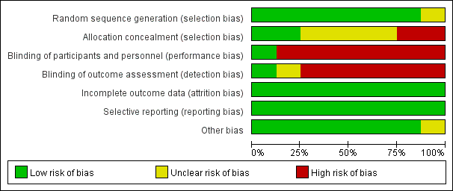

Figure S2. Risk of bias summary: review authors' judgements about each risk of bias item for each included study.


