Supplementary material 1. Database search record
Pubmed
#1 "Preeclampsia"[Mesh]
#2 "Aspirin"[Mesh]
#3 (clinical[tiab] AND trial[tiab]) OR "clinical trials as topic"[mesh] OR "clinical trial"[pt] OR random*[tiab] OR "random allocation"[mesh] OR "therapeutic use"[sh]
#4 ((#1) AND (#2)) AND (#3)
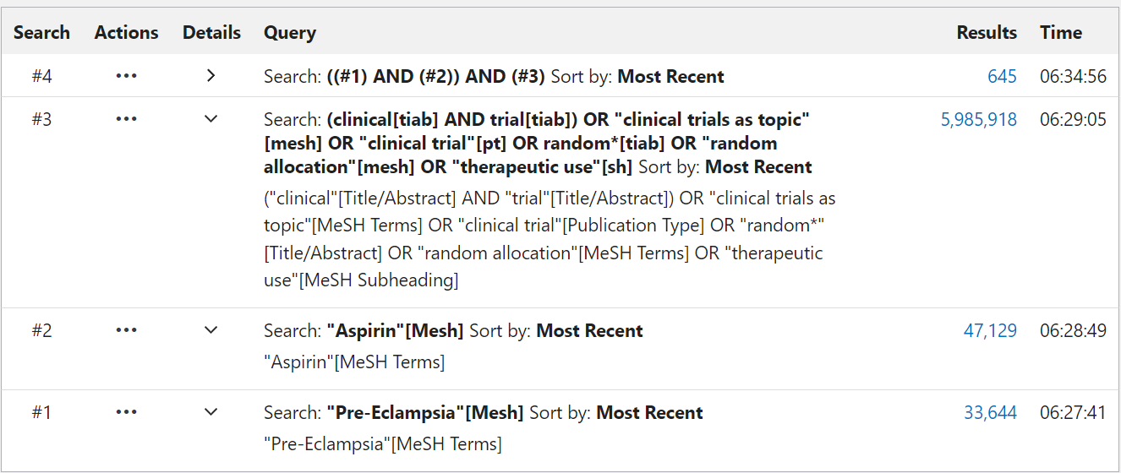
Embase
#1 MeSH descriptor: [Aspirin] explode all trees 6168
#2 MeSH descriptor: [Pre-Eclampsia] explode all trees 988
#3 #1 AND #2 in Trials 140
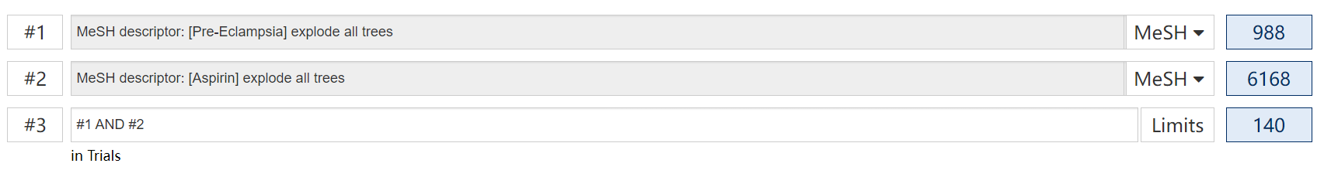
Cochrane Central Register of Controlled Trials databases
#5 #3 AND #5 456
#4 'randomized controlled trial':ab,ti OR 'randomized':ab,ti OR 'placebo':ab,ti OR 'rct':ab,ti 1,047,350
#3 #1 AND #2 2,427
#2 aspirin 125,090
#1 'preeclampsia'/exp OR preeclampsia 75,302


