Supplementary Table: Quality assessment of included studies based on Newcastle-Ottawa Scale
Code | First author (year) | Selection | Comparability | Outcome | Overall
1 | Sudfeld, C. R.et al. (2015) | *** | ** | ** | 7
2 | Sudfeld, C. R.et al. (2017) | *** | ** | ** | 7
3 | Mokhtar, R. R et al (2017) | **** | * | *** | 8
4 | Chowdhury, R., et al. (2017) | ** | ** | ** | 6
5 | Nasiri-Babadi, P. et al. (2020) | *** | ** | *** | 8
6 | Sharif, Y, et al. (2020) | **** | ** | *** | 9
7 | Chowdhury, R., et al. (2020) | ** | ** | *** | 7

Supplementary Figure 1
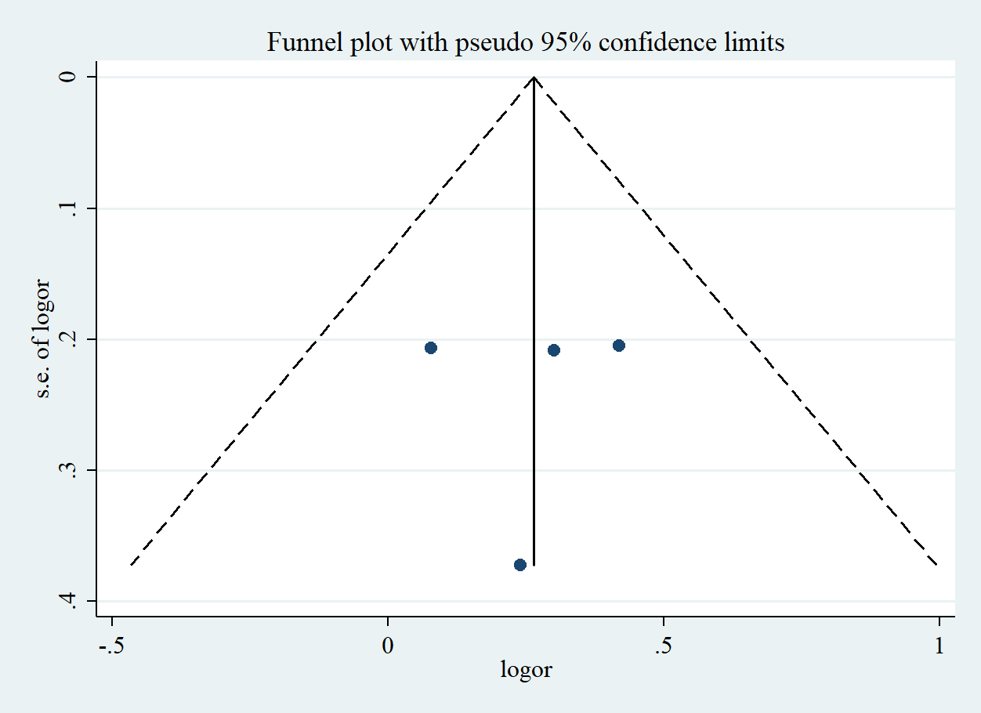
Funnel plot of the risk estimates of four studies on the association between lowest versus highest serum vitamin D level and risk of wasting in children. Each dot represents one study. Egger’s test P=0.93. SE, standard error.

Supplementary Figure 2
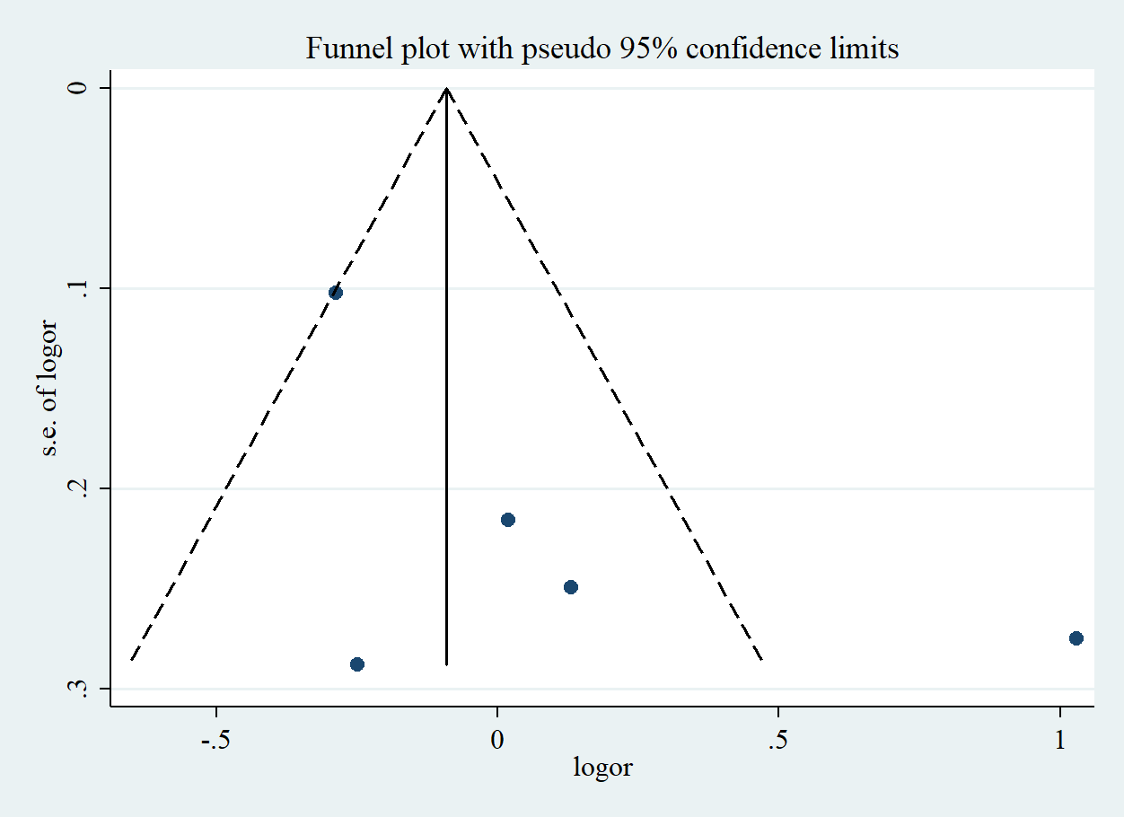
Funnel plot of the risk estimates of five studies on the association between lowest versus highest serum vitamin D level and risk of stunting in children. Each dot represents one study. Egger’s test P=0.20. SE, standard error.

Supplementary Figure 3
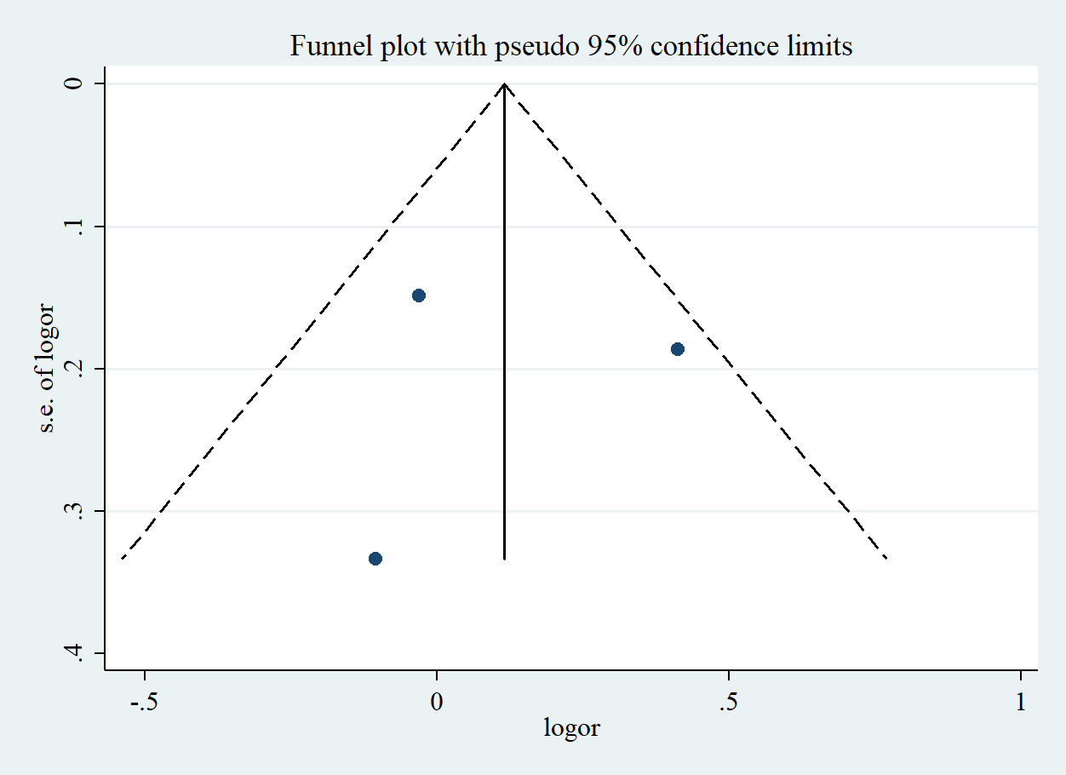
Funnel plot of the risk estimates of five studies on the association between lowest versus highest serum vitamin D level and risk of underweight in children. Each dot represents one study. Egger’s test P=0.97. SE, standard error.

Supplementary Figure 4
Sensitivity analysis of the association between lowest versus highest serum vitamin D level and risk of wasting in children. CI, confidence interval

Supplementary Figure 5

Sensitivity analysis of the association between lowest versus highest serum vitamin D level and risk of stunting in children. CI, confidence interval

Supplementary Figure 6

Sensitivity analysis of the association between lowest versus highest serum vitamin D level and risk of underweight in children. CI, confidence interval

