Figure S1. Risk of bias summary of randomized controlled trials. + low risk, ? unclear risk, - high risk.
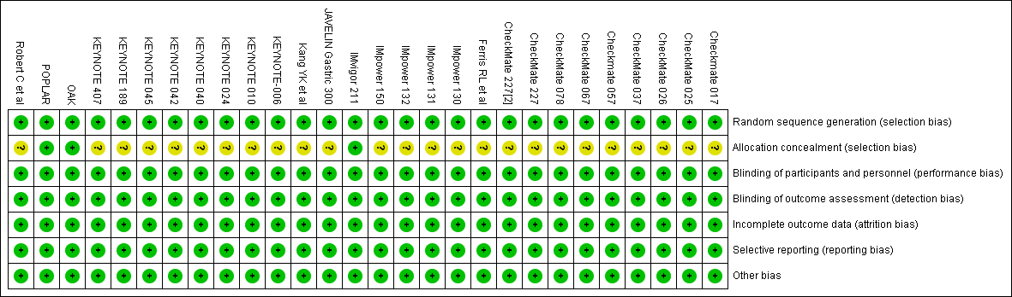

Figure S2. Funnel plots of ORR by cancer type. (A), treatment line (B), drug combination (C), and therapeutic regimen (D).
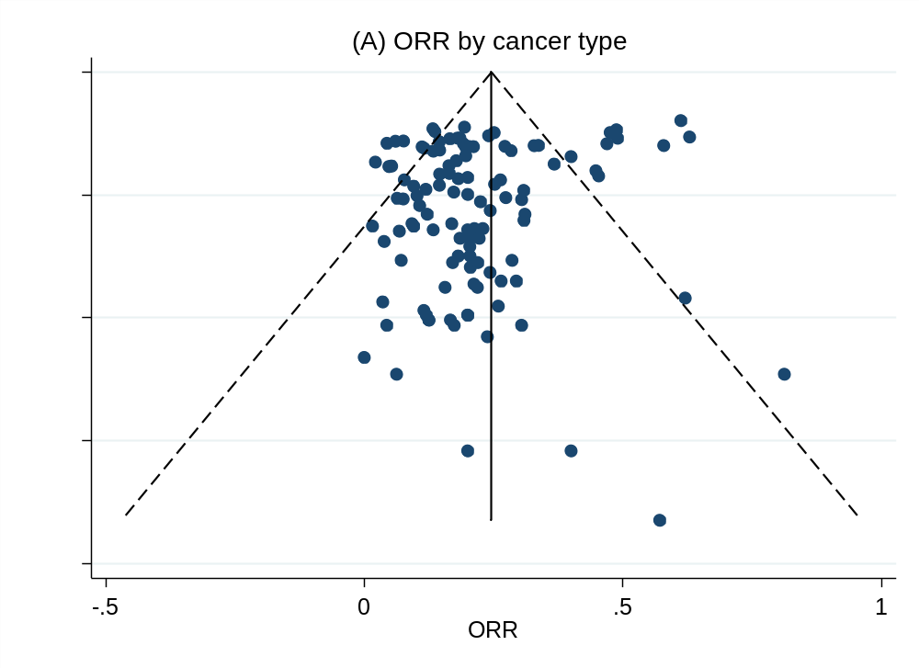
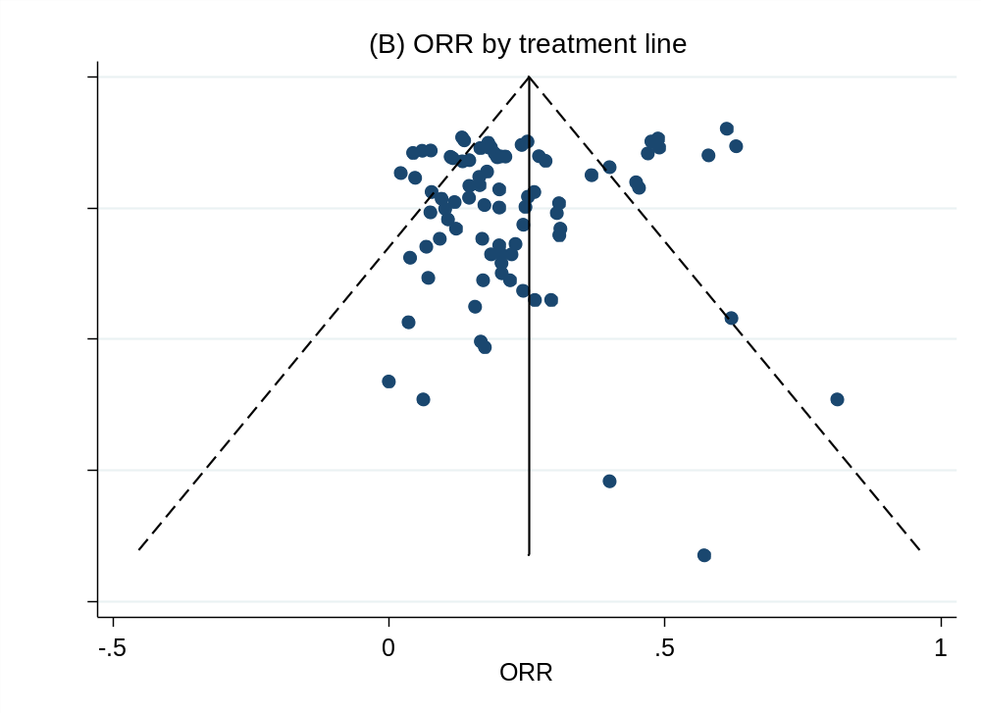
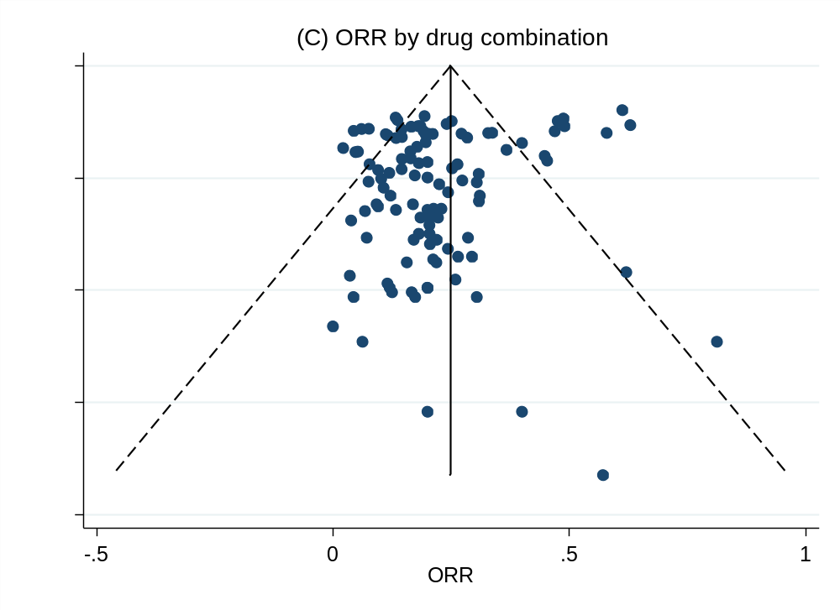
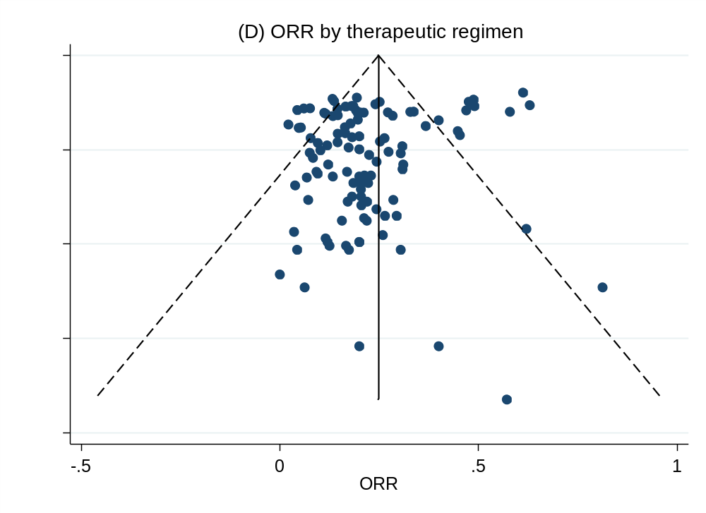

Figure S3. Funnel plots of TTR by cancer type. (A), treatment line (B), drug combination (C), and therapeutic regimen (D).

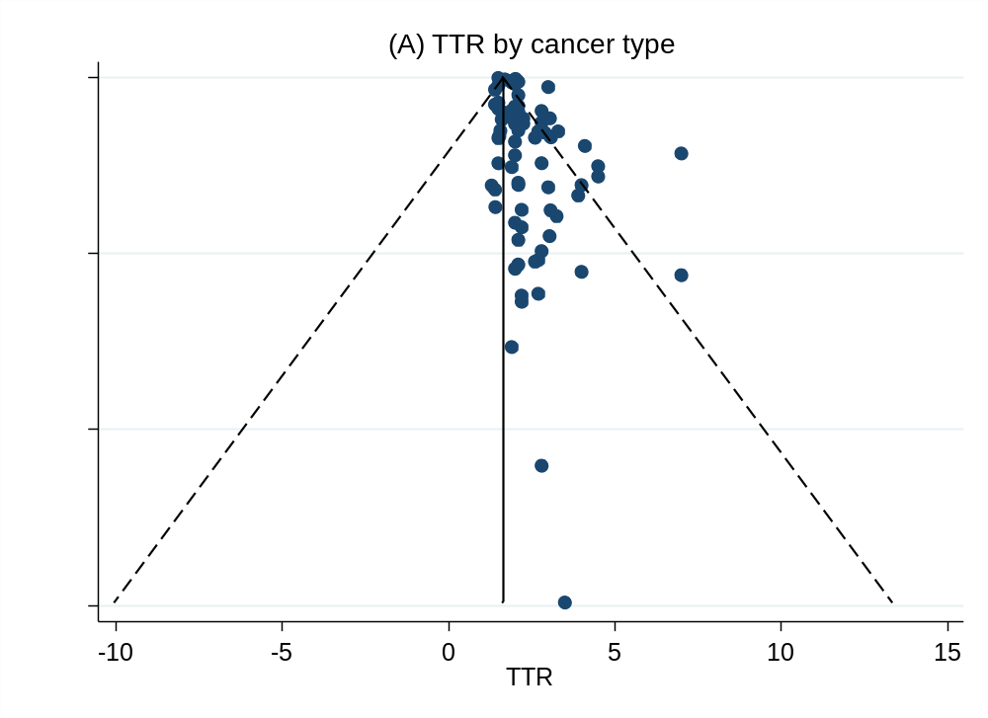

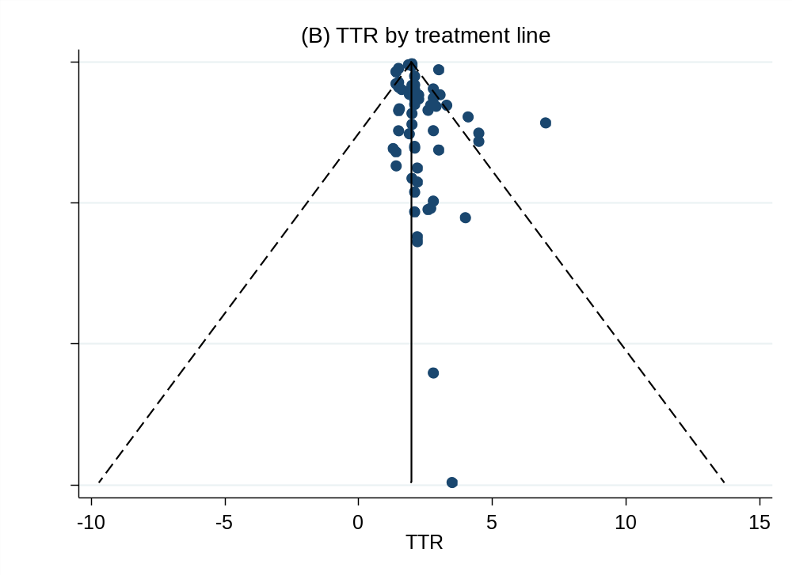
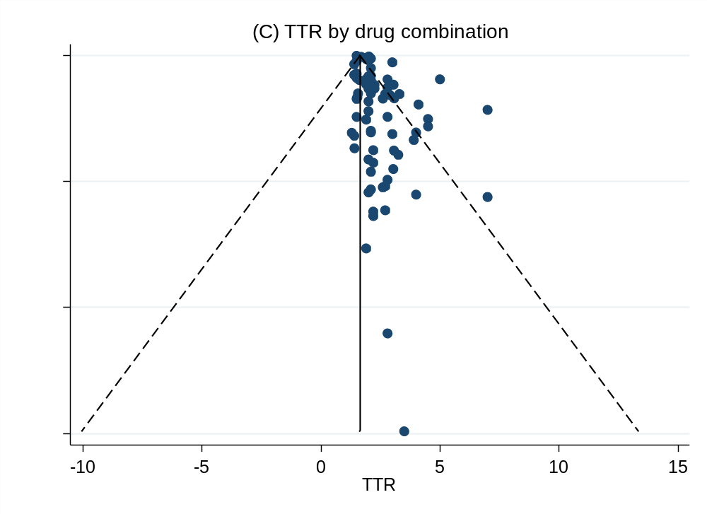
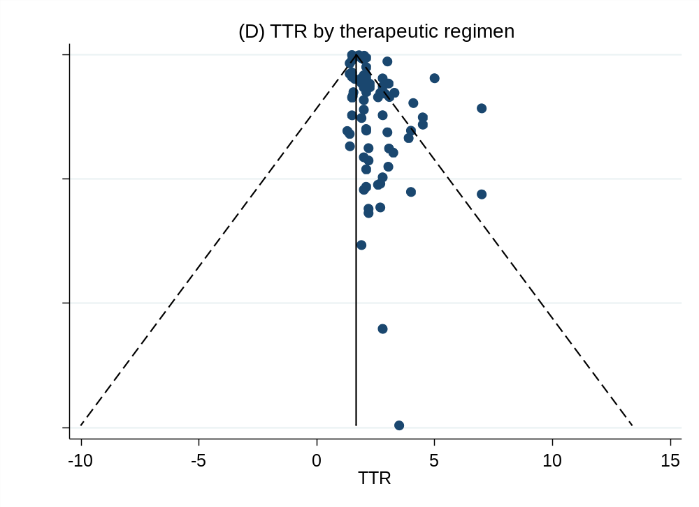

Supplementary Figure S4. Funnel plots of DOR by cancer type. (A), treatment line (B), drug combination (C), and therapeutic regimen (D).
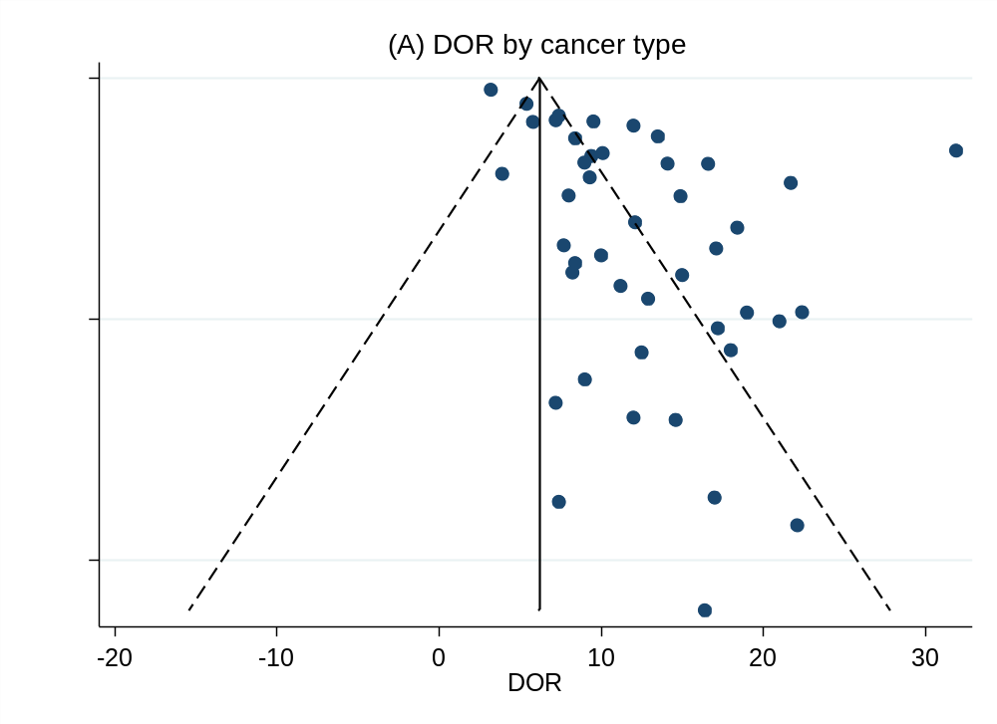
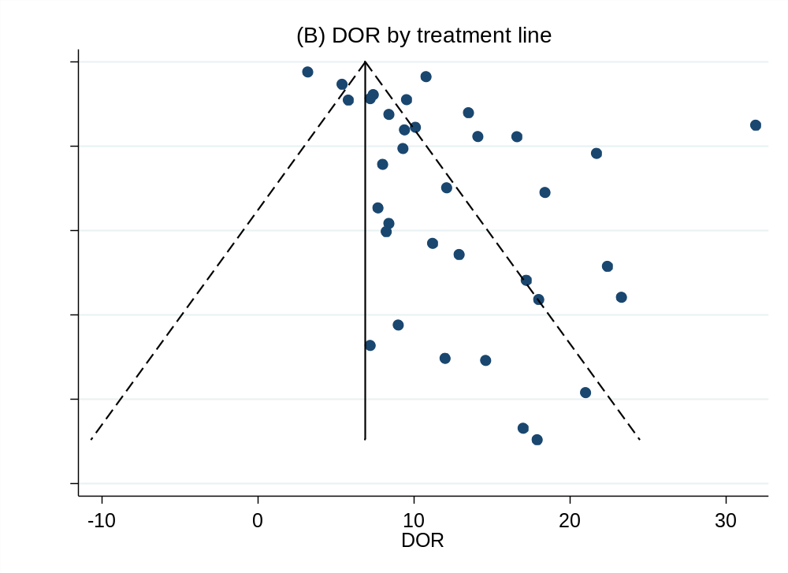
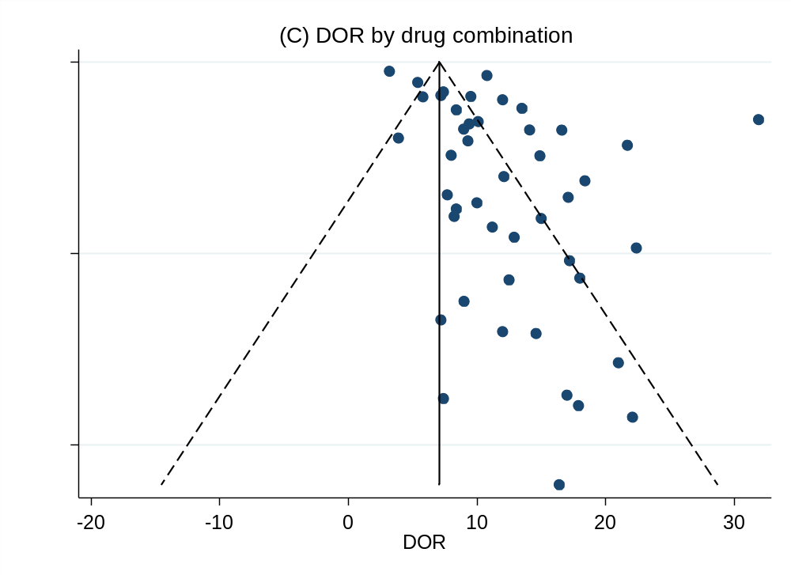
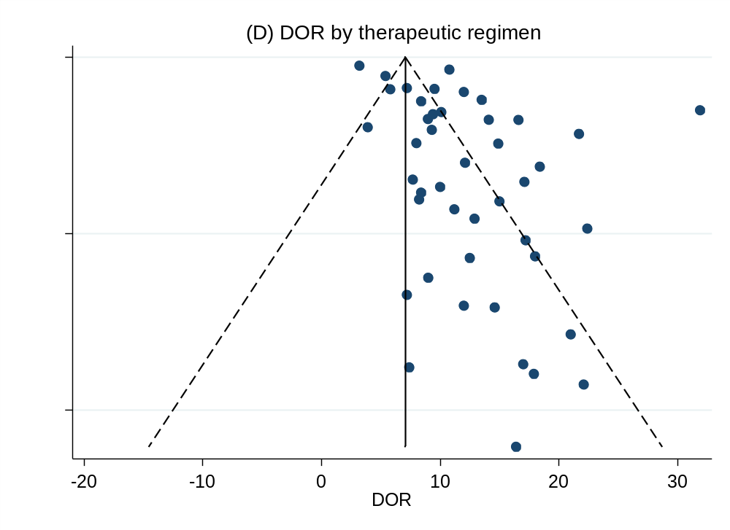

Outcomes | Included study numbers | Begg's tests (P) | Egger’s tests (P)
ORR by cancer type | 112 | 0.104 | 0.019
ORR by treatment line | 84 | 0.184 | 0.065
ORR by drug combination | 108 | 0.111 | 0.033
ORR by therapeutic regimen | 109 | 0.112 | 0.032
TTR by cancer type | 80 | 0.002 | 0.001
TTR by treatment line | 58 | 0.573 | 0.102
TTR by drug combination | 79 | 0.001 | 0.001
TTR by therapeutic regimen | 80 | 0.001 | 0.002
DOR by cancer type | 44 | 0.172 | 0.000
DOR by treatment line | 35 | 0.733 | 0.002
DOR by drug combination | 45 | 0.395 | 0.001
DOR by therapeutic regimen | 45 | 0.270 | 0.001
Table S2. Publication bias of different outcomes

