Appendices

Appendix 1: Abbreviations

Abbreviations
ABCA1 | ATP Binding Casette transporter A1 (HDL binds ABCA1 for cholesterol efflux)
ABCG1 | ATP Binding Casette transporter G1 (HDL binds ABCG1 for cholesterol efflux)
ACS | Acute Coronary Syndrome
CE | Cholesterol Ester
CETP | Cholesteryl Ester Transfer Protein
CETPi | CETP inhibitors
CVD | Cardiovascular disease
FC | Free Cholesterol
HDL | High Density Lipoprotein
HDL-C | High Density Lipoprotein Cholesterol
LDL | Low Density Lipoprotein
LDL-C | Low Density Lipoprotein Cholesterol
RCT | Randomised Controlled Trial
T2DM | Type 2 Diabetes Mellitus
TG | Triglyceride

Appendix 2: Search Strategies

Search 1: EMBASE (via OVID)

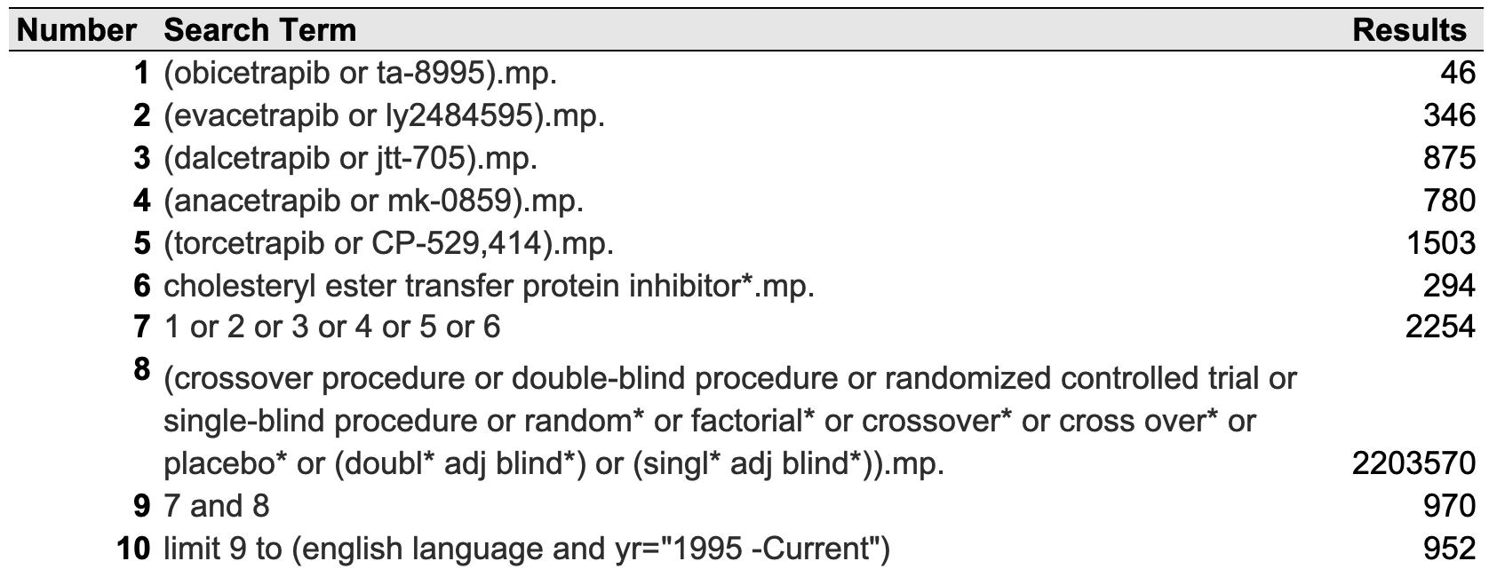

Search 2: MEDLINE (via OVID)

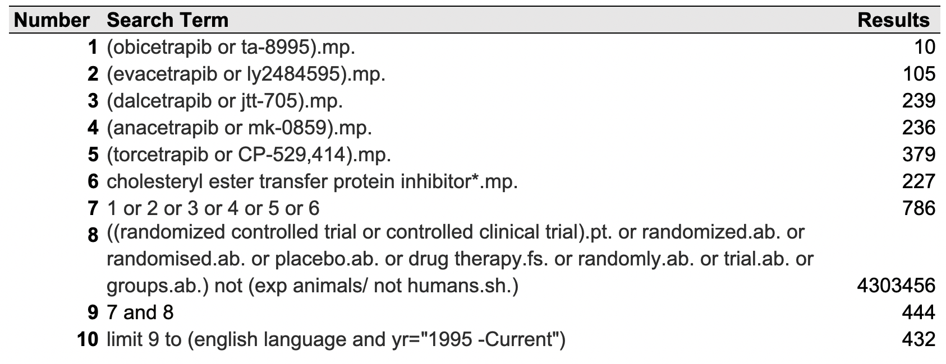
Search 3: CENTRAL
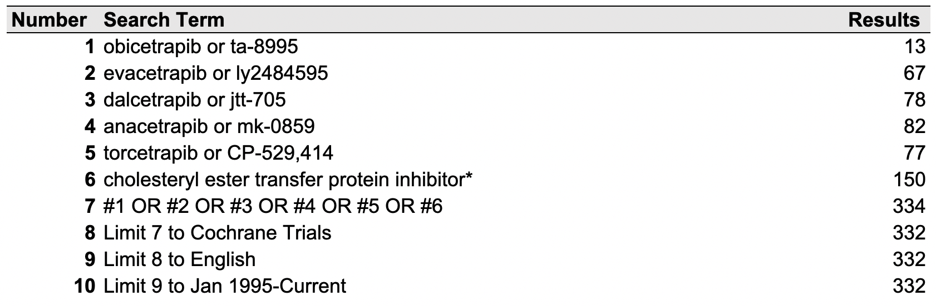

Appendix 3: PRISMA Flow Chart
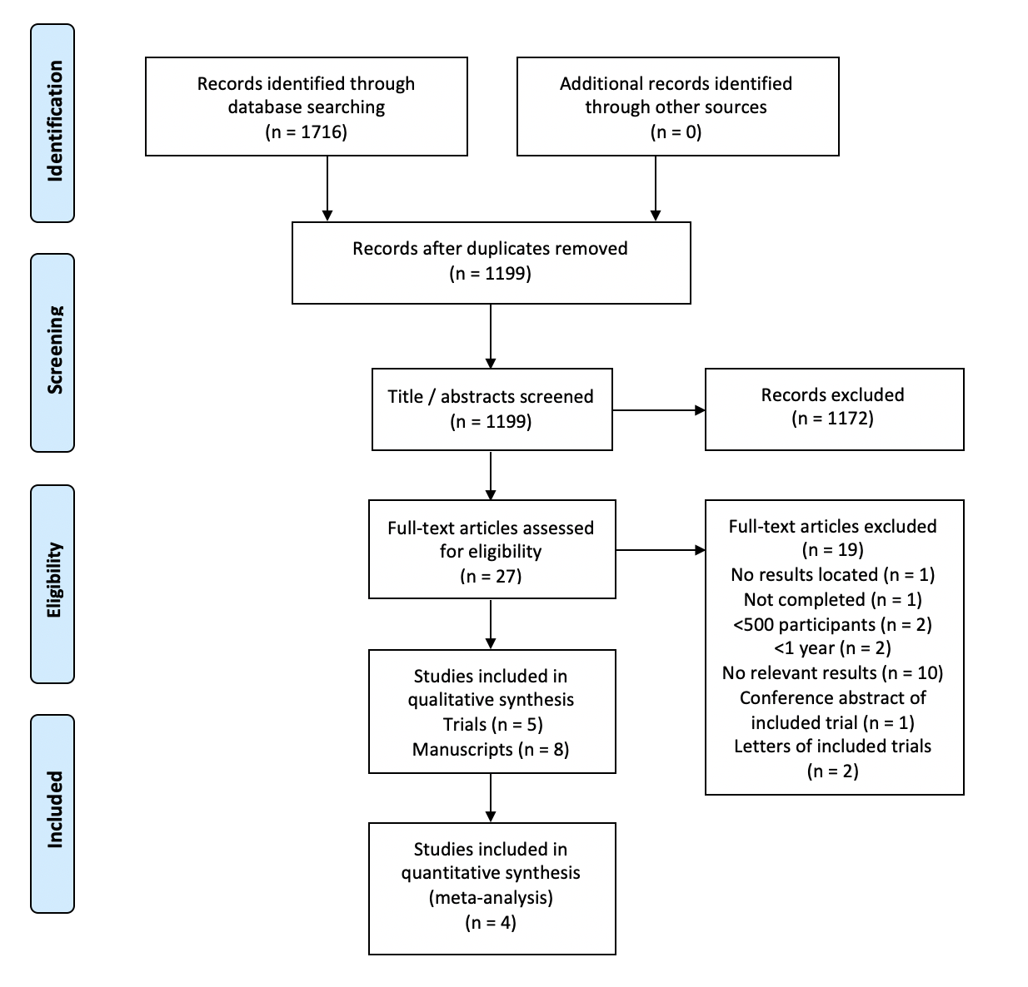

This systematic review with meta-analysis followed a pre-specified protocol, designed and reported according to Preferred Reporting Items for Systematic Reviews and Meta-Analyses (PRISMA) guidelines.

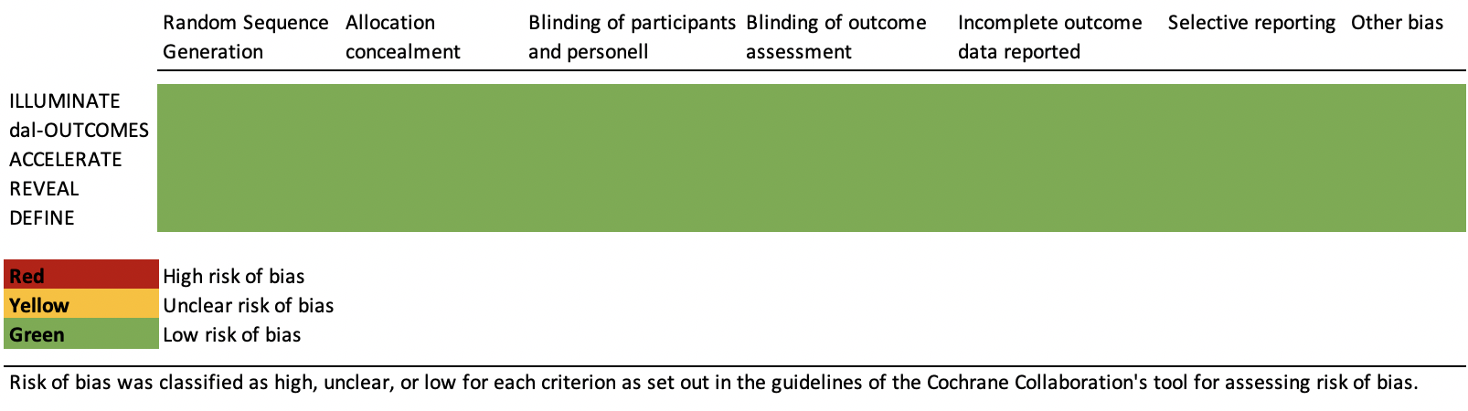
Appendix 4: Quality Assessment Table

Quality of included studies was assessed independently by two reviewers using Cochrane Collaboration’s tool for assessing risk of bias¹. Disagreements not resolved by consensus were resolved by a third reviewer. Each domain (sequence generation, allocation concealment, blinding of participants, personnel and outcome assessors, incomplete outcome data, selective outcome reporting and other potential sources of bias) was given a score of “high,” “unclear,” or “low”. All five trials included in this meta-analysis were of very high-quality with low risk of bias detected. Trials included were ILLUMINATE², dal-OUTCOMES³, ACCELERATE⁴, REVEAL⁵ and DEFINE⁶.
Appendix 5: Funnel plot

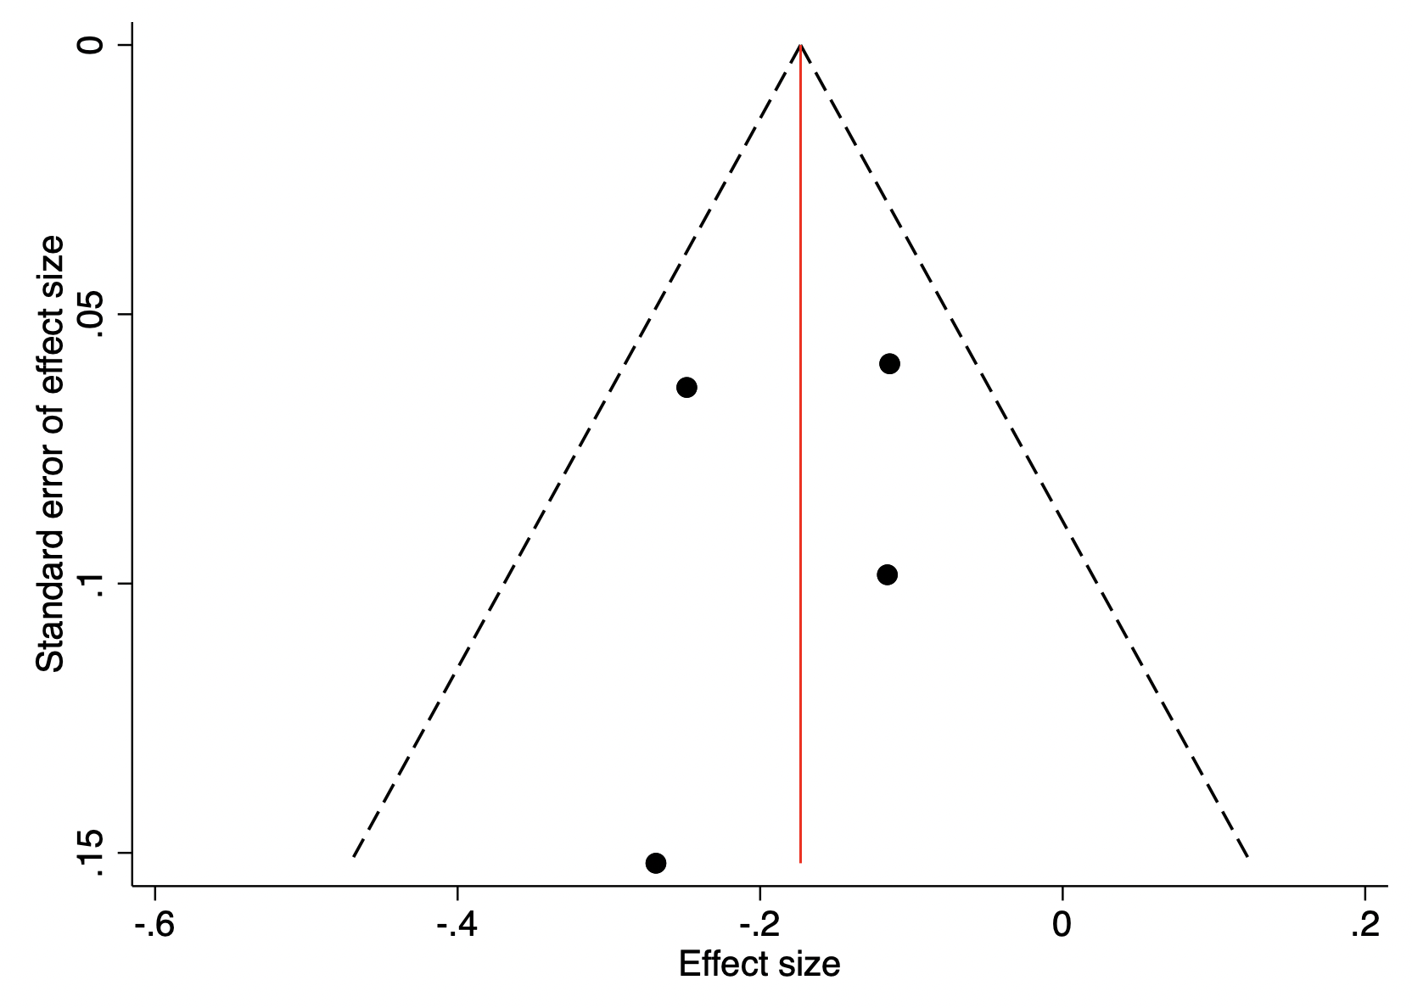
Funnel plot of effect size for new-onset diabetes indicates no evidence of publication bias.

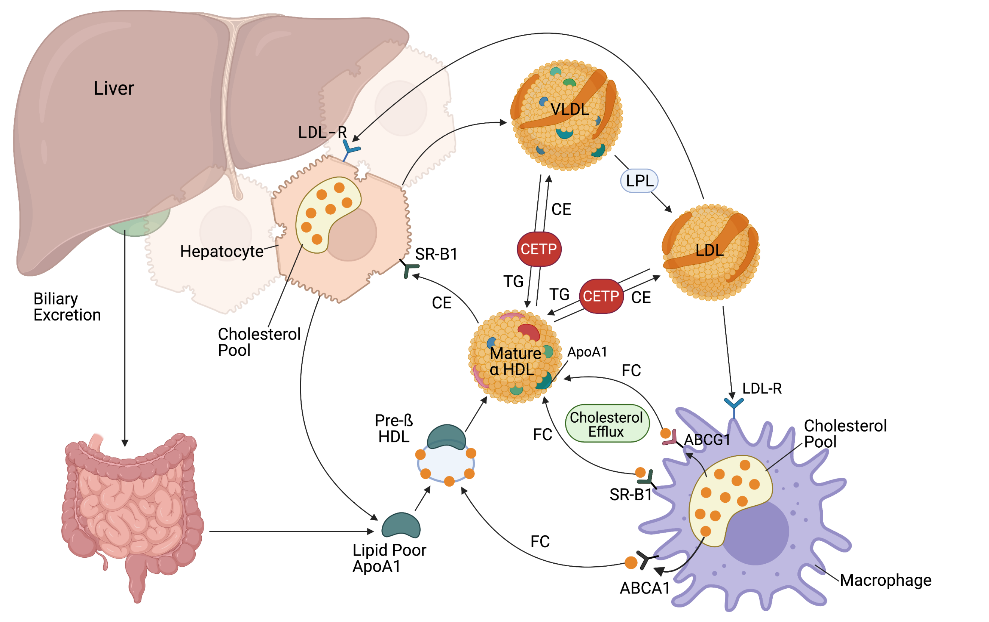
Appendix 6:

CETP mediates transfer of cholesterol ester (CE) from HDL to VLDL/LDL and triglycerides (TG) from VLDL/LDL to HDL. As HDL matures, it amasses free cholesterol (FC) from macrophages in periphery via ABCA1, SR-B1, and ABCG1 and deposits CE at hepatocytes via SR-B1. CETP inhibition thus increases HDL-C, stimulating cholesterol-efflux, and lowers LDL-C decreasing peripheral cholesterol deposits. Created with Biorender.com.

Appendix 7: PRISMA Checklist

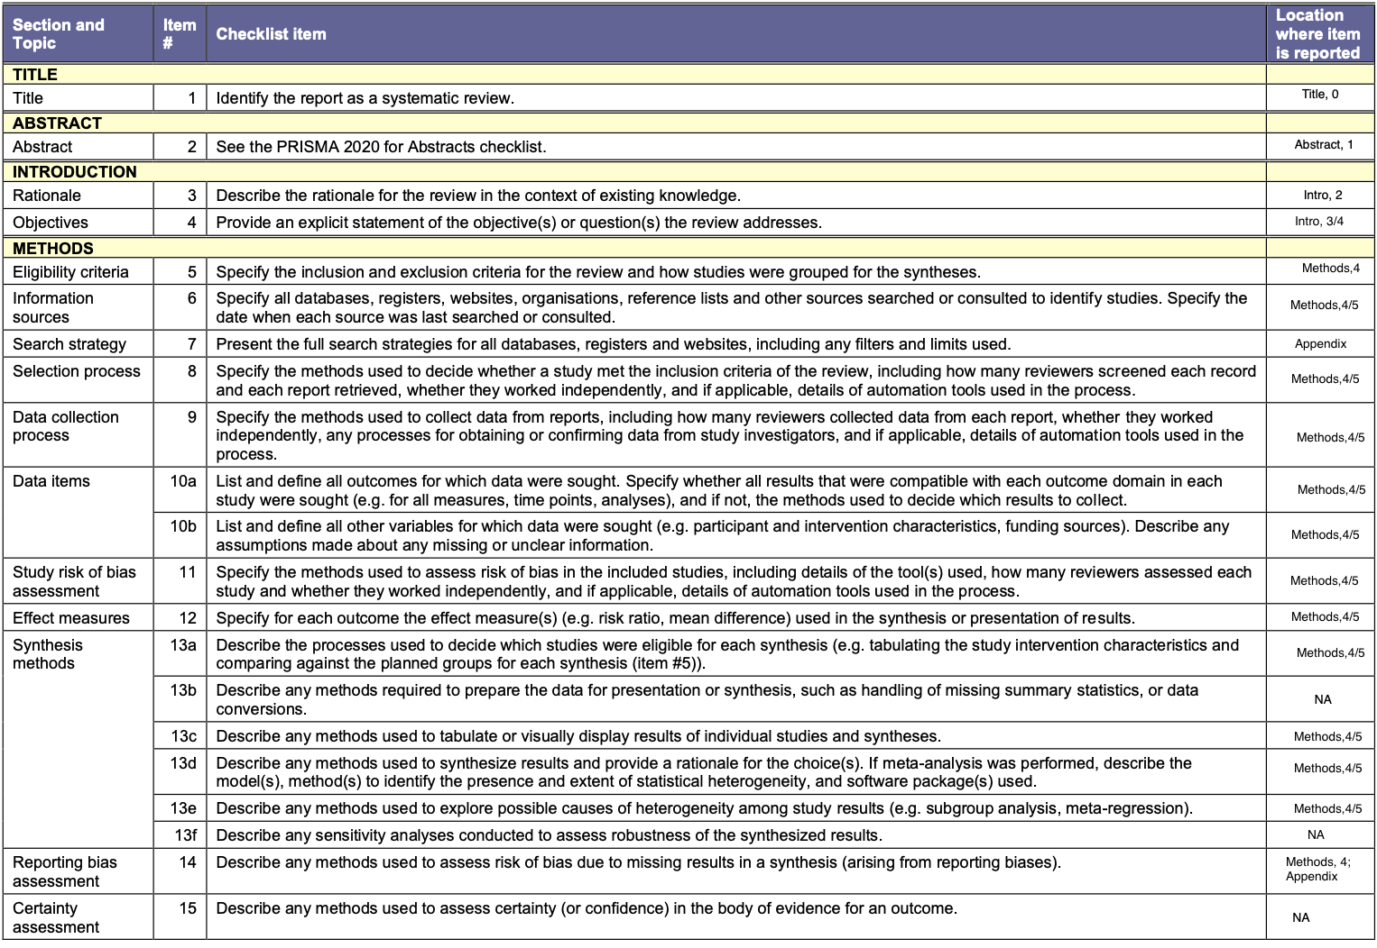

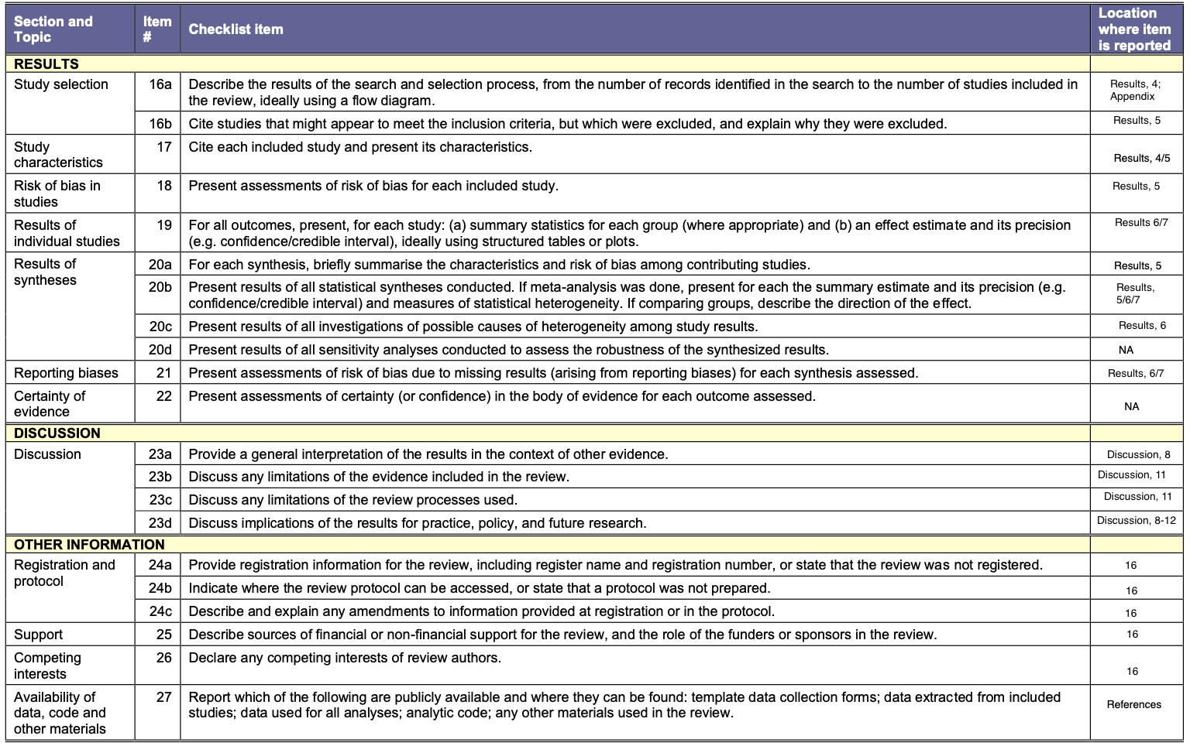

References

1. Higgins, J. P. T. et al. The Cochrane Collaboration’s tool for assessing risk of bias in randomised trials. BMJ 343, (2011).
2. Barter, P. J. et al. Effect of torcetrapib on glucose, insulin, and hemoglobin a1c in subjects in the investigation of lipid level management to understand its impact in atherosclerotic events (Illuminate) Trial. Circulation (2011) doi:10.1161/CIRCULATIONAHA.111.018259.
3. Schwartz, G. G. et al. Effects of Dalcetrapib in Patients with a Recent Acute Coronary Syndrome. N. Engl. J. Med. (2012) doi:10.1056/nejmoa1206797.
4. Lincoff, A. M. et al. Evacetrapib and Cardiovascular Outcomes in High-Risk Vascular Disease. N. Engl. J. Med. (2017) doi:10.1056/nejmoa1609581.
5. Bowman, L. et al. Effects of Anacetrapib in Patients with Atherosclerotic Vascular Disease. N. Engl. J. Med. 377, 1217–27 (2017).
6. Cannon, C. P. et al. Safety of anacetrapib in patients with or at high risk for coronary heart disease. N. Engl. J. Med. 363, 2406‐2415 (2010).

