S1 Fig – Funnel plots

Paediatric cohorts

Adult cohorts
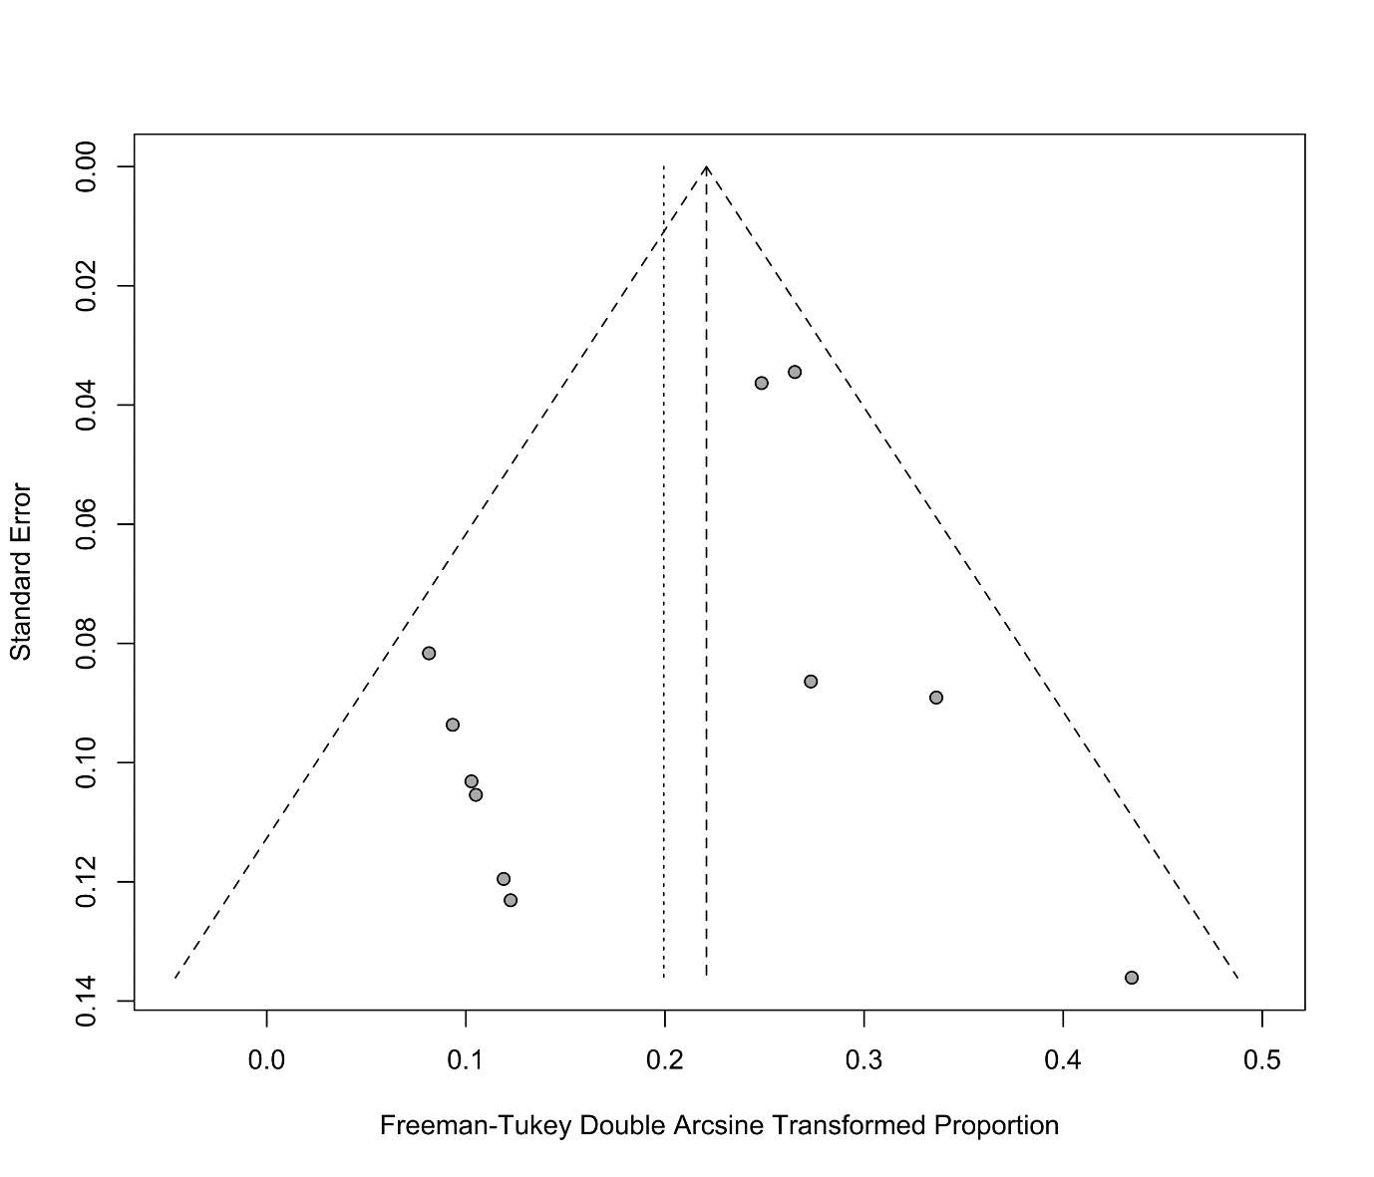

All cohorts


