Supplementary Material

Article Title | Effects of Acute Resistance Exercise on Executive Function: A Systematic Review of the Moderating Role of Intensity and Executive Function Domain
Authors | Tzu‑Yu Huang, Feng‑Tzu Chen, Ruei‑Hong Li, Charles H. Hillman, Trevor L. Cline, Chien‑Heng Chu, Tsung‑Min Hung and Yu‑Kai Chang
Contents | Table S1. Classification of executive function assessments  Fig. S1. Quality ratings of individual studies

Table S1. Classification of executive function assessments
Inhibitory control | Working memory | Cognitive flexibility
Stroop task - color-word  Stroop task -incongruent  Stroop task -interference score  Simon task  Eriksen Flanker task - incongruent  Go/no-go Task | N-back (2 back)  Verbal running span task  Paced auditory serial Addition task  Modified Sternberg test | Trail making test – B  Plus-minus task  Dimension-switching task  More-odd task  Task-switching test

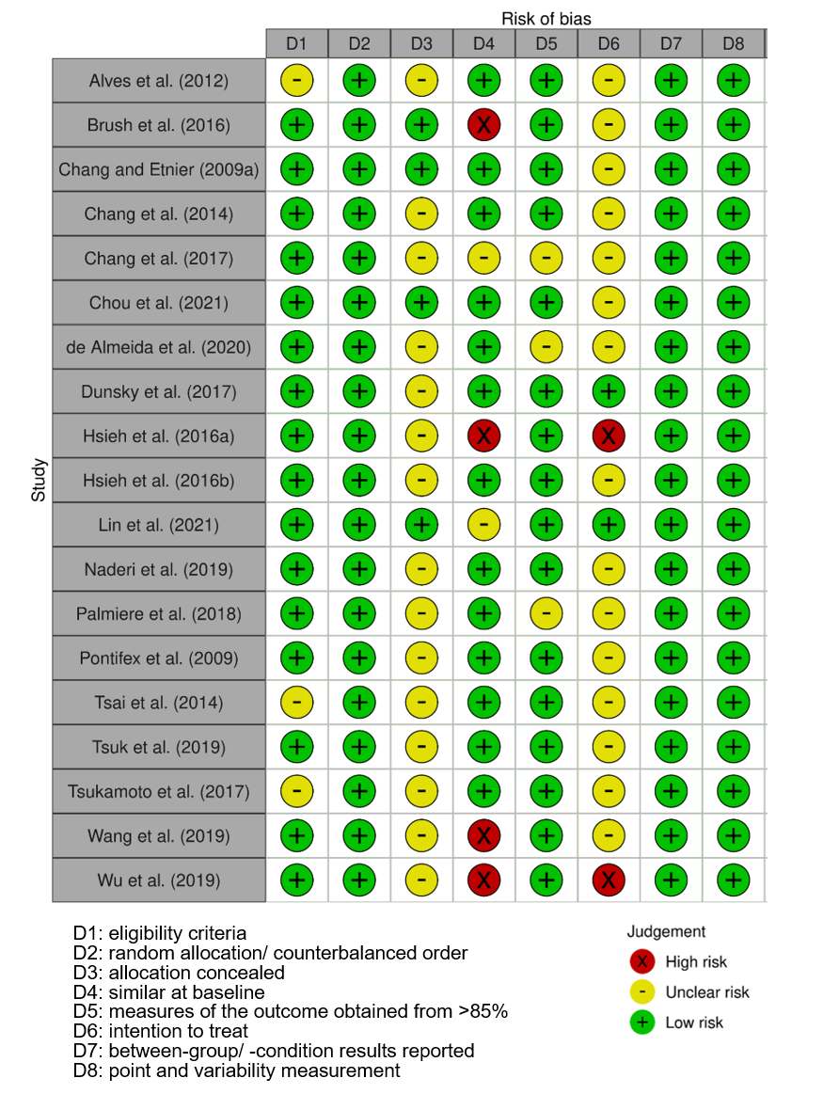

Fig. S1. Quality ratings of individual studies

