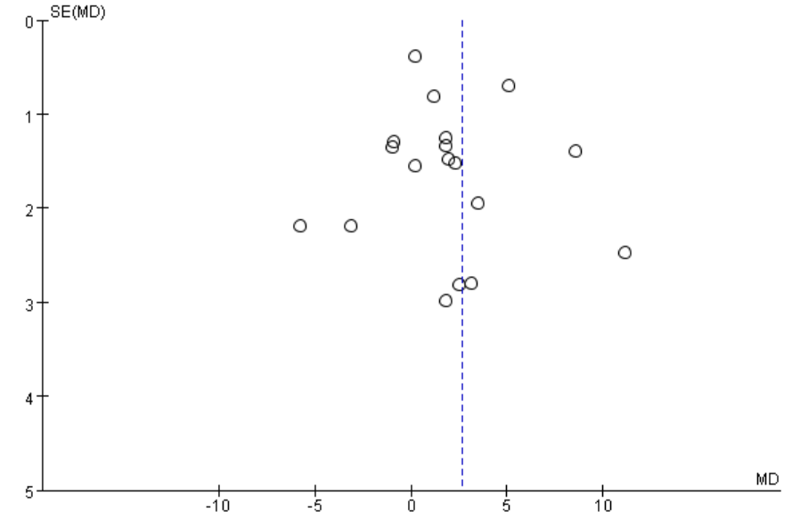
Supplementary Figure 1 Funnel plot in the meta-analysis on the association of FBG between RPL and control group
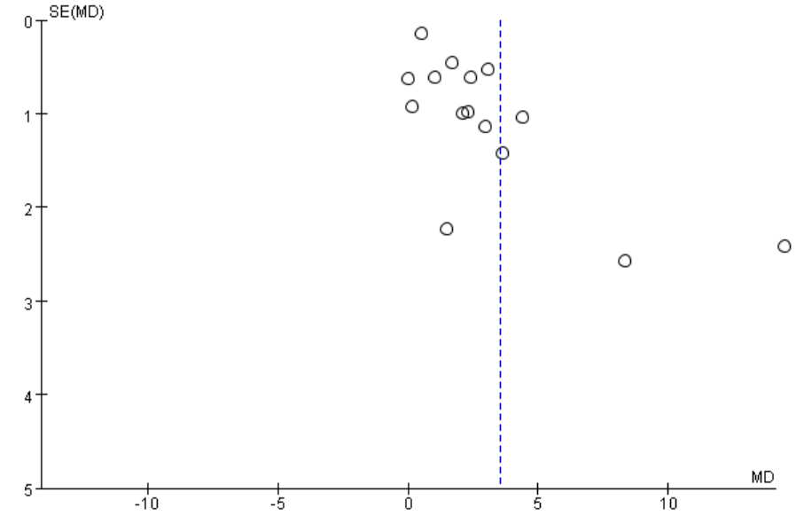
Supplementary Figure 2 Funnel plot in the meta-analysis on the association of FIN between RPL and control group
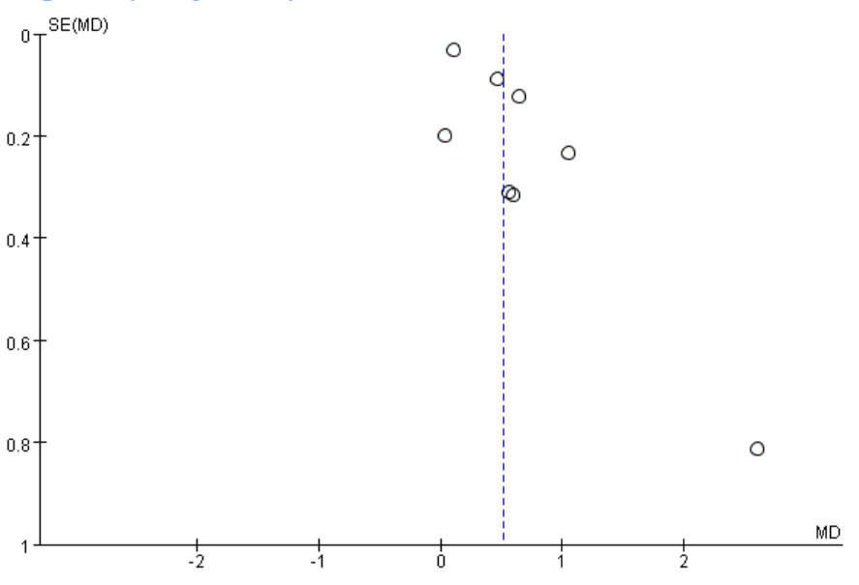
Supplementary Figure 3 Funnel plot in the meta-analysis on the association of HOMA-IR between RPL and control group
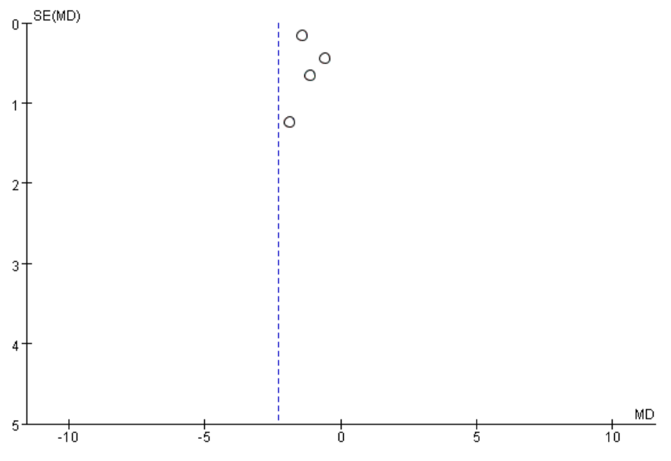
Supplementary Figure 4 Funnel plot in the meta-analysis on the association of GI ratio between RPL and control group
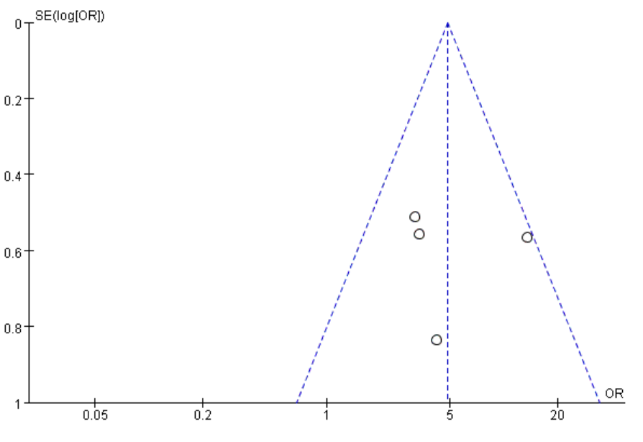
Supplementary Figure 5 Funnel plot in the meta-analysis on the association of IR by abnormal HOMA-IR between RPL and control group
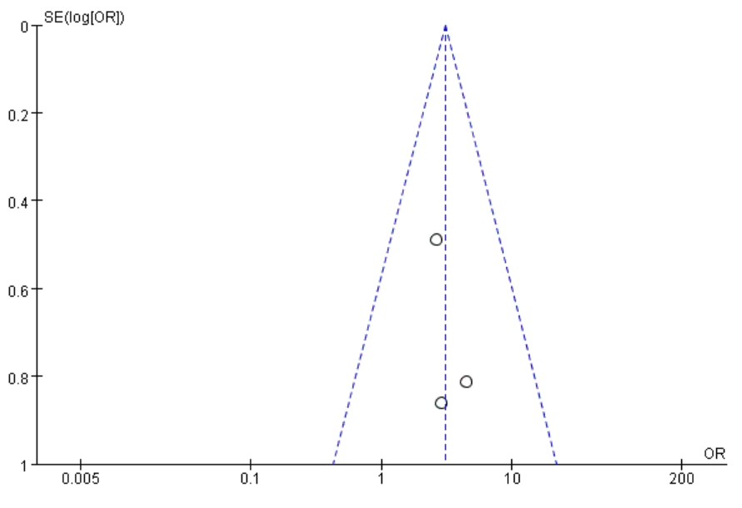
Supplementary Figure 6 Funnel plot in the meta-analysis on the association of IR by abnormal GI ratio between RPL and control group
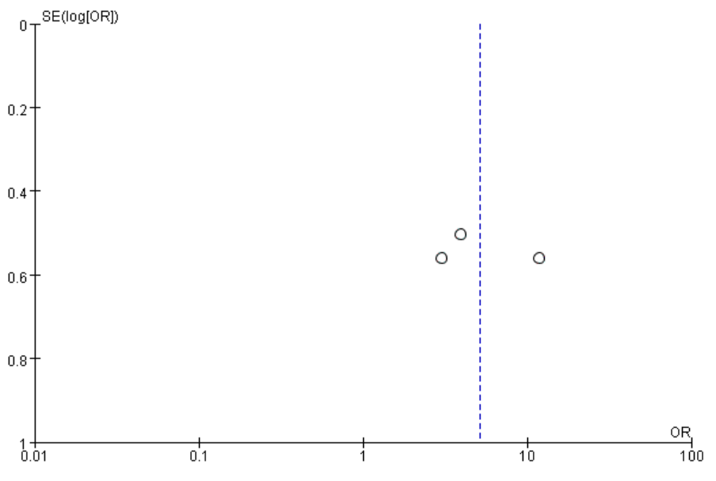
Supplementary Figure 7 Funnel plot in the meta-analysis on the association of IR by abnormal FIN between RPL and control group

