Additional file
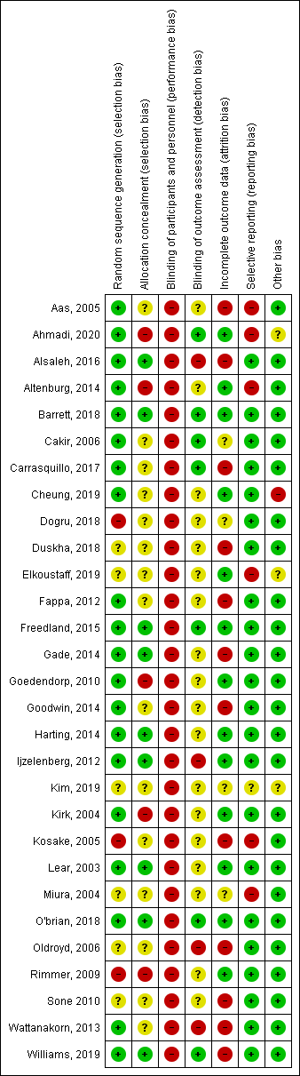
Risk of bias summary for all included studies

