Figure S1. Risk of bias of the included studies
Revised Cochrane risk-of-bias tool for randomised trials (RoB2)

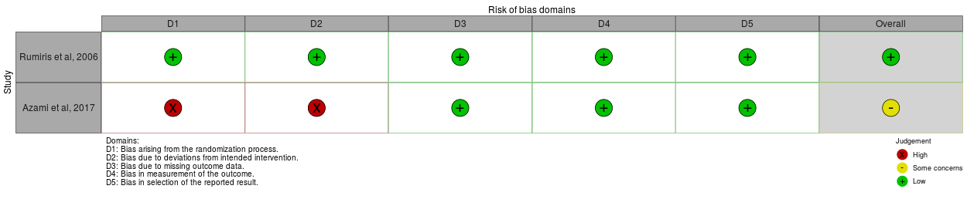
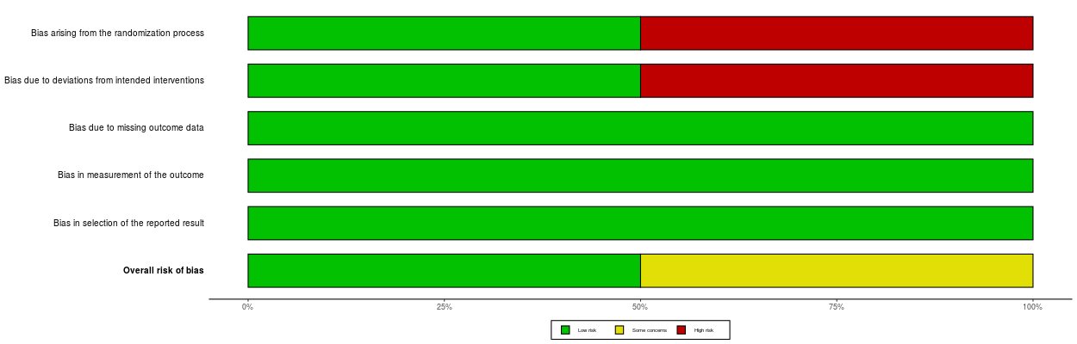
Newcastle Ottowa Scale (NOS)
Study | Selection | Comparability | Outcome | Total
Bodnar et al, 2006 | 4 | 2 | 3 | 9
Catov et al, 2009 | 3 | 2 | 3 | 8
Høgh et al, 2020 | 3 | 2 | 3 | 8
Vanderlelie et al, 2016 | 3 | 2 | 3 | 8

