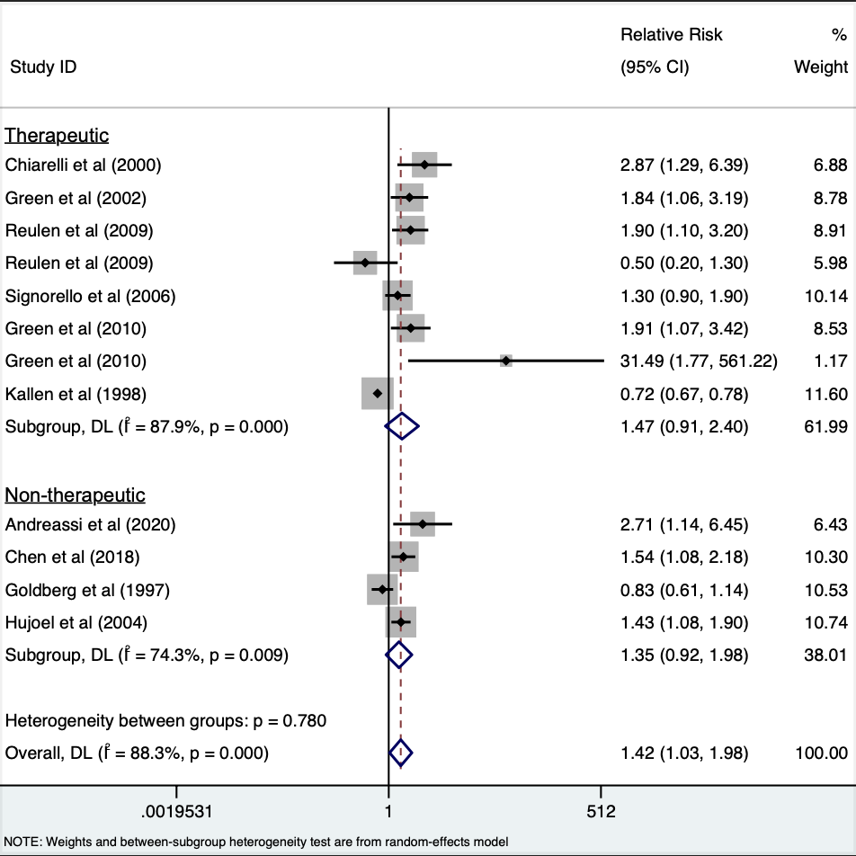
Supplementary Fig. 1 Estimates of risk of LBW by low dose (non-therapeutic) and high dose (therapeutic) exposure to ionizing radiation relative to those unexposed. The weights represent the contribution of each study effect estimate to the overall meta-estimate.

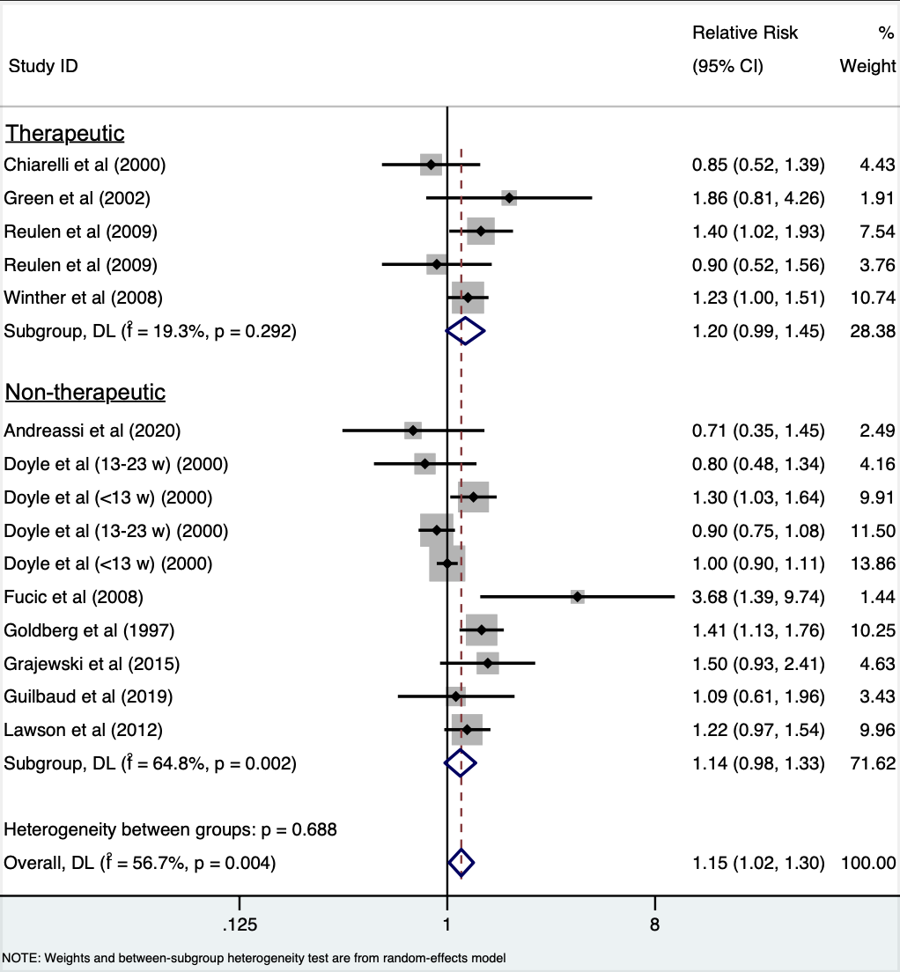
Supplementary Fig. 2 Estimates of risk of miscarriage by low dose (non-therapeutic) and high dose (therapeutic) exposure to ionizing radiation relative to those unexposed. The weights represent the contribution of each study effect estimate to the overall meta-estimate.

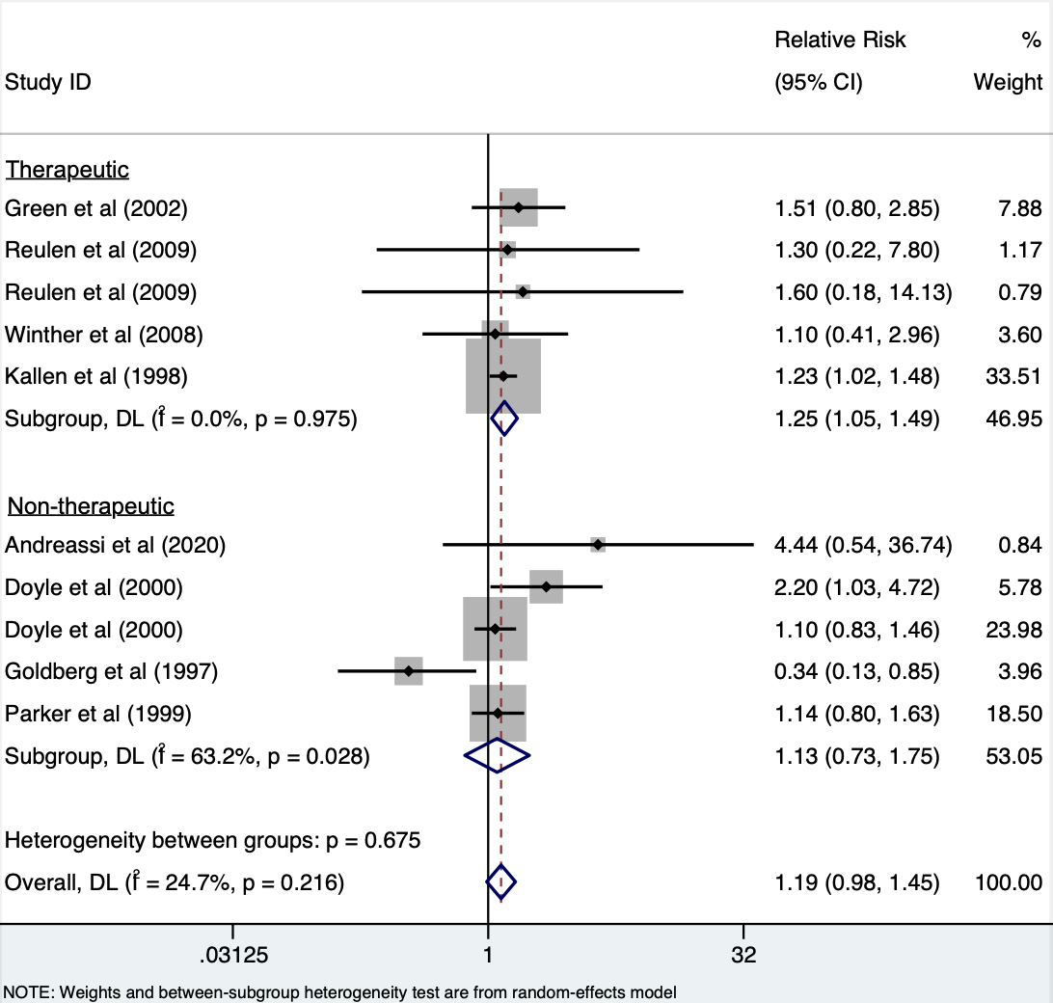
Supplementary Fig. 3 Estimates of risk of stillbirth by low dose (non-therapeutic) and high dose (therapeutic) exposure to ionizing radiation relative to those unexposed. The weights represent the contribution of each study effect estimate to the overall meta-estimate.

