Multimedia Appendix 4. Quality assessment

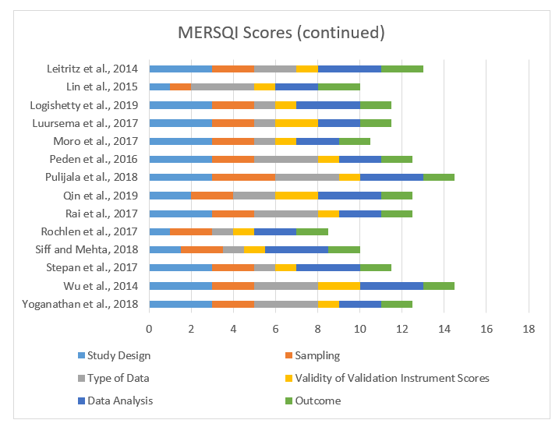
Medical Education Research Quality Instrument (MERSQI) scores

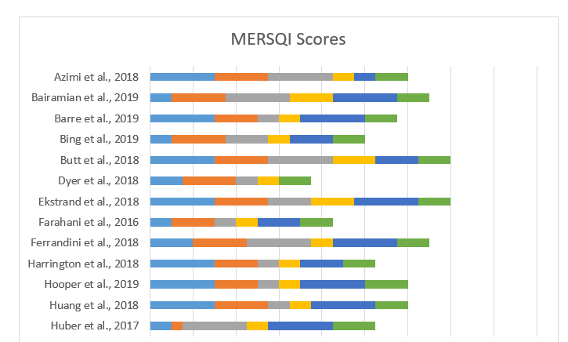

Figure 1. Medical Education Research Quality Instrument (MERSQI) scores, studies 1-13 with scores ranging from 5-18
Newcastle-Ottawa Scale-Education (NOS-E) scores
NOS-E Scores
Azimi et al., 2018
Bairamian et al., 2019 Barre et al., 2019 Bing et al., 2019 Butt et al., 2018 Dyer et al., 2018 Farahani et al., 2016
Ferrandini et al., 2018 Huber et al., 2017 Leitritz et al., 2014 Lin et al., 2015 Peden et al., 2016 Qin et al., 2019 Rochlen et al., 2017 Siff and Mehta, 2018 Wu et al., 2014
0
1
2
3
4
5
6
Representativeness
Selection of Comparison Group
Comparability of Comparison Group Blinding of Assessment
Study Retention

Figure 2. Newcastle-Ottawa Scale-Education (NOS-E) scores of non-randomized studies with scores ranging from 0-6.

Risk of bias assessment for non-randomized studies
Table 1. Risk of bias assessment for non-randomized studies.

Study | Risk of Bias | Study | Risk of Bias
Azimi et al., 2018 | Low | Huber et al., 2017 | Low
Bairamian et al., 2019 | Low | Leitritz et al., 2014 | Low
Barre et al., 2019 | Low | Lin et al., 2015 | No information
Bing et al., 2019 | Low | Peden et al., 2016 | Low
Butt et al., 2018 | Low | Qin et al., 2019 | Low
Dyer et al., 2018 | Serious | Rochlen et al., 2017 | Low
Farahani et al., 2016 | Serious | Siff and N. Mehta, 2018 | Low
Ferrandini et al., 2018 | Low | Wu et al., 2014 | Low

