Multimedia Appendix 5. Three levels of knowledge.
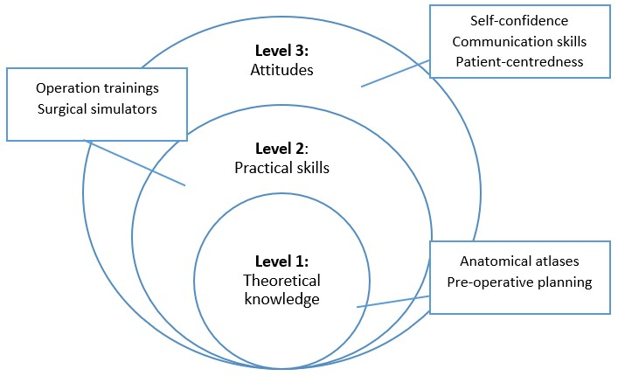
Three levels of knowledge for XR (adapted and modified from Górski et al., 2017).

