Supplementary 1: Table showing the search queries used in this review.
EMBASE search query | PubMED Search query
(brucellosis OR 'brucellosis epidemiology' OR 'brucellosis'/exp OR brucell*) AND ('inappropriate vasopressin secretion' OR 'inappropriate vasopressin secretion'/exp OR 'syndrome of inappropriate antidiuretic hormone secretion' OR siadh) | (((((((siadh[MeSH Terms]) OR (syndrome of inappropriate adh siadh secretion[MeSH Terms])) OR (adh syndrome, inappropriate[MeSH Terms])) OR (antidiuretic hormone, inappropriate secretion[MeSH Terms])) OR (SIADH)) OR (antidiuretic hormone)) OR (inappropriate vasopressin)) AND (((((((((Brucellosis) OR (Brucella)) OR (Brucella infection)) OR (Cyprus Fever)) OR (Maltese Fever)) OR (Undulant Fever)) OR (brucella[MeSH Terms])) OR (brucelloses[MeSH Terms])) OR (brucellosis[MeSH Terms]))

Supplementary 2: Forest plot after adding suspected SIADH cases in Zhao study to the analysis.

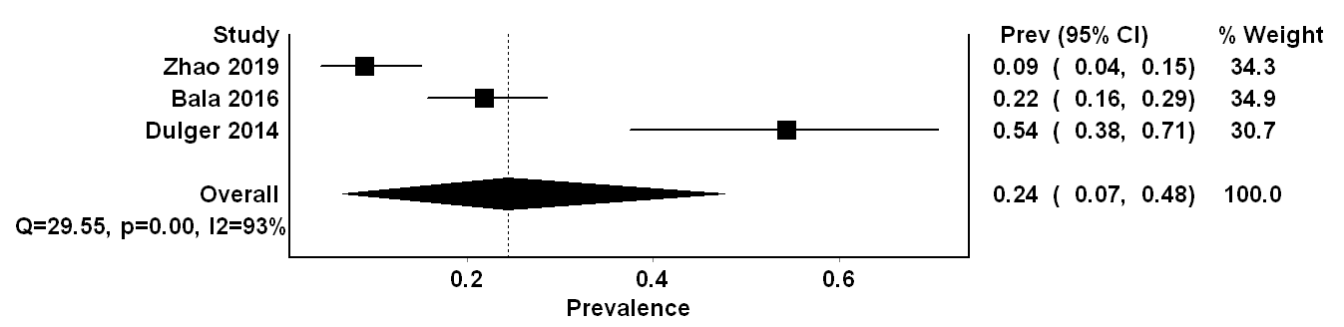

Supplementary 3: Table showing the results of sensitivity analysis
Excluded study | Pooled Prevalence | LCI 95% | HCI 95% | Cochran Q | p | I 2 | I 2 LCI 95% | I 2 HCI 95%
Zhao 2019 | 0.351668579 | 0.058962564 | 0.711153041 | 13.31064062 | 0.000263904 | 92.48721359 | 74.56010805 | 97.78136009
Bala 2016 | 0.228590992 | 0 | 1 | 45.48753253 | 1.54E-11 | 97.80159542 | 94.71936851 | 99.08477183
Dulger 2014 | 0.107548543 | 0 | 0.342790967 | 25.54133353 | 4.33E-07 | 96.08477765 | 88.99883108 | 98.6066057

Supplementary 4: Figure 1 showing DOI plot showing absence of asymmetry suggestive of the absence of a publication bias
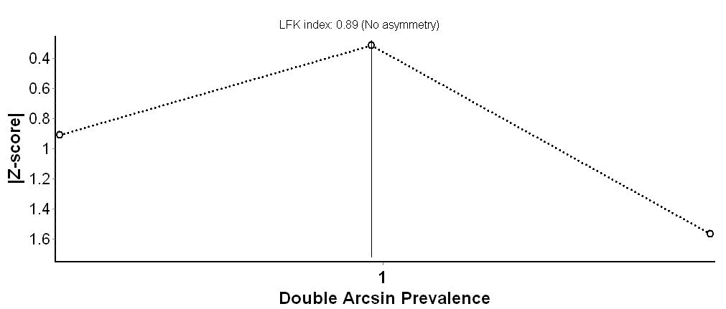
*The small number of studies in this analysis may have limited proper assessment of publication bias.

