Supplemental Figure 1– Risk of Bias Assessment
 | Randomization Process | Adhering to Intervention | Missing outcome data | Bias in Measurement of Outcome |  | Bias in Selection of Reported Result |  | Overall Risk of Bias
Abd-Elsalam 2021 | Low | Low | Some concerns | Low |  | High |  | High
ACTT-1 2020 | Low | Low | Low | Low |  | Low |  | Low
CATCO 2021 | Low | Low | Low | Low |  | Low |  | Low
DISCOVERY 2021 | Low | Low | Low | Low |  | Low |  | Low
Mahajan 2021 | Some concerns | Some concerns | Some concerns | Low |  | High |  | High
Spinner 2020 | Low | Low | Low | Low |  | Low |  | Low
Wang 2020 | Low | Low | Low | Low |  | Low |  | Low
WHO SOLIDARITY 2020 | Low | Low | Low | Low |  | Low |  | Low

Supplemental Figure 2 – Sensitivity Analysis – Oxygenation status precisely known
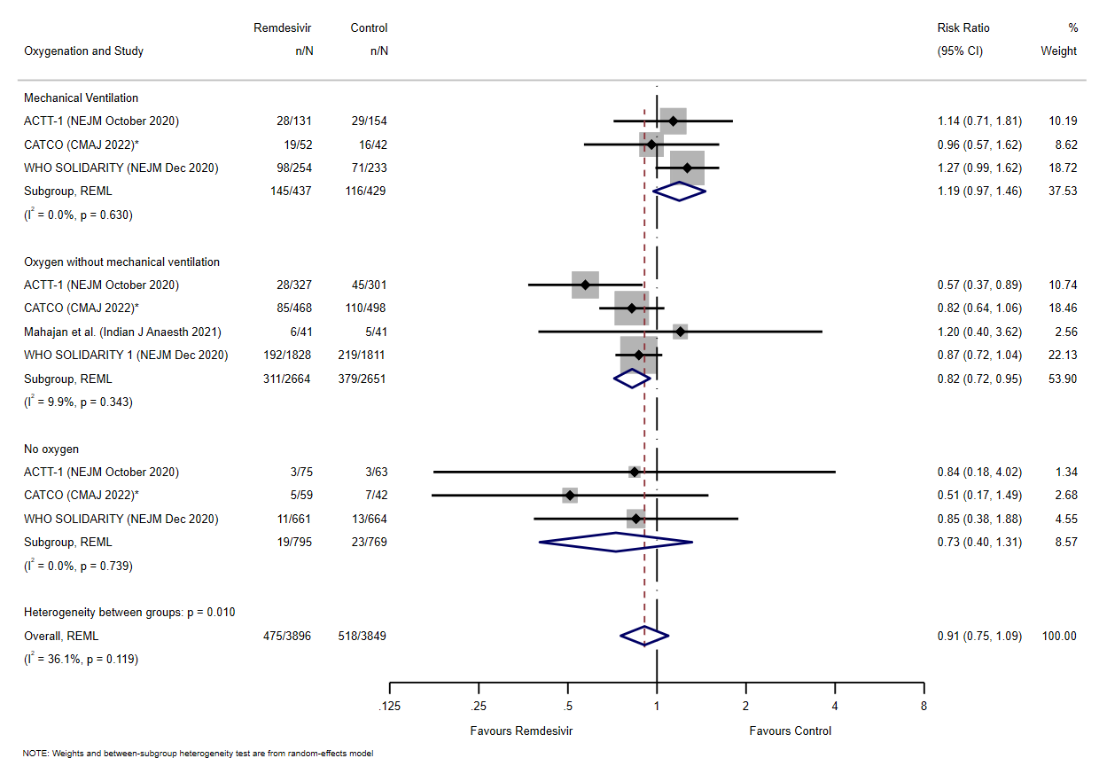
Supplemental Figure 3 – Sensitivity Analysis Excluding Trials at High Risk of Bias

